March 19th 2019

Dear Dr. Jaydev Upponi

Please find enclosed the second version of the revised manuscript ref. JoVE59798, now entitled “Detection of extravascular trypanosoma parasites by Fine Needle Aspiration”, which we hope can now be accepted by JoVE and be transferred to the video stage.

We are submitting a revised version of the manuscript in which changes have been tracked. Below is a point-by-point reply to the editorial’s comments.

1. The editor has formatted the manuscript to match the journal's style. Please retain the same.
Retained.
2. Please address specific minor comments marked in the manuscript.
All comments and suggestions were addressed (changes tracked in the manuscript resubmitted).
3. Please reword following lines as it matches with previously published literature:
- 92-93 – removed.
- 200-202 and 229-231 – reworded.
4. Please proofread the manuscript carefully for any grammar or spelling issues.
Done.
5. Figure 4 is missing panel C. Please check.
Panel C in now included in Figure 4.
Also, all the figures have a black border on the top. Please check this as well.
Black border removed.

Although the invitation to write this manuscript was made to Luisa Figueiredo, the person who actually has the expertise in FNA and wrote the manuscript was Tania Carvalho. Therefore, we propose that Tania should be the first and corresponding author.

Thank you for considering our manuscript.

Sincerely,
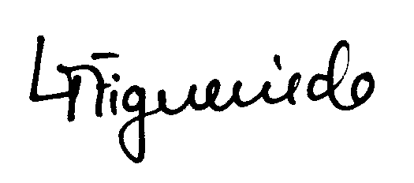
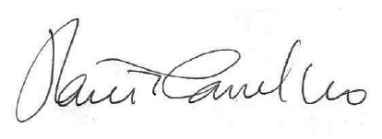

Tânia Carvalho Luisa Figueiredo
Experimental Pathologist Head of laboratory iMM
Head of the Histology and
Comparative Pathology Laboratory iMM

