
Department of Neurology and Neurosurgery

Phone: 410-929-3453
Email: sz@jhmi.edu

Steven R. Zeiler, M.D., Ph.D.
Johns Hopkins Neurology
Phipps 4-446
600 North Wolfe Street
Baltimore MD, 21287-6953

March 13, 2019

JOVE manuscript submission
Evaluating Skilled Prehension in Mice Using an Auto-Trainer

Dear Dr. Myer, JOVE editors, and esteemed Reviewers

As discussed, we are excited to share our concept of the mouse auto-trainer. To our knowledge, this is the first auto-training device for mice purposefully designed to train animals in their home cage and thus reduce excitability/anxiety. Importantly, we show that our auto-trainer trains mice to a high level of prehension success, which equals that seen with time-consuming manual training.

In this revision, we have addressed the Editorial and Reviewer issues. We believe that the manuscript is significantly improved.

Sincerely, and on behalf of my co-authors,

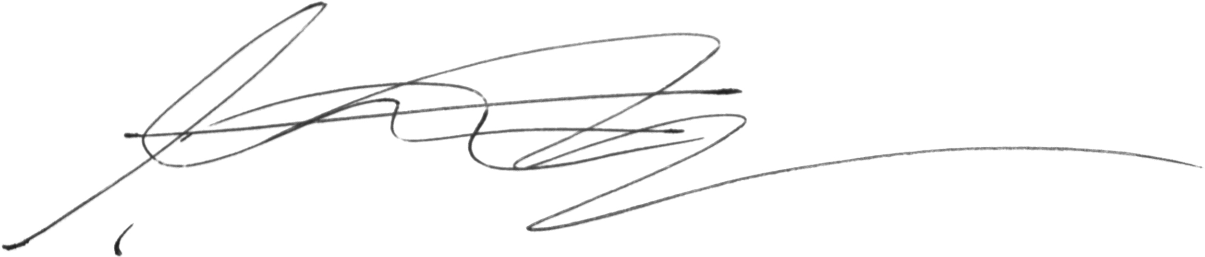

Steven R. Zeiler, M.D., Ph.D.
Assistant Professor, Johns Hopkins
Head of Stroke Research Johns Hopkins Bayview Medical Center
Director Vascular Neurology Fellowship Johns Hopkins

