Supporting Information

Dual Bioluminescence Imaging of Tumor Progression and Angiogenesis

Kaiyue Zhang¹, Chen Wang¹, Ran Wang², Shang Chen¹ and Zongjin Li^{1*}.

¹Nankai University School of Medicine, Tianjin, China;
²State Key Laboratory of Medicinal Chemical Biology and College of Pharmacy, Nankai University, Tianjin, China.

*Corresponding Author:
Zongjin Li, MD, PhD
Email: zongjinli@nankai.edu.cn
Tel: +86-22-23509332

Figure S1
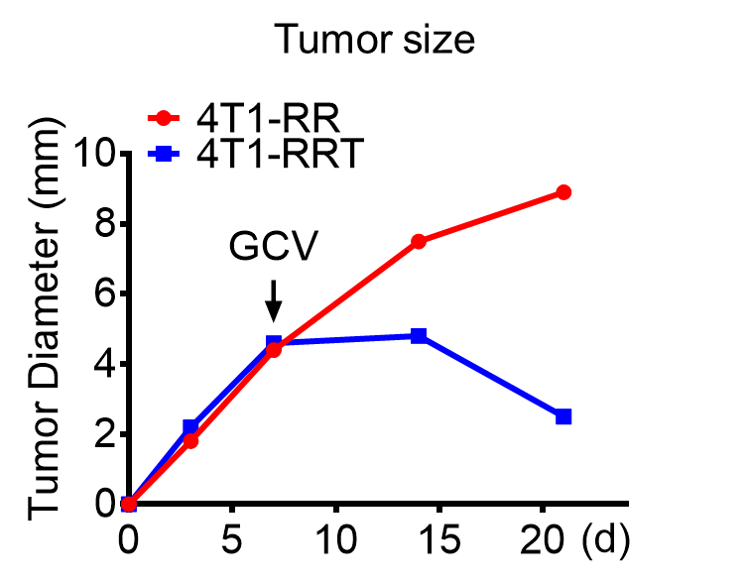
Figure S1. The curve of tumor size during tumor progression in vivo. The tumor size of 4T1-RR and 4T1-RRT cells increased after implantation, but the tumor size of 4T1-RRT cells sharply decreased post GCV treatment.

Figure S2
Figure S2. The cytotoxic effect of GCV on 4T1-RRT cells. With increased concentrations of GCV, the viability of 4T1-RRT cells was significantly inhibited.

Figure S3
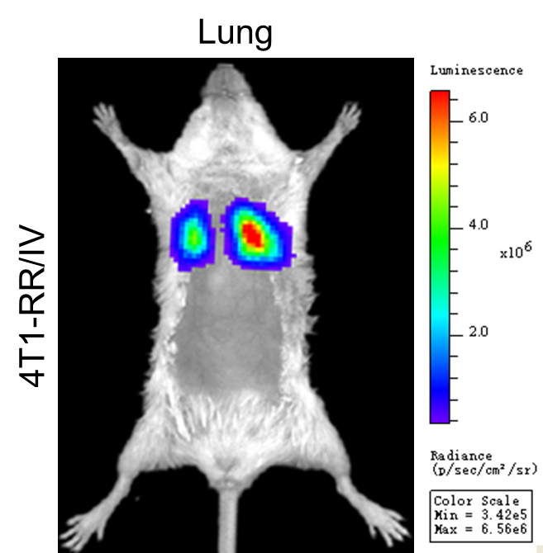
Figure S3. The BLI image of 4T1-RR cells in the lungs. After tail vein injection of 4T1-RR cells, the Rluc signal of cells was detected by BLI.

