

Department of Neurosurgery

Nikos Tapinos, MD, PhD
Associate Professor
Brown University
Director
Molecular Neuroscience & Neuro-Oncology Research - RIH
593 Eddy Street
Aldrich Building, Room 401
Providence, RI 02903
Tel: 401 606-4393
Email: nikos_tapinos@brown.edu

January 28, 2019

JoVE
1 Alewife Center, Suite 200
Cambridge, MA 02140
tel: 617-945-9051
fax: 866-381-2236

Dear Editor,

We are submitting our manuscript entitled: “Real-time monitoring of human glioma cell migration on DRG axon-oligodendrocyte co-cultures” and would appreciate it if you would consider it for publication in “JoVE”. This is an original study that was not submitted before for publication.

Human glioblastoma is one of the most aggressive and lethal human tumors due to the presence of tumor-propagating glioma stem cells and the highly migratory nature of these cells. Despite the wealth of knowledge regarding the genetic background of this disease, studies on glioma cell migration are hindered by the lack of efficient in vitro or in vivo migration models.

Here we present a novel approach for the study of human glioma cell migration on myelinated and non-myelinated axons. We developed an ex vivo system containing Dorsal Root Ganglion axon-oligodendrocyte co-cultures and then seeded these cultures with patient derived glioma cells. We discovered that glioma cells interact with axonal tracks and migrate along the myelinated and non-myelinated axons thus mimicking the common clinical scenario of tumor infiltration in human glioblastoma. In our co-culture model, we observed that glioma cells interact with neighboring axons through extensive formation of pseudopodia.

On behalf of all authors, I would like to note that there is no conflict of interest to disclose.

Thank you for your time and consideration.

Sincerely,
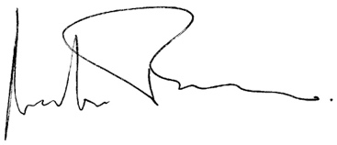

Nikos Tapinos MD, PhD

