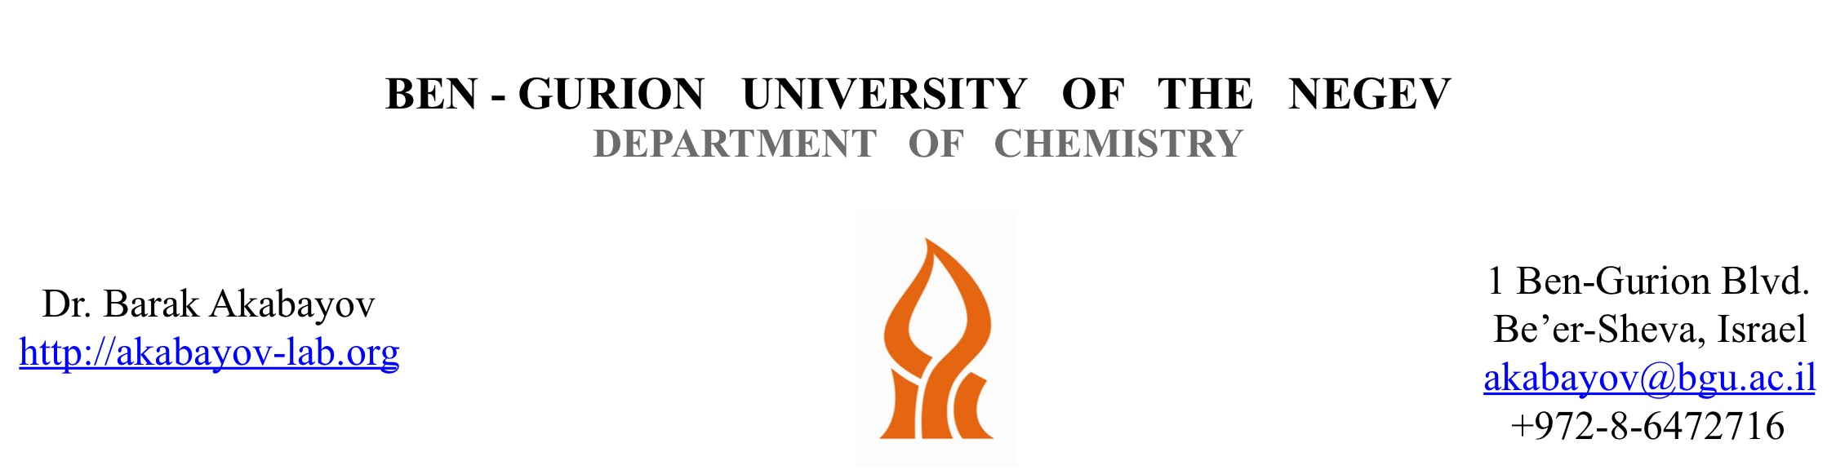

March 26, 2019

Dear Dr. DSouza,

We are submitting a revised version of our manuscript JoVE59737, entitled “DNA sequence recognition by DNA-primase using high-throughput primase profiling (HTPP)”.

In response to the reviewer comments, we further clarified the text and added new explanatory notes as elaborated in the response letter. As this paper provides an overview of the methodology (FHTPP) and didn’t aim to present new data, we think that the modified version provide an extended view on the method and do not repeat in any way the published data on the recognition by T7 primase.

Overall, we believe our revised manuscript is much stronger, addresses the reviewers’ comments, and describes the implications of primase binding and functional activity. Thus, we hope you will consider our revised manuscript for publication in JOVE.

Sincerely,
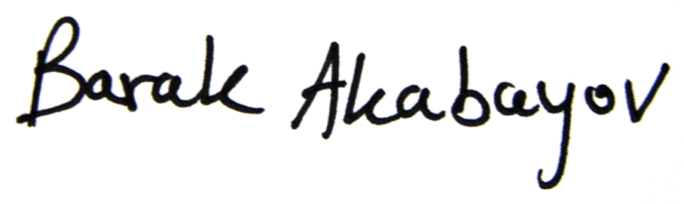
Barak Akabayov

