Supplementary File

Optimized conditions for LC-MS/MS analysis of M. aeruginosa extracts

LC-MS/MS analysis was performed with an 1290 HPLC system coupled to a Q‐Exactive Quadrupole Orbitrap mass spectrometer . Chromatographic conditions consisted of an Eclipse Plus C18 RRHD column (2.1 × 100 mm, 1.8 μm) maintained at 35°C using. The mobile phase consisted of water with 0.1% formic acid (mobile phase A), and acetonitrile with 0.1% formic acid (mobile phase B) (LC-MS grade). Mobile phase B was held at 0% B for 0.5 min before increasing to 35% over 1.5 min. Mobile phase was slowly increased to 45% over 3.5 min, before increasing to 100% B over 2.0 min. Mobile phase B was held at 100% for 3 min before returning to 0% over 0.5 min. Culture extracts were injected with a volume of 5 μL and separated at a flow rate of 0.3 mL/min. Heated electrospray ionization was used in positive ionization mode with the following settings: capillary voltage, 3.9 kV; capillary temperature, 400°C; sheath gas, 19 units; auxiliary gas, 8 units; probe heater temperature, 450°C; S‐Lens RF level, 45.00. MS data were acquired using untargeted DDA that included a full MS scan at 35 000 resolution, with a scan range of 200–1450 m/z; automatic gain control target (AGC), 1 × 10⁶ ; and a maximum injection time (IT) of 128 ms. The five highest intensity ions were selected from each full scan for MS/MS analysis using a 1.0 Da isolation window, and were analyzed using the following conditions: resolution, 17 500; AGC, 1 × 10⁶; max IT, 64 ms; normalized stepped collision energy, 30/45; intensity threshold, 1.6 × 10⁵ ; dynamic exclusion, 10 s. The mass accuracy obtained in this m/z using this platform is < 3.0 ppm. The mass range used here (m/z 200-1450) allows for the detection of other secondary metabolites, however screening datasets only uses 430-1200, which covers the range of all known MCs both [M+H]⁺ and [M+2H]²⁺

Table S1 Putative MCs detected by DFF of M. aeruginosa strain CPCC300 extract
 |  | m/z | RT (min) | Comment | ppm
1 | C₄₈H₇₂N₁₀O₁₂ | 981.5388 | 3.42 | [D-Asp³]MC-LR; previously confirmed in strain | -1.62
2 | C₄₉H₇₄N₁₀O₁₂ | 995.5576 | 3.37 | MC-LR; previously confirmed in strain | 1.56
3 | C₄₇H₇₀N₁₀O₁₂ | 967.5264 | 3.47 | multiple isobaric congeners known. i.e [Gly1,Asp³]MC-LR, [D-Asp³, Dha7]MC-LR | 1.71
5 | C₄₈H₇₄N₁₀O₁₃ | 999.5502 | 3.27 | multiple isobaric congeners known. i.e [Asp³,Mser⁷]MC-LR, [L-Ser⁷]MC-LR | -0.76
6 | C₅₀H₇₆N₁₀O₁₂ | 1009.5735 | 3.59 | multiple isobaric congeners known. i.e MC-HilR, MC-LHar | 1.79
7 | C₄₉H₇₆N₁₀O₁₃ | 1013.5667 | 3.27 | multiple isobaric congeners known. i.e [L-Mser⁷]MC-LR; [seco-1/2]MC-LR | 0.09
4 |  | 997.5353 | 3.28 | m/z not listed in Spoof database; wrong m/z for MC-Waba | -
8 | - | 934.4821 | 5.12 | m/z not listed in Spoof database | -
9 | - | 952.5031 | 5.1 | m/z not listed in Spoof database; wrong m/z for MC-LL | -
10 |  | 979.5281 | 3.44 | m/z not listed in Spoof database | -
11 |  | 993.5389 | 3.45 | m/z not listed in Spoof database | -
12 |  | 497.2746 | 3.45 | [M+2H]²⁺ of m/z 993.5389 | -
13 |  | 1011.5511 | 3.36 | m/z not listed in Spoof database; wrong m/z for [D-Asp³]MC-LW | -
14 |  | 1025.5591 | 3.49 | m/z not listed in Spoof database; wrong m/z for MC-LW | -
15 |  | 1053.5622 | 3.29 | m/z not listed in Spoof database | -

Spoof database = Spoof, L. & Catherine, A. Appendix 3: tables of microcystins and nodularins. Handbook of cyanobacterial monitoring and cyanotoxin analysis. 526-537 (2016)

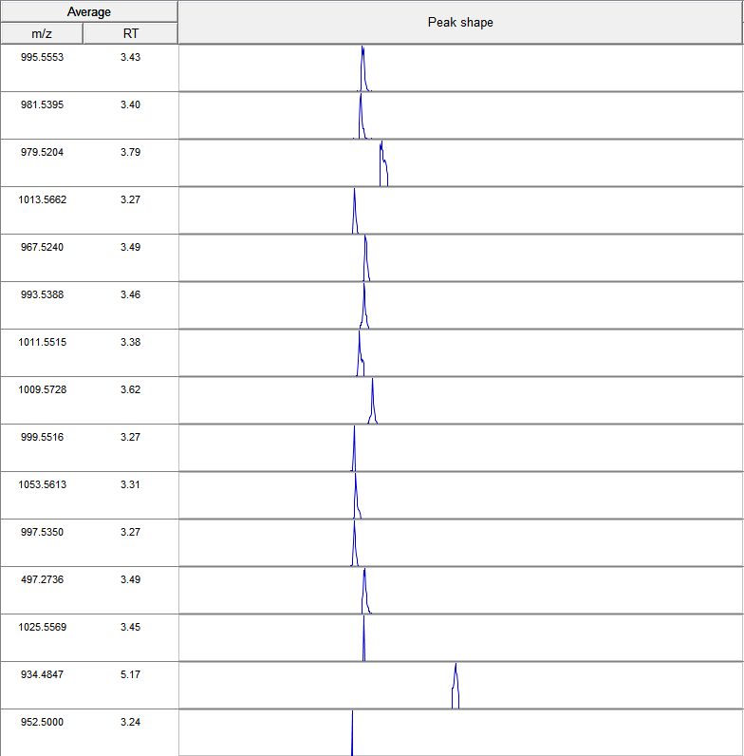
Figure S1. Extracted ion chromatograms for putative MCs as shown using the targeted detection module of MZmine 2. Duplicates, isotopes and adducts have been removed.

