MINOR time 0: Add middle initial: Jaakko O. Nieminen, Jaakko O. Nieminen should be with affiliations 1,2,3

MINOR time 0:14-0:17 : good to show the raw data, but not a perfect example of oscillatory activity, maybe there is a similar segment where both the positive and negative peaks of the oscillation being hit are visible more clearly

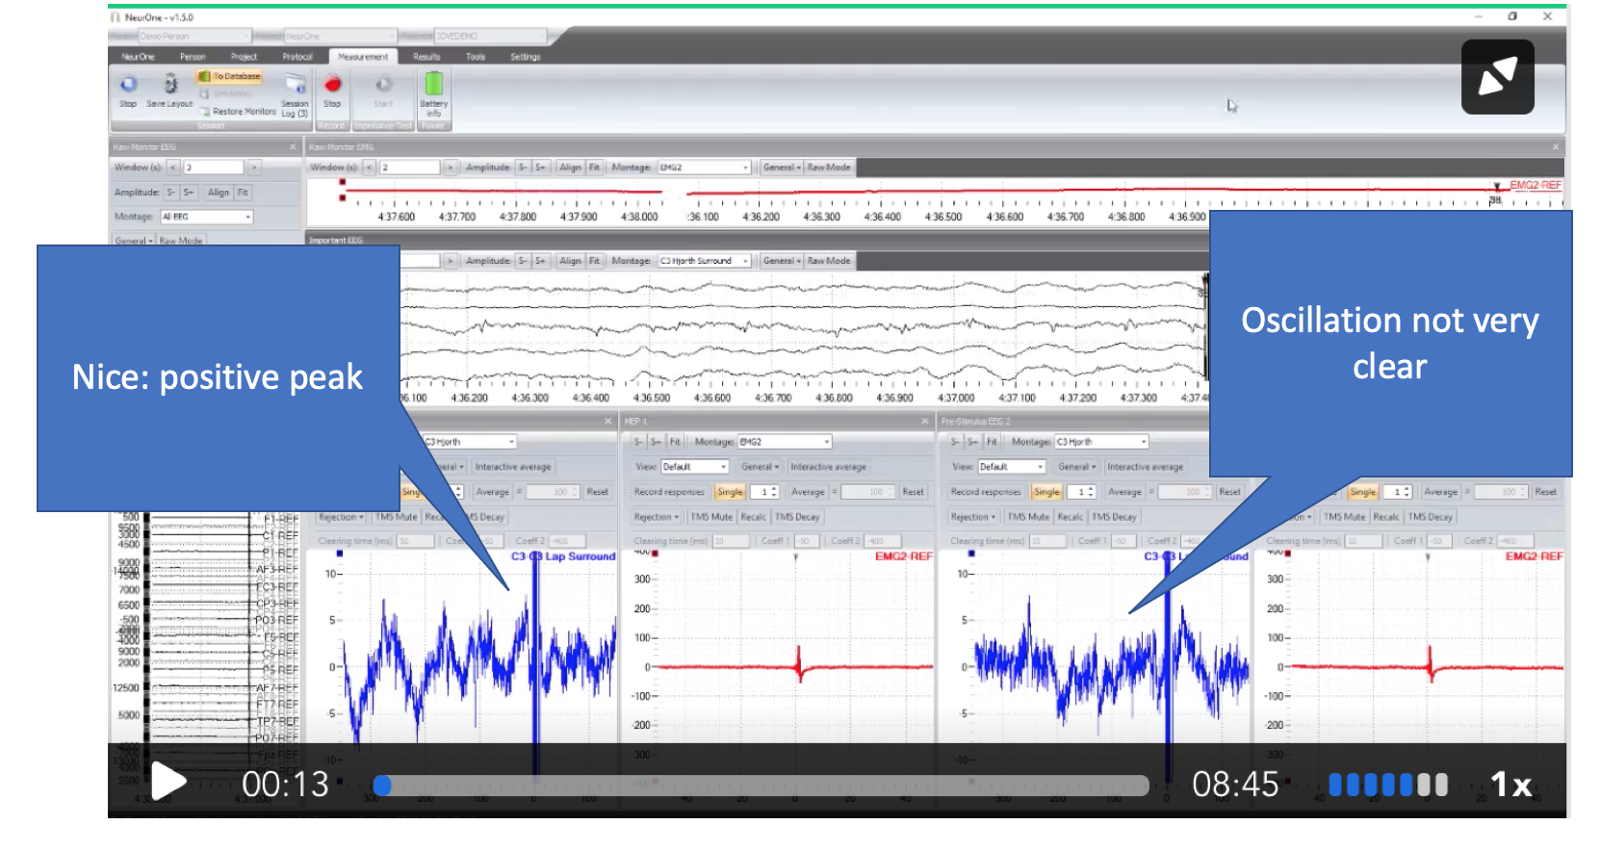

MAJOR time 1:19-1:23: "Ethic" is a typo should be "Ethics"

MAJOR time 1:30-1:35: remove "TMS COIL" label, this should be shown later, it does not fit the text that describes the EEG. Better to label the EEG ELECTRODES instead

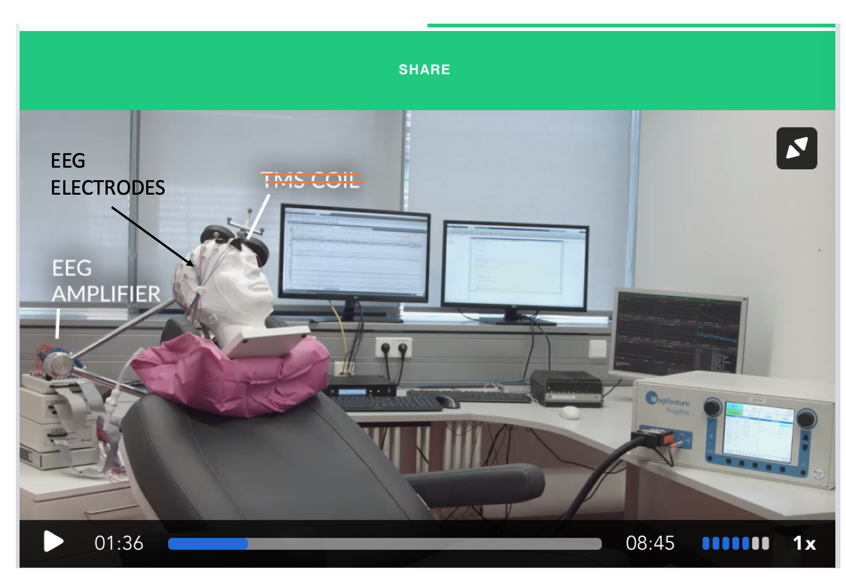

MAJOR time 1:44 "thereby closing the signal loop" here the TMS coil should be shown, since this is the part that stimulates the brain

MINOR time 2:00 the narrative talks about the coil but the coil is not visible in the shot (it's cut off).

MINOR time 2:00-2:07: video doesn't fit narrative, this needs to be replaced with a different shot showing the coil on the head

MINOR time 4:15-4:22: the red EMG trace is cut off in some of the responses at the bottom. Can you chose a few of the later pulses which are not cut off? Maybe also label the EEG (on the left) and the EMG (on the right).

MINOR time 05:50: can you retype the magnified text so that it's not so blurry? it can also stay on for longer

MINOR time 06:17: the second EMG response is cut off at the bottom, can you chose a different segment where the responses are not cut off?

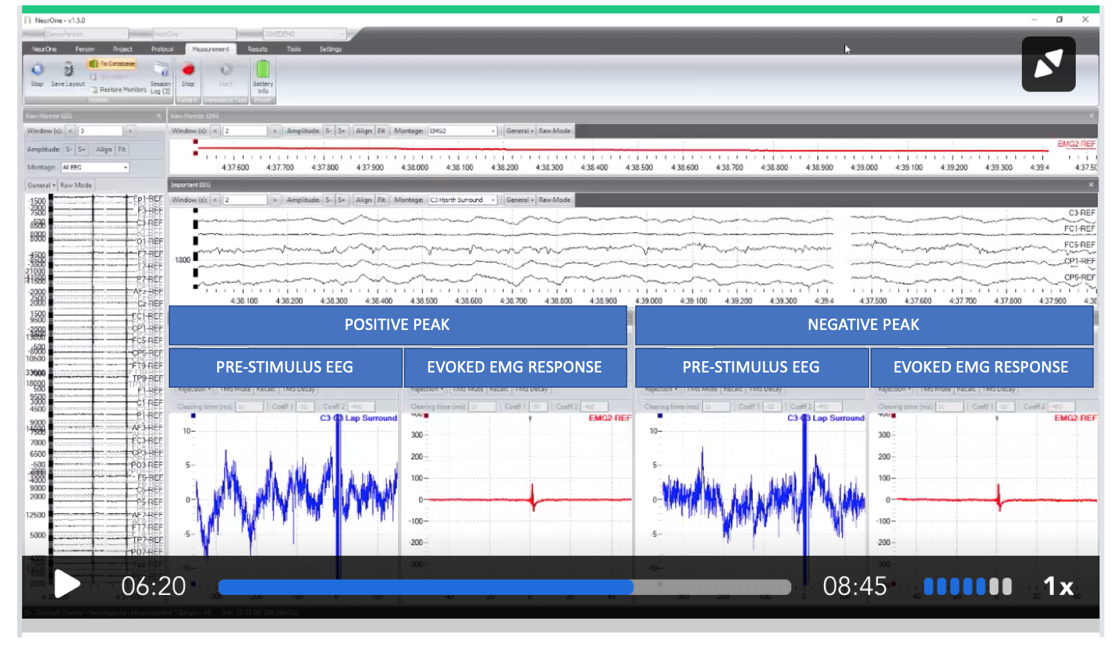

STEP 4.11.1 is now uploaded

STEP 4.12.1 is now uploaded

MAJOR time 6:50-07:02: Please chose a slightly later sequence of the screen capture, just a few seconds, we don't need to see the period where the average was turned on and the single trials were turned off, this looks messy and we don't see the resulting average.

