Submission ID #: 59694

Scriptwriter Name: Maja Fiket

Project Page Link: https://www.jove.com/account/file-uploader?src=18206718

Title: Preparation of Newborn Rat Brain Tissue for Ultrastructural Morphometric Analysis of Synaptic Vesicle Distribution at Nerve Terminals

Authors and Affiliations: Bianca Ferrarese^{1,2}, Nadia Lunardi¹

¹Department of Anesthesiology, University of Virginia Health System, Charlottesville, VA, USA
²Department of Anesthesiology, Universita’ degli Studi di Padova,
Padova, Italy

Corresponding Author:
Nadia Lunardi

NL3F@virginia.edu

Email addresses for Co-authors:
Bianca Ferrarese
biancaferrarese@gmail.com

Author Questionnaire:

1. Microscopy: Does your protocol involve video microscopy, such as filming a complex dissection or microinjection technique? (Y/N) N

2. Does your protocol include software usage? (Y/N) N

3. Which steps from the protocol section below are the most important for viewers to see? Please list 4-6 individual steps using the step numbers listed in this document. This information is important to prepare your Videographer for your shoot. (You do not need to include steps that will be screen captured. Please do not list entire sections.)
Authors, please answer this question with the steps listed here in the Protocol section below for use by the videographer.
Steps 3.1, 4.2, 5.1, 5.2, 5.3 and 5.4

4. What is the single most difficult aspect of this procedure and what do you do to ensure success? Please list 1-2 individual steps using the step numbers listed in this document. (Please do not list entire sections.)
Authors, please answer this question with the steps listed here in the Protocol section below for use by the videographer.
Step 3.1. It is imperative to add the embedding reagents in the order listed. Add the accelerator last. To obtain a cured block that has the desired characteristics, it is critical to use the exact amount of the hardener and the accelerator.
Step 4.2. During flat embedding it is important to handle sections very carefully. Delicately lift the specimen by means of a fine paint brush and a micro spatula, and gently pull it out of the vial as you transfer it on the plastic sheet.
5. Will the filming need to take place in multiple locations? (Y/N) N

Section - Introduction
Videographer: Interviewee Headshots are required. Take a headshot for each interviewee.

Authors, these headshots will be used for the JoVE Dedicated Author Webpage. Here is one example if you wish to take a look.

- REQUIRED Interview Statements: (Said by you on camera) - All interview statements may be edited for length and clarity.

  - Nadia Lunardi: Among several existing protocols for tissue preparation for transmission electron microscopy, we selected methods that yield optimal structural preservation and high-resolution micrographs to perform morphometric analysis of synaptic vesicle distribution [1].
    - Interview

  - Nadia-Lunardi-Author Name: The high-contrast images obtained allow to quantify parameters [1], such as vesicle distance from the pre-synaptic membrane [2], number of docked vesicles and inter-vesicle distance [3], indicative of synaptic function [4].
    - Figures 1 and 2
    - Figure 1B
    - Figure 2B
    - Interview

OPTIONAL Interview Statements: (Said by you on camera) - All interview statements may be edited for length and clarity.

I moved one statement in the protocol, step 2.2.

  - Nadia-Lunardi: Since the perturbation of vesicle spatial organization may be associated with disruption of synaptic function, these methods have been used to examine the effects of general anesthetics on synaptic development [1].
    - Interview

  - Nadia-Lunardi: This method could be used to examine the effects of any drug or treatment on the detailed morphology of synapses to provide insight into their function [1] [2].
    - Videographer, could you get some B-roll of the interesting looking steps that we can show during this interview statement?
    - Interview.

Ethics title card: (for human subjects or animal work, does not count toward word length total)

  - All studies were approved by the Institutional Animal Care and Use Committee at the University of Virginia (Charlottesville, VA) and conducted in accordance with the National Institutes of Health guidelines.

Section - Protocol
- Post-Fixation, Sequential Dehydration and Staining of Brain Sections
  - Begin by preparing osmium tetroxide for post-fixation of rat brain sections previously fixed with paraformaldehyde and glutaraldehyde via vascular perfusion [1].
    - MED: Establishing shot. Talent handling rat brain sections. TEXT: OsO₄ is extremely volatile and its fumes are toxic!
  - Nadia-Lunardi: Preparation of tissue for TEM requires finesse and concentration. Limit the number of sections you are handling at once initially. Be focused and patient [1].
    - Interview
  - Open one 5 mL glass ampoule of 4% osmium tetroxide in water and drop it inside a brown glass bottle [1]. Add 5 mL of 0.2-molar phosphate buffer [2-TXT] and then add additional 10 mL of 0.1 M phosphate buffer to achieve 1% final solution [3-TXT].
    - CU: Talent opening glass ampoule and drops it inside a brown bottle.
    - MED: Talent adding phosphate buffer. TEXT: phosphate buffer=PB
    - MED: Talent adding phosphate buffer. TEXT: Final solution: 20 mL of 1% OsO₄ in 0.1 M PB
  - Use a 20-milliliter syringe fitted with a long needle to draw 1% osmium tetroxide [1] and then add osmium tetroxide to a brown glass jar covered with aluminum foil [2].
    - CU: Shot of the syringe with the needle.
    - MED: Talent adding osmium tetroxide to a brown glass jar.
  - After making sure that the specimen has been unfolded and flattened [1] add 1% osmium tetroxide in 0.1-molar PB to the specimen vial [2]. Incubate the specimen in osmium tetroxide for 1 hour at room temperature [3].
    - ECU: Shot of the unfolded and flattened specimen. Videographer please take multiple usable shots.
    - CU: Talent adding osmium tetroxide to the specimen.
    - MED: Talent leaving the specimen for incubation.
  - Extract osmium tetroxide with a micropipette after incubation is finished and rinse the sections as described in the protocol [1].
    - CU: Talent removing osmium tetroxide with a micropipette.

  - To prepare uranyl acetate, place a 200 mL volumetric glass flask containing 100 mL of 70% ethanol on a stirring plate [1-TXT]. Add 4 grams of uranyl acetate to the flask [2], wrap in aluminum foil to prevent precipitation by light [3] and stir continuously [4].
    - MED: Talent placing glass flask with ethanol on a stirring plate. TEXT: Uranyl acetate is mildly radioactive and highly toxic!
    - CU: Talent adding uranyl acetate.
    - MED: Talent starts the stirrer.
  - Dehydrate the sections in 50% ethanol, stain with the prepared 4% uranyl acetate for 1 h, and follow with serial dehydration and rinsing as described in the manuscript [1].
    - MED: Talent starts preparing the sections for dehydration OR preparing solutions for dehydration.

- Infiltration and Embedding
  - Remove the syringe plunger from a a 60 mL gavage syringe [2] and cap it with a safety needle [1] . Position the syringe with the open side up and add each ingredient of the resin mix one by one [3-TXT]. Finish by adding 525 microliters of DMP-30 with a pipette, moving the plunger of the pipette very slowly as DMP is very viscous [4].

3.1.2. CU: Talent removing the plunger.
    - CU: Talent capping a 60 mL gavage syringe with a safety needle.
    - CU: Talent removing the plunger. (Move above 3.1.1)
    - CU: Talent positioning the syringe and starts adding resin ingredients. TEXT: For right order of ingredients and exact amounts see text!
    - CU: Talent slowly moving the plunger of the pipette when adding DPM-30.
  - Put the plunger back in the syringe [1]. Invert the syringe a few times to mix the contents. The color will change from yellow to amber [3]. Evacuate the air inside the syringe, and place it on a rocker with continuous shaking for at least 30 minutes [2-TXT].
    - CU: Talent placing the plunger back.

3.2.3. CU: Shot of the changed color – amber
    - MED: Talent placing the syringe on a rocker. TEXT: Leave a small bubble of air at the syringe hub.
    - CU: Shot of the changed color – amber. (Moe above 3.2.2)
  - Add 1 volume of epoxy resin and 1 volume of acetone to a scintillation vial [1] and shake to mix [2]. Apply this 1:1 resin:acetone mixture on the tissue section after the last acetone rinse keeping it covered to avoid acetone evaporation [3]. after 2-4 h [4-TXT].
    - CU: Talent adding resin and acetone to a vial.
    - MED: Talent shaking the vial.
    - CU: Talent removing acetone and adding the mix to the section and covering it.
  - Remove the 1:1 mixture of resin and acetone after 2-4 hours and replace it with full resin and incubate for 4 h [1-TXT]. Put all resin waste in a collection container under the hood to polymerize and disposed of it later [2].
    - CU: Talent replacing the resin-acetone mixture with full resin. TEXT: Or overnight.
    - MED: talent placing all resin waste in a collection container under the hood.
- Flat Embedding

  - Cut two rectangular pieces of clear Polychlorotrifluoroethylene film [1-TXT] and wipe them with 70% ethanol [2]. Trim them so that there is at least 1.5 cm of tissue-free plastic on every side of the section [3], making sure that they have the same width but the height of sheet on top is approximately two thirds of the bottom sheet [4].
    - CU: Talent cutting 2 pieces of the film. TEXT: PCTFE
    - CU: Talent wiping with ethanol.
    - ECU: Talent trimming the sheets. (Author Comment: I believe this shot was not taken.) (Editor: If this shot was not taken, just show 4.1.4 for the narration originally intended for 4.1.3 and 4.1.4)
    - ECU: Shot of the sheets where they have the same width but the height of sheet on top is approximately two thirds of the bottom sheet.

  - Slowly tilt the vial [1] and use a fine camel paint brush, and a flexible micro spatula to very gently lift the specimen from the bottom [2]. Then carefully move the section along the vial walls [3] and transfer onto the bottom PCTFE sheet [4]. Remove excess resin with a micro spatula [5.2.4a] and gently cover the specimen with the top sheet [5].
    - CU: Talent tilting the vial
    - ECU: Talent gently lifting the specimen.
    - ECU: Talent using a micro flexible spatula and a fine brush to carefully move the section along the vial walls.
    - CU: Talent transferring the section onto the film.

4.2.4a. Editor: I’m not sure if a shot was filmed for this. The authors wanted the step added here, but did not make it clear if they’d filmed a shot.
    - CU: Talent covering with top sheet.
  - Gently push out any trapped air bubbles without applying direct pressure onto the tissue section [1] and wipe out the excess resin [2]. Use a solvent resistant pen to label the sheets and place in oven at 60 ͦC for 2-3 days to polymerize [3].
    - ECU: Talent removing air bubbles.
    - CU: Talent cleaning excess resin.
    - CU: Talent labeling the sheets.
- Capsule Embedding
  - Gently pull apart the sandwiched PCTFE sheets to open them [1]. Use a solvent resistant pen to mark the side of the sheet that contains the adhering section, marking it near the tissue [2]. Use a disc punch to obtain a circle sample of the section making sure that the pen mark is part of the punched-out tissue [3]. The pen mark will gleam when light is shined on the specimen [5.2.3].
    - ECU: Talent opening the sheets.
    - ECU: Talent marking the sheet with the section.
    - ECU: Talent using disk punch to obtain a circle sample of the section.

5.2.3. ECU: Talent shining the light on the specimen to show the pen mark gleaming
  - Place the cap of an embedding capsule side up on a capsule holder [1]. Place a drop of resin on the cap [5.2.1a], and insert the punched disc inside the cap with the tissue section facing up [2]. [3].
    - CU: Talent placing the cap of an embedding capsule side up on a capsule holder.

5.2.1a. Editor: I’m not sure if a shot was filmed for this. The authors wanted the step added here, but did not make it clear if they’d filmed a shot.
    - ECU: Talent inserting the punched disc inside the cap with the tissue section facing up.
    - ECU: Talent shining the light on the specimen to show the pen mark gleaming. (Move below 5.1.3)
  - Insert a capsule into the cap using a gentle corkscrew movement [1]. Use fine tweezers to roll and lower a printed 2-centimeter-long piece of paper label into the capsule [2], making sure it fits to the curvature of the side walls of the capsule [3].
    - CU: talent inserting a capsule into the cap.
    - CU: Talent rolling and lowering paper label into the capsule.
    - ECU: Talent checking label fits the curvature.
  - Pour the embedding resin inside the capsule, fill up to the edge of the capsule [1] and use a pointed wooden stick to push the tissue specimen down to the bottom [2]. Place the capsule in the oven at 60 ͦC for 2-3 days for polymerization and then continue with sectioning and staining as described in the protocol [3].
    - CU: Talent filling the capsule with resin.
    - ECU: Talent pushing the tissue specimen down to the bottom.
    - MED: Talent placing the capsule in the oven at 60 ͦC.

Section – Results
- Results: Electron Micrographs of Newborn Rat Brain Tissue
  - Electron micrograph of satisfactory preservation of neuronal cell structure shows layered cell membranes without breaks [1]. The cytoplasm is finely granular and without empty spaces [2]. Mitochondria are neither swollen nor shrunk, with conserved outer double membrane and intact internal cristae [3].
    - Figure 1 A Video editor: on the original image emphasize the two membranes marked in red in this example image:

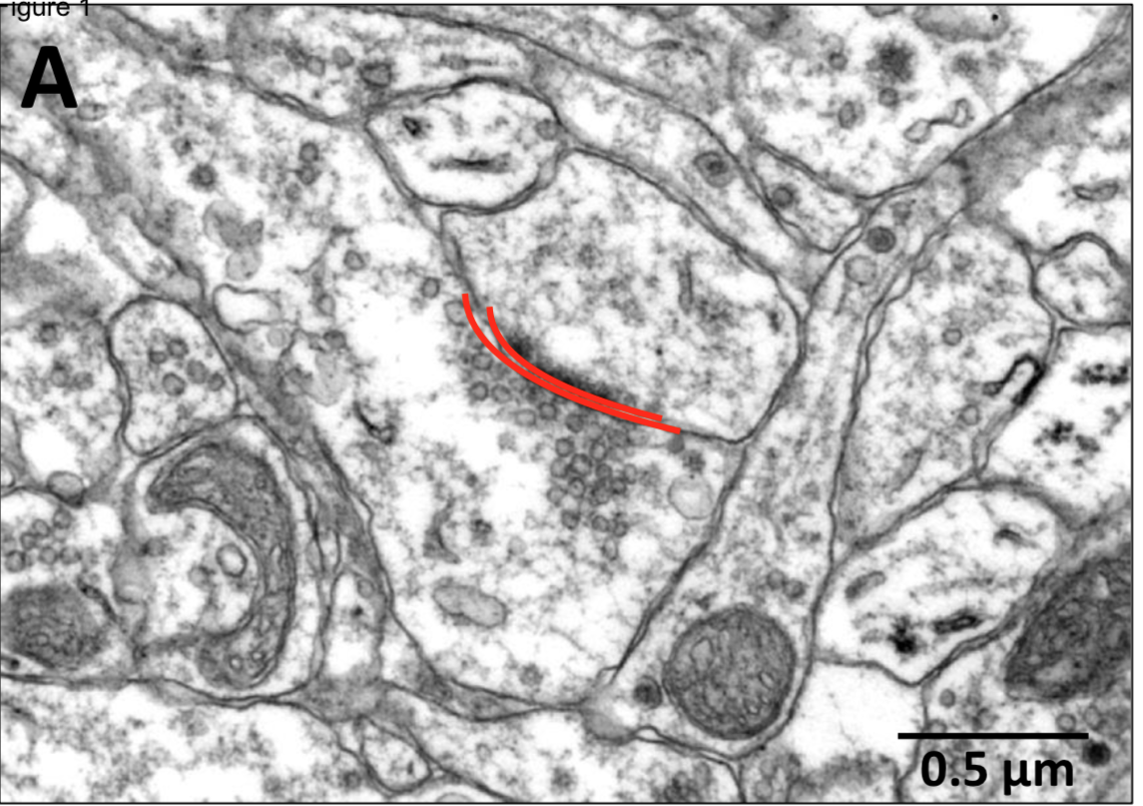

    - Figure 1 A Video editor: on the original image emphasize what is within the bigger cell marked in red in this example image.
    - Figure 1 A Video editor: on the original image emphasize what is marked in yellow in this example image.

Example image:

  - Optimal preservation of neuronal ultrastructure and fine morphological detail is essential in order to visualize synaptic vesicles and measure their distance from the pre-synaptic membrane.
    - Figure 2A
  - Synaptic vesicles should be distinct and lined by an unbroken single membrane [1]. In order to facilitate morphometric analysis of synaptic vesicle distribution, pre-synaptic and post-synaptic membranes should be parallel, and their continuity preserved [2].
    - Figure 2A Video editor: on the original image emphasize vesicles, which are small circles within the cell almost in the middle of the image (I circled some of them in red in this example image).
    - Figure 2A Video editor: on the original image emphasize the membranes I marked yellow in this example image.

Example image:

  - This is an example of synaptic vesicles counting within the pre-synaptic terminal [1].
    - Figure 3
  - Electron micrograph of defective preservation of tissue structure shows the distortion and breakage of neuronal cell membranes and the presence of markedly enlarged extracellular spaces. Mitochondria appear distended and have swollen cristae [1].
    - Figure 3 Video editor emphasize parts marked with * when “the presence of markedly enlarged extracellular spaces” are mentioned. Then emphasize what the arrow is pointing at when mitochondria are mentioned.
  - In another example of defective tissue structure preservation there were large white empty spaces within the cytoplasm, in place of finely granular cytoplasmic substance, with enlarged extracellular spaces [1]. An artifactual membranous whorl likely resulted from mobilization of lipids during fixation with glutaraldehyde [2].
    - Figure 4 Video editor emphasize space marked with ǂ when “large white empty spaces within the cytoplasm” are mentioned.
    - Figure 4 Video editor emphasize the structure marked with “MF” when “an artifactual membranous whorl” is mentioned.

Section - Conclusion
- Conclusion Interview Statements: (Said by you on camera) - All interview statements may be edited for length and clarity.
  - Nadia Lunardi: When working with young brain tissue, use 0.1 M phosphate buffer as a solvent for all solutions [1], in order to keep tonicity as close as possible to that of newborn rat brain and minimize artefactual tissue shrinkage and/or swelling [2].
    - Use 2.3.3.
    - Interview
  - Nadia Lunardi: Sections become rigid after treatment with osmium, therefore tissue handling requires finesse and concentration from then on [1]. Before adding osmium, make sure sections are flattened, as any fold will cause subsequent tissue fracture [2].
    - Use 2.5.1.
    - Interview
  - Nadia Lunardi: The micrographs thus obtained can be used to study the detailed morphology and dimensional structural relations of cellular components other than synaptic vesicles, i.e., mitochondria, Golgi apparatus, chromatin [1].
    - Interview

  - Nadia Lunardi: Several steps in this protocol require chemicals that can be toxic. Work under a fume hood and wear personal protective equipment when handling aldehydes, osmium, uranium and lead compounds [1].
    - Interview

