movie times:

3.5.2. 3.5.2. movie (Here the focus should be on the left top where it shows around 3.5 MO, here the resistance is shown. This part we also shot with the photographer)

3.5.3. 3.5.3. movie (Here the focus is the big window in the middle showing the current pulse, you will see that there is a square pulse in the window, the current before and after the pulse jumps to 0, which is the solid green line in the middle of the window)

3.6.1. Microscope movie2 0:27 - 0:46 (Part of the frame of this video needs to be cut off. This is the right part with white blank. This part is the software to record current, but not show the cell)

3.7.2. Microscope movie2 0:50 - 1:00 (Same problem as 3.6.1)

3.8.1. Patchmaster movie3 1:04 - 1:24(Here the focus should be the two current peaks in, two 0.1 ms current pulse induce the two current peaks in the movie)

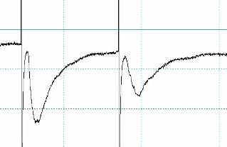

3.8.2. Patchmaster movie3 1:04 - 1:24 (Here the focus should be the test pulse before the two current peaks. It is the current amplitude in response to a 5 mV step, therefore the same movie should be used as in 3.8.1.)

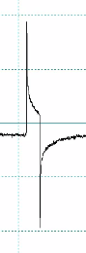

not as submitted by author marked in script:

release pressure: Patchmaster movie1 0:37 - 0:47 (This is 3.6.2 and could combine with the photographer shooting)

potential to -70mV: Patchmaster movie1 0:50 - 1:05 (This is 3.6.3 and could combine with the photographer shooting)

seal: Patchmaster movie1 2:25 - 2:30 (This can be combined with 3.7.2)

compensation capat.: Patchmaster movie1 2:30 - 2:40 (This is 3.7.3)

open cell: Patchmaster movie1 2:43 - 2:53 (This is also 3.7.3 and could combine with the photographer shooting)

