Supplementary Material
- Description of mechanical testing device
The impactor stage is built onto the stage plate of an inverted microscope, which may be either a standard epifluorescence microscope (used in this study) or a confocal laser scanning microscope. The mechanical testing device consists of a base with a glass slide (#1.5, 0.17 mm thick, 40 mm diameter) through which in situ articular chondrocytes can be visualized in real time. The glass slide is glued to the bottom of the elevated stainless-steel rim to serve as a cup for holding HBSS to hydrate the specimen. The specimen is placed onto the glass slide, which sits on top of a thin stainless-steel plate screwed into the bottom of the base (the stainless-steel rim) of the device. The center of the plate has a small pinhole (0.16” in diameter, positioned below the location on the glass where specimen is placed) that serves as a viewing window for the inverted epifluorescence microscope. The pinhole/viewing window is sufficiently small that the glass resists bending and does not break under the loading conditions applied in this study (for both physiological and supraphysiological loading conditions). The impactor guide block, which is vertically extended from the base, is a reamed bore through which a cylindrical weight can slide, thereby enabling application of controlled mechanical loads or impacts to the specimen. The loads can be applied either through a pulley system driven by computer-controlled linear actuator (for static or dynamic loading regimens) or by manually dropping a weight from different heights, resulting in impacts of different prescribed kinetic energies. (Figure 1 in the manuscript)

- Physiological relevance of mechanical loading chosen for the study
The load distribution on the medial and lateral condyles of cartilage-on-femur explants was measured previously¹. In this study, we found that both the medial and lateral femoral condyles experience approximately 40% of the total applied load (with the contact point between the glass and femoral diaphysis taking up the remainder of the load). To our knowledge, the physiological loads on the cartilage of each compartment of the mouse knee have not been rigorously assessed. It has been shown that an axial load of approximated 9 N applied to the mouse tibia leads to bone strains similar to those induced during locomotion². However, the axial load on the tibia is not equivalent to the load experienced by knee articular cartilage in vivo due to the complex geometry of the knee and the possible contributions of active muscles and passive surrounding tissues (e.g., the menisci). Nevertheless, we can determine the physiological relevance of each loading condition in our study by considering the strains induced in the tissue using our platform and comparing with physiological strains in the human knee reported in the literature (assuming physiological strains in articular cartilage are roughly conserved across species). For total applied loads of 0.1 N, we have previously measured peak compressive strains of 20.7% and 34% on the medial and lateral femoral condyles (data not shown). These strains are comparable to the reported strains of 39% observed in articular cartilage on the tibial plateau in human subjects after 30 min of standing³. Similarly, in unpublished studies, we have found that for a total applied load of 0.1 N on the murine humeral head, the peak strain is 31.6% (data not shown). Previous studies have reported peak strains of 22% 9 min after push-up exercises⁴. During this waiting and imaging time (9 min), cartilage may have recovered its thickness, potentially resulting in an underestimate of peak strain during or immediately after exercise. Taken together, these finding suggest that the strains induced by 0.1N loading in our study lie within the upper limit of physiologically relevant strains. We consider higher magnitudes of static loading (0.5N and 1N) to be supraphysiological, since the peak strains surpass physiological levels and induce significant cell injury.
Unfortunately, confocal microscopy is not fast enough to capture tissue strains during impact experiments. However, additional studies have determined peak forces during these tests. Using a custom strain gauge apparatus, the peak impact forces were found to be higher than the statically applied forces. For example, a 1 mJ impact intensity induced a peak load of 8.3 N (data not shown). It is difficult to assess whether these forces lie within physiological limits in the absence of rigorous analyses of mouse joint mechanics during ambulation. We speculate that the impact-induced forces in this study are supraphysiological, given that substantial cell injury is induced in all experimental groups. However, it is important to note that impacts across a wide range of intensities (e.g., low intensity impact during ambulation and high intensity impacts during vehicle accidents) are clinically relevant.

- Alternative method of analyzing the integrity of the tissue through PI staining before mechanical testing
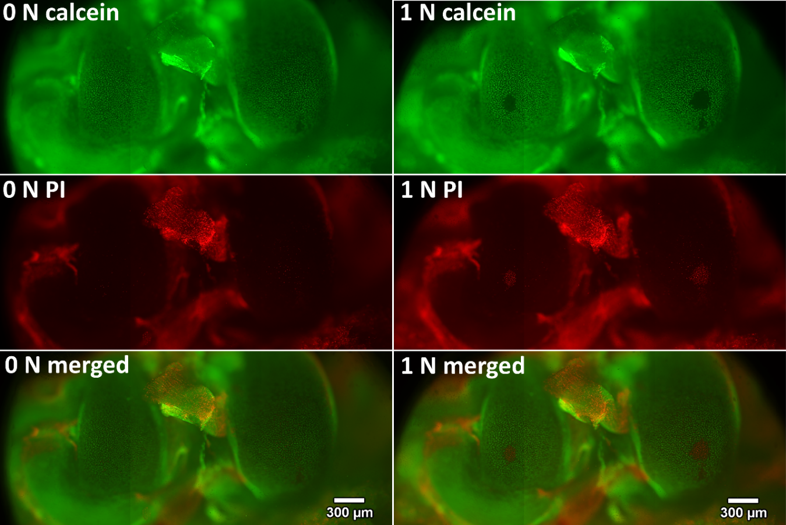
The protocol described in the manuscript involves analysis of the initial integrity of the tissue (through calcein AM straining) to ensure that there is no initial damage (i.e., no areas with obvious “gaps” in calcein-positive cells should be visible). That is, in every specimen, an initial fluorescence micrograph is acquired after calcein AM staining. Alternatively, the integrity of the tissue can be analyzed through PI staining before mechanical testing. To compare this approach to the approach used in the manuscript, a cartilage-on-femur specimen obtained from a 10 week old Balb/c female mouse was stained with both calcein AM and PI prior to mechanical testing (1N applied for 5 min) (Figure S1). At baseline, a uniform distribution (without noticeable gaps) of calcein positive cells on the femoral condyles (Figure S1, left) and negligible numbers of randomly distributed PI-positive cells were observed. In contrast, after mechanical testing, a clear and localized area of cells that lost calcein fluorescence and gained PI fluorescence was observed on both femoral condyles (Figure S1, right). This pilot study suggests that it is not necessary to stain cells with PI before an experiment. However, doing so provides a more rigorous confirmation that dissection-associated damage did not occur, and may be advisable – especially when the researcher is becoming acquainted with the dissection procedure.
Figure S1 Representative micrographs of in situ femoral condyle articular chondrocytes obtained at baseline (left) and after the application of mechanical loading (1 N for 5 min, right). Green calcein fluorescence and the absence of red fluorescence indicate viable articular chondrocytes; red PI fluorescence and absence of green fluorescence indicate injured articular chondrocytes. These figures suggest that cell death patterns indicated by PI and calcein staining are consistent.

- Limitations of live/dead staining as a measure of cell death
The primary weakness of permeability stains like PI and calcein AM lies in the potential detection of false PI-positive and false calcein-negative cells due to their mechanism of action. For example, consider calcein AM, a molecule that is membrane permeant and non-fluorescent until it is cleaved by intracellular esterases and becomes membrane impermeant and fluorescent. The fluorescent form of this molecule (calcein) remains within the cell while the membrane is intact; hence, calcein-positive cells are considered to be viable. However, if the membrane is only temporarily permeabilized (i.e., damaged prior to repair/resealing), a viable cell could appear calcein-negative. Similarly, consider PI is a membrane-impermeant molecule that is only able to diffuse into the cell and bind DNA if the membrane is not intact. A PI-positive cell is considered to have a ruptured membrane and be dead. However, if the membrane is only temporarily permeabilized (i.e., damaged prior to repair/resealing), a viable cell could appear PI-positive.
To confirm death of in situ articular chondrocytes due to mechanical loading, we have conducted a pilot study (n=5) in which we longitudinally analyzed injury of in situ chondrocytes on femoral condyles immediately and 3 h after mechanical tests (0.5 N statically applied over 5 min) with calcein AM re-staining applied 2.5 h after the injury. The time scale of membrane repair is approximately 5 min⁵; thus, we presume that 2.5-3 h provides sufficient time to quantify the number of false PI-positive and false calcein-negative cells (i.e., the number of cells whose membrane was permeabilized only temporarily prior to repair/resealing). We found that the area of injured cells recovered by only 5.25% (approximately 22 cells per specimen) over the course of 180 min following the mechanical trauma (Figure S2). It is worth noting that cells in which the plasma membrane appeared to be repaired became both PI and calcein positive, a finding that is consistent with the mechanism of action of both permeability dyes.
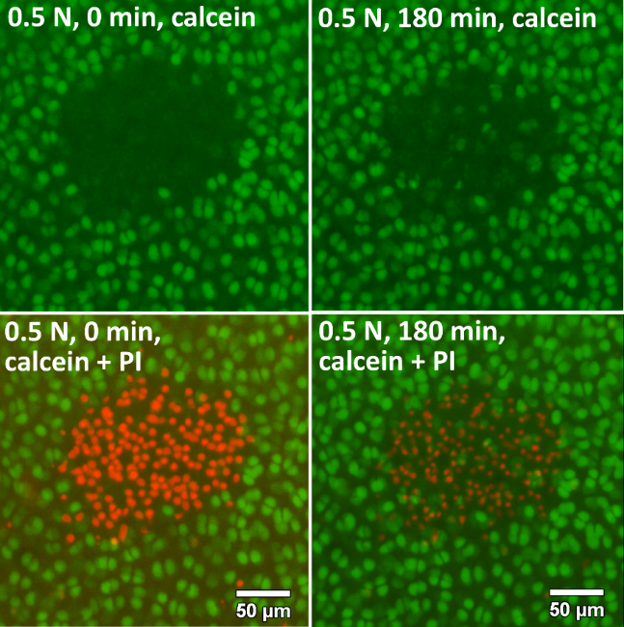
This experiment suggests that in our system, live/dead staining (i.e., the use of permeability dyes) provides a reasonably accurate indication of cell viability, overestimating true viability by just 5%.
Figure S2 (a) Representative micrographs of in situ articular chondrocytes on a medial femoral condyle obtained at 0 min (left) and at 180 min (right) after the application of mechanical loading (0.5 N static loading for 5 min). Green calcein fluorescence and the absence of red fluorescence indicate articular chondrocytes with intact plasma membranes; red PI fluorescence and the absence of green fluorescence indicate cells with compromised cell membrane integrity. The area/number of cells that gain calcein fluorescence within the 180 min time interval following mechanical trauma indicates the area/number of cells that exhibited membrane repair. Note that overall PI intensity has decreased over the 180 min time period, presumably due to photobleaching. (b) Area of injured cells (n=5) measured immediately (blue circles) and 180 min (green squares) after mechanical loading. Although the reduction in area of injured cells was significant, only approximately 5.25% of cells exhibited membrane repair. * denotes significance at α=0.05.

- Use of the method in older mice
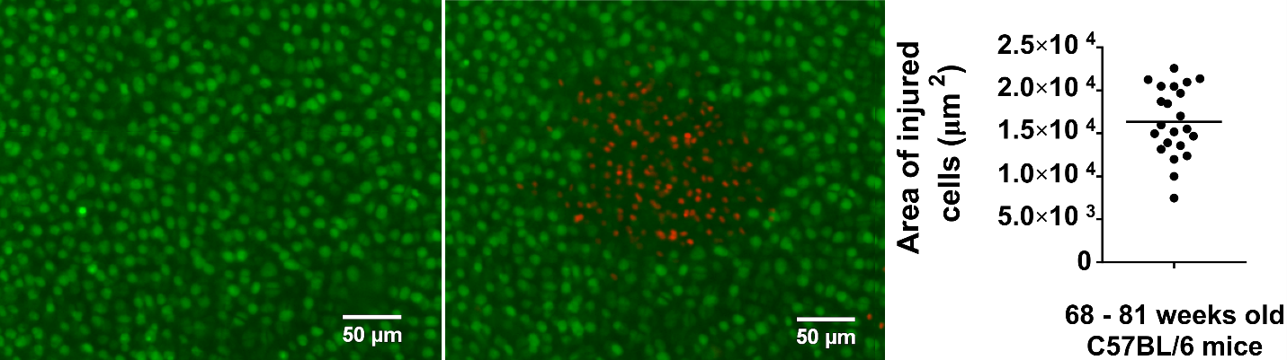
An additional set of experiments was performed to assess whether the method could be used in older mice. Cartilage-on-humerus explants of female and male C57BL/6 mice between 61 and 81 weeks old were tested using the protocol described in the manuscript. No additional difficulties were noted in performing these tests. However, attempted tests using cartilage-on-femur explants from these same mice yielded a success rate of just 40% (data not shown).
a
b
c

Figure S3 Representative micrographs of in situ chondrocytes on the humeral head articular surface of an 81 week old male C57BL/6 mouse (a) at baseline and (b) after statically applied mechanical loading of 0.5 N for 5 min. Green calcein fluorescence and the absence of red fluorescence indicate viable articular chondrocytes; red PI fluorescence and the absence of green fluorescence indicate injured/dead cells. (c) Area of injured cells, induced by 0.5 N statically applied for 5 min, quantified for specimens obtained from 68 – 81 weeks old C57BL/6 mice. Each data point represents a test on a different specimen and the mean value is indicated by horizontal bar.

References
1 Kotelsky, A., Woo, C. W., Delgadillo, L. F., Richards, M. S. & Buckley, M. R. An Alternative Method to Characterize the Quasi-Static, Nonlinear Material Properties of Murine Articular Cartilage. Journal of Biomechanical Engineering. 140 (1), doi:10.1115/1.4038147, (2018).
2 Adebayo, O. O. et al. Kinematics of meniscal- and ACL-transected mouse knees during controlled tibial compressive loading captured using roentgen stereophotogrammetry. Journal of Orthopaedic Research. 35 (2), 353-360, doi:10.1002/jor.23285, (2017).
3 Halonen, K. S. et al. Deformation of articular cartilage during static loading of a knee joint--experimental and finite element analysis. Journal of Biomechanics. 47 (10), 2467-2474, doi:10.1016/j.jbiomech.2014.04.013, (2014).
4 Zhang, H. et al. In Vivo Assessment of Exercise-Induced Glenohumeral Cartilage Strain. Orthopaedic Journal of Sports Medicine. 6 (7), 2325967118784518, doi:10.1177/2325967118784518, (2018).
5 McNeil, P. L. & Kirchhausen, T. An emergency response team for membrane repair. Nature Reviews Molecular Cell Biology. 6 (6), 499-505, doi:10.1038/nrm1665, (2005).

