

Dr. Verena Pichler
Medical University of Vienna
Department of Biomedical Imaging and image-guided Therapy, Division of Nuclear Medicine
T: +43-1-40400-78300
@: verena.pichler@meduniwien.ac.at


Vienna, February 1st 2019

Dear Bing Wu,

Please find enclosed the revision of our manuscript. We have carefully addressed the editorial issues and the responses are listed in a point-to-point manner below. The changes were performed in the track change modus for better orientation. All filmable parts are highlighted in yellow.
All authors agree to the publication of this article and have approved the final manuscript.
On behalf of all co-authors, sincerely, yours,
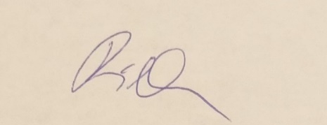
Dr. Verena Pichler
Medical University of Vienna

Editorial comments:
The manuscript has been modified and the updated manuscript, 59557_R0.docx, is attached and located in your Editorial Manager account. Please use the updated version to make your revisions.
1. Please take this opportunity to thoroughly proofread the manuscript to ensure that there are no spelling or grammar issues.
Thank you for the revision and we carefully proofread the manuscript.
2. Please remove registered (®) symbols from the manuscript.
We removed every trademark symbol from the manuscript.
3. Please do not abbreviate journal title for reference 3.
It is corrected to “ Applied Radiation and Isotopes”.
4. For in-text referencing, please put the reference number before a comma or period.
Thank you for the comment. We proofread the reference style and performed the editing.
5. Please do not highlight notes for filming.
We remove the highlighting of notes for the filmable part within the manuscript.
6. Line 203-214: Please ensure that all text is written in the imperative tense. Please split this step into more sub-steps so that each step contains only 2-3 actions and is less than 4 lines.
7. Line 217-219: Please ensure that all text is written in the imperative tense.
8. Line 223-228: Please ensure that all text is written in the imperative tense. Please split this step into more sub-steps so that each step contains only 2-3 actions and is less than 4 lines.
9. Line 235-236: Please ensure that all text is written in the imperative tense.
10. Line 239-242: Please ensure that all text is written in the imperative tense.
We splitted these part in more steps and included imperative tense for your consideration.
11. Calculation steps cannot be filmed unless a software with graphical user interface is used. Please do not highlight such calculation steps. For steps that are done using software, a step-wise description of software usage must be included in the step. Please mention what button is clicked on in the software, or which menu items need to be selected to perform the step.
Thank you for the comment. We removed the calculation step within the filmable parts.

