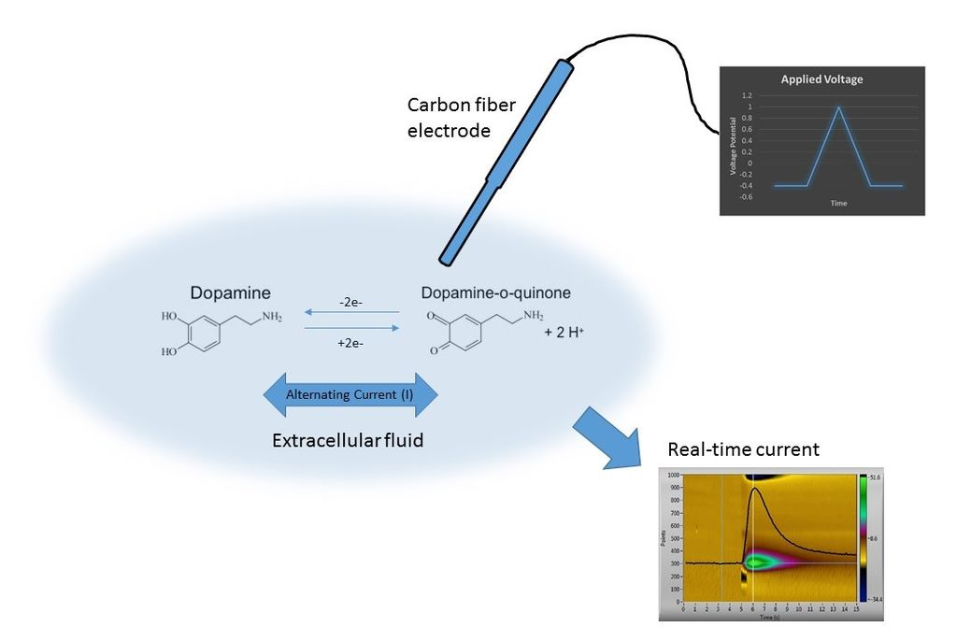
Figure 1

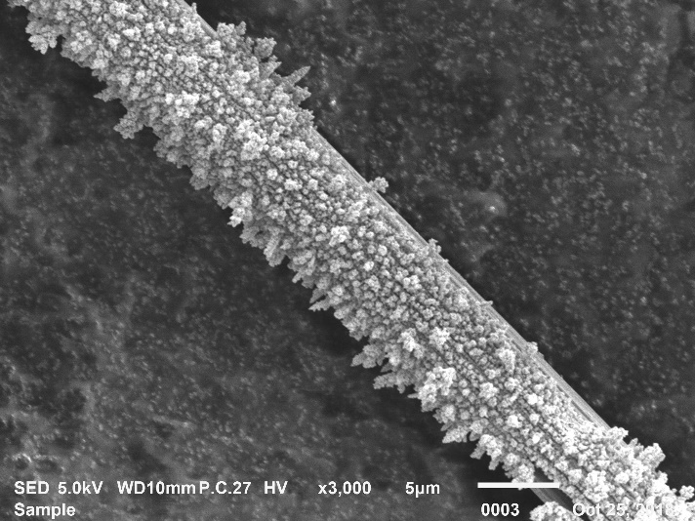
Figure 2c
Figure 2
Figure 3

Figure 4

Figure 5

Figure 6

