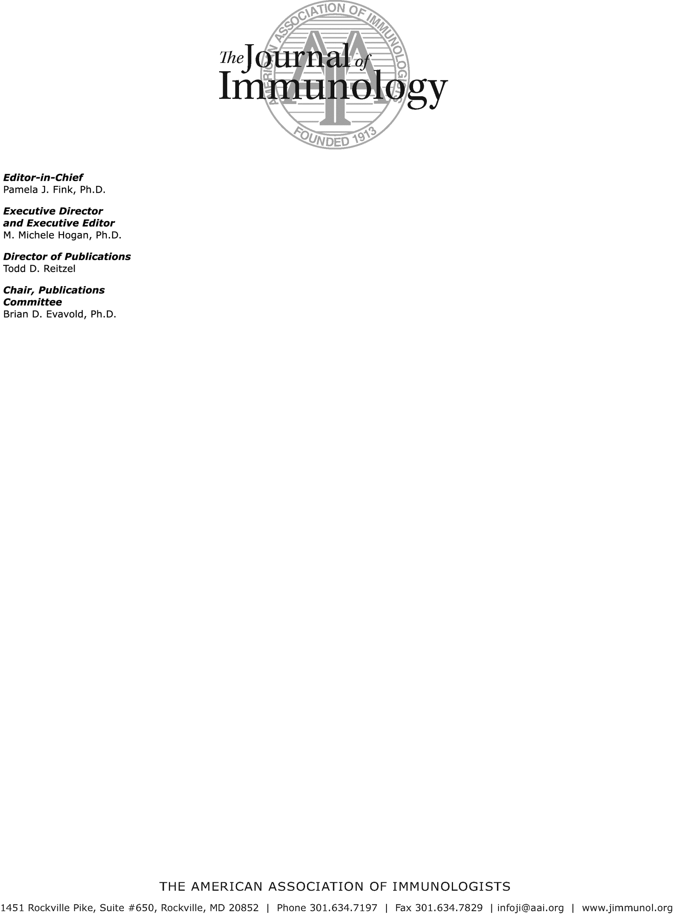

May 4, 2018

Joshua Choi Western University
1151 Richmond Street
London, Ontario, Canada, N6A 3K7 Canada

Email: jchoi443@uwo.ca

Dear Dr. Choi:

The American Association of Immunologists, Inc., grants permission to use Figure 4 from the article, “Regulatory T cells suppress CD8+ T cell responses induced by direct priming and cross-priming and moderate immunodominance disparities” published in The Journal of Immunology, vol. 174, pp. 3344-3351, 2005, in JOVE, published by JOVE, contingent on the following conditions:

- That you give proper credit to the authors and to The Journal of Immunology, including in your citation the volume, date, and page numbers.

- That you include the statement:

Copyright 2005. The American Association of Immunologists, Inc.

- That permission is granted for one-time use only for print and electronic format. Permission must be requested separately for future editions, revisions, derivative works, and promotional pieces. Reproduction of any content, other than Figures and Figure Legends, from The Journal of Immunology is permitted in English only.

Thank you for your interest in The Journal of Immunology. Sincerely,
Todd D. Reitzel Director of Publications
The Journal of Immunology

