Submission ID #: 59523

Scriptwriter Name: Tara Cass

Project Page Link: https://www.jove.com/account/file-uploader?src=18154563

Title: Investigating Corrosion at the Metal-Paint Interface Using Time-of-Flight Secondary Ion Mass Spectrometry

Authors and Affiliations: Jennifer Yao¹, Anthony Guzman², Zihua Zhu³, Xiao-Ying Yu¹

¹ Earth and Biological Sciences Directorate, Pacific Northwest National Laboratory
² Energy and Environment Directorate, Pacific Northwest National Laboratory
³ Wiley Environmental Molecular Sciences Laboratory, Pacific Northwest National Laboratory

Corresponding Author:

Xiao-Ying Yu

xiaoying.yu@pnnl.gov

Email addresses for Co-authors:

juan.yao@pnnl.gov

anthony.guzman@pnnl.gov

zihua.zhu@pnnl.gov

Authors: Please ensure that all authors’ names are spelled correctly and that the affiliations listed here are correct. This is how your names and affiliations will appear in the video.

PLEASE READ THE INSTRUCTIONS IN THE GRAY BOXES CAREFULLY AND USE TRACK CHANGES WHILE MAKING ANY EDITS TO THE DOCUMENT.

This document has several sections on separate pages, so take care to view each page.

Author Questionnaire:
Authors, please fill out the unanswered questions below.

1. Microscopy: Does your protocol involve video microscopy, such as filming a complex dissection or microinjection technique? (Y/N) N
Can you record movies/images using your own microscope camera? (Y/N) N/A
If no, JoVE will need to record the microscope images using our scope kit (through a camera port or one of the oculars). Please list the make and model of your microscope. N/A

2. Does your protocol include software usage? (Y/N) Y. The data acquisition software of IONTOF SIMS is illustrated.
If yes, we will need you to record using screen recording software to capture the steps. If you use a Mac, QuickTime X also has the ability to record the steps.

3. Which steps from the protocol section below are the most important for viewers to see? Please list 4-6 individual steps using the step numbers listed in this document. This information is important to prepare your Videographer for your shoot. (You do not need to include steps that will be screen captured. Please do not list entire sections.)
Locating ROIs, conducting mass calibration, and identifying peaks are very important steps demonstrated in this work. The steps include the following:
2.5.1, 2.5.2, 2.7.2, 2.11.1, 2.11.2. A screen shot of each step is provided to assist filming.
Authors, please answer this question with the steps listed here in the Protocol section below for use by the videographer.

4. What is the single most difficult aspect of this procedure and what do you do to ensure success? Please list 1-2 individual steps using the step numbers listed in this document. (Please do not list entire sections.)
Locating ROIs is the most challenging aspect of this procedure due to the use of the top-mount sample holder. To prevent the extraction cone from hitting the sample, move the joystick slowly when adjusting the z direction and monitor the distance between sample surface and the extraction cone through the main chamber window. Steps associated with locating the ROIs include the following:
2.5.1, 2.5.2
Authors, please answer this question with the steps listed here in the Protocol section below for use by the videographer.

5. Will the filming need to take place in multiple locations? (Y/N) Y
If yes, how far apart are the locations?
The instrument portion will be filmed in the laboratory at BSF 1233. The interview portion will be filmed in a conference room at either BSF or CSF, an office building adjacent to the laboratory. A short 5 min walk is expected between the two locations.

Section - Introduction
Videographer: Interviewee Headshots are required. Take a headshot for each interviewee.

- REQUIRED Interview Statements: (Said by you on camera) - All interview statements may be edited for length and clarity.

- The total introduction length (i.e., Required and Optional Interview Statements) cannot exceed 150 words.
- Restrict the length of each statement to no more than 30 words.
- Please answer the questions below in full sentences to highlight the significance of your protocol. You will be expected to memorize and deliver these sentences as spoken interview statements during filming.
- Indicate the full name of each author who will give each statement. If only one author is giving the REQUIRED statements, the same author may speak both statements.

Why is your protocol significant? OR What key questions can this method help answer?
  - Jennifer Yao: This approach reveals the corrosion process at the metal-paint interface, providing insights of mechanical and chemical changes at the interface with high surface sensitivity.

What is the main advantage of this technique?
  - Xiao-Ying Yu: Time-of-flight secondary ion mass spectrometry (ToF-SIMS) is a powerful surface tool. It provides chemical maps with high lateral and mass resolution and allows effective characterization at the metal-paint interface.

OPTIONAL Interview Statements: (Said by you on camera) - All interview statements may be edited for length and clarity.

- The following OPTIONAL questions may be answered to provide additional introductory information about your protocol.
- These OPTIONAL statements must be spoken by different authors than those who gave the Required Interview Statements.
- The length of each OPTIONAL statement is restricted to no more than 30 words and contributes to the total introduction length, which cannot exceed 150 words.
- Indicate the full name of each author who will give each OPTIONAL statement.

Do the implications of this technique extend toward the corrosion characterization? How so?
  - Xiao-Ying Yu: Understanding surface damage and corrosion development is very challenging. ToF-SIMS is a perfect tool for this application as illustrated in this this procedure.

Are there any specific areas of research that this method could provide insight into?

Can this method be applied to any other systems?
  - Jennifer Yao: In addition to studying the corrosion process, ToF-SIMS have been widely used in material surface characterization in radiological, biological, or environmental samples.

How would you expect an individual who has never performed this technique to struggle?

Do you have any advice to offer to somebody who is trying this technique for the first time?
  - Zihua Zhu: One of the most important tips that a new practitioner should know is to ensure that the sample does not touch the extraction cone and avoid potential damage to the instrument.

Why is visual demonstration of this method critical?
  - Anthony Guzman: The visual demonstration of this method is critical to researchers who are new to ToF-SIMS and will help them with the fundamental analysis process.

Introduction of Demonstrator: (Said by you on camera)

- Please use this statement ONLY if any of the individuals who will be demonstrating the procedure on camera have not given a required or optional Introduction interview statement already.
- Include the full name(s) of the person(s) demonstrating the experiment followed by their title (e.g., technician, post doc, grad student, clinician, etc.)
- Also indicate the full name of the author who will introduce the demonstrator(s).
  - Xiao-Ying Yu: Demonstrating the procedure will be, Jennifer Yao, a staff scientist from my laboratory. (Add additional mention of demonstrators as necessary).
    - Interview style: Author saying the above
    - The named technician, post doc, student looks up from workbench or desk or microscope and acknowledges the camera.

Section - Protocol
- Read through the entire protocol carefully to understand what you will need on the filming day and prepare accordingly.
- The two-digit numbers (e.g. 2.1., 2.2.) represent the “steps” of your protocol and will be read by a professional voiceover talent.
- The three-digit numbers (e.g. 2.1.1., 2.2.2.) represent the “shots” that our videographer will capture at your lab.
- To ensure that your protocol can be filmed in a single work day, the protocol is restricted to 30 steps and/or 60 shots.
- It is critical for a smooth and organized shoot that all materials and work spaces are prepared and labeled (if applicable) in advance.
- Any specimens/samples that require long or overnight incubation steps should be prepared in advance. (i.e. day 0 sample preparation will be filmed on the day of the shoot; day 1 samples should be prepared the day before the shoot so their processing can be filmed on the day of the shoot/after their overnight culture/treatment/etc.)
- Time-of-Flight Secondary Ion Mass Spectrometry (ToF-SIMS) Analysis of the Metal-Paint Corrosion Interface

Authors: You do not need to prepare the requested screen capture files yet, as the screen capture shots may change based on your revisions and any extra information you can provide about the software.
  - To begin, load the salt-exposed and air-exposed samples into the instrument loadlock and turn on the vacuum pump to achieve desired high vacuum before transferring them to the main chamber. Once the instrument is ready, power up the liquid metal ion gun (LMIG), the analyzer, and the light source.
    - MED: Talent shows example salt-exposed and air-exposed samples to the camera. TEXT: See text for sample preparation and loading Videographer: Please get at least 5-6 seconds of footage for this shot.
    - WIDE: Talent approaches the instrument and goes to the instrument computer. TEXT: See text for sample preparation and loading Video Editor: Please show this text overlay during “load the corrosion…main chamber” in the voice-over.
    - SCREEN: (Please see attached screen shots) – Click the LMIG, Analyzer, and Illumination boxes in the Power Control window. Authors, please upload this screen capture to your project page.
  - Next, enable access to the LMIG settings and activate the LMIG. Select the desired spectrometry settings file and apply the settings to the LMIG.
    - SCREEN: (Please see attached screen shots) – Click the LMIG box in the Fpanel window, click the LMIG tab in the Instrument window, click the Source subtab, and click Start LMIG. Then, in the pop-up window, select the predefined spectrometry settings file, click Open. Authors, please upload this screen capture to your project page. TEXT: See text for all instrument settings

Authors: How do you usually say LMIG out loud? (e.g., ‘L-M-I-G’, ‘L-mig’, etc.)

It is pronounced as L-mig.
  - Once the LMIG has fully started, move the sample stage to the Faraday cup. [1]
    - SCREEN: In the Navigator GUI, select Faraday Cup in the Cursor Position drop-down menu and click Go to start moving the stage to the Faraday cup or manually move the stage to the Faraday Cup using Joystick. Authors, please upload this screen capture to your project page.

Authors:
- When you are loading the analyzer settings file, do you also need to click Open and select Analyzer from a list before applying the settings?
- When loading the analyzer setting, click the Loading Settings button, then select the predefined analyzer setting file and click Open. After that, select Analyzer in the pop-up window and click Ok.
- About how long does it take to start up the analyzer?

It only takes about 10-20 seconds.
  - Next, auto-align the ion beam and start measuring the target current. Click X Blanking and adjust the current until it is maximized. Then, click Y Blanking and maximize the target current again. Stop the measurement when finished.
    - SCREEN: (Please see attached screen shots) – The stage is now positioned in the Faraday cup with the camera showing the Faraday cup under either Maco/Micro view, click the C button in the Gun subtab of the LMIG tab to start auto-aligning the beam. Authors, please upload this screen capture to your project page.
    - SCREEN: (Please see attached screen shots) – Click the Start button, click the Pulsing subtab, check the DC box, click the Focus subtab, click X Blanking to increase the target current shown in Fpanel using the mouse wheel. Authors, please upload this screen capture to your project page.
    - MED: Talent uses the mouse wheel to adjust the X blanking current until it is maximized, and then clicks Y Blanking and starts maximizing the target current with the mouse wheel. TEXT: To > 14 nA
    - SCREEN: (Please see attached screen shots) – Show reaching the maximum Y blanking current, and then click Stop in the Focus subtab to stop the measurement. Authors, please upload this screen capture to your project page.

Authors: About how long does it take to auto-adjust the ion beam?

Auto-adjust the ion beam takes approximately 1 minute.
  - Next, lower the sample stage until the extractor cone is just above the metal-paint interface of the sample. [1] Adjust the horizontal position of the cone until the interface is centered in the macro-scale view in the software. [2]
    - MED: Talent presses the Z button on the joystick control panel and uses the joystick to lower the sample stage until the extractor cone is just above the metal-paint interface.
    - MED: Talent presses the X or Y button on the joystick control panel and moves the joystick to bring the interface assembly into view in the Macro view.

Authors: Is the joystick control panel part of the software, or are these manual buttons on the joystick?

The joystick control is a separate control box with manual buttons.
  - Set the instrument to detect negative ions. Then, select the desired analyzer settings and activate the analyzer. Switch to the micro-scale view and set the ROI to 300 micrometers by 300 micrometers. Then, set the signal type to Secondary Ion, set the raster size to 128 by 128 pixels, and set the raster type to Random. [1]
    - SCREEN: To be provided by the authors – Select Negative from the drop-down Instrument Setup menu, click Load Settings, select the analyzer settings file, and click OK.
    - SCREEN: (Please see attached screen shots) – Switch to Micro view, right-click the SE/SI Primary Gun window to expand the field of view, and set the ROI to 300 µm x 300 µm. Then, select the SI signal type, set the raster size to 128 x 128 pixel, and set the raster type to Random. Authors, please upload this screen capture to your project page.
  - Adjust the secondary ion image of the ROI [1] so that the image is centered on the crosshair in the Primary Gun window. [2] After that, use DC cleaning to remove the gold coating and surface contaminants. [3]
    - SCREEN: (Please see attached screen shots) – Click the black triangle button to display the SI image in the SE/SI Primary Gun window and use the cursor to point out the round SI image of the ROI. Authors, please upload this screen capture to your project page.
    - MED: Talent presses the Z button on the joystick control panel and moves the joystick to bring the round shape to the center of the crosshair.
    - MED: Talent checks the DC box in the Fpanel, clicks the black triangle button, and monitors the Micro view as DC cleaning progresses.
  - Next, enable charge compensation and load the desired flood gun settings. Readjust the secondary ion focus on the ROI as needed. [1]
    - SCREEN: (Please see attached screen shots) – Check the Flood Gun box, click the Load Setting File button, select the flood gun settings file, click OK, and then click the Adjust SI button to represent starting to readjust the SI focus. Authors, please upload this screen capture to your project page.

Authors: Do you need to click anything else after selecting the setting file? If so, what?

No, we do not need to select anything after this selection.
  - After that, adjust the reflector voltage and increase the voltage until the secondary ion image disappears. Then, decrease the voltage by 20 volts and stop the adjustment. [1]
    - SCREEN: (Please see attached screen shots) – Click the Analyzer/Main tab, click the TOF subtab, click Reflector, click the value on the left side of the bar until the round SI shape disappears, and then increase the reflector voltage by 20 V, uncheck the Adjust SI button, and click the black square button. Authors, please upload this screen capture to your project page.
  - Open the mass spectrum and imaging programs and display the ROI of the metal-paint interface. Perform a quick scan, and stop the scan once a spectrum appears. [1]
    - SCREEN: (Please see attached screen shots) – Click the Spectrum and Image icons, display the selected ROI in the Micro view, click the triangle button to run a quick scan, and click the red square to stop the quick scan once a SIMS spectrum appears in the spectrum program. Authors, please upload this screen capture to your project page.
  - Then, open the Mass Calibration window, select the known peaks in the quick spectrum, and fill in the corresponding formulas. [1] After that, select the peaks of interest from the spectrum. [2]
    - SCREEN: (Please see attached screen shots) – Select Mass Calibration from the drop-down menu on the toolbar, click a known peak, and fill in its formula. Authors, please upload this screen capture to your project page.
    - SCREEN: (Please see attached screen shots) – With the calibration peaks now assigned, click a peak of interest and click Add Peak. Authors, please upload this screen capture to your project page.
  - Open the measurement window, set the raster type to random, the size to 128 by 128 pixels, and the rate to one shot per pixel. Set the instrument to perform 60 scans and begin the measurement. [1]
    - SCREEN: (Please see attached screen shots) – With all peaks of interest now added to the list, click the red triangle button, set the raster type to Random, set the size to 128 x 128 pixel, set the rate to 1 shot/pixel, set the number of scans to 60, click OK, and show the mass spectrum acquisition starting. Authors, please upload this screen capture to your project page.
  - Save the completed spectrum when the measurement finishes. Then, name and save the ROI location. Move the stage to locate new ROIs to analyze. Next, load the desired imaging settings and select LMIG from the list of categories. [1]
    - SCREEN: (Please see attached screen shots) – Save the acquired mass spectrum, go to the Navigator GUI, click + sign, name the ROI, click the Stage Pos button, and click OK to save the ROI location. Then, click Load Setting File, select the imaging setting file, click Open, select LMIG in the Categories to Load window, and click OK. Authors, please upload this screen capture to your project page.
  - Re-align and re-focus the ion beam for imaging and measure the target current at Faraday Cup. The current in imaging mode is > 0.6 nA. Then, select the saved ROI and move the stage into position. [1-TXT] Adjust the reflector voltage and acquire a quick spectrum for mass calibration. [2]
    - SCREEN: (Please see attached screen shots) – Open the drop-down menu of Cursor Position in the Navigator GUI, select the previously-saved ROI position, and click Go. Authors, please upload this screen capture to your project page. TEXT: > 0.6 nA. Video Editor: Please show the text overlay during “Re-align…for imaging” in the voice-over.
    - SCREEN: (Please see attached screen shots) – With the ROI displayed in Micro view, click the triangle button to start the quick scan, and click the red square to stop the quick scan when the spectrum appears. Authors, please upload this screen capture to your project page.
  - Then, set the raster type to random, the size to 256 by 256 pixels, and the rate to one shot per pixel. Set the number of scans to 150 and run the image acquisition. [1] When finished, export the data, remove the sample, and shut down the instrument. [2]
    - SCREEN: To be provided by the authors – With the calibration peaks and the peaks of interest already selected and defined, click the red triangle button to open the Start Measurement window, set the raster type to Random, set the size to 256 x 256 pixel, set the rate to 1 shot/pixel, set the number of scans to 150, and click OK to start the image acquisition. Authors, please upload this screen capture to your project page.
    - MED: Talent clicks File in the Spectrum program, clicks Export, names the spectrum file, selects the folder to save the file to, and clicks OK.

Authors: When you return the revised script, please also attach screenshots (still images) of every window or menu that you will use in the ToF-SIMS software to your reply email. This will help me ensure that the screen capture shots are split up correctly and that the voice-over pacing is suitable for the screen capture shots.

Screenshots are submitted.

OPTIONAL – Critical Step Statement:
- An OPTIONAL brief statement may be submitted for further elaboration of the best way to perform the required technique for the single most critical step of this procedure.
- If there is no single critical step, then there is no need to fill out this statement.
- This will be an interview style shot interjected after the relevant step within the Protocol section of the video.
- This statement is limited to 30 words or less.
- Please indicate the full name of the Author who will give this statement and the step of the protocol to which the statement pertains using the step numbers from the Protocol section (above).

Fill in the details below based on the instructions above for the “Critical Step Statement”

Jennifer Yao, Step 2.7.2: Do not move the joystick handle down too fast when adjusting the z direction, otherwise the extraction cone will hit the stage and get damaged.

Section – Results

The Results section is restricted to 200 words of narrative. Please read through the results as presented to make sure that it accurately represents your findings. If you would like to highlight other data, please revise this section accordingly, keeping in mind the word count restriction. Please note that we cannot include narrative without an accompanying visual.

- Results: Comparison of Corroded and Non-Corroded Aluminum-Paint Interfaces
  - Secondary ion mass spectrometry showed small aluminum oxide [1] and oxyhydroxide peaks at the aluminum-paint interface [2] of a sample exposed only to air, indicating mild corrosion. [3]
    - LAB MEDIA: Figure 3b – Video Editor: On “aluminum oxide”, highlight ‘Al₃O₅⁻ (m/z⁻ 161)’, the arrow under it, and the small lump that the arrow points to (the peak for the aluminum oxide compound).
    - LAB MEDIA: Figure 3b – Video Editor: Please maintain the highlighting from before, and also highlight ‘Al₂O₄H⁻ (m/z⁻ 119)’, the arrow under it, and the short line that the arrow points to (the peak for the aluminum oxyhydroxide compound).
    - LAB MEDIA: Figure 3b – Video Editor: Highlight ‘Al in Air’ in the upper right of the figure.
  - In contrast, a sample treated with salt water [1] had much larger peaks [2] and additional oxyhydroxide species. [3] This was consistent with the salt water-treated sample having experienced more severe corrosion [4] than the sample exposed only to air. [5]
    - LAB MEDIA: Figure 3a – Video Editor: At the beginning of “a sample…” in the voice-over, highlight ‘Al in Salt Solution’ at the upper right of the figure.
    - LAB MEDIA: Figure 3a – Video Editor: Highlight the ‘Al₃O₅⁻ (m/z⁻ 161)’ and ‘Al₂O₄H⁻ (m/z⁻ 119)’ labels, the arrows under them, and the lines that those arrows point to.
    - LAB MEDIA: Figure 3a – Video Editor: Highlight the ‘Al₂O₅H₃⁻ (m/z⁻ 137)’ and ‘Al₃O₆H₂⁻ (m/z⁻ 179)’ labels, the arrows under them, and the short lines that those arrows point to (the peaks for the new oxyhydroxide compounds).
    - LAB MEDIA: Figure 3 – Video Editor: Emphasize Figure 3a.
    - LAB MEDIA: Figure 3 – Video Editor: Emphasize Figure 3b.
  - 2D molecular images confirmed that [1] the aluminum oxide [2] and oxyhydroxide species [3] were much more prevalent in the sample that had been treated with salt water. [4]
    - LAB MEDIA: Figure 4 – Video Editor: Label 4a ‘Al in Salt Solution’ and 4b ‘Al in Air’. Please maintain these labels throughout showing Figure 4 (3.3.1-3.3.4).
    - LAB MEDIA: Figure 4 – Video Editor: Emphasize the left two images and the ‘m/z⁻ 161 Al₃O₅⁻’ label over them.
    - LAB MEDIA: Figure 4 – Video Editor: Emphasize the right two images and the ‘m/z⁻ 179 Al₃O₆H₂⁻’ label over them.
    - LAB MEDIA: Figure 4 – Video Editor: Emphasize Figure 4a and its added ‘Al in Salt Solution’ label.

Authors: Please upload each panel of Figure 3 and Figure 4 as individual image files to your project page. Please remove the a/b labels from the images and please add axis titles as needed. This will help the video editor highlight individual aspects of your figures. Please let me know if you have any questions.

Figure 3a

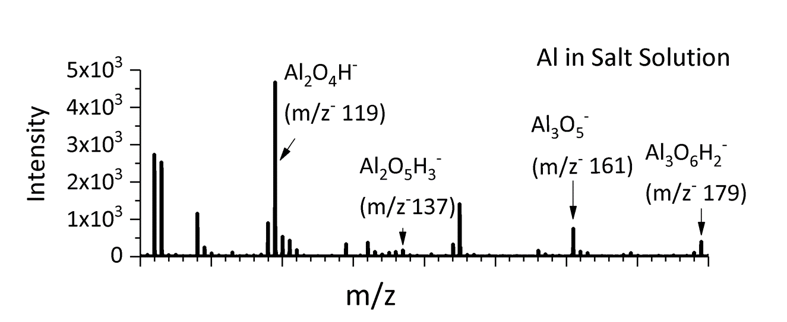

Figure 3b

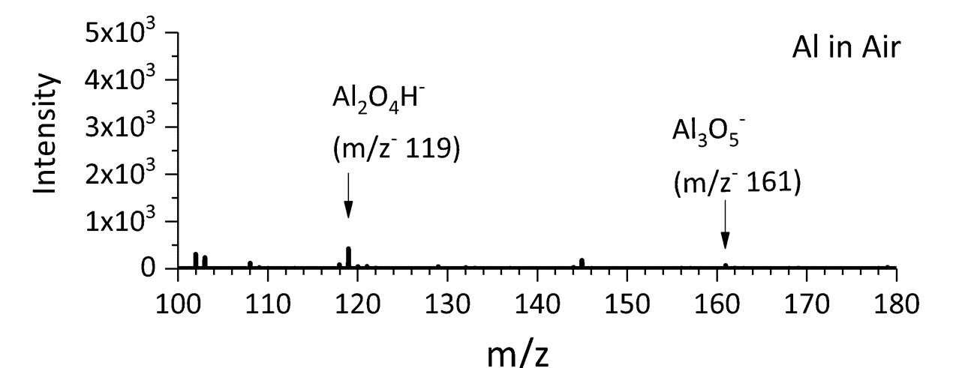

Figure 4a

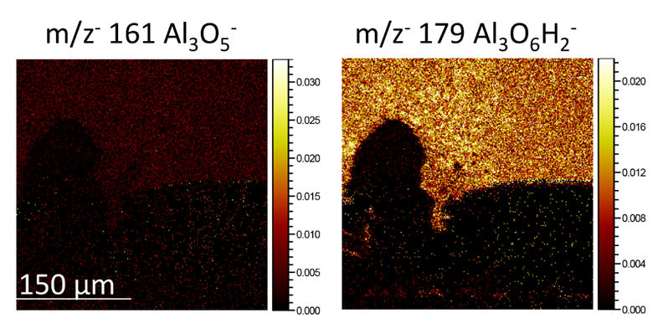

Figure 4b

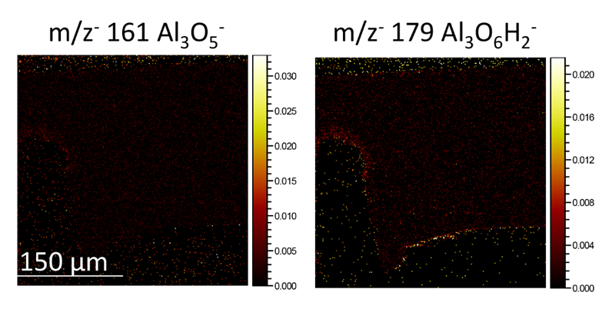

Section - Conclusion
- Conclusion Interview Statements: (Said by you on camera) - All interview statements may be edited for length and clarity.

- Below are questions for statements that can be used to further emphasize the significance of your protocol. At least one statement is required.
- Each statement is limited to 30 words.
- Answer the questions in full sentences, as you will be expected to memorize and deliver the sentences as spoken interview statements during filming.
- Indicate the full name of the author who will give each Conclusion Interview statement.

What is the most important thing to remember when attempting this procedure? Please indicate the steps (e.g., 2.4., 2.5.) in the Protocol section this advice correlates to.
  - Jennifer Yao: Please be mindful that the settings of the mass spectrum and image acquisition vary depending on the types of LMIG, remaining life of the LMIG, and other factors.

Following this procedure, what other methods can be performed? What questions would these additional methods answer?
  - Jennifer Yao: The same sample can be analyzed using SEM and XPS to obtain quantitative measurements of the chemical state and confirm morphological features in the corrosion process.

After its development, did this technique pave the way for researchers to explore new questions within a specific scientific field? If so, how?
  - Xiao-Ying Yu: We illustrate in this method that ToF-SIMS is very powerful in revealing the interfacial chemistry at the microscale and providing chemical mapping with high lateral distribution and high mass accuracy.

Are any of the reagents or instruments hazardous? If so, please use this interview statement to remind viewers of what precautions they should take.
  - Zihua Zhu: ToF-SIMS is a surface sensitive technique. Please always wear gloves and protect the samples you are handling.

Thank you for following the instructions and addressing our questions. We will incorporate your answers/suggestions and send you the finalized script before your shoot. You will also receive detailed shoot preparation instructions in the email accompanying the finalized script.

