FIGURE AND TABLE LEGENDS:

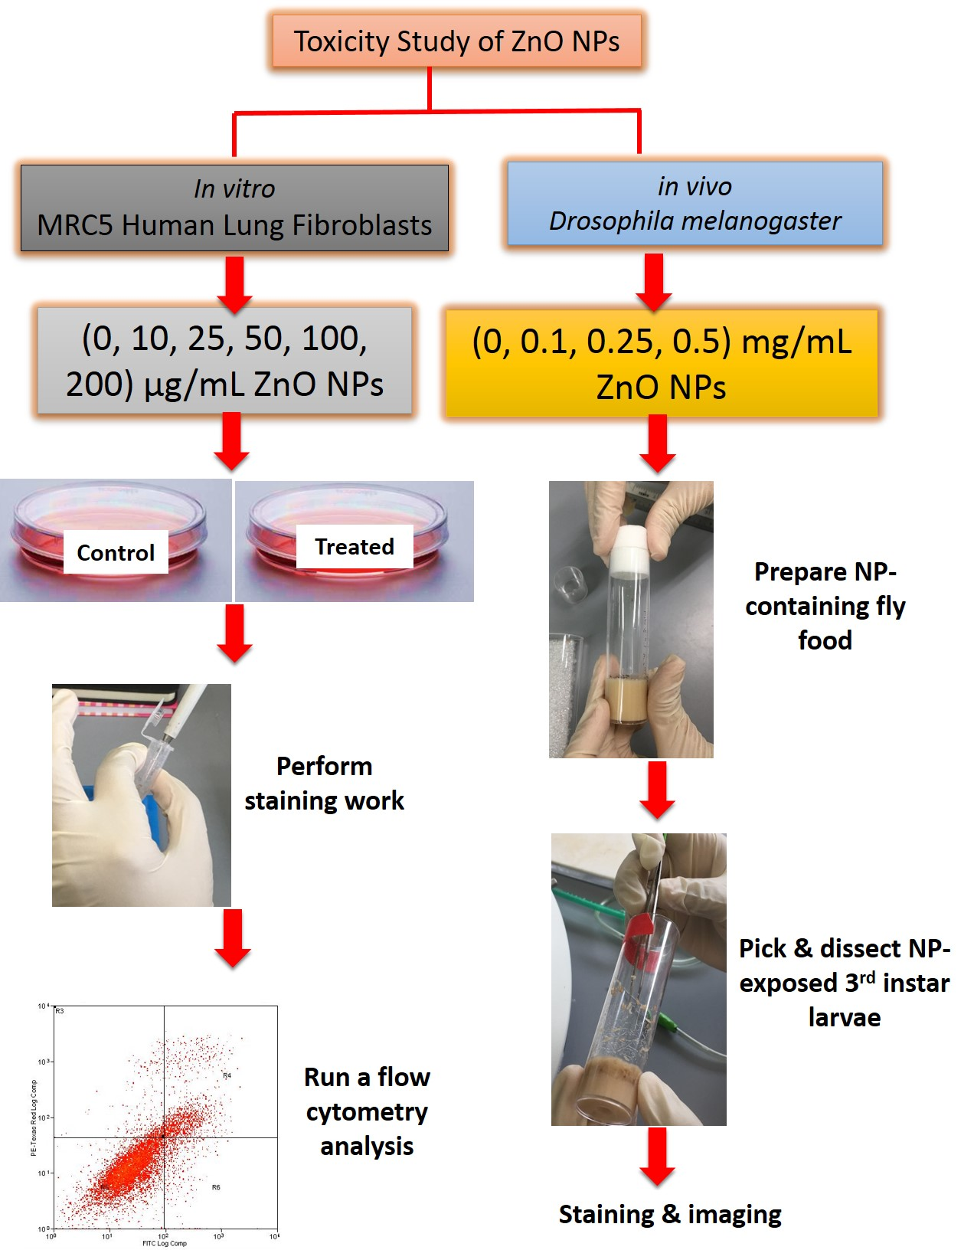
Figure 1 Overview of the method used for toxicity study of ZnO NPs. For in vitro work, ZnO NP-treated cells were stained prior to flow cytometry analysis. For in vivo work, gut was dissected from 3rd instar larvae, followed by staining with DHE dye and image acquisition.
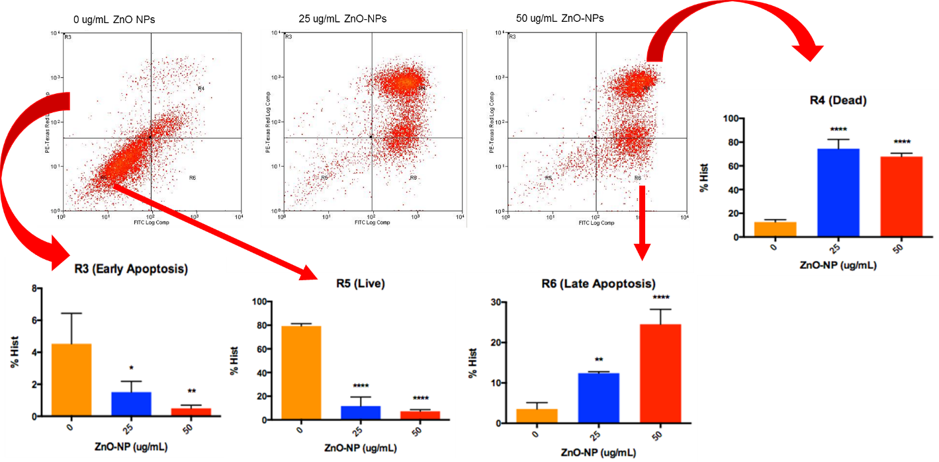
Figure 2 Dot plot of cells separated into different populations based on their FITC and PE staining. The pictograms show the results of FITC/Annexin V assay on 24 h treatment of ZnO-NPs on MRC-5. Statistical analysis of the cells at different stages can then be performed.

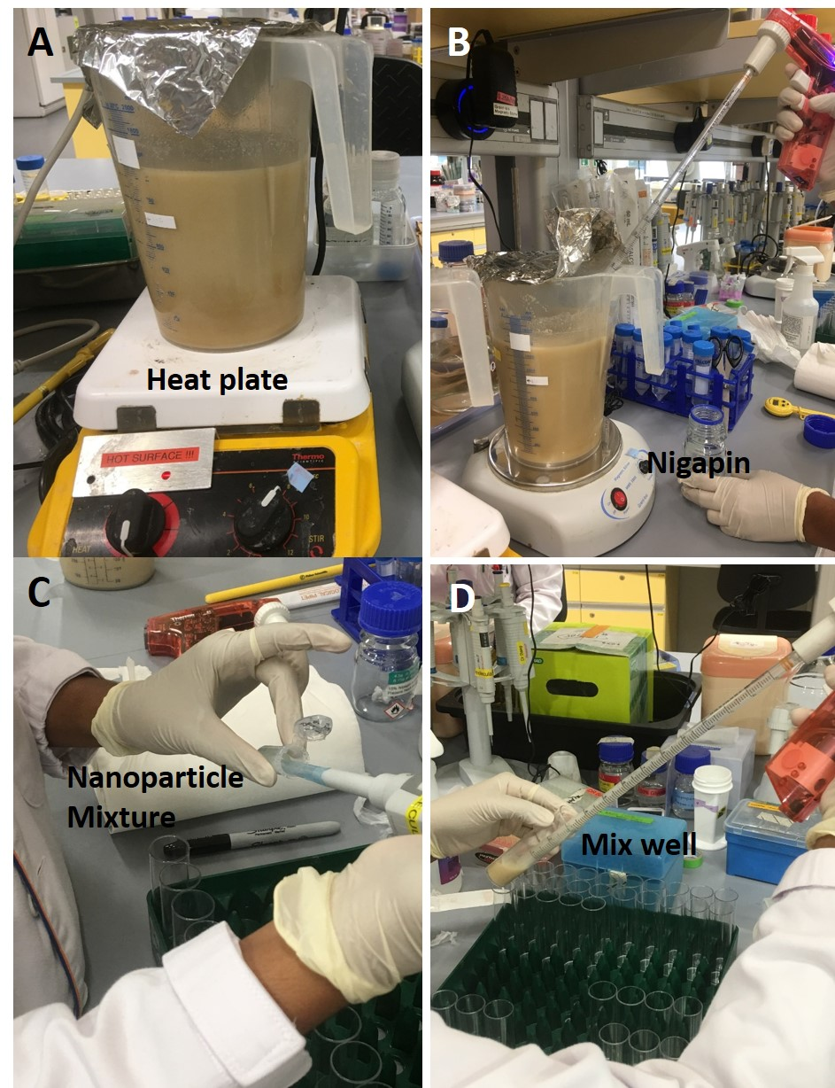
Figure 3 Preparation of ZnO NP-containing fly food medium. A) Ingredients for fly food were added to water and allowed to swell, and boiled for 5 min. B) After cooling down to 50 °C with stirring from time to time, Nipagin was added and mixed thoroughly. C) Prepare a master mix for the nanoparticles (total volume not exceeding 10% of the final food volume). D) Medium is then aliquoted, mixed with ZnO NPs at various concentrations and allowed to cool down completely before storage.

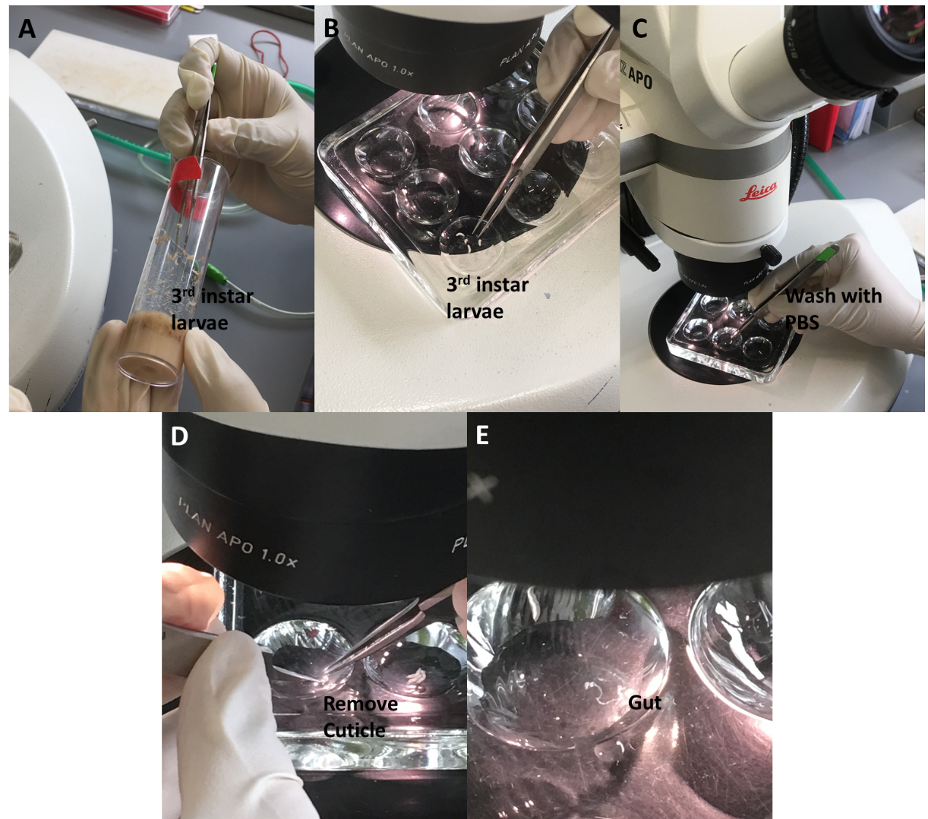
Figure 4 The whole gut dissection procedure. A) Transfer 3rd instar larvae to a dissection disc. B) Use forceps to gently hold a larva, and C) wash away the remnant of food using saline. D) Gently tear the cuticle apart without touching the gut and other internal organs. E) Place the gut into the saline for subsequent procedure.

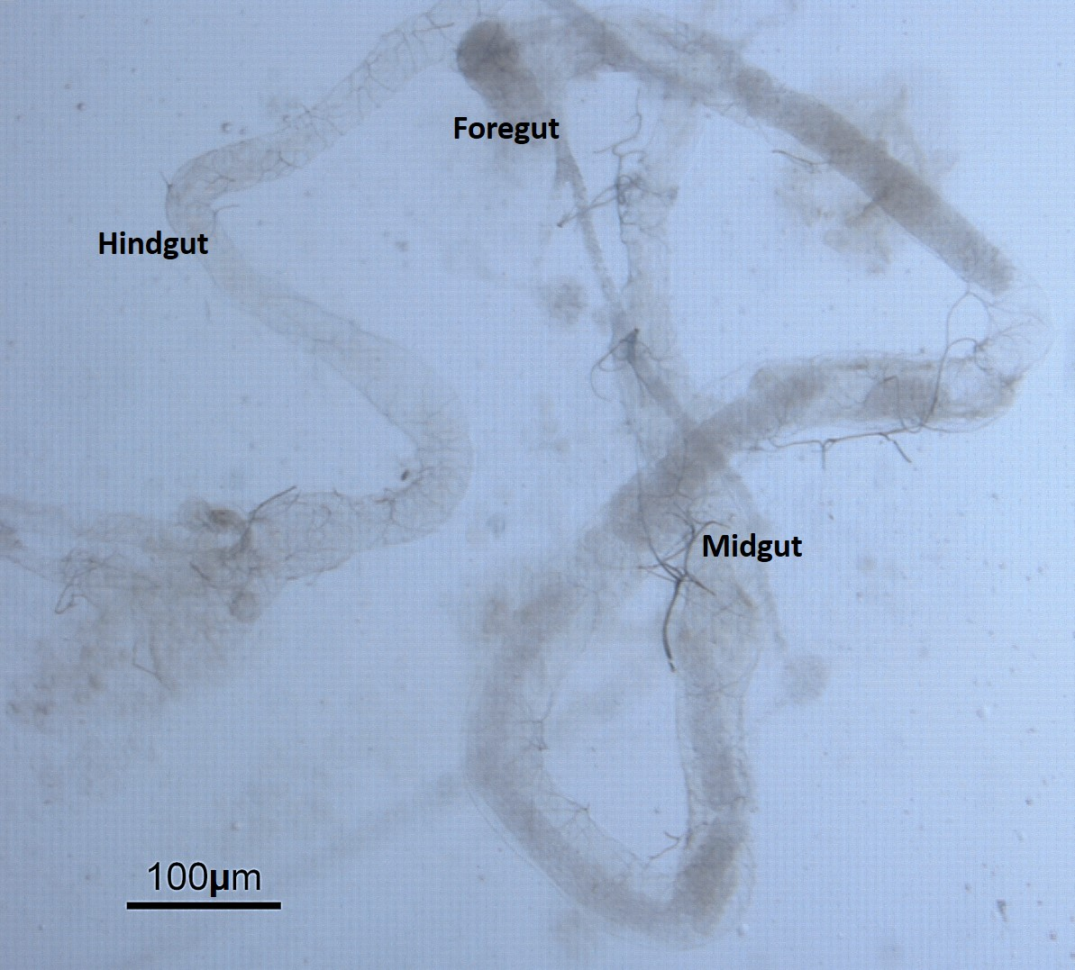
Figure 5 The anatomy of the digestive tract/gut. The gut extracted from the Drosophila larva is divided into three discrete domains of different developmental origin namely the foregut, midgut, and hindgut.

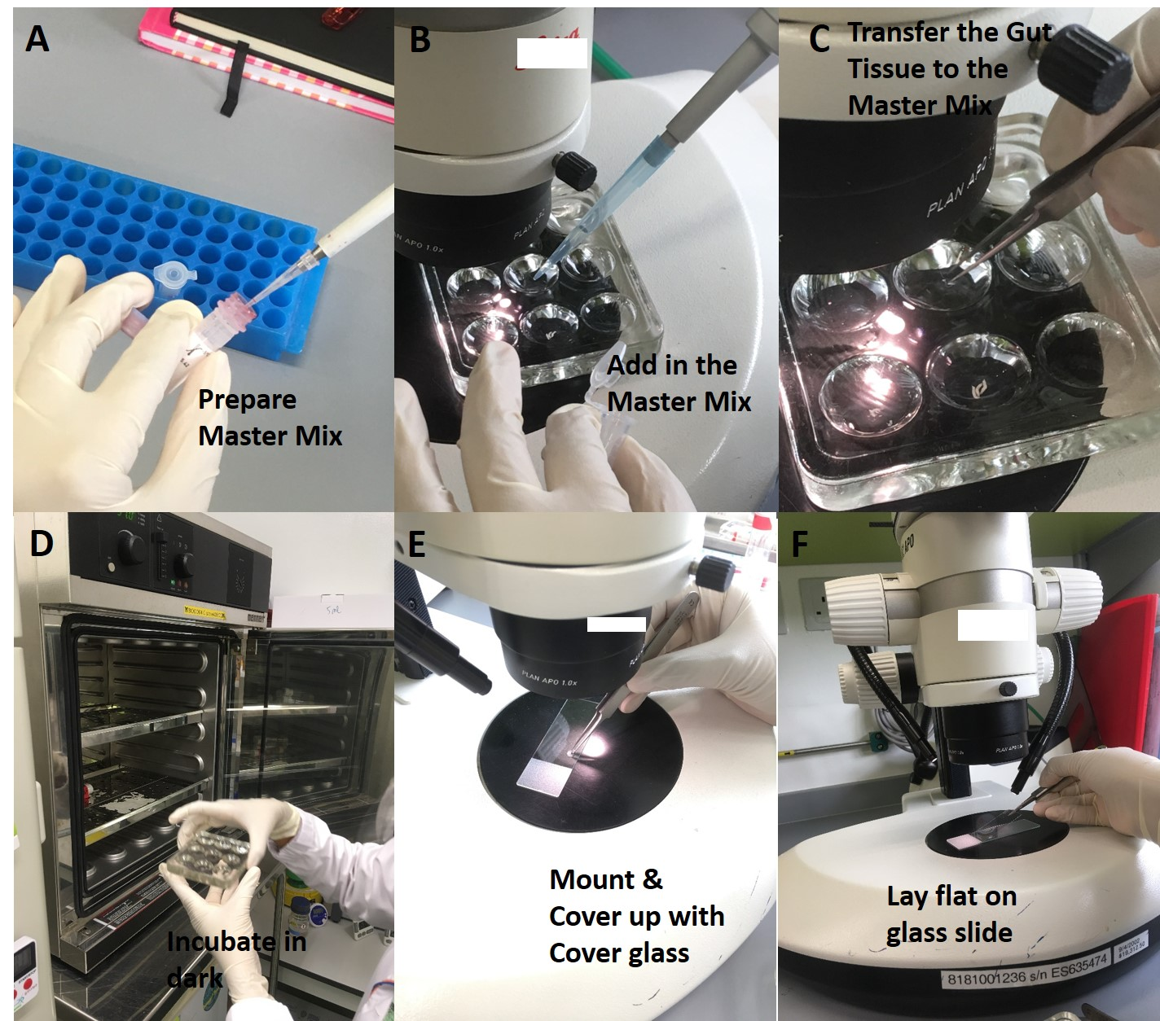

Figure 6 Staining of the gut tissue with DHE. A) Prepare a master mix containing growth medium and DHE (to a final concentration of 30 μM). B) Add the master mix into the well of a dissection disc. C) Transfer the dissected gut tissue into the well containing the DHE master mix. D) Incubate at RT for 5 min and protect the tissue from light; wash 3x 5mins interval, in PBS/saline. E) Fix in 4% PF for 10 min; wash the tissue thrice with PBS (optional). F) Gently transfer the gut onto a glass slide, lay flat without having any tissue folded and mount with mounting medium before covering with cover glass.
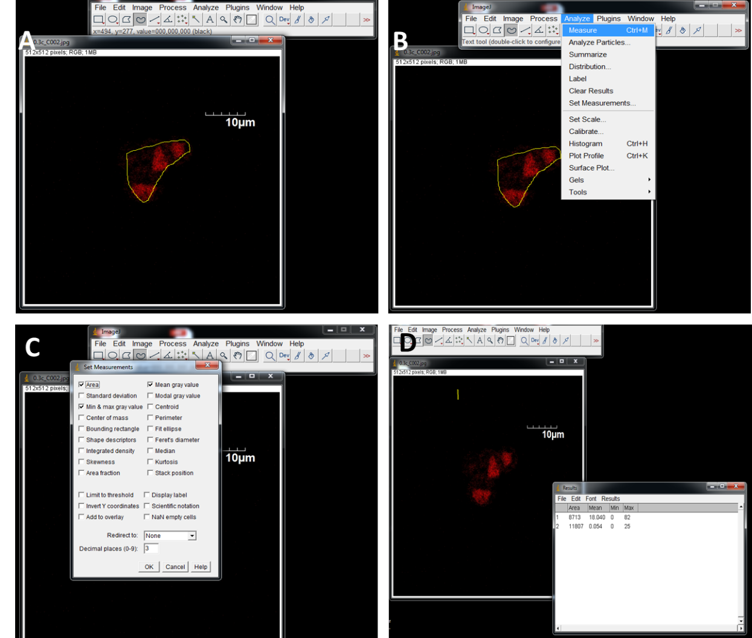
Figure 7 Quantitation of fluorescent images using ImageJ. A) Import the captured images. B) Click on the Analyze menu and select “set measurements”. C) Select the area integrated intensity and mean grey value. Select a region without fluorescence to set the background. D) Export the data into Excel and calculate the CTCF for subsequent statistical analysis.

