Responses to Reviewers’ Comments on manuscript EMID: e334840c2d49e554
We thank the editor and reviewers for their constructive analyses and thoughtful suggestions. Point-by-point responses to the specific issues are provided below:
Response to Editor:
- Please take this opportunity to thoroughly proofread the manuscript to ensure that there are no spelling or grammar issues. We have proofread the manuscript for spelling and grammar issues.
- Please obtain explicit copyright permission to reuse any figures from a previous publication. Explicit permission can be expressed in the form of a letter from the editor or a link to the editorial policy that allows re-prints. Please upload this information as a .doc or .docx file to your Editorial Manager account. The Figure must be cited appropriately in the Figure Legend, i.e. “This figure has been modified from [citation].” We thank the editor for this recommendation. All the figures in this manuscript are original and have not been previously published.
- Please define all abbreviations before use, e.g., PBS, FBS, etc. All abbreviations have been defined as recommended.
- Please use h, min, s for time units. All time units have been edited as recommended.
- Step 5.3: What’s the temperature for incubation? The incubation temperature has been added to Step 5.2.2 in the revised version.
- 7.3: Is it Colbalt-60 or Cobalt 60? Cobalt-60 is the proper nomenclature and has been consistently used in the updated manuscript.
- Please do not abbreviate journal titles for all references. All the references have been edited according to the new instructions.
- There is a 2.75 page limit for filmable content. Please highlight 2.75 pages or less of the Protocol steps in yellow (including headings and spacing) for filming that identifies the essential steps of the protocol for the video, i.e., the steps that should be visualized to tell the most cohesive story of the Protocol. We have highlighted sections for potential filmable content.

Response to Editor: Comments from 2/1

- Please take this opportunity to thoroughly proofread the manuscript to ensure that there are no spelling or grammar issues. The manuscript has been proofread for grammar and spelling mistakes.
- JoVE cannot publish manuscripts containing commercial language. This includes company names of an instrument or reagent. Please remove all commercial language from your manuscript and use generic terms instead. All commercial products should be sufficiently referenced in the Table of Materials and Reagents. Examples of commercial language in your manuscript include Commercial language has been removed from lines 108, 109, 112, 115, 155, 171, 203, 213, 231, 285, and 326.
- Please do not highlight notes for filming. Notes have been excluded from highlighted text in lines 131, 132, 167, 168, 284, and 285.
- Please specify all antibodies in the manuscript. Antibodies have been specified in lines 295, 311, and 316.
- Please use µL instead of µl. µl has been replaced with µL in lines 181, 191, 198, 199, 227, 254, 295, 314, and 334.
- Please remove trademark (™) and registered (®) symbols from the Table of Equipment and Materials. Trademark symbols have been removed from the Table of Materials.

Response to Reviewer 1:
Questions:
Intro: In second paragraph of Introduction, it's worthwhile to specify 2D cell culture, rather than cell culture in general. Some groups culture salivary-derived cells in 3D either on or within scaffolds. We have edited the introduction to clarify the culture system of prior research (lines 58-62).
- Protocol 1.3. Should "paraffin" be "parafilm"? The text has been modified to exclude all commercial language according to editor comment #2 from 2/1.
- Protocol 2.3. Add 1.5 mL or 1.0 mL, respectively, *per well*, correct? In the edited manuscript, we have added this detail in line 160.
- Protocol 3.3. Was this meant to say "a 12 mm diameter, 0.4 µm pore size …" rather than 30mm? Only the 12 mm insert seems to be listed in Materials. All data within the figures were conducted on 12mm diameter inserts and the text has been updated accordingly (lines 174-176).
- Protocol 3.3. When the salivary section is laid on the membrane insert, is it expected that the 300 µL of media would reach the membrane bottom? i.e. should the tissue also be in contact with media? It's probably worthwhile to specify this for readers, as they'll likely be wondering prior to using the method. We have edited the text to clarify this process in lines 174-176.
- Protocol 4. This is unclear - it seems to be making the same FBS-containing media as is already described in 3.2, and then culturing "in FBS conditions" which is already described. Please explain and/or revise. This section has been deleted as recommended.
- Protocol 6.4 "permeabilization" We have edited the text accordingly (lines 250-253).
- Protocol 6.9. and 6.12. Can you estimate a volume to use for these two steps? We have provided an approximate volume for both of these steps (lines 262-263, 273-275).
- Protocol 6.18 Can you estimate a volume to use here? Also, it's probably worthwhile to note that bubbles are very easily acquired with ProLong, and advise on how to minimize this, as it can interfere with imaging. We have provided more details about this process in lines 293-295.
- Protocol 6.18. and 7. The introduction of section 7 seems to be the details of the mounting for section 6.18. Please move this "NOTE" over to section 6.18 (as 6.18.1, etc.), as these details really are important for mounting with ProLong. We moved the text per the recommendation.
- Protocol 7. Section 7 feels either redundant/unnecessary, or very underdeveloped. I suggest that it is moved out to section 6, or further developed in Protocol 7 with more details - i.e. what is important for the confocal imaging? I'd say that recommendations on magnification/objective (4x? 10x? 20x?), and corresponding Nyquist settings for optical section thickness are really key. Stitching the z-stacks together is probably also desirable, and tips here would also be good to share. We have provided more details on how to image the slices using confocal microscopy.
- Protocol 8. (7.3, 7.4) This is a typo; subsections should be 8.1 and 8.2. But it seems that much more detail is warranted here, as the radiation treatment is really the key difference for this entire protocol. How should sample be arranged, in relation to irradiator? What distance from source? What kind of irradiator? (in Materials) How long is a typical exposure? Is it acceptable to irradiate the tissue *before* sectioning? We have provided more details on how to irradiate the samples and moved the irradiation protocol to section 4. We have not addressed whether or not the tissue can be irradiated prior to sectioning.
- I do not see a protocol for phalloidin staining. Please add this. We have provided a note about phalloidin staining (269-271).
- Figure 1: It is unclear what the conclusion is from the experiment in Figure 1. Which condition was best? How was that determined from the brightfield images? Data from both Figure 1 and 2 were utilized to assess culture conditions. Optimal culturing conditions was based on observations using phase contrast on an inverted microscope with cells appearing bright and retractile as viable and increasing cellular darkness as dying, nonviable organ cultures. This was confirmed through assessments of tissue area stained positive for Trypan blue and the amount of cells incorporating the live cell stain.
- Figure 2: What %FBS was used in the culture in Figure 2? I did not see this information listed in the Figure caption. And, while trypan blue's typical use is evident, it is difficult to determine what the data in Fig 2A is showing. i.e. How is the conclusion for Fig 2 ("We visually observe high number of Trypan blue positive cells in 0% FBS culture conditions while higher FBS culturing conditions exhibit fewer blue positive cells (Figure 2A and 2B).") supported by those Figure panels? We have added details about FBS conditions across all the figures. We have also included more text on the observations and conclusion from Figure 2 (lines 331-353).
- Figure 3: What FBS level was used for this culture? We used 2.5% FBS in Figure 3 and have edited the figure legend accordingly.
- Figure 3A: Ki67 staining should be nuclear, and although patterns can vary, the images in D14 do not look like positive Ki67, as there is no overlap with nuclei. Images in D14 also appear to be processed differently, as the small amount of overlapping channels do not appear as a bright cyan color (i.e. for tightly overlapping blue and green signals). For a method-based manuscript like this one, this D14 data isn't optimal for demonstrating a trend. Can the authors revise this? We have repeated the Ki67 staining and presented representative images.
- Figure 3B: Cleaved Caspase: The authors don't resolve how cleaved caspase staining is seemingly low in these images, but peripheral trypan blue staining is so high, especially at late timepoints. These two assessments (demonstrating cell death) should be related, correct? These two assessments do not implicitly measure the same thing; Trypan blue measures viability on unfixed tissues and cleaved caspase-3 specifically measures apoptosis in fixed tissues. Cleaved caspase-3 images were taken in central sections of the tissue and correspondingly there is little trypan blue staining in these areas. We have also presented cleaved caspase-3 images of the tissue edges, which does not recapitulate the peripheral Trypan blue staining.
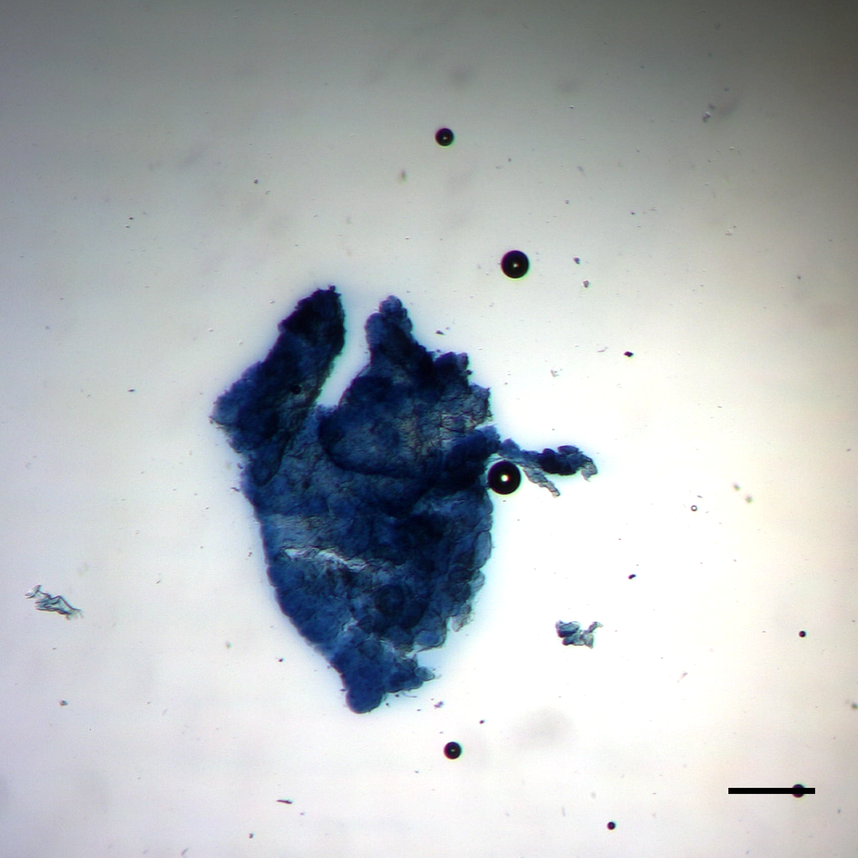

The high peripheral trypan blue staining noted by the reviewer is a small % of the total area of the cultured section. The image to the left represents a truly dead section and the peripheral Trypan blue color is much darker than a majority of images presented in Figure 2.

- Figure 5: Why are sections stained again for Ki67? If this signal isn't overlapped directly with alpha-amylase, then it seems redundant here. Figure 5 is from parotid sections and Figure 3 is from submandibular sections, so these are distinct analyses.
- Figure 6: A key hallmark of radiotherapy (RT)-induced xerostomia is a loss of acinar cell populations, and a replacement with immune infiltrate, adipose, scar, or other repair/remodeling cells and ECM. Here, the authors do not use these indicators (e.g. by staining for alpha-amylase positive acinar cells over time); instead, the success of their RT model hinges on the disruption of actin filaments at a single timepoint, day 8.
There are a number of radiation-induced cellular changes in the salivary gland that have been reported in the literature including, reductions in amylase, apoptosis of acinar cells, compensatory proliferation of acinar cells, loss of polarity and disruptions in cytoskeletal structure. In addition, there are acute and chronic hallmarks of RT and the ones noted in this comment are all chronic phenotypes. Therefore, the intent of the analysis of irradiated vibratome cultures was to evaluate many of these phenotypes as feasible. Apoptosis of parotid acinar cells is observed in D2 (24 hrs after IR) and apoptosis in submandibular acinar cells is observed at D2 and D4 (24 and 72 hrs after IR), which is similar to previously reported in vivo analysis. Parotid and submandibular vibratome cultures have increases in proliferation at D8 (7 days after IR), which is similar to previously reported in vivo analysis. As noted by the reviewer, the cytoskeletal changes are similar to our most recent report on radiation damage to salivary glands. We have added analysis of acinar cell markers in Figures 6 and 7. As for immune infiltrates, the cultures were irradiated ex vivo so this would not be feasible analysis. In addition, the adipose and fibrotic (scar) changes are at much later time points in the literature (>30 days); therefore the vibratome culture methodology would not be able to address these outcomes.
Although the authors are recognized as deeply involved in the field, this criterion for evaluating the model seems like a somewhat generic mechanism, and isn't convincing without (a) more references to other published data that reinforce the proposed success criteria, and (b) a complementary non-radiated control tissue at day 8. The control tissue in Fig 7 was stained at D1. Unfortunately, the D8 RT-treated section resembles a staining artifact that can occur commonly with phalloidin in 3D treatment (i.e. loss of signal in the last sample in a bunch). The D1 untreated represented the tissue architecture at the time of radiation and later time points in culture were presented in Figure 4. We have revised the radiation figures to the reviewer’s suggestion. As noted in the previous response, we evaluated a number of cellular changes in irradiated vibratome cultures to demonstrate the feasibility of this methodology.

- Please add to Materials list: - Parafilm (and probably capitalize, as it is a trade name), Embedding molds, Irradiator. These have been added as recommended.

Responses to Reviewer #2:
- More details on the irradiation should be provided. Which irradiator (model, and cat no) Are the samples uncovered during this step? What is the duration of the treatment? We have provided more details about how the irradiation process should be performed in section 4 of the protocol.
- It seems logical to put the irradiator treatment before the fixation and processing of the samples rather than after the whole process. We have moved the irradiator treatment section as requested.
- The brightfield an ICC images show clear and continuous loss of tissue integrity throughout the course of the experiment that conflicts with many of the authors interpretations.
Fig.3. The lack of progressive increase in the SMG cleaved caspase 3 signal indicates that the accumulation of this marker of intrinsic pathway apoptosis is either transient and not an accurate indicator of apoptosis, or that the cells are dying by a caspase 3-independent apoptosis pathway, or through another mechanism, such as necrosis. Since the Ki67 levels also do not change, this figure does not reflect the progressive cell loss and this marker does not seem particularly useful except maybe to rule out cell cycle entry and proliferation. The authors should remove this figure or combine with other markers discussed below to indicate that the system is not valid beyond perhaps 14 days. We respectfully disagree that there is a continuous loss of tissue integrity. We respectfully disagree with these conclusions. The brightfield images depict some shrinkage of the cells; however, this is likely a volume effect rather than a loss of tissue integrity because E-cadherin levels remain high and located at the plasma membrane. In addition, the overall tissue viability remains high as determined by minimal central trypan blue staining, low levels of cleaved caspase-3 and high levels of staining using the live cell dye. The levels of cleaved caspase-3, Ki-67 and live cell stain are similar to Su et al who evaluated human vibratome sections. None of these indicators suggest that there is a progressive cell loss. We do concur with the assessment that the day 30 cultures have some deteriorations from earlier time points and we have transparently shown this to the readers to allow them to make their own assessments on how to use this methodology.
- Fig. 4. The markers in 4A show a striking loss of SMG tissue structure after day 14, particularly in the loss of membrane localized E-cadherin, suggestive that most E-cadherin expression beyond day 14 is in dead cells or cells that have likely undergone EMT. This conclusion is consistent with the SMA and phalloidin profiles. In 4B, the loss of Aqp5 at day 7 indicates that functional studies of the gland slices are only valid through day 7, and that functional studies that require innervation or vasculature may not be valid after day 3. The difficulty in observing E-cadherin noted by the reviewer appears to be based on the yellow color used to present the images. We have changed this to red and the membrane staining is much more apparent. As noted above, E-cadherin staining is maintained for the entire 30-day culture period. We have noted in the results the markers that are maintained acutely versus those that are sustained longer.
- Fig. 5. The amylase stains suggest that PG functional studies may be valid only through day 7. Due to the smaller size of the parotid gland, we obtained fewer sections and did not have sample to evaluate at later time points. We have added further analysis to demonstrate that amylase positive cells are readily detectable at day 14 albeit it is reduced compared to the earlier time points. Even if the reviewer is correct and the PG is only functional through day 7, this is significantly longer than the previously published study of 48 hours.
- Fig. 6. The comparison of day 1 untreated with days 2, 4, and 8 after irradiation (and the markers chosen) precludes meaningful conclusions of the ability of the slice cultures to be used to model gland irradiation. This figure and conclusions about the effects of irradiation should be removed or the authors should acknowledge that the data indicate irradiation causes a loss of tissue structure without any insight into mechanisms, which does not seem useful enough to merit inclusion. Alternatively, the data could be reworked to show E-cadherin and Aqp5/Amy in parallel irradiated samples. However, based on the literature, these studies may require intact vasculature and/or innervation which may limit the ability of the slice cultures to model longer term irradiation damage and which should also be addressed. The D1 untreated represented the tissue architecture at the time of radiation and later time points in culture were presented in the untreated cultures in Figure 4. There are a number of radiation-induced cellular changes in the salivary gland that have been reported in the literature including, reductions in amylase, apoptosis of acinar cells, compensatory proliferation of acinar cells, loss of polarity and disruptions in cytoskeletal structure. Therefore, the intent of the analysis of irradiated vibratome cultures was to evaluate many of these phenotypes. Apoptosis of parotid acinar cells is observed in D2 (24 hrs after IR) and apoptosis in submandibular acinar cells is observed at D2 and D4 (24 and 72 hrs after IR), which is similar to previously reported in vivo analysis. Parotid and submandibular vibratome cultures have increases in proliferation at D8 (7 days after IR), which is similar to previously reported in vivo analysis. Cytoskeletal changes in parotid and submandibular vibratome sections are observed at D8 (7 days after IR) and are similar to our most recent report on radiation damage to salivary glands. We have modified the untreated images to day 8 in culture as recommended and added E-cadherin, Aqp5 and amylase images. Notably, new data for the parotid gland in figure 5 suggests that the vascular and neuronal structures are maintained better than in the submandibular gland. As for mechanisms, this recommendation is outside the scope of the instructions of this methods journal.
- Details of the vibratome (company, model number) should be provided in the text. The vibratome details are included in the Table of Materials; however, editor comment #2 from 2/1 prevents us from including these details in the manuscript.
- More detail regarding the specs on the paintbrush should be provided. We have included these details in the Table of Materials.
- Should other publications be referenced for the culture media or is this the first publication using it? Media was based off of our 2D primary culture media with the exception of FBS concentration and the addition of pen-strep.
- The authors should explain why two 1X PBS washes are needed with each media change. Typically, less disruption to 3D cultures is preferred. Presumably, if used, the PBS should be sterile and prewarmed, which should be mentioned. The finalized culturing method no longer includes a media change; therefore, this has been deleted.
- Is the storage after Step 6.3 in PBS or PBT? The time frame for storage should be indicated. The original text of PBS for the storage is correct. Time frame has been updated in text (lines 244-246).
- Step 6.7. Define NEN. NEN is a trademark name used by PerkinElmer and it stands for New England Nuclear; this detail has been added to the Table of Materials.
- Step 6.12 Is incubation for 1.5 hrs really sufficient for this step? We observe positive staining in the center of our vibratome sections, which suggests that it is a sufficient amount of time for the secondary antibody incubation. Of note, both previously published studies on vibratome sections from salivary glands utilized a one hour incubation.
- Step 7. Sealing of coverslips with nail polish should be mentioned as required for long-term storage. This information can be found in step 6.18.2.
- Its not clear why PG were not stained for AQP5. Is this channel protein maintained longer in the PG slice cultures? These images have been added to Figure 5.
- Fig.2. Trypan blue staining can indicate panoramic changes in viability, as observed around the tissue slice edges, but is not suitable for assessing single cell or multicellular tissue compartment viability. The authors should provide an alternative method with improved sensitivity for monitoring viable cells, such as live cell staining kits that detect active esterases or acknowledge this limitation in the text. We have added a live cell stain to Figure 2.
- Fig. 5. The absence of PG CD31 and tubb3 stains for endothelial cells and nerves, respectively, makes the validity of functional studies that require either vasculature or innervation not possible, and the authors should acknowledge this limitation. We have acknowledged this limitation in the discussion (lines 377-383).
- Reference 14 is incorrect for Su et al. https://www.ncbi.nlm.nih.gov/pubmed/27214128. We edited this reference accordingly.

Responses to Reviewer #3:
- There should be more discussion/commentary on the importance of the culture media and FBS gradients in the vibratome culture media (3.2 on page 3 of 12). A rationale for testing different FBS concentrations and the final recommended FBS level would be appreciated. We have added more rationale to the FBS experiment and clarified the recommendation (lines 327-331, 350-353).
- A demonstration/discussion showing the transfer of the culture plates/dishes between the biology laboratory and the radiation facility and placing the cultures in the radiation machine would be helpful for viewers who are interested in using the system to study the effect of radiation on SGs. Additional information regarding radiation has been added in protocol section 4.
- Please spell out "NEN" blocking agent. NEN is a trademark name used by PerkinElmer and it stands for New England Nuclear; this detail has been added to the Table of Materials.
- It is interesting that the trypan blue data appear to show more dead cells on the surface than in the center of the organotypic cultures. A comment on this observation would be helpful for the viewers. We have added more data and discussion on this observation in the revised manuscript.
- The authors may want to comment/speculate on whether or not the PG organotypic cultures would be expected to remain viable with functional capacity for up to 30 days and if not why? We have added more parotid time points and the tissue architecture appears to be maintained better than the submandibular gland. That said, it is likely to deteriorate between days 14 and 30 similar to the submandibular gland.

