We are grateful to the Editor and the Reviewers for taking the time to provide insightful comments that led to improvements in both the quality and potential impact of our manuscript. A point-by-point response to each critique appears below.

Editorial comments:

E Q1. Please expand the Summary to briefly describe the applications of this protocol.
The summary has been revised as requested. See lines 31-33.

E Q2. Please remove commercial language: Mcllwain, BD LSRFortessa, etc.
Commercial language has been removed.

E Q3. Please include an ethics statement before your numbered protocol steps, indicating that the
protocol follows the animal care guidelines of your institution.
An ethics statement is now included on lines 119-122.

E Q4. In steps 1.1, 1.8: Please list an approximate volume to prepare.
Appropriate preparation volumes are now included for all protocol solutions (See Protocol Section 1. Protocol Preparation). In addition, we added a table which indicates how protocol reagents should be scaled for high-throughput experiments (Table 1).

E Q5. In step 1.2: How large is the culture dish?
The size of the culture dish is now included on line 133.

E Q6. In step 2.1: Please specify the gender and strain of the pups.
Mouse gender and strain are now included on line 176.

E Q7. Please combine some of the shorter Protocol steps so that individual steps contain 2-3 actions
and maximum of 4 sentences per step.
Protocol steps were combined where appropriate.

E Q8. Please include single-line spaces between all paragraphs, headings, steps, etc.
Single-line spaces now separate all paragraphs, headings and steps.

E Q9. After you have made all the recommended changes to your protocol (listed above), please highlight 2.75 pages or less of the Protocol (including headings and spacing) that identifies the essential steps of the protocol for the video, i.e., the steps that should be visualized to tell the most cohesive story of the Protocol. Please highlight complete sentences (not parts of sentences). Please ensure that the highlighted part of the step includes at least one action that is written in imperative tense. Notes cannot usually be filmed and should be excluded from the highlighting. Please do not highlight any steps describing anesthetization and euthanasia. Please include all relevant details that are required to perform the step in the highlighting. For example: If step 2.5 is highlighted for filming and the details of how to perform the step are given in steps 2.5.1 and 2.5.2, then the sub-steps where the details are provided must be highlighted.
Appropriate steps for filming are highlighted in the revised protocol.

E Q10. Lines 221-229: Please remove these lines from the manuscript. They are not necessary.
These lines, referencing an attached Table of Materials, have been removed.

E Q11. References: Please do not abbreviate journal titles.
All journal titles are now provided in full.

E Q12. Table of Materials: Please sort the items in alphabetical order according to the name of
material/equipment.
Materials in the Table are now listed in alphabetical order.

Reviewer #1:
R1 Q1. (It) might be good to provide guidance in the protocol about how much volume of the
collagen solution to make (per animal equivalent).

This was a great suggestion. We have included a new table (Table 1) to clearly indicate the reagent volumes required for large-scale preparations.

R1 Q2. Is there any need to swirl plates occasionally during the incubation?

We have found that swirling is unnecessary as long as the collagen solution completely covers the dish during the entire incubation period. We now emphasize that the dish must remain completely covered throughout the coating procedure on lines 133-137.

R1 Q3. Are there any alternatives to the "McIlwain Tissue Chopper"? Seems like manually chopping
the skin tissue with a straight-edged razor blade would be an acceptable substitute. This might be nice to comment on so that investigators would not necessarily have to purchase a MTC.

We have looked into the availability of other tissue choppers/homogenizers and unfortunately there are few commercial alternatives to the “McIlwain Tissue Chopper”. In our experience, the strong chopping force and 1 µm sectioning size provided by the tissue chopper are critical for obtaining consistent melanocyte yields. We have found that manual chopping is unable to provide the same consistency, force and granularity of homogenization as the mechanical chopper. Nevertheless, we have removed all commercial language from the protocol as similar choppers have been available in the past.

R1 Q4. How long in advance can the digestion buffer be made? Can it be frozen into aliquots or need it
be made fresh each time?
We have only prepared the digest buffer immediately before melanocytes isolation and have not attempted to freeze aliquots of digest buffer.

R1 Q5. How long is the melanocyte growth media good for at 4 degrees? Can it be frozen into aliquots?
A comparable melanocyte medium is used by the Bennett lab (Godwin et al, Current Protocols in Cell Biology, 2014; PMID: 24894835). We now include protocol notes based upon their storage suggestions (lines 153-155). Specifically, complete growth medium should be made fresh. However, base medium containing serum, antibiotics and L-glutamine can be stored at 4 °C for up to one month. If supplemental mitogen stocks are frozen at -20 °C these can be thawed and added to make fresh, complete growth medium.

R1 Q6. Do pups need to be harvested on their day of birth? Other isolation protocols call for pups 0-3
days old.

Initial attempts to isolate melanocytes from mice older than postnatal day 0 were performed during the early stages of protocol development. Therefore, we revisited this question using our new dual (fibroblast & melanocyte) isolation method. We found that melanocyte cultures can be effectively generated from mice up to 4 days of age. Fibroblast cultures can also be isolated up until postnatal day 4. Our revised manuscript has been updated to include these findings (See Protocol Section 2 and lines 402-405 of the Discussion).

R1 Q7. Can the pup carcasses be sterilized before extremity amputation (as an alternative to after amputation)?

We do not have any reason to believe that sterilization of the carcass before extremity amputation would affect the protocol. We typically use the same scissors for euthanasia and extremity amputation, therefore we like to sterilize the mice after these procedures in order to avoid contamination of our cell culture hood.

R1 Q8. (The protocol details) very specific instructions to this one kind of tissue chopper. Wonder if
the protocol can incorporate more "generalizable" instructions (such as "chop the tissue at
least ___ times until skin pieces are roughly ____ sized").

We have made the protocol instructions more generalized, but we are not aware of any current alternatives that provide the same precision, force and granularity. Please refer to response R1 Q3 for more details.

R1 Q9. (The) degree of melanocyte purity (and fibroblast/keratinocyte percentages) should be indicated
at various time points after collection; their method by flow is fine, but the percentages should be included in the manuscript. Certainly in our experience, even though epidermal suspensions are grown in melanocyte-selective media similar to the one listed in this protocol, there seems to always be some degree of co-culture with other types of skin cells (mainly dermal fibroblasts, even long-term after several weeks in culture).

This point is now addressed in Figure 4 and on lines 328-329 of the results. Specifically, we performed flow cytometry to quantify the melanocyte, keratinocyte and fibroblast content of our cultures 1, 2, 3, 4 and 10 days post-isolation. We found a low amount of fibroblast and keratinocyte contamination in our early melanocyte cultures (<25% combined). However, levels of these contaminating cells decreased over time and were lost completely upon passaging.

R1 Q10. It is not clear why this method is not successful in generating melancoytes in animals >d0. I
would have thought that since this method does not require separation between epidermis and dermis (which limits applicability to pups <3-4 days old because of the challenges of separating epidermis from dermis once hair sprouts through the epidermis), then could it be used in older animals (for example using the skin of ears/tail that maintains interfollicular epidermal melanocytes)?

Please refer to comment R1 Q6. Since we were unable to isolate melanocytes from mice older than postnatal day 4 we do not believe our protocol would enable melanocyte isolation from adult mice.

Reviewer #2:
R2 Q1. It is unclear why this method works to purify primary melanocytes away from keratinocytes and
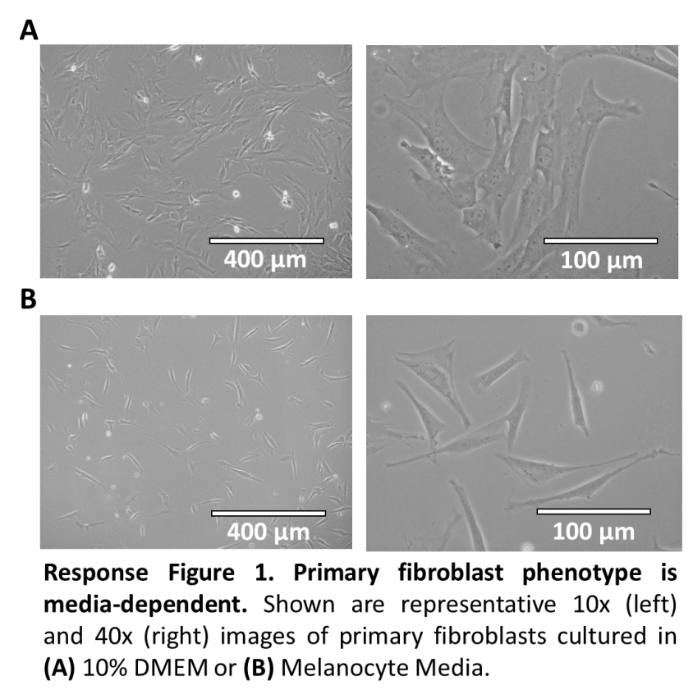
fibroblasts. As the authors write in their introduction, current practices require both physical separation of epidermis and dermis in addition to selective culturing practices such as selective media, treatment with G418, or selective disassociation. This protocol uses homogenized full skin and media that would be expected to be permissive to at least fibroblast, if not also keratinocyte, growth. In the discussion, can the authors discuss the theory behind this isolation or speculate as to why it works? Would it be expected to work with other species?

We thank the reviewer for raising these astute concerns which led to important protocol modifications.

We first attempted to address these comments by determining if primary fibroblasts would grow in our original melanocyte culture medium. We found that fibroblasts grew efficiently in this medium, but adopted a more dendritic phenotype reminiscent of melanocytes (See Response Figure 1). Seeing this phenotype led to concerns about the specificity and sensitivity of our cell type-specific flow cytometry antibodies. Therefore, we performed extensive antibody testing and optimization. After this process, we re-ran our analyses and confirmed that a significant number of fibroblasts were contaminating our original melanocyte cultures.

We made several protocol changes to remedy this problem, including selective plating of the skin homogenate and transient G418 treatment (See manuscript Figures 3 & 4). At the same time, we discovered that primary fibroblast cultures could be generated as a byproduct of our revised isolation procedure. This ability to produce fibroblast and melanocyte cultures from the same skin sample has become a unique feature of our revised protocol. Although we concede that low-level fibroblast and keratinocyte contamination still remain in our initial melanocyte cultures (<25% combined), we find that these cells are lost during melanocyte propagation (manuscript Figure 4).

We have not tried to implement this procedure in other species and do not feel comfortable speculating on its broader utility at this point.

R2 Q2. Positive and negative control cell populations are really needed throughout. Assume there will be scientists interested in this protocol with no melanocyte experience. What do pure melanocytes look like when derived with current best practices? What do the potentially contaminating fibroblasts and keratinocytes look like? Showing these images side-by-side with the images in Figure 1 is critical. Using them as controls for the flow cytometry data in Figure 2 would be important as well. Higher magnification images would be appreciated.

Positive and negative controls are now included in all of our flow cytometry studies (manuscript Figures 3 and 4). We have also added new, high magnification images of the resulting fibroblast and melanocyte cultures (manuscript Figures 1 & 2). A cluster of contaminating keratinocytes is indicated by an arrow in manuscript Figure 2A, but contaminating fibroblasts are more difficult to discern (See Response Figure 1).

We find that there is little difference in the phenotype of melanocytes isolated using a traditional protocol versus our new method (See Response Figure 2).
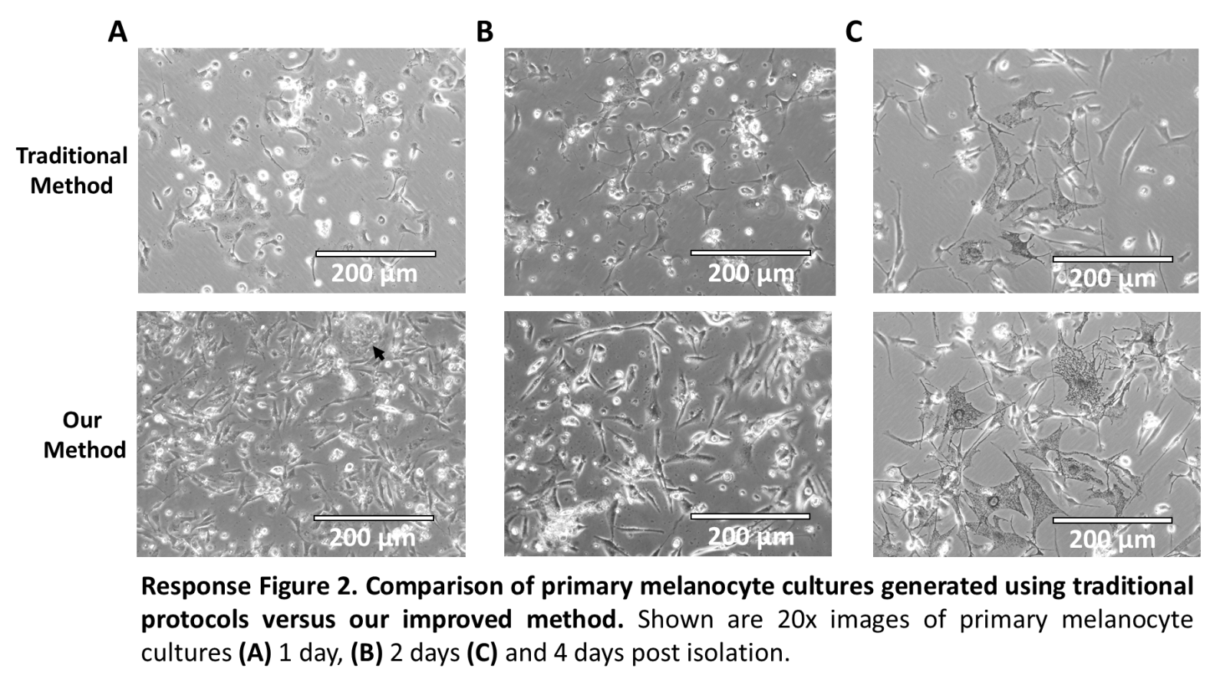
R2 Q3. Figure 1C, right image shows two patches of keratinocytes (upper right corner and just below
the "10x" label). Figure 2B, confirms that the melanocyte population contains keratin expressing cells. It is fine if the melanocyte population is not 100% pure, but the authors should comment on the range and reproducibility of keratinocyte contamination they observe with this protocol. Simply highlighting the keratinocytes in the image and using the K10/14 cytometry data to estimate a purity would suffice.

These concerns are now addressed in the Discussion (lines 408-410) as well as manuscript Figures 2A & 4C. Quantitative analysis indicates that keratinocytes make up ~15-20% of the initial melanocyte culture and decrease in frequency with passage.

R2 Q4. The MITF antibody staining does not appear to have worked. All three cell populations look
equally positive. If true, where did the dominant MITF negative population in whole skin go? The authors' K10/14 and FSP1 staining look beautiful and show what these profiles look like when an antibody has been optimized and has no background staining. The authors need to achieve equivalently as convincing profiles with a melanocyte marker. Tyrosinase, DCT, or Sox10 would all be reasonable, among others. As an alternative suggestion, if the authors have access to the mouse lines with Tyr::CreER and an inducible fluorescent reporter, these could be a useful tool for demonstrating the purity of the culture. Either way, the authors need to identify some marker that is specific to the melanocytes in order to provide convincing data on the purity of the cells.

We were unable to find a flow-compatible MITF antibody that provided sufficient specificity and sensitivity. Therefore, we switched to using a pre-conjugated glycoprotein 100 (gp100) antibody (manuscript Figures 3A & 4A). Unfortunately, because gp100 is transmembrane protein involved in melanosome maturation, its expression does not appear to be robust in early melanoblast populations. Nevertheless, strong positivity can be seen in differentiated melanocyte cultures 10 days after plating (manuscript Figure 4A).

R2 Q5. Can the authors comment on how many cells per unit area are being plated in section 2.14?
Assuming that different investigators will experience different efficiencies of cell recovery, it would be useful to know approximately how many cells that authors are plating in this step.

We quantified skin homogenate following resuspension in step 2.11 and determined that approximately 10.5 million cells were obtained from the skin of a single day 0 mouse. However, as small clusters of cells and tissue were excluded from this quantification we do not feel comfortable stating a specific cell number in the manuscript. We also fear that alternative enumeration methods may be differentially impacted by the lack of sample homogeneity and believe that even the larger pieces of tissue likely contain relevant cells. Thus, we would prefer not to provide enumerated values which could confuse those using the protocol.

R2 Q6. The authors mention that this protocol is scalable. A useful addition to the protocol would be a
table that lists the steps that need changed and by how much for different desired melanocyte yields.

Please refer to manuscript Table 1.

