Luhur 59459 JoVE

We thank the editor and reviewers for comments and suggestions that improved the clarity of this manuscript. Our point-by-point responses are in blue.

Editorial comments:
Changes to be made by the author(s) regarding the manuscript:
1. Please take this opportunity to thoroughly proofread the manuscript to ensure that there are no spelling or grammar issues.

We have proofread the manuscript for spelling and grammar issues.
2. Please remove the embedded table(s) from the manuscript. All tables should be uploaded separately to your Editorial Manager account in the form of an .xls or .xlsx file. Each table must be accompanied by a title and a description after the Representative Results of the manuscript text.
We have removed the tables and created separate .xls file for each Table.
Each table has a title, both in the xls.file and in the FIGURE and TABLE LEGENDS section.
3. Please number the tables in the sequence in which you refer to them in the manuscript text.

We have changed the numbering of the Table according to the sequence in which they are referred to in the text.
4. Tables 4-6: Please replace commercial language (Milli-Q) with a generic term.

We have replaced Milli-Q with the generic term “sterile purified water”.
5. Table of Equipment and Materials: Please sort the items in alphabetical order according to the name of material/equipment.

We have sorted the items in alphabetical order.
6. Figure 3B: Please crop the image to so that the brand name (BIO-RAD) is not shown.

We have amended Figure 3B as suggested.
7. Please revise the title to avoid the use of colon.

We have revised the title to avoid the use of colon.
8. Keywords: Please provide at least 6 keywords or phrases.

We have provided 6 keywords.
9. Please define all abbreviations before use.

We have checked the manuscript and defined all abbreviations before use.
10. Please revise the protocol text to avoid the use of any personal pronouns (e.g., "we", "you", "our" etc.).

We have revised the entire manuscript to eliminate the use of personal pronouns.
11. Lines 92-96, 132-152, 214-219, etc.: Please revise the protocol to contain only action items that direct the reader to do something (e.g., “Do this,” “Ensure that,” etc.). The actions should be described in the imperative tense in complete sentences wherever possible. Avoid usage of phrases such as “could be,” “should be,” and “would be” throughout the Protocol. Any text that cannot be written in the imperative tense may be added as a “Note.” Please include all safety procedures and use of hoods, etc. However, notes should be used sparingly and actions should be described in the imperative tense wherever possible. Please move the discussion about the protocol to the Discussion.

We have revised the identified sections, included several notes, and moved most of the content to the Discussion.
12. 1.5: Please specify the volume transferred each time.

We have specified to transfer the entire volume of the cell suspension.
13. 2.1.4: Please provide more specific guidance here.

We have expanded this in Protocol 2, steps 2 and 3.

2. Examine the morphology and confluence of the culture under a microscope. Look for clear signs of microorganismal contaminations in the culture.
Determine whether the cells are ready to be passaged, based on the characteristics of the culture: cell density and doubling time, including the last time they were subcultured.

3. If the culture appears highly confluent (Figure 1), determine the cell density. In the sterile hood, dislodge the cells from the growing surface by pipetting up to 10 mL of the medium from the plate and dispensing it over the cells. Repeat a few times, ensuring not to create foam, until the growing surface becomes clear. Determine the cell density using a hemocytometer or an automatic particle counter (Figure 3) (Protocol 3). Subculture the cells if the cell density is between 5 X 10⁶ – 1 X 10⁷ cells/ mL.

Note: Do not subculture Drosophila cell lines to a cell density below 1 X10⁶ cells/ mL.
14. 2.1.8: Please specify the concentration of trypsin used.

We have specified the concentration of Trypsin-EDTA (0.05%)
15. 2.1.10: Please specify the incubation temperature.

We have specified the incubation temperature (25 °C)
16. 2.1.11: What volume of medium is added?

We have specified the volume added. (9 mL)
17. Please combine some of the shorter Protocol steps so that individual steps contain 2-3 actions and maximum of 4 sentences per step.

We have combined the shorter steps of the protocol as recommended. Each protocol now contains on average 5 steps.
18. Please include single-line spaces between all paragraphs, headings, steps, etc.

We have included single-line spaces between paragraphs, headings, and protocol steps.
19. After you have made all the recommended changes to your protocol (listed above), please highlight 2.75 pages or less of the Protocol (including headings and spacing) that identifies the essential steps of the protocol for the video, i.e., the steps that should be visualized to tell the most cohesive story of the Protocol.

We have highlighted the essential steps portion of the Protocol (including headings and spacing). The highlighted sections now comprise 2.5 pages. We did not highlight actions that are repeated between protocols.
20. Please highlight complete sentences (not parts of sentences). Please ensure that the highlighted part of the step includes at least one action that is written in imperative tense. Notes cannot usually be filmed and should be excluded from the highlighting.

We have highlighted only complete sentences and ensured that the highlighted step includes at least one action written in the imperative tense.
21. Please include all relevant details that are required to perform the step in the highlighting. For example: If step 2.5 is highlighted for filming and the details of how to perform the step are given in steps 2.5.1 and 2.5.2, then the sub-steps where the details are provided must be highlighted.

We have taken this into account when highlighting the protocol steps.
22. Lines 169, 204: Figure 2 shows images of cell lines, not the cell counter. Please reference the correct figure here (i.e., Figure 3B).

We have rectified the error.
23. References: Please do not abbreviate journal titles.

We are not completely sure what we needed to do for this point.

We have utilized the JoVE plugin for EndNote (JoVE.ens), which was downloaded from JoVE (Please see the screen shot below). We have not altered the way journals were referenced. In addition, we checked the plugin properties and it is set to display the Journal Titles using their full journal names, and not the abbreviated version.

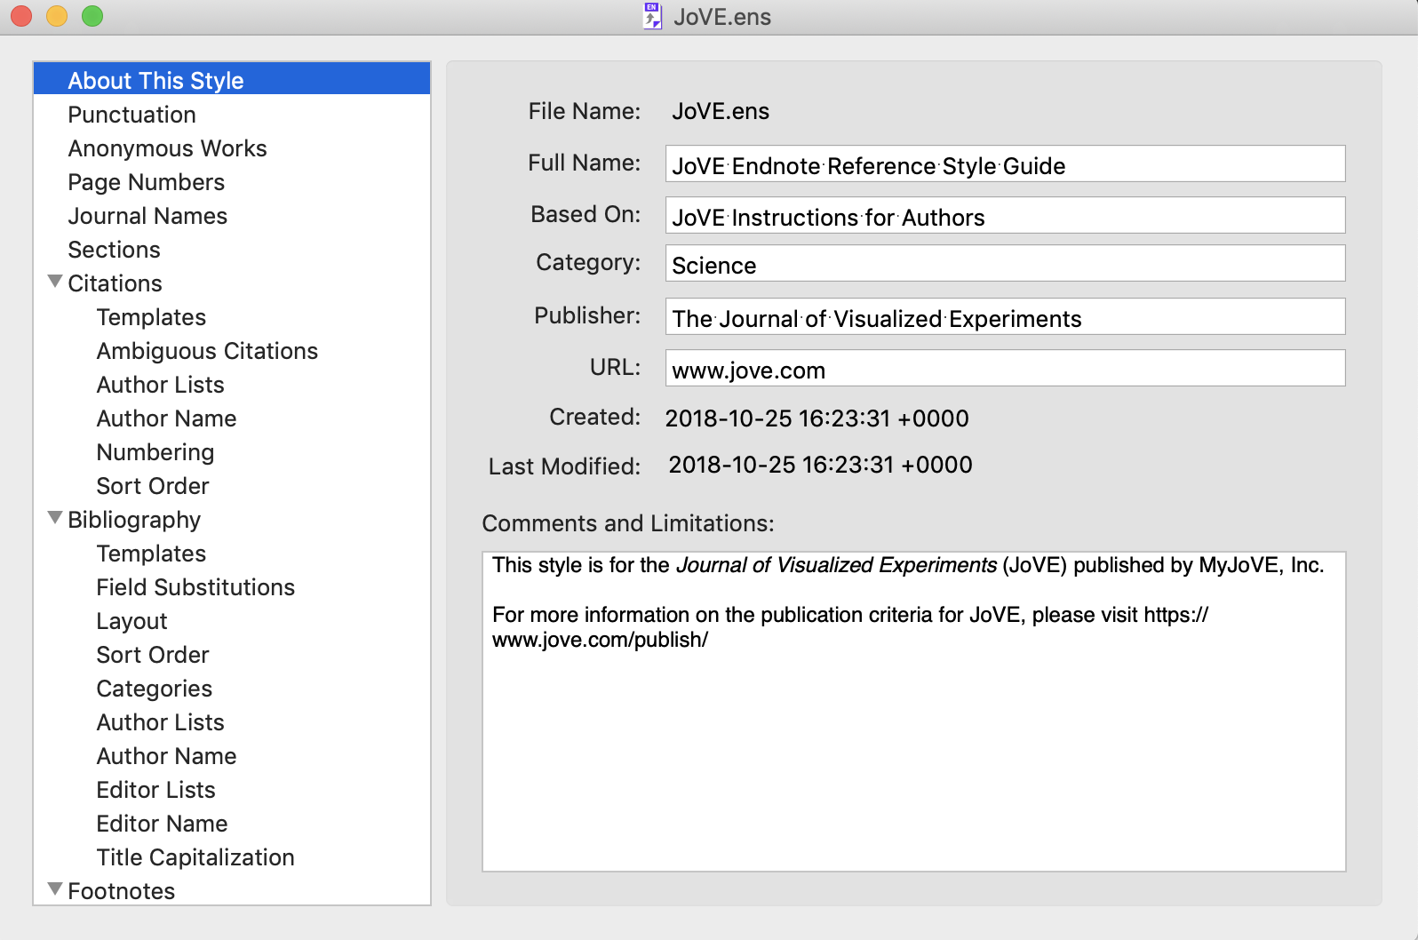

Reviewers' comments:
Reviewer #1:
The authors outline basic methods of storing and culturing Drosophila cell lines. There are clear and well described methods for thawing, subculturing, counting and cryopreserving cell lines as well as detailed information on required media and doubling times. If I were a novice this would be an incredibly useful resource. I have a few small comments about the text.

We thank the reviewer for the positive comments.
67 -78
As this is aimed at novices, it may be useful to include information as to which cell types these are, e.g. epithelial, adherent etc.

We have directed the reader to Table 1 for important details regarding the different cell lines.
101-104
We find it useful to thaw vials using RT media dispensed into a 10ml tube. This avoids having to change tips, and dipping the pipette in and out of the stock bottle.

We thaw the cells in a similar fashion in Protocol 1, using media pre-dispensed into a T-25 flask, instead of a 10 mL tube to thaw the frozen cells. We have edited Protocol 1, Step 3. to reflect this similarity.
116
Do you mean to thaw cells as described above, or leave the vial to thaw by itself?

Protocol 1.1 uses centrifugation to collect thawed cells. The thawing step is similar to the step 3 in Protocol 1. We have amended the sentence to reflect thawing cells by resuspending cells in room temperature media. (Protocol 1.1, Step 1).

158, 187
Some visual descriptions of common contaminations might be useful to novices - eg cloudiness, a basic description of how bacteria and yeast look under the scope.
We have added the following sentence in the discussion line 257.

“Contaminated cultures can be identified by an increase in media turbidity. Under the microscope, contaminants may appear as bacterial rods, cocci, budding yeast cells or string-like fungal hyphae.”
232
'count cells that lie on the top and left sides' is a bit confusing, as it doesn't specify that these are cells that cross the boundary. Maybe 'count cells that partially cross the top and left boundary grooves' instead?

We have edited the sentence to read as follows:

“To avoid duplicate counting, count cells that overlay the top and left boundaries, but not cells that cross the right and bottom boundaries of the 200 μm² squares.”
271 - 272
'Freezing container' in 4.11 becomes 'cooler' in 4.12, which may be confusing

We have kept to using the term freezing container to maintain consistency.
279
You could mention that they can be briefly stored in dry ice whilst preparing for transfer to liquid nitrogen.
We have added the following statement in the Discussion, line 455:

Alternatively, place the frozen cyrovials on dry ice while preparing for their transfer into liquid N₂.
Reviewer #2:
Manuscript Summary:
This protocol provides best practices for thawing, culturing and freezing Drosophila cell lines from an established cell culture lab.
Major Concerns:
None
Minor Concerns:
Protocol step
1.7: Mention here that 25 degree incubator does not need CO2. Mention about whether flasks should be closed or with breathable filter and humidity levels of 25 deg incubator or provide note reference to later text description.

We have added the following sentences to address the above in the discussion section, line 401.

The incubator for Drosophila cell cultures does not need to facilitate CO₂ gas exchange because Drosophila cell culture media do not use CO₂ for buffering. The humidity inside the incubator for culturing cell lines is an important factor not to be overlooked when culturing cells in plates. Depending on the type on incubator and the working environment, it may necessary to place a beaker of sterile water inside the incubator. To minimize media evaporation, use closed T-flasks or store culture plates/vessels are stored in a tightly sealed plastic container while inside the incubator.
1.1.1 Thawing cells be done at what temperature?

We have amended the sentence to reflect thawing cells by resuspending the frozen cell pellet in room temperature media. (Protocol 1.1, step 1).

“In a sterile hood, thaw cells in the hood by resuspending the frozen pellet with 1 mL of room temperature media. Transfer all the thawed cell suspension into a 15 mL conical tube.”
1.1.2 Specify range of g's (only one mentioned but the word between is used)

We have edited Step 2 of Protocol 1.1

“Pellet the cells by centrifugation at 1000 x g for at 5 minutes.”
1.6.2 Define what is considered fully confluent and whether passaging should be 100% confluent or slightly less.

In the manuscript, we avoid recommending passaging based on confluence. We use confluence status as a visual guide to estimate cell density for different cell lines. We recommend cell counting to determine cell density accurately and passage cells such that the seeding density does not fall below 1 X10⁶ cells/ mL.

We added this paragraph in the Discussion section.

The confluence of a culture, expressed as a percentage, describes the growth surface area that is covered by cells. Cell confluence for a cell line depends on its cell shape and size. Distinct cell lines have different morphologies and adherence properties. As a result, different cell lines at approximately similar confluence may have vastly distinct cell density (Figure 1). Culture confluence may not be an ideal indicator for passaging Drosophila cell cultures because Drosophila cell lines continue to proliferate either by piling on top of one another as foci or in suspension even after the growth surface has been covered (Figure 1). However, users experienced with specific cell lines may often use confluence as a rapid visual guide for when to subculture.

Table 2: Define abbreviation for FCS here rather than Table 7.
We have defined FCS in the Table legend as suggested.
Fig. 2: Discuss the morphologies and how they are distinct for those readers who might be new to cell culture.

We have described the cell morphologies in Figure 2 legend. \

Figure 2. Representative images of the eight distinct Drosophila cell lines. A and B. Round embryo-derived S2-DGRC and Kc167, respectively. C and D. Round larval CNS-derived ML-BG2-c2 and spindle-shaped ML-BG3-c2, respectively. E. CME L1, a cell line derived from the larval leg imaginal discs, are smaller and have round/fusiform morphology. F. OSS, a cell line derived from adult ovaries, displays spindle-shaped morphology. G. Spindle-shaped Ras^{V12} cell line expressing activated Ras. H. Ras^{V12}; wts^{RNAi} (WRR1) cell line expressing activated Ras and double-stranded RNA targeting the tumor suppressor warts (wts) displays epithelial characteristics. Scale bar = 50 μm.
Discussion, line 363: list out the advantages.

We have reworded the sentence as follows:

Drosophila cell cultures are primary reagents for high throughput cell-based screens. Their use also complements in vivo genetic research by providing a homogenous population of cells suitable for biochemistry, rapid testing of transgenic constructs prior to injecting into flies, cell biology, microscopy and more recently somatic cell genetic manipulations by genome editing ^{1-3,8-10}.
Some typos were noticed, including mismatches in verb tenses and lack of prepositions. A careful read is needed.
We have proofread our manuscript for grammar and spelling.
Reviewer #3:
Manuscript Summary:
Cell lines are an important resource that make the Drosophila model ideal for investigating basic problems in cell and developmental biology. The present manuscript, from Luhur and colleagues at the Drosophila Genomics Resource Center, is an informative guide for both experienced and novice users of Drosophila cells that should further advance their use for standalone studies or as a complement to the more prevalent genetic studies.
It should be published and is very appropriate for JoVE, but below are a few questions/comments/suggestions for the authors to consider:

We thank the reviewer for the positive comments.
1. In Protocol Section (line 93), DGRC is mentioned without defining it. More importantly, a sentence in the Introduction to mention Drosophila Genomics Resource Center (DGRC) and its activities, especially as it relates to cell lines, would be useful to readers.

We added the following statements in the Introduction, line 59

The Drosophila Genomics Resource Center (DGRC) serves as a repository and distribution center for Drosophila cell cultures. One of the goals of the DGRC is to assist members of the research community in using Drosophila cell culture resources.

2. In step 1.8-1.9 of the thawing protocol, it is stated: "1.8 One to two hours later, examine the cells under the microscope to ensure that most cells have settled on the growing surface. 1.9. Remove all the media from the flask and replace with 5 mL of fresh media." In our experience, with only 2 hrs of plating, the majority of cells will not have attached, especially given the weakly adherent behavior of some Drosophila cell lines, therefore changing all media might risk the loss of many viable cells. The "1-2hrs" could be extended to 6-8hrs or even overnight to minimize cell loss, while mentioning that media change is important to remove residual DMSO. Maybe this can be addressed in a footnote or by some other means.

We have not had any problems with letting the cell sit for 1-2 hours after thawing. We agree with the reviewer’s suggestion to be on the conservative side and we have added the following statement in the Representative Result section:

Under the circumstances in which most of the cells have not attached on the growing surface within two hours after thawing, it is recommended to incubate the cells overnight before changing the media.
3. In the Alternate Protocol for thawing, a mention of temperature or method of thawing the vial would be useful, eg. in waterbath, at room temp, with mixing etc.

We have edited the sentence to clearly describe thawing by resuspending the frozen pellet with room temperature media.

“In a sterile hood, thaw the cells by resuspending the frozen pellet with 1 mL of room temperature media. Transfer all the thawed cell suspension into a 15 mL conical tube.”
4. In the Alternate Protocol for thawing cells (line 113-123), the numbering system is slightly confusing (1.1 vs. 1.1.1). Maybe "Alt1.1" or similar would be better. A similar numbering system is used in Section 2, so if changed, then a similar change should be made in Section 2.

We note this suggestion and have changed the way we number the protocol steps.
All protocol steps are numbered from Step 1 onwards.
5. When removing DMSO by centrifugation, in line 117, the authors recommend 1000xg for 10 minutes. We routinely use 5 minutes and cells are well-pelleted. Less time will minimize damage to the fragile thawed cells.

We have changed this accordingly.
6. Depending on the type of incubator and environmental conditions of the culture room, maintaining humidity can be an issue. When culturing cells in 60mm or 100mm plates, we often face problems with media evaporation. Into the closed plastic box, we usually include an open beaker or vessel with sterile distilled water to generate humidity, which should be changed periodically and handled carefully to avoid spillage. If authors think that humidity control is necessary and worth mentioning, perhaps a phrase should be included.

We agree with the reviewers that the humidity issue may depend on the type of incubator and environmental conditions. At the DGRC, we have not had the need to humidify. In addition, we have 96 plates (with parafilm) containing cells incubating for 3-4 weeks without much loss of media volume. We elaborate on this in the Discussion section, line 402.

“Note: The humidity inside the incubator for culturing cell line is an important factor not to be overlooked. Depending on the type on incubator and the working environment may be necessary to place a beaker of sterile water inside the incubator. Depending on the type on incubator and the working environment, it may necessary to place a beaker of sterile water inside the incubator. To minimize media evaporation, use closed T-flask or store culture plates in a tightly sealed plastic container while inside the incubator.”
7. In line 182, there begins a subsection called "Subculturing adherent cells using trypsin in 100 mm culture plates." This is first mention of trypsin. If the article is for novices, it is worth briefly mentioning just before this section, 1) what trypsin is and why it is used and that 2) some cell lines are more adherent and require trypsin for dissociation and passage (see Table 2 for requirements). This theme is mentioned later in Discussion, but would be better mentioned ahead of the Protocol with Trypsin.

We have added a note regarding trypsin to Protocol 2.1

Note: The use of digestive enzymes such as trypsin aids in passaging strongly adherent cell lines. Trypsin is a mixture of proteases often derived from porcine pancreas and is commercially available in different grades of purity.
8. For some of the culture media formulations, "fly extract" is included, but there is no mention of what this is, how to prepare it, or where to obtain it. Some mention of this should be made, providing a suitable accessible reference or URL for novice users. This could be placed in Discussion, in paragraph which discusses media and serum (line 416). Also, regarding serum, the authors mention "reserving a batch of serum from a single lot". While this is a good idea, especially for a distributor of cell stocks, it may not be necessary or financially feasible for occasional users.

We have added a paragraph in the Discussion regarding fly extract. We have also removed the statement regarding serum batch reservation.

Media additions for most Drosophila cell lines include fetal calf serum (FCS). Insulin and adult fly extract (FEX) are required for some specific lines. FEX contains undefined components essential to the growth of specific larval imaginal disc lines and the adult ovarian cell lines. of The DGRC prepares, and makes available adult FEX derived from one-week old Oregon-R-modENCODE flies (RRID: BDSC_25211) in 2.5 mL and 10 mL aliquots. The DGRC also provides instructions for small scale FEX preparation on its website <https://dgrc.bio.indiana.edu/include/file/additions_to_medium.pdf>. FEX preparation, however, is time-consuming and requires a large quantity of adult flies.
9. There is no mention of the use of "conditioned media". We have encountered protocols that recommend production and use of conditioned media to facilitate recovery from freezing and encourage proliferation when culturing at lower density (e.g. when selecting stable populations or clones). Perhaps the authors can include some words about the conditioned media and whether or not it is helpful or recommended.

We have added the following sentences discussing the use of conditioned media (line 377).

For cell lines that are slow to recover from the effects of thawing, the use of conditioned media may be useful. Culture media conditioned by a cell line likely contains growth factors secreted by the cells into the media which may encourage the recovery and proliferation of the cells after thawing.
10. In line 422, the authors mention the preparation of a working stock of "50-100 ampules". Again, for a distribution center, this may be a reasonable number, but for novice and/or occasional users, 10-20 ampules may be sufficient. Maybe text can be revised to reflect that numbers/quantities can be adjusted according to needs.

We have revised the quantity to better reflect the need for the occasional user/novice.

