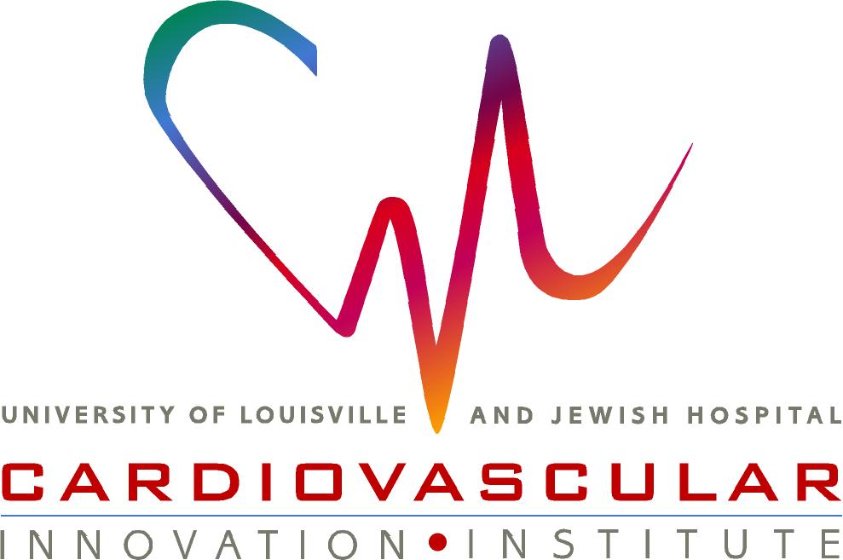
Jason E. Beare, M.S.
Research Coordinator
University of Louisville
302 E. Muhammad Ali Blvd, Suite 508
Louisville, KY 40202
Office: 502-852-2278
Fax: 502-852-1391
Jason.Beare@louisville.edu
Nov 29th 2018

Nandita Singh, Ph.D.
Senior Science Editor

Dear Dr. Singh:

Please accept this original research article entitled Rat heterotopic osteomyocutaneous flap model of vascularized composite allograft rejection and vasculopathy for review and consideration for publication in JoVE.

This paper details a modified VCA surgical method which allows for serial histological assessments and offers the opportunity to study various rejection paradigms. We believe this study would be of great interest to your readers.

This manuscript, in its current form or in part, has not been published nor is it currently under consideration for publication by any other journal. I declare that the co-authors have read the manuscript and approved its submission to JoVE. If you have any questions, please do not hesitate to contact me.

Sincerely,

Jason E. Beare

302 EAST MUHAMMAD ALI BOULEVARD, LOUISVILLE, KY 40202

