Alisha Dsouza, Ph.D.
Senior Review Editor
JoVE

Dear Dr. Dsouza,

We are pleased to resubmit the revised version of manuscript JoVE9420, now entitled “Functional MRI in Conjunction with a Novel MRI-Compatible Hand-Induced Robotic Device to Evaluate Rehabilitation of Individuals Recovering from Hand Grip Deficits”

We thank you for your additional instructions, queries and recommendations for alteration. We have revised the content in response to those items, with descriptions of those specific alterations to follow. Figures have been rearranged to better align with the content adjustments. In addition, we have created a supplementary figure, a flow chart through the software’s sequence of dialog windows with screen shots of the typical data traces, to address the issue you raised regarding assistance to the script writer. However, we do not feel that this figure should be included in the manuscript itself, so it is not referred to in the body of the text.

We look forward to addressing any new items that may arise in response to the alterations.

Respectfully yours,

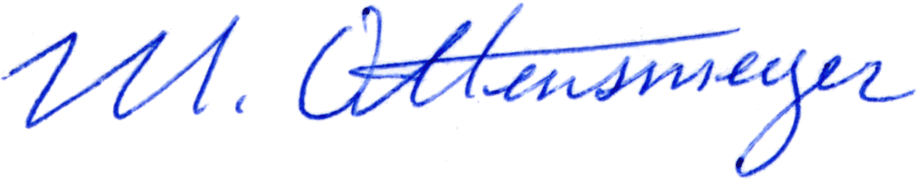
Mark P. Ottensmeyer, PhD.

Line references correspond with the revised document.

Line 2: Evaluate "what" is individuals exactly? Seems like a word is missing. "Evaluate recovery"?

The title has been revised to clarify this

Line 52: Please expand your Introduction to include the following:…

The Introduction has been expanded and revised to include elements addressing the JoVE guidelines for this section

Line 53: The introduction repeats the summary and abstract and the first paragraph sounds like another abstract.

We believe the expanded version of the Introduction now addresses your concern in this respect

Line 57 and other locations: Please re-order your references so that they are listed in the order of call-outs.

The references have been reordered and checked to ensure that they are listed in order of appearance

Line 64: Improvements in what?

The treatment aims in make improvements in grip strength and control. The Introduction now makes this specific.

Line 65 and other locations: Text marked in red font overlaps with previously published work and must be re-written using original language.

The relevant sections have been reworded and/or revised to substantially avoid repetition of previously published phrasing.

Line 69: Employs the device to do what exactly?

The description now explains that the device provides a resistance force against which the subject grips and releases the handle of the device.

Line 153: Have you tested this? It does not add value to state that it can be used in a VR environment unless you have performed some level of testing yourself.

A gaming application for our device has been developed but is not yet of a VR variety. Gaming/VR will be presented in a later publication, and the reference as such has been removed, presented instead by reference to other research.

Line 159: I have edited the protocol structure slightly to meet JoVE's style requirements.

We thank you for making the changes on our behalf.

Line 165: History of stroke or brain lesion?

This has been clarified as an inclusion criterion for non-control subjects.

Line 182: I have unhighlighted these steps due to low filmable content.

We appreciate your insight into the video production process.

Line 224: Check and edit

Thank you for catching the typo on the name of the device.

Line 230: <no text included>

We believe the term “brain lesion” is generic enough to cover a variety of conditions that would result in motor impairment that could benefit from use of our system.

Line 257: Is a script run for this? A screenshot of the software will be useful here to help the scriptwriter out.

A minor modification has been included to specify that the initial force level is set automatically. In addition, supplementary images showing the sequence of user interface dialogs and data displays have been included for the benefit of the script writer. We do not believe that these images would warrant inclusion as a separate figure.

Line 349: Please avoid product names in the manuscript. List this item in the table of materials instead.

The MR scanner vendor and model have been removed, specifying only that a 3T full body MR scanner system was used in our experiments. The scanner has been added to the equipment list.

Line 359: Sentence is incomplete, please revise.

We have modified the sentence slightly for clarification, but we believe the sentence was complete, in the form “Not only was X collected, but also Y”. We can revise it further if needed.

Line 403: Unclear what a glass brain is and why it is in quotes. Reference citations will be helpful.

“Glass brain” is a standard rendering method for presenting regions of excitation in the brain, as if the viewer is looking through a transparent body with opacity related to the excitation. As the specific phrase is of minimal importance, it has been removed in favor of a more generic description.

