
FACULTEIT DER NATUURWETENSCHAPPEN, WISKUNDE & INFORMATICA Swammerdam Institute for Life Sciences

To: editorial office of Journal of Visualized Experiments Prof. Stanley Brul
Science Park 904
1098 XH Amsterdam
The Netherlands
Tel: +31(0) 205256970
E-mail: S.Brul@uva.nl

January 12th 2019

Concerns rebuttal of the manuscript ‘Visualization of the germinosome and the inner membrane in B. subtilis spores’

Dear editor,
Hereby we would like to submit our revisions of the manuscript,

‘Visualization of the germinosome and the inner membrane in B. subtilis spores’

by Juan Wen, Raymond Pasman, Erik M.M. Manders, Peter Setlow and Stanley Brul
Below we answer point by point the editorial comments made with reference to version 59388_R1. Please note that in the revised version we extended the yellow highlighted part of the protocol text to section 7. We realised this omission and truly hope that it will be possible to include also this part of the protocol in the video.

Editorial comments:
Changes to be made by the author(s) regarding the manuscript:

1. Please take this opportunity to thoroughly proofread the manuscript to ensure that there are no spelling or grammar issues.

Author’s answer: This has been done to the best of our abilities.
2. The Short abstract is over the 50 word limit.

Author’s answer: The short abstract has been rewritten and is now 46 words.
3. Please use h, min, s for time units.

Author’s anwer: This has been amended in the revised text.
4. For steps that are done using software, a step-wise description of software usage must be included in the step. Please mention what button is clicked on in the software, or which menu items need to be selected to perform the step.

Author’s answer: This has been changed in the revised text.
5. Step 1.1.1: Please ensure that all text is written in the imperative tense.

Author’s answer: This has been changed in the revised manuscript.
6. 5.1: Please write this step in the imperative tense.

Author’s answer: This has been changed in the revised manuscript.
7. Figure 3: Please add a title for the whole figure.

Author’s answer: The legend of the figure has been modified accordingly.

We hope that with these answers to the editorial points raised the manuscript is now acceptable for publication in the Journal of Visualised Experiments.

Yours sincerely,
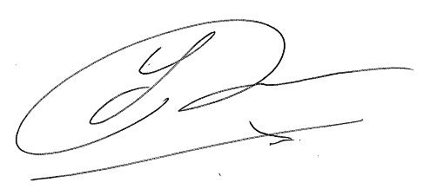Stanley Brul
===================================
Prof. dr. Stanley Brul
Professor of Molecular Biology
Director Biomedical Sciences UvA (FNWI-AMC)
Head Dept. of Molecular Biology & Microbial Food Safety
http://sils.uva.nl/

Cc: all co-authors

