

To the Editor: February 21, 2019

Dear Dr. Wu,

Thank you for your quick response. Please find below a detailed description specifying how each editorial comment was addressed.
- The manuscript was proofread, spelling and grammar errors have been corrected.
- A step-wise description of software usage was included in step # 3
- A single space between numerical values and their units was added.
- Greek characters for SI units were put in place.
- More details were added to Step 3.2.4.
- Step 3.2.5 has been modified to be a Note to 3.2.4 instead.
- The table was removed from the manuscript (Line 193) and uploaded separately as Table 3.
- Steps describing euthanasia or anesthesia now are not highlighted.
- The details for anesthetization were added.
- The importance of maintenance of sterile conditions during survival surgery was emphasized.
- The step specifying that the animal is not left unattended until it has regained sufficient consciousness to maintain sternal recumbency was added.
- The step specifying that the animal that has undergone surgery is not returned to the company of other animals until fully recovered.
- Trademark (™) and registered (®) symbols were removed from the Table of Equipment and Materials.

Sincerely,
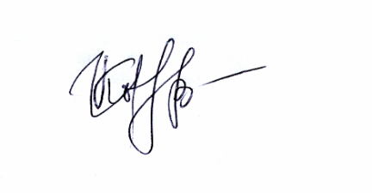
Irina V. Kovtun, Ph.D
Assistant Professor
Department of Molecular Pharmacology
And Experimental Therapeutics
Mayo Clinic
Rochester

507-538-0920 (lab)
Email: ivkru@yahoo.com
kovtun.irina@mayo.edu

