From: Wiley Global Permissions <permissions@wiley.com>
Sent: dinsdag 23 oktober 2018 12:55
To: Verwaal, Rene <Rene.Verwaal@dsm.com>
Cc: Ciurkot, Klaudia <Klaudia.Ciurkot@dsm.com>
Subject: RE: Request re-use of figure from our manuscript DOI: 10.1002/yea.3278

--- This mail has been sent from an external source ---
Dear René Verwaal,

Thank you for your email.

Permission is hereby granted for the use requested subject to the usual acknowledgements (author, title of material, title of book/journal, ourselves as publisher). You should also duplicate the copyright notice that appears in the Wiley publication; this can be found on the copyright page if the material is a book or within the article if it is a journal.

Any third party material is expressly excluded from this permission. If any of the material you wish to use appears within our work with credit to another source, authorisation from that source must be obtained.

This permission does not include the right to grant others permission to photocopy or otherwise reproduce this material except for accessible versions made by non-profit organisations serving the blind, visually impaired and other persons with print disabilities (VIPs).

Kind regards,

Aimee Masheter
Permissions
John Wiley & Sons Ltd
The Atrium
Southern Gate, Chichester
West Sussex, PO19 8SQ
UK

From: Verwaal, Rene <Rene.Verwaal@dsm.com>
Sent: 16 October 2018 13:25
To: RightsLink <RightsLink@wiley.com>
Cc: Ciurkot, Klaudia <Klaudia.Ciurkot@dsm.com>
Subject: Request re-use of figure from our manuscript DOI: 10.1002/yea.3278

Dear reader,

I am the first author of a paper we published last year in Yeast:
https://onlinelibrary.wiley.com/doi/10.1002/yea.3278

We were invited to write a “methods paper” about the experimental details of a part of the Yeast manuscript, i.e. multiplex genome editing experiments.
For clarification, we would like to re-use Figure 5a and figure 5b in the paper.

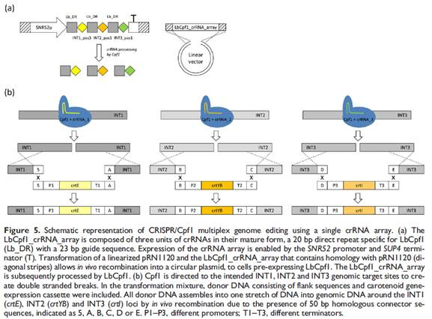

I hereby request permission to re-use Figures 5a and figure 5b from our Yeast paper.

Kind regards,

René Verwaal
René Verwaal | Senior Scientist | DSM Biotechnology Center | Alexander Fleminglaan 1 | 2613 AX Delft | Netherlands | T +31621695215 | rene.verwaal@dsm.com | DSM Biotechnology Center is part of DSM Food Specialties B.V., Trade Register Number 27235314

DISCLAIMER:
This e-mail is for the intended recipient only.
If you have received it by mistake please let us know by reply and then delete it from your system; access, disclosure, copying, distribution or reliance on any of it by anyone else is prohibited.
If you as intended recipient have received this e-mail incorrectly, please notify the sender (via e-mail) immediately.

