November 1, 2018

Journal of Visualized Experiments (JoVE)
1 Alewife Center, Suite 200
Cambridge, MA 02140

Dear Editors:

We are submitting our manuscript entitled “Sequential immunofluorescence and immunohistochemistry on cryosectioned zebrafish embryos” for consideration as an original methods article in JoVE. Zebrafish are a widely used animal model in biomedical research, but the availability of standardized protocols and reagents for scientific experimentation is limited in comparison to mammalian models. In particular, the relatively small number of commercially available antibodies that are validated for use in zebrafish is a hindrance for antibody-based detection methods. Here we describe a protocol that we developed for the sequential application of immunofluorescence (IF) and immunohistochemical (IHC) assays on a single slide containing cryosectioned zebrafish embryos. This method is designed for precise co-localization of two proteins of interest at the single-cell level in the same tissue section. Our method provides a significant advantage over sequential protocols that are limited to only one methodology (dual IF or dual IHC). This is especially important for studies with zebrafish, as antibodies that have been validated for use in this species are often compatible with either IF or IHC assays, but not both. While designed for use in cryosectioned zebrafish embryos, this protocol could easily be adapted for use with other model organisms.

This manuscript has not been published nor is under consideration elsewhere, including the internet.

Sincerely,
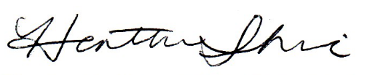

Heather R. Shive, D.V.M., Ph.D., Dipl. ACVP
Assistant Professor, Department of Population Health and Pathobiology
North Carolina State University, College of Veterinary Medicine
RB 248
1060 William Moore Drive
Raleigh, NC 27608
Tel: 919-513-6296
Email: hrshive@ncsu.edu

