 | COCKRELL SCHOOL OF ENGINEERING  THE UNIVERSITY OF TEXAS AT AUSTIN  Department of Biomedical Engineering • 107 W. Dean Keeton St. • Austin, Texas 78712-0238  Office Phone: (512) 471-3604 • Fax: (512) 471-0616
Dear Dr. Steindel,

Thank you for considering our manuscript JoVE59342 "Evaluating the vasculogenic potential of iPSC-derived endothelial progenitors in 3D collagen microenvironments" for publication in JoVE. We hope that our responses (outlined below) sufficiently addressed the comments we received and that our manuscript is now suitable for publication.

Please note that we have decided to change the title of the manuscript to fit its focus better: “A novel in vitro 3D model and computational pipeline to quantify the vasculogenic potential of iPSC-derived endothelial progenitors”.

Editorial Comments:

Comment 1: Please take this opportunity to thoroughly proofread the manuscript to ensure that there are no spelling or grammar issues

Response: We apologize for the presence of any spelling or grammar issues in the original document. These have now been corrected.

Comment 2: JoVE cannot publish manuscripts containing commercial language. This includes trademark symbols (™), registered symbols (®), and company names before an instrument or reagent. Please remove all commercial language from your manuscript and use generic terms instead. All commercial products should be sufficiently referenced in the Table of Materials and Reagents. You may use the generic term followed by “(see table of materials)” to draw the readers’ attention to specific commercial names. Examples of commercial sounding language in your manuscript are: Matrigel, Falcon, Accutase, Eppendorf, Triton-X, Tween-20, MathWorks, MATLAB, etc.

Response: These have been removed.

Comment 3: Please revise the protocol text to avoid the use of any personal pronouns (e.g., "we", "you", "our" etc.).

Response: These have been removed.

Comment 4: Please revise the protocol to contain only action items that direct the reader to do something (e.g., “Do this,” “Ensure that,” etc.). The actions should be described in the imperative tense in complete sentences wherever possible. Avoid usage of phrases such as “could be,” “should be,” and “would be” throughout the Protocol. Any text that cannot be written in the imperative tense may be added as a “Note.” Please include all safety procedures and use of hoods, etc. However, notes should be used sparingly and actions should be described in the imperative tense wherever possible. Please move the discussion about the protocol to the Discussion.

Response: These have been fixed.

Comment 5: Please revise the Protocol steps so that individual steps contain only 2-3 actions per step and a maximum of 4 sentences per step. Use sub-steps as necessary.

Response: These have been fixed.

Comment 6: Approximate volumes for all buffers, gradients, and stock solutions to be set up should be given.

Response: Reviewer 3 has kindly pointed this out to us and we have revised the manuscript to include these numbers. Please refer to our response to comment 4 of Reviewer 3.

Comment 7: Step 4.6: Please specify gating strategies.

Response: This needed further detail and the following step has been added as outlined below:
4.6 On the appropriate fluorescent channel, sort 10,000 cells that have not been labeled with a fluorescent antibody. Gate a region at a high fluorescent intensity that does not contain any of these 10,000 cells (Figure 1D). This serves as a negative control.

Comment 8: 6.3: Please specify how the primary antibody is appropriately diluted.

Response: This has been revised as outlined below:
Incubate with the desired primary antibodies diluted in blocking buffer overnight at 4°C. For example, if immunostaining with phalloidin and VE-cadherin, dilute 1:40 and 1:200, respectively, in blocking buffer.

Comment 9: 6.4: Please specify the secondary antibody used here.

Response: This was unclear, so we have added an example in the text: (e.g., 1:200 Alexa Fluor 488 in PBS)

Comment 10: Figure 1: Please label and describe different panels in the figure legend.

Response: This has been addressed and the figure caption has been updated accordingly.

Comment 11: Please rename Figure 2 as Movie 1 and update figure numbers in the manuscript. Please include a scale bar in the movie if possible.

Response: This has been addressed and a scale bar has been added to the movie, as requested.

Comment 12: Table of Materials: Please sort the items in alphabetical order according to the name of material/equipment.

Response: This has been addressed. We have also added additional items as requested by Reviewer 3.

Reviewer 1

Comment 1: The manuscript does not include the percentage of ECs and mural cells (SMCs or pericytes) generated from the protocol. The authors would benefit from including FACS data of EC and SMC markers to characterize the efficiency of differentiation using this specific protocol.

Response: To address this comment we added Figure 1D, a flow cytometry distribution that shows the percentage of CD34⁺ iPSC-EPs generated from this protocol (in our experience, this percentage varies from 10-25%). Regarding the generated number of ECs and SMCs, we have thoroughly characterized CD34⁺ iPSC-EP bipotency in a manuscript recently accepted for publication in Tissue Engineering; we have reproduced the relevant data below.

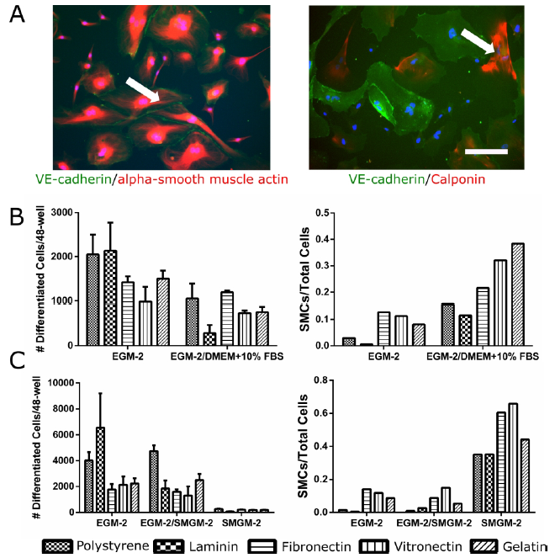

Figure S.2: FACS-isolated CD34⁺ iPSC-EP are bipotent. (A) Following differentiation of iPSC-EPs into iPSC-ECs and iPSC-SMCs, cells were immunostained with endothelial marker (VE-cadherin) and smooth muscle cell markers (alpha-smooth muscle actin (α-SMA), and calponin). Most iPSC-ECs stained positively for both VE-cadherin and α-SMA (left image; arrow points to VE-cadherin positive junctions). We therefore used calponin to distinguish iPSC-SMCs from iPSC-ECs as shown in the right image (arrow points to calponin positive SMC). Scale bar for both images is 400 μm. (B) CD34⁺ iPSC-EPs were cultured on ECM protein-coated plates for 7 days in EGM-2, DMEM supplemented with 10% FBS, or a combination of the two media (n=3). No data is shown for the latter medium because the cells underwent rapid apoptosis hours after seeding. (C) CD34⁺ iPSC-EPs were cultured on ECM protein-coated plates for 7 days in EGM-2, SMGM-2, or a combination of the two media (n=3). All counts are reflective of the total cell populations 7 days after seeding.

This is now cited as reference 20 in the manuscript; additionally, to aid the reader, we have added the following:
NOTE: These endothelial progenitors can be further differentiated along an endothelial lineage (35-99%) or a smooth muscle lineage (1-65%). Differentiation efficiencies vary depending on the type of ECM coating and the cell culture medium used during differentiation ²⁰.

Comment 2: While there is inclusion of F-actin staining to determine the development of a primary capillary plexus from iPSC-EPs, it would be more convincing to stain the networks with an EC specific marker such as CD31.

Response: F-actin is indeed insufficient to claim that extended cells have formed an endothelial lumen. To image the network, we employed rhodamine-phalloidin because the fungal toxin exhibits very low off-target binding; in other words, there is very little fluorescence visible in the interstitial space between lumens. However, to better define the endothelial nature of the described capillary plexus, we stained cell-laden collagen hydrogel containing fully formed lumen with VE-cadherin, a canonical endothelial marker. We rendered this image in three dimensions and have added it as a supplemental movie (Movie S.1).

Comment 3: The authors developed a computational pipeline that uses ImageJ to pre-process acquired confocal images, however, they have not included examples of the data output. Furthermore, there is no mention of a comparison of the accuracy of their method to the standard methods commonly used and listed in the manuscript. It would be helpful to show a side-by-side comparison of their results, in comparison to those from more established approaches like Imaris or Metamorph.

Response: Please refer to our response to Reviewer 3, who asked for similar data. In short, we have included a sample data file, figures of this confocal network and node-based topology, and the associated statistics.

Comment 4: The authors state that "We have observed that the collagen hydrogels do not bind to the ultra-low attachment plates; the hydrogels tend to remain suspended in the media and will occasionally float to the top of the well." Are these acellular hydrogels or cell-seeded ones?

Response: We should clarify that this observation holds true for acellular and cell-laden hydrogels. The text has been amended as follows:
Acellular and cell-laden collagen hydrogels do not bind to the ultra-low attachment plates; the hydrogels tend to remain suspended in the media and will occasionally float to the top of the well.

Comment 5: The authors should cite the origin of their differentiation protocol (i.e., "Directed endothelial progenitor differentiation from human pluripotent stem cells via Wnt activation under defined conditions. Xiaoping Bao, Xiaojun Lian, and Sean P. Palecek.")

Response: We thank the reviewer for their valuable comment. In addition to the original paper, “Lian, X. et al. Efficient differentiation of human pluripotent stem cells to endothelial progenitors via small-molecule activation of WNT signaling. Stem Cell Reports” (citation 11), we added the suggested reference (citation 19) as follows:
Replace the medium daily with 2 mL of LaSR Basal for 2-3 additional days. At this time point (D5 of differentiation), a significant proportion of these cells will express CD34 and can be characterized as endothelial progenitors. A schematic of this protocol is outlined with representative results in Figure 1 and described in full by the investigators who first published this method ^{11,19}.

Comment 6: What is the concentration of collagen used? And what vendor? The volume of NaOH to be added is dependent on the molar concentration of acid in the collagen.

Response: The reviewer makes two excellent points, and we would like to address each individually.
First, to address the importance of the concentration of collagen, we have added the following note:
NOTE: the final concentration of collagen can have a significant impact on the formation of the capillary plexus. This protocol assumes that the collagen has been supplied at 10 mg/mL and that the hydrogels have a final concentration of 3.5 mg/mL. Adjust these volumes to achieve their final collagen concentration; it is recommended to restrict the final collagen concentration from 2 mg/mL to 4 mg/mL.
The supplier of the collagen used in this study, as noted in the Table of Materials, is VWR (Corning, Product number 354249).
Second, as noted by the reviewer, the purpose of the NaOH is to neutralize the acetic acid present in the collagen solution and to thereby encourage spontaneous fibrillation at elevated (e.g., incubator) temperatures. 5 $μ$L of 1M NaOH has been shown to be sufficient to neutralize collagen that has been solubilized in 0.02 N acetic acid at a final concentration of 3.5 mg/mL¹⁰.

Reviewer 2

Comment 1: The "progenitor" character of endothelial cells is very often defined not just by CD34 expression but also the presence of CD133 and VEGFR2 - did the authors check for that or do they would like to include this in the characterization step?

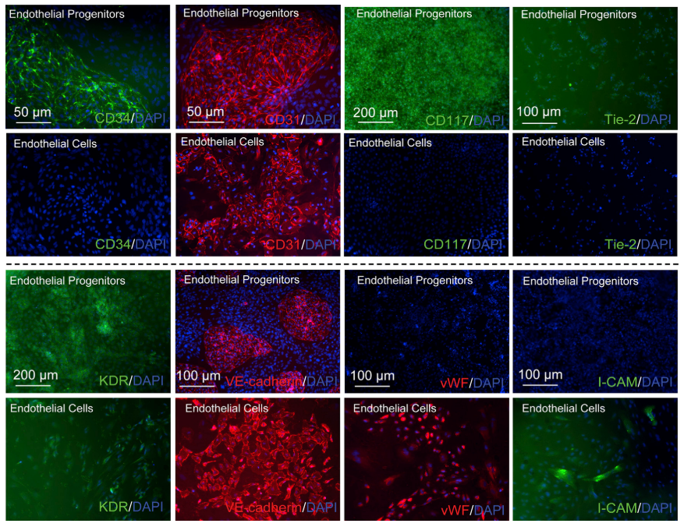
Response: We agree that CD34 alone is insufficient to define a population of endothelial progenitors. The Palecek research group that first described this method to generate pluripotent stem cell-derived endothelial progenitors, performed a thorough characterization of these markers and found that these iPSC-EPs also displayed high levels of CD31, CD117, Tie-2, KDR, and VE-cadherin (reproduced below for Reviewer 2’s convenience)¹¹.

In our recently accepted manuscript in Tissue Engineering: Part A, we have also analyzed a set of canonical endothelial progenitor, pluripotency, arterial, venous, and mesenchymal markers. We characterized these markers for the following populations: D5 differentiated cells, sorted CD34 positive (CD34⁺) cells, and their counterpart cell population expressing low or negative levels of CD34 (CD34^{low/negative}). We have reproduced this data below and cited this data in the manuscript as reference 20. We would like to direct the reviewer’s attention to VEGFR2 (KDR) expression levels in these CD34⁺ iPSC-EPs. Based on these data we anticipate that iPSC-EPs, expressing CD34 are highly likely to co-express the markers discussed above. We, therefore, do not believe a characterization step is necessary but added this as an optional step, as follows:

4.7.1 Optional: if further iPSC-EP characterization is desired, add other primary antibodies (e.g., CD31-APC) simultaneously with CD34-PE. Ensure that crosstalk between different fluorescent channels is minimized.

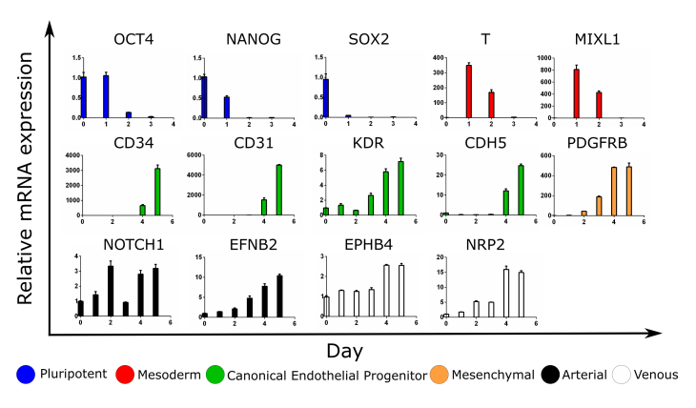
Figure 1: (Top) mRNA was isolated from the unsorted cells every 24 hours after CHIR99021 induction. qPCR was performed to evaluate temporal gene expression profiles during the five days of differentiation into iPSC-EPs. (Bottom) Expression levels of EP and EC markers of sorted CD34⁺ iPSC-EPs were compared to the counterpart subpopulation which is low or negative for CD34 expression (CD34^{low/negative}).
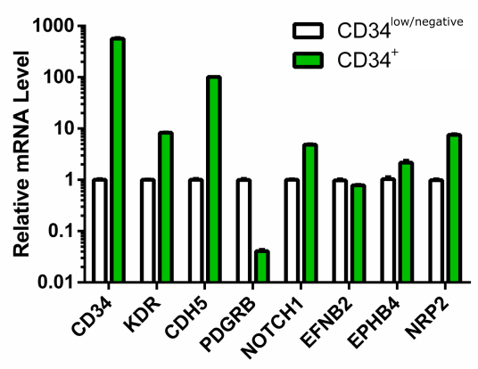
Comment 2: I would suggest including one chapter on troubleshooting. Sometimes the networks in 3D are very difficult to analyze with the given software. Such a chapter would be very beneficial for the reader.

Response: We have expanded sections 6 and 7 significantly to address these concerns. Also, we believe that a considerable amount of detail regarding troubleshooting can be currently found in the discussion.

Comment 3: Please include also the following reference, where also detailed network analyses are described: https://www.ncbi.nlm.nih.gov/pubmed/25687101 (Charwat et al., 2015)

Response: We apologize for not including this reference in the first version of the manuscript. We have added the following sentences:
In the past decade, different open-source computational pipelines and skeletonization algorithms have been developed to quantify and compare vascular network length and connectivity. For example, Charwat et al. developed a Photoshop-based pipeline to extract a filtered, binarized image of vascular networks derived from a co-culture of adipose-derived stem cells and outgrowth ECs in a fibrin matrix ^{13,14}. Perhaps the most widely used topology comparison tool is AngioTool, a program published online by the National Cancer Institute ¹⁵; despite the program’s widespread adoption and well-documented fidelity, the program is limited to analyzing vessel-like structures in two dimensions; other programs, including AngioSys and Wimasis, share the same dimensionality limitation ¹⁶.

Reviewer 3

Comment 1: In line 49: it's not clear what does "to inform current models of cardiovascular disease" means.

Response: We thank the reviewer for pointing out the lack of clarity in this sentence; This sentence has been changed as follows:
Such vascular platforms promise to illuminate molecular and tissue-level mechanisms of cardiovascular disease and may present physiological insight into the development of primitive vascular networks ^{2,3}.

Comment 2: In line 89: the acronym iPSC-EPs is used for the first time, but it is not explained. Add the meaning of the acronym.

Response: The acronym has now been defined as follows:
In particular, protocols have been published that outline the generation and isolation of iPSC-derived endothelial progenitors (iPSC-EPs) ^{10,11}; iPSC-EPs are bipotent and can, therefore, be further differentiated into endothelial cells and smooth muscle cells/pericytes, the building blocks of mature, functional vasculature.

Comment 3: In step 1.1: Can the vitronectin solution be stored for future uses?

Response: As for most proteins, we do not recommend storing vitronectin in a sparse solution. The text has been updated as follows:
Once diluted, it is not recommended to store this solution for future use.

Comment 4: In steps 1.4, 1., 3.3, and 5.6: It would be more convenient to add actual volume values instead of concentrations. How much should the reader prepare? Also, how should it be done? This means to elaborate on how much material should be weighted, and which volume should be used to dilute the material. Please, be thorough when explaining if the reader should dilute the entire vial in a specific volume or should previously weight a certain amount of material. This helps making protocols much clearer.
a. Step 1.4: 100 mg/ml ascorbic acid magnesium-2-phosphate in ultrapure water.
b. Step 1.5: 10 mM CHIR99021 in DMSO.
c. Step 3.3: 10 µM Y-27632 in E8 medium.
d. Step 5.6: 50 ng/ml VEGF in Y-27632-supplemented EGM-2 medium.

Response: We thank the reviewer for their valuable comment, We have updated the text as follows:
- Step 1.4: Prepare a 100 mg/mL stock solution of ascorbic acid magnesium-2-phosphate (a white lyophilized powder) in ultrapure water by adding 500 mg of powder to 5 mL of water in a 10 mL glass scintillation vial. Agitate with a stir bar until the solution is completely transparent (this may take up to an hour). This solution can be stored at -20 °C for up to one year.
- Step 1.5: Create a 10 mM stock of CHIR99021 (CHIR) by dissolving 10 mg of lyophilized powder in 1.9928 mL of dimethyl sulfoxide (DMSO) in a 15 mL conical centrifuge tube and warm in a 37 °C bead (or water) bath until the solution is transparent. Aliquot into 1.8 mL microcentrifuge tubes and store at -20 °C for up to one year.
- Step 3.3: During the above one-hour incubation, remove the E8 medium and Y-27632 from the refrigerator and freezer, respectively. Once E8 medium and Y-27632 reach room temperature, prepare E8 + ROCKi by adding 13 μL of 10 μM Y-27632 to 13 mL of E8 in a 15 mL conical centrifuge tube.
- Step 5.6: Prepare 1 mL of culture medium comprised of EGM-2 supplemented with 10 μM Y-27632 and 50 ng/mL vascular endothelial growth factor (VEGF) by adding 1 μL of each stock solution to a microcentrifuge tube. After mixing well, pipette 100 μL of this cell culture medium onto the cell-laden hydrogels. Transfer the plate to 37°C for long-term culture.

Comment 5: In step 2.2: Is there a recommended number of cells for thawing and seeding? This may arise from a cell amount that the authors usually freeze per vial, but it is not revealed to the reader.

Response: We have added the following note to Step 2.2:
Note: Even under optimal conditions, iPSCs tend to recover poorly from cryopreservation. It is recommended to cryopreserve a near-confluent 6-well for future seeding into a single 6-well. Significant debris may be normal for 2-3 days during cell recovery.

Comment 6: In step 2.6:
a. It would be helpful to add some kind of parameter that will help the reader determine when to stop the EDTA incubation. There is a range (between 5 and 7 minutes), but with no information on how to choose either incubation time.
b. The same goes for the cell suspension. How can the reader know if he/she should take 75 µl or 200 µl?

Response: We have added the following note to Step 2.6.2:
CAUTION: The incubation time for iPSC detachment is cell-line dependent; it is recommended that the user of this protocol tests a range of times upon sufficiently expanding a received/generated iPSC line. 75 μL of cell suspension generally results in 4 days between passages; 150 μL or more leads to 2-3 days between passages.

Comment 7: In step 3.7:
a. It is not clear when the E8 medium added in step 3.6 should be removed to start step 3.7.
b. The preparation of the LaSR Basal could be explained in section "1. Preparation of Culture Media and Coating Solutions".

Response: We apologize for lack of clarity; We have added the following to Step 3.6:
Incubate for another 24 hours under the same conditions.

As suggested by the reviewer, we have moved the preparation of LaSR Basal to “1. Preparation of Culture Media and Coating Solutions”.

Comment 8: In step 3.8: Even though it is shown in the timeline in figure 1, it should be explicitly stated in the text the incubation duration of the LaSR Basal supplemented with ascorbic acid.

Response: LaSR culture duration is now described in steps 3.9 and 3.10 as follows:
3. 9 After 48 hours of incubation with CHIR99021, replace with 2 mL of LaSR Basal.
3.10 Replace the medium daily with 2 mL of LaSR Basal for 2-3 additional days.
.

Comment 9: In step 4.4:
a. The line "that has been conjugated to a bright secondary fluorophore" gives the notion that the reader should do this step. Maybe re-writing the sentence could help understand that the authors use a commercially available fluorophore-conjugated secondary antibody.
b. How much of the CD34 antibody should the reader use? What did the authors do in this step?

Response: We apologize for lack of clarity, we have updated the sentence as follows:
Add 5 μL of the concentrated CD34-PE antibody to the cell-sorting buffer suspension and incubate for 10 minutes at 4°C.

Comment 10: In step 4.5:
a. "centrifuge at for 5 minutes". Remove "at".
b. In line 257, after the centrifugation, there shouldn't be a suspension. Please, clarify if the reader should remove supernatant and resuspend in sorting buffer.

Response: This has been correct as follows:
Re-suspend in 5 mL of ice-cold sorting buffer. Filter this suspension through a cell strainer with a 40 μm cap before placing on the sorter.

Comment 11: In step 4.6, line 261: Is the term "isolation" used instead of "sorting"?

Response: We have changed “isolation” to “sorting” throughout the manuscript to prevent future confusion.

Comment 12: In step 5.4: Why do you add the 1M NaOH solution when the cells are suspended into the material? Can this be done to the collagen separately to avoid harming the cells?

Response: In our experience, gelation occurs relatively quickly after the addition of NaOH. This makes the addition of cells after the addition of NaOH difficult and can result in cell aggregation in the hydrogel. Based on our experience, more than 80% of the cells are viable 24 hours after encapsulation.

Comment 13: In step 6.1:
a. It is convenient to remind the reader that the used volume should cover the entire hydrogel.
b. Frequently used staining protocols perform a quick PBS wash between removing the medium and adding the PFA. Is this missing?

Response: We thank the reviewer for their valuable comment, we have updated our protocol as follows:
After one week of culture, add 250 μL of 4% paraformaldehyde (PFA) solution to a 48-well plate. Fill as many wells as there are hydrogels. Remove the medium from the hydrogels (PFA) and use fine-tipped tweezers to transfer the hydrogels to PFA containing wells. Incubate for 10 minutes at room temperature and remove the PFA by washing rapidly with PBS.

With regards to point b, we have noted that the networks are sensitive to temperature fluctuations and changes in cell culture medium composition. Therefore, to maximally preserve the integrity of the 3D networks, we do not perform an additional washing step. We have not noticed any adverse effects during the immunostaining process.

Comment 14: In step 6.2 and 6.3: There is no blocking step, nor is the primary antibody suspended in blocking solution. This is not common for staining protocols. These steps might have been forgotten.

Response: We apologize for this omission. In the first section, we have added the following paragraph:
To prepare blocking buffer, add 500 mg of lyophilized bovine serum albumin (BSA) and 50 μL of Tween-20 to 48 mL of DPBS. Incubate at 37 °C for at least 15 minutes to ensure that the BSA does not clump and subsequently separate from the solution.

We have added the following to step 6.2:
Block by immersing the hydrogels in 250 μL of blocking buffer for 30 minutes.

Step 6.3 now reads:
Incubate with the desired primary antibodies diluted in blocking buffer overnight at 4°C.

Comment 15: In step 6.6, line 319: "of" instead of "if".

Response: Corrected.

Comment 16: In step 6.7, line 322: "using" instead "with". Makes it clearer.

Response: Corrected.

Comment 17: In step 6.8: It would be helpful to explain the image output format/extension (e.g., TIF, LSM, CZI).

Response: The following note has been added to step 6.8:
NOTE: For future processing, ensure that the z-stacks are saved with minimal compression (.czi is recommended on Zen instruments).

Comment 18: In step 7.1:
a. Is this step performed using ImageJ?
b. The authors should comment more about the chosen correction parameters. What should be the expected output after the contrast correction?

Response: We apologize for not explaining adequately the utility of ImageJ. We have updated step 7.1 as follows:
Step 7.1 Inspect each z-stack to ensure that slices only contain vessels. Open the z-stack in ImageJ and enhance the contrast by clicking “Image Adjust Brightness/Contrast.” The vessel borders are now clearly demarcated, and the background level is minimized.

CAUTION: ECs will migrate towards the edges of the gel and will form small cobblestone colonies. While these are useful to estimate the boundaries of the hydrogel, they will interfere with the final image analysis and should be deleted.

NOTE: ImageJ is a Java-based open-source image analysis software developed in concert by the National Institutes of Health and the Laboratory for Optical and Computational Instrumentation. It is recommended to download Fiji, which is simply ImageJ bundled with useful plugins (https://fiji.sc/)

Comment 19: In steps 7.3, 7.4, 7.5: These steps should be described more thoroughly.
a. How are the commands opened? Explain the exact steps as it was done in step 7.1 using the arrows.
b. Which parameter values do the author recommend for each command?

Response: These steps have been expanded as follows (please note that the step numbers have changed since the last version):
Step 7.2: In ImageJ, blur the image in 3-dimensions clicking ProcessFilters Gaussian Blur 3D and then setting the sigma values in all 3 dimensions to 2.0 (this value might need to be adjusted by the end user).
Step 7.3: In ImageJ, click Process Binary Make Binary and then select an appropriate thresholding algorithm. The cross-entropy thresholding algorithm developed by Li et al. is effective in separating vessels from the background 21. Calculate the threshold for each image and set the background to “Default”.
Step 7.4: In ImageJ, remove spurious noise and fill in “holes” in lumen by clicking Process Noise Remove Outliers.
Sub-step: Removing “bright” outliers will fill in small holes in connected vessels; removing “dark” outliers will remove dead cells. The size of the removal radius will vary based on the magnification and size of the vessels. For images acquired with a wide-field objective that are 512 x 512 pixels, the radii will typically range from 4-6 pixels.

Comment 20: In step 7.6: Please explain how to load a multi-paged TIFF file in MATLAB into a variable. A better option is to add a code that does this.

Response: We have added the code responsible for this upload and updated the description of these Step 7.6 as follows:
Save the processed .tif files in the same folder as the file “BatchProcessSkeleton.m”, available for download in the manuscript. This script, developed by the authors, calls the functions published by Phillip Kollmannsberger22 and conducts some additional file manipulation.

Comment 21: In step 7.7 and 7.9: Add links to the corresponding functions for the paper's online version. Explain how to install/unzip the files for the user to work with them.

Response: We have added the links to download the necessary files from the MATLAB depository. We will assume that the reader can download and unzip these files, as this only requires to follow the instructions provided on-screen and will vary considerably based on the requirements of different OS’s.

Comment 22: In step 7.8 and 7.9: There are many missing key points for a reader with little experience in MATLAB. The authors should explain thoroughly how to perform ALL the steps to run the functions. The best way to achieve this is adding an example code with comments for each line, or at least for the lines that involve actions that might not be known to the reader. Moreover, an example image to perform the analysis would be a great and helpful addition, especially if the authors add the results they obtained for said image.

Response: We have overhauled this section and attached the necessary scripts for application. Please refer to manuscript for all of the updated text.

Comment 23: In step 7.9: There is no explanation on how the parameters are obtained for use. How can the reader analyze and compare the data they obtained after doing the image analysis? Where is this data stored? Again, this would be better explained by adding a detailed code. Furthermore, it is very important that the authors will give full detail of the steps performed to obtain the images in figure 3B, since they seem to use the data from step 7.9.

Response: We have overhauled this section and attached the necessary scripts for application. We have also attached a sample z-stack, its skeleton, its analyzed network, and final data output.

Comment 24: In lines 409-410: This should be added into the protocol section.

Response: This has been moved as suggested.

Comment 25: The next materials are missing from the materials list:
*Ultrapure water
*Accutase

Response: Both have been added to the Table of Materials.

Sincerely,

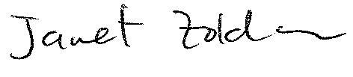
Janet Zoldan, Ph.D.
Assistant Professor
Department of Biomedical Engineering
The University of Texas at Austin

