Submission ID #: 59315

Scriptwriter Name: Qingyun Ping

Project Page Link: https://www.jove.com/account/file-uploader?src=18091123

Title: Rapid Evaluation of Toxicity of Chemical Compounds using Zebrafish Embryos

Authors and Affiliations: Ashok Aspatwar¹, Milka Marjut Hammaren¹, Mataleena Parikka^{1,2} Seppo Parkkila^{1, 3}

¹Faculty of Medicine and Health Technology, Tampere University, Tampere, Finland.
²Oral and Maxillofacial Unit, Tampere University Hospital, Tampere, Finland
³Fimlab Ltd, Tampere University Hospital, Finland

Corresponding Author:

Ashok Aspatwar

ashok.aspatwar@tuni.fi

Email addresses for Co-authors:

milka.hammaren@tuni.fi

mataleena.parikka@tuni.fi

seppo.parkkila@tuni.fi

Author Questionnaire:
1. Microscopy: Does your protocol involve video microscopy, such as filming a complex dissection or microinjection technique? (Y/N) Y
Can you record movies/images using your own microscope camera? (Y/N) N
If no, JoVE will need to record the microscope images using our scope kit (through a camera port or one of the oculars). Please list the make and model of your microscope.
- Stereomicroscope, Zeiss with mounted camera as seen in the picture (one which is used for the protocols in our lab). This is attached to computer. (Zeiss, Stemi 2000-C/Axiocam 105 color)
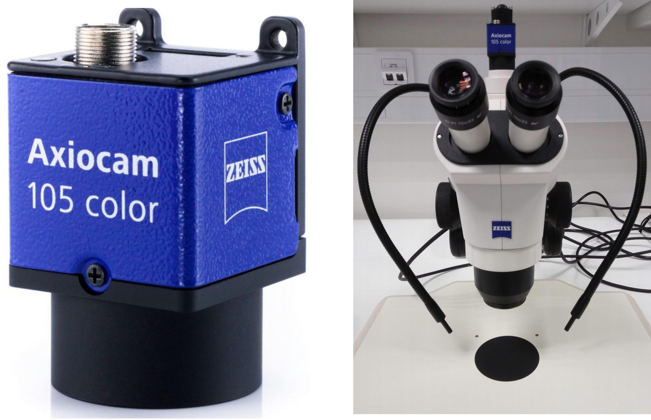

2. Does your protocol include software usage? (Y/N) N

3. Which steps from the protocol section below are the most important for viewers to see? Please list 4-6 individual steps using the step numbers listed in this document. This information is important to prepare your Videographer for your shoot. (You do not need to include steps that will be screen captured. Please do not list entire sections.)
The steps of protocol that are important for the viewer are 2.1.1., 2.2.1., 2.4.2.,3.2.1., 4.1.3., and 4.2.2.
4. What is the single most difficult aspect of this procedure and what do you do to ensure success? Please list 1-2 individual steps using the step numbers listed in this document. (Please do not list entire sections.)

Ans: All the steps are simple, however step 4.4.2 involving taking video requires good equipment (microscope and suitable camera attached to the computer) for taking a 30 sec video of swim pattern of 5 dpf larvae.

5. Will the filming need to take place in multiple locations? (Y/N) N

Section - Introduction
Videographer: Interviewee Headshots are required. Take a headshot for each interviewee.

Authors, these headshots will be used for the JoVE Dedicated Author Webpage. Here is one example if you wish to take a look.

- REQUIRED Interview Statements: (Said by you on camera) - All interview statements may be edited for length and clarity.

  - Ashok Aspatwar: Our protocol identifies off-target effects and detects subtle toxic effects of the chemicals in the early phase of drug discovery that may be missed in the cell culture or other animal models [1].
    - INTERVIEW

  - Ashok Aspatwar: The main advantages of our technique are: It is rapid and efficient, requires very small amount of chemical and only basic facilities in the laboratory [1].
    - INTERVIEW

OPTIONAL Interview Statements: (Said by you on camera) - All interview statements may be edited for length and clarity.

  - Ashok Aspatwar: Toxicity screening will help us in deciding the concentration of the compound for studying its efficiency against mycobacteria that cause tuberculosis and further preclinical characterization [1].
    - INTERVIEW

  - Ashok Aspatwar: This method gives insights into off-target effects of chemical and hence the method can be used in any area of research where toxicity of chemical is of primary importance [1].
    - INTERVIEW

  - Ashok Aspatwar: This method is very simple and can be carried out by anybody without prior experience. Individual with no experience should plan the experiment carefully and use just one compound [1].
    - INTERVIEW

  - Ashok Aspatwar: This method provides toxic effects of chemicals in the form of phenotypic changes in the developing embryos and hence safety of the compounds tested [1].
    - INTERVIEW

Introduction of Demonstrator: (Said by you on camera)

  - Seppo Parkkila: Demonstrating the procedure will be Ashok Aspatwar, a Post-Doctoral researcher from my laboratory [1] [2].
    - Interview style: Author saying the above
    - The named technician, post doc, student looks up from workbench or desk or microscope and acknowledges the camera.

Section - Protocol

The zebrafish core facility at Tampere University has an establishment authorization granted by the National Animal Experiment Board (ESAVI/7975/04.10.05/2016). All the experiments using zebrafish embryos were performed according to the Provincial Government of Eastern Finland, Social and Health Department of Tampere Regional Service Unit protocol # LSLH-2007-7254/Ym-23.
- Collection of Embryos
  - To begin, place 2-5 adult male zebrafishes and 3-5 adult female zebrafishes into mating tanks overnight [1-TXT]. In the morning, turn on the light to induce breeding [2]. To avoid handling stress to the animals, allow the animals to rest for 2 weeks before using the same individuals for breeding [3].
    - MED: Talent places fishes into tanks. TEXT: a minimum of 20 embryos for each toxicity concentration Videographer: Take multiple shots, as this will be used later. Author comment: This shot is 2.1.3
    - WIDE: Talent turns on light. Focus on the tanks.
    - MED: Talent transfers fishes from one tank to another tank. Author comment: This shot is 2.1.1
  - The next day before noon, collect the embryos using a fine-mesh strainer [1] and transfer them onto a Petri dish containing E3 embryo medium [2-TXT].
    - MED: Talent collects embryos.
    - CU: Talent places them onto a dish with medium. TEXT: See manuscript for media preparation.
  - Place the Petri dish under a stereomicroscope [1] to examine each batch of embryos. Identify the opaque appearance, and remove them as unfertilized or dead embryos [2]. Keep the embryos at 28.5 degrees Celsius in an incubator overnight [3].
    - MED: Talent places the dish under a microscope.
    - SCOPE: Talent removes dead and unhealthy opaque embryos. Author comment: This shot is 2.4.2
    - MED: Talent places the dish in an incubator.
  - The next morning, examine the embryos under a stereomicroscope [1] and remove any unhealthy or dead embryos [2].
    - WIDE: Talent transfers the dish from the incubator to a microscope.
    - SCOPE: Talent removes opaque embryos. Author comment: This shot is 2.3.2
  - Carefully use a Pasteur pipette to transfer 1 embryo into each well of a 24-well plate [2]. Make sure each well contains enough E3 medium to cover the embryos [3].

    - CU: Talent transfers medium into a well. Focus on the well.
    - MED: Close up of the wells with medium covering the embryos.
- Exposure to Toxicity
  - Take out the vials containing inhibitor compounds stored at 4 degrees Celsius in a refrigerator [1]. Use an analytical balance to weigh appropriate amount of the compound [2], and prepare 250 microliters of 100 millimolar stock solution for each compound in E3 medium or another appropriate solvent [3-TXT].
    - WIDE: Talent takes out vials from the refrigerator.
    - MED: Talent weighs compound.
    - CU: Talent adds solvent and compound into a vial. TEXT: Store the stock solution at 4 °C.
  - Then, use E3 medium to make serial dilutions of the stock solutions based on toxicity levels in 15-milliliter centrifuge tubes [1-TXT]. From the wells that each contains one 1 dpf (pronounce as D-P-F) embryo, use a Pasteur pipette and 1-milliliter pipette to remove the E3 water, one row at a time [2-TXT].
    - MED: Talent make dilutions. TEXT: e. g., 10 μM, 20 μM, 50 μM, 100 μM, 150 μM, 300 μM and 500 μM
    - CU: Talent removes medium, one row at a time. TEXT: 1 dpf: 1 day post fertilization Video editor: Show text when VO says 1 dpf
  - Immediately distribute 1 milliliter of each diluent of the stock solutions into the wells of the 24-well plate, starting from lower and moving to higher concentration. For the control groups, add E3 water or another relevant solvent [1].
    - MED: Talent adds solutions into the wells.
  - Label 24-well plates with the name and concentration of the compound [1-TXT] and keep the plates at 28.5 degrees Celsius in an incubator [2].
    - CU: Talent labels plates. TEXT: Minimum of 20 embryos for each concentration of a compound.
    - MED: Talent places plates into incubator.
  - Ashok Aspatwar: Take care that the diluents of the chemicals in the wells is not evaporated in the incubator by sealing the sides of the 24-well plate [1].
    - INTERVIEW
- Phenotypic Analysis
  - Twenty-four hours after exposure to the chemical compounds [1], use a Pasteur pipet to transfer the larvae exposed to each concentration of the compound in a small Petri dish [2] containing 3% high molecular weight methyl cellulose. With a metal probe, lay it sideways [3].
    - WIDE: Talent takes out a dish from the refrigerator.
    - MED: Talent transfers the larvae into a Petri dish.
    - CU: Talent uses a probe to lay the larvae sideways.
  - Place the Petri dish under a stereomicroscope attached to a camera [1]. Take the images, and save the images in a separate folder each day till the end of the experiment [2].
    - MED: Talent places the dish under a microscope.
    - MED: Talent operates on the computer to take images.
  - Enter all the observations in a table each day either in an online table or on a printed sheet [1]. For neurotoxic compound exposure, the 4 to 5-dpf larvae may show abnormal swim pattern [2]. In that case, make a record of such changes by capturing a short 30 seconds to 1 minute video of the larvae [3].
    - SCREEN: Talent enters observations.

    - SCREEN: Talent records a video. Author comment: A short video was recorded at 4.3.3 using a camcorder brought by videographer. So there is no screen shot as such for this step.
  - After 5 days of exposure to the chemical compounds, note the concentration at which half of the embryos die as the half maximal lethal concentration 50 of each chemical [1-TXT]. Construct a curve for mortality of embryos for all the concentrations using a suitable program [2].
    - SCREEN: Talent shows half of the embryos dead. TEXT: LC50
    - SCREEN: Talent construct a curve for mortality. Author comment: 4.4.1-4.4.2All the SCREEN shots were taken by a video camera.

Section – Results
- Results: Toxicity Analysis
  - In this protocol, the critical part of the evaluation of toxicity is testing different concentrations of one or multiple chemical compounds in a single experiment [1].
    - Figure 3
  - For the compounds that induce any phenotypic defects in the larvae, the defects were recorded every 24 hours over the period of 1-5 days post exposure to the chemical [1].
    - Figure 4
  - The embryos treated with β-CA (pronounce as beta-C-A) inhibitors at the concentrations of 250 micromolar and 125 micromolar exhibit various phenotypic defects [1], compared with the control [2]
    - Figure 4 – Video editor: Emphasize Figure 4C&D
    - Figure 4 – Video editor: Emphasize Figure 4A
  - For example, unhatched embryos even at day 3 [1], curved body structure [2], unutilized yolk sack and pericardial edema [3] and absence of otolith sacs in the larvae at 5 days after treatment [4].
    - Figure 4 – Video editor: Emphasize Figure 4C&D, and emphasize the day 3 images.
    - Figure 4 – Video editor: Emphasize Figure 4C&D, and emphasize the day 4 image in 4C.
    - Figure 4 – Video editor: Emphasize Figure 4C&D, and emphasize the day 4 image in 4D, and the day 5 image in 4D.
    - Figure 4 – Video editor: Emphasize Figure 4C&D, and emphasize the day 5 image in 4C.
  - In another study, the embryos treated with CA inhibitor showed the absence of otolith sacs and swim bladder [1].
    - Figure 4 – Video editor: Emphasize Figure 4E
  - The experiments identified a representative compound, carbonic anhydrase IX, which induced minimal or no phenotypic changes during the embryonic development at 500 micromolar [1]. The compound showed a high LC50 (pronounce as L-C-fifty) dose [2].
    - Figure 4 – Video editor: Emphasize Figure 4B
    - Figure 5
  - However, in a comparison with the control [1], the same compound at 300 micromolar was found to be neurotoxic and induced ataxia in the larvae after 5-days of exposure [1].
    - Figure 6 – Video editor: Emphasize Figure 6A
    - Figure 6 – Video editor: Emphasize Figure 6B

Section - Conclusion
- Conclusion Interview Statements: (Said by you on camera) - All interview statements may be edited for length and clarity.
  - Ashok Aspatwar: Good quality embryos are important for toxicity screening of chemical compounds. For obtaining good quality embryos, use young pair of adult fish for breeding [1].
    - Use 2.1.1
    - INTERVIEW
  - Ashok Aspatwar: The compounds that emerge as safe, can be further characterized by performing relevant in vitro and in vivo experiments [1].
    - INTERVIEW
  - Ashok Aspatwar: In the field of anti-tuberculosis drug development, this technique helped us setup further experiments on in vivo inhibition of Mycobacterium marinum using zebrafish embryos [1].
    - INTERVIEW
  - Ashok Aspatwar: Protocol involves use of chemical that may be toxic to humans. Persons involved in the experiments should take proper care when handling the chemicals [1].
    - INTERVIEW

