Nandita Singh, Ph.D.
Senior Science Editor
Journal of Visualized Experiments
Email: nandita.singh@jove.com

11 February 2019

Dear Dr. Singh,

Please find enclosed our revised manuscript entitled, “Studying Normal Tissue Radiation Effects using Extracellular Matrix Hydrogels.” We would like to thank the editorial staff and the reviewers for their supportive statements of the article. We appreciate the feedback and have addressed each comment in the attachment. We have also updated our manuscript to reflect the editorial comments.

Thank you for considering our revised manuscript for publication. Please contact us if you have any questions.

Sincerely,

Marjan Rafat, Ph.D.
Assistant Professor of Chemical and Biomolecular Engineering
Assistant Professor of Biomedical Engineering (Secondary)
Assistant Professor of Radiation Oncology (Secondary)
Faculty Member, Breast Cancer Research Program, Vanderbilt Ingram Cancer Center
Vanderbilt University

Ms. No. JoVE59304
Title: Studying Normal Tissue Radiation Effects using Extracellular Matrix Hydrogels

We thank the editor and reviewers for their careful feedback, which has helped us to strengthen our manuscript significantly. We believe that we have addressed their comments and criticisms thoroughly. Below, we respond to the specific issues raised by the reviewers and discuss how we have revised the paper to address these points.

Response to Editors
Editor Comments | Response
1. Please take this opportunity to thoroughly proofread the manuscript to ensure that there are no spelling or grammar issues. | Completed.
2. JoVE cannot publish manuscripts containing commercial language. This includes trademark symbols (™), registered symbols (®), and company names before an instrument or reagent. Please remove all commercial language from your manuscript and use generic terms instead. All commercial products should be sufficiently referenced in the Table of Materials and Reagents. You may use the generic term followed by “(see table of materials)” to draw the readers’ attention to specific commercial names. Examples of commercial sounding language in your manuscript are: Kimwipe, Triton x-100, IVIS Lumina, Whatman, TA Instruments, Fluoromount, etc. | Completed.
3. Please add more details to your protocol steps. There should be enough detail in each step to supplement the actions seen in the video so that viewers can easily replicate the protocol. Please ensure you answer the “how” question, i.e., how is the step performed? Alternatively, add references to published material specifying how to perform the protocol action. See examples below. | Completed.
4. Please add more details to your protocol steps. There should be enough detail in each step to supplement the actions seen in the video so that viewers can easily replicate the protocol. Please ensure you answer the “how” question, i.e., how is the step performed? Alternatively, add references to published material specifying how to perform the protocol action. See examples below. | MFPs are collected into a 15 mL conical tube containing RPMI media supplemented with 1% penicillin-streptomycin and 10% fetal bovine serum.
5. 1.6: Please specify the size of the tube used. | 15 mL.
6. 2.3: How to divide the tissue? | Now 2.4. It is suggested to use a pair of forceps with scissors or a scalpel.
7. 2.6: Please split into two or three steps so that each step contains only 2-3 actions and a maximum of 4 sentences per step. | Now 2.8. Completed.
8. 2.9: Please specify the mesh size of the strainer. | Size 25 mesh strainers.
9. 7.13: What is the incubation temperature? | H&E slides are incubated with eosin for 90 seconds at room temperature.
10. Please combine some of the shorter Protocol steps so that individual steps contain 2-3 actions and maximum of 4 sentences per step. | Completed.
11. Please include single-line spaces between all paragraphs, headings, steps, etc. | Completed.
12. After you have made all the recommended changes to your protocol (listed above), please highlight 2.75 pages or less of the Protocol (including headings and spacing) that identifies the essential steps of the protocol for the video, i.e., the steps that should be visualized to tell the most cohesive story of the Protocol. | Completed.
13. Please highlight complete sentences (not parts of sentences). Please ensure that the highlighted part of the step includes at least one action that is written in imperative tense. Please do not highlight any steps describing anesthetization and euthanasia. | Completed.
14. Please include all relevant details that are required to perform the step in the highlighting. For example: If step 2.5 is highlighted for filming and the details of how to perform the step are given in steps 2.5.1 and 2.5.2, then the sub-steps where the details are provided must be highlighted. | Completed.
15. Table of Materials: Please sort the items in alphabetical order according to the name of material/equipment. | Completed.

Response to Reviewer #1

Reviewer 1 Comments | Response
1. There would be benefit to adding minor rationale to some of the steps of the protocol or discussion. For example, what is expected to change in the tissue upon radiation? Further, are there concerns with the irradiated tissue not decellularizing as well under the same conditions as the control tissue? How was this checked? | We thank the reviewer for this comment. It has been well documented that radiation induces fibrosis (Haubner, F. et al. Wound healing after radiation therapy: Review of the literature. Radiation Oncology. 7 (1), 1–9, doi: 10.1186/1748-717X-7-162 (2012)), and we expect to see changes to extracellular matrix remodeling. In future studies, we will characterize these changes. For clarification, we have added the following sentence to the discussion:  “We expect that irradiation of MFPs will alter ECM remodeling and composition, and these compositional changes will be characterized in future studies.”  We evaluated decellularization and delipidation by H&E staining and Oil Red O staining, respectively. Figure 2 shows these results in the unirradiated condition, which was representative of irradiated condition as well. Based on the results of these stains, incomplete decellularization was not considered an issue.

Response to Reviewer #2

Reviewer 2 Comments | Response
1. The tissues were weighed before and after decellularization, but no data were presented related to the weight in the manuscript. Could the authors give the data related to weight change or the water contents before and after decellularization? | We thank the reviewer for this suggestion. The data related to weight change is provided in the added Table 1.  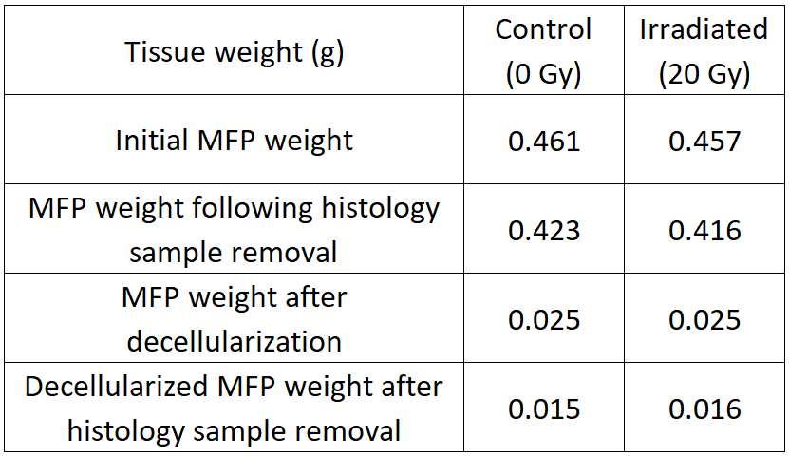
2. What is the advantage of the decellularization procedure in this study over the others in the literature employing SDS treatment? Could the authors compare their method to others? | We thank the reviewer for this comment. While SDS treatment and sodium deoxycholate treatments are comparable in removing cellular material, sodium deoxycholate has been shown to be more effective at removing DNA (Young, D.A. et al. Injectable hydrogel scaffold from decellularized human lipoaspirate. Acta Biomaterialia. 7 (3), 1040–1049, doi: 10.1016/j.actbio.2010.09.035 (2011)). This cited publication studies the effect of decellularization on human lipoasiprate, which is comparable to the adipose in murine mammary fat pads. We have added the following to the protocol for clarification:  “This procedure was adapted from previously published methods focused on adipose decellularization, which included the sodium deoxycholate ionic detergent rather than sodium dodecyl sulfate to remove DNA efficiently ^{12,16,17}.”
3. Do the authors have images with lower magnification to show an overall picture of the tissues after H&E and Oil Red O staining (Figure 2)? | We thank the reviewer for this suggestion. Sectioning adipose was technically challenging and resulted in few images at lower magnifications due to the inability of OCT to retain tissue morphology. Included here are images of H&E staining at 20x magnification as opposed to 64x shown in Figure 2, which demonstrates again the successful removal of cellular material following decellularization. We unfortunately cannot provide Oil Red O stained slides at lower magnifications due to the aforementioned technical difficulties. We would like to note that the staining shown in Figure 2 is confirmed by other previously published work, and we are confident that we observed de-lipidation: Brown BN et al. Tissue Engineering. Part C, Methods. 2011; 17(4): 411-421 and Choi YS et al. Biochem Biophys Res Commun. 2006; 345(2): 613-637 both show similar Oil Red O staining in adipose tissue.  H&E staining before decellularization (A) and after decellularization (B). Scale bars represent 100 μm.  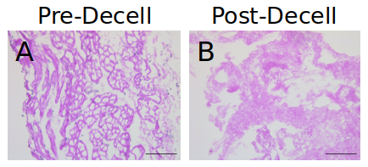
4. In Figure 4C, bioluminescence data show a significant difference between the cells embedded in hydrogels from radiation-treated and untreated matrices. How do the authors explain such a difference after only one dose of 20 Gy of radiation as compared to multiple doses of 40-50 Gy of radiation applied clinically for radiotherapy? In Figure 4A and B, GFP results also show higher staining in the irradiated gels. However, whether the cells in the control are alive or dead is not clear. Live/dead assay would be of importance to compare the cells in the control and irradiated samples. | We thank the reviewer for these questions. We have updated Figure 4 to include data from additional replicates of the proliferation experiment. In the clinic, patients are given approximately 50 Gy in 28 fractions post-mastectomy or 50 Gy with a 10 Gy boost following lumpectomy. We chose to irradiate to a single dose of 20 Gy as opposed to fractionated doses given the time constraints in our previous in vivo study that would influence overall tumor burden. It is well known that fractionating doses results in higher cell survival due to the possibility for repair of double-strand breaks in between fractions that is not possible when giving a single dose (see Hall EJ and Giaccia AJ. Radiobiology for the Radiologist. 2012, 7th edition). We therefore used a 20 Gy dose in a single fraction to ensure tissue damage.  After multiple experiments, our results continue to show an increasing trend toward higher proliferation using bioluminescence imaging. We have also added live/dead staining analysis in Figure 4 to evaluate whether interaction with ECM hydrogels altered cytotoxicity (see below). We found that there was a trend toward a higher live/dead ratio in the irradiated ECM hydrogels, indicating that the ECM hydrogels are not cytotoxic and that the irradiated ECM hydrogels may promote increased proliferation. We have added the following to the Discussion section to describe this finding:  “We observed an increasing trend in the proliferation of 4T1 cells within irradiated ECM hydrogels using both bioluminescence imaging and viability staining (Figure 4).”  Scale bars represent 200 μm.  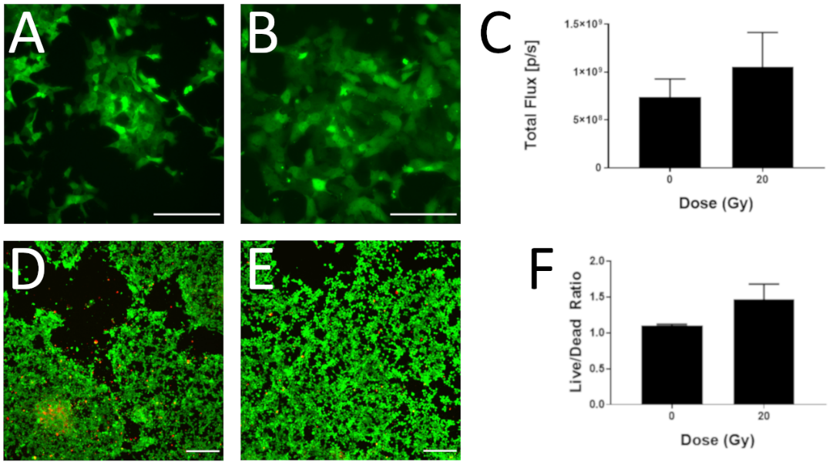
5. In Fig. 5, the image of the cells on the untreated control is missing. It would be more complete if the authors provide an image for the control. That would also show the cell number on the untreated control and support Fig. 4. | We thank the reviewer for this observation. We have updated Figure 5 to compare the cytoskeleton in cells grown in the control and irradiated ECM hydrogels (see below). We observed that cells grown on irradiated ECM exhibited enhanced actin alignment and tumor cell elongation, which may be indicative of enhanced tumor cell invasion. We have added the following in the Discussion section to describe this finding:  “In addition, we used phalloidin conjugate to stain F-actin filaments in encapsulated tumor cells and found a qualitative increase in actin alignment and tumor cell elongation in irradiated ECM hydrogels, which suggests an increase in adhesion strength and invasive capacity (Figure 5) (Mierke, C.T., Frey, B., Fellner, M., Herrmann, M., Fabry, B. Integrin 5 1 facilitates cancer cell invasion through enhanced contractile forces. Journal of Cell Science. 124 (3), 369–383, doi: 10.1242/jcs.071985 (2011).; Ahmadzadeh, H. et al. Modeling the two-way feedback between contractility and matrix realignment reveals a nonlinear mode of cancer cell invasion. Proceedings of the National Academy of Sciences. 114 (9), E1617–E1626, doi: 10.1073/pnas.1617037114 (2017).). Future experiments will explore changes in focal adhesion dynamics and protease-mediated remodeling for the evaluation of cell migration and invasion.”  Scale bars represent 100 μm.  