Author’s Response to the Review Comments
  - Journal: Journal of Visualized Experiments
  - Manuscript #: JoVE59297
  - Title of Paper:
Generation of 3D skin Organoid from Cord Blood-derived Induced Pluripotent Stem Cells
  - Authors: Yena Kim (First author); Ji Hyeon Ju (Corresponding author)
It is with excitement that we resubmit the revised version of the manuscript JoVE59297, “Generation of 3D skin from Cord Blood-derived from induced pluripotent stem cell” for Journal of Visualized Experiments. Thank you for the opportunity to revise and resubmit this manuscript. We addressed all issues and concerns indicated in the review report. We appreciate the time, the efforts and the constructive suggestions by the editor and referees in reviewing this manuscript.
We have responded specifically to each suggestion below. The changes were numbered to make it easier to identify where necessary.
The major changes suggested by the reviewers were highlighted in the manuscript.
Response to Comments from Editorial comments
Changes to be made by the author(s) regarding the manuscript:
1. Please take this opportunity to thoroughly proofread the manuscript to ensure that there are no spelling or grammar issues.
Answer) Thank you for your comment. We confirmed spelling and grammar issues using editing service.
2. Please revise lines 282-284 and 319-322 to avoid previously published text.
Answer) We edited this text.
3. Please provide an email address for each author.
Answer) We added the email address to manuscript. Yena Kim (First author, kyena0430@gmail.com), Ji Hyeon Ju (Corresponding author, juji@catholic.ac.kr).
4. Please revise the Summary to contain only complete sentences.
Answer) We revise summary to the complete sentences. We propose a protocol that differentiation of induced pluripotent stem cells (iPSC)-derivced keratinocytes and fibroblasts. And we generate the 3D skin organoid using the iPSC-derived keratinocytes and fibroblasts and propose a protocol that generation of humanized mice.
5. JoVE cannot publish manuscripts containing commercial language. This includes trademark symbols (™), registered symbols (®), and company names before an instrument or reagent. Please remove all commercial language from your manuscript and use generic terms instead. All commercial products should be sufficiently referenced in the Table of Materials and Reagents. You may use the generic term followed by “(see table of materials)” to draw the readers’ attention to specific commercial names. Examples of commercial sounding language in your manuscript are: Matrigel, Essential 8, Aggrewell, etc.
Answer) We replaced the matrigel to basement membrane matrix and edited the protocol and table of materials. Essential 8 medium was changed to iPSC medium and Aggrewell medium was replaced to EB formation medium. We revised the protocol and table of materials.
6. Since mice skin is used in the protocol, please include an ethics statement before your numbered protocol steps, indicating that the protocol follows the animal care guidelines of your institution.
Answer) We added ethics statement to the protocol of 2.2 skin graft. All procedures involving animals were performed in accordance with the Laboratory Animals Welfare Act, the Guide for the Care and Use of Laboratory Animals, and the Guidelines and Policies for Rodent Experimentation provided by the Institutional Animal Care and Use Committee of the School of Medicine of The Catholic University of Korea. The study protocol was approved by the Institutional Review Board of The Catholic University of Korea (CUMC-2018-0191-01). IACUC and Department of Laboratory Animal (DOLA) in Catholic University of Korea, Songeui Campus accredited the Korea Excellence Animal laboratory Facility from Korea Food and Drug Administration in 2017 and acquired AAALAC International full accreditation in 2018.
7. Please add more details to your protocol steps. There should be enough detail in each step to supplement the actions seen in the video so that viewers can easily replicate the protocol. Please ensure you answer the “how” question, i.e., how is the step performed? Alternatively, add references to published material specifying how to perform the protocol action. See examples below.
8. 1.1: Please list an approximate volume of medium to prepare.
Answer) All medium were prepared on the basis of 500 mL.
9. 1.2.3, 1.2.4: What volume of the solution is used to coat?
Answer) We used the 100 mm dish for differentiation. And the volume of coated solution for 100 mm is 5 mL. We edited the 1.2.
10. 1.3.1: Please describe the conditions for maintaining the iPSCs.
Answer) iPSCs were maintained to the vitronectin-coated dish and were changed the Essential 8 medium daily. We revised more details of the 1.3.1.
11. 1.3.2: When (after how many days) is the medium removed?
Answer) We changed the medium of iPSCs every day. Prepare iPSCs at 80% confluent, we detached the cells and formed the embryonic body.
12. 1.3.9: How to harvest the EBs?
Answer) We harvested the EBs using pipette with Essential 8 medium or PBS and washed out the lid of plate. We reflected your comment and edited the 1.3.9.
13. 1.4.1, 1.5.1: How to ensure they settle to the bottom? Is centrifugation done? If so, please specify centrifugation parameters.
Answer) We didn’t use the centrifugation just settled down in the 50 mL tube. We described more detail at the manuscript. Wash out the lid of plate using pipette with Essential 8 medium or PBS and harvest to 50 mL conical tube. Maintain at RT for 1 min to settle down the EBs.
14. 2.1.5: What are the incubation conditions?
Answer) We described more detail at the manuscript. We incubated the matrix at 37 ℃ with 5 % CO₂ for 5-7 days.
15. 2.1.6: Please specify how detachment is done.
Answer) We used to EDTA for detachment. We added 1 mL of EDTA and incubated at 37 ℃ with 5 % CO2 for 2 min. And we harvested the detached cells and counted the cells using a hemocytometer. We revised more detail of the 2.1.6.
16. 2.2.1: Please describe how this is done. Specify all surgical instruments used.
Answer) We removed the mice skin using the iris standard curved scissor with meriam forceps thumb. We added the surgical instruments to table of materials.
17. 2.2.3: What is observed? How are the mice sacrificed? Please provide more details about the histological analysis.
Answer) After 2 weeks, mice skin covered and healed by grafted skin. We sacrificed the mice at the grafted skin cover by the mice skin. Histological analysis protocol was We added the citation of previous study ¹.
18. Please reference Table 1 in the protocol.
Answer) We edited the table 1 and added the reference sequence ID.
19. Please combine some of the shorter Protocol steps so that individual steps contain 2-3 actions and maximum of 4 sentences per step.
Answer) Thank you for your comments. We reflected your comments and revised the manuscript.
20. Please include single-line spaces between all paragraphs, headings, steps, etc.
Answer) Thank you for your comments. We edited the manuscript form.
21. After you have made all the recommended changes to your protocol (listed above), please highlight 2.75 pages or less of the Protocol (including headings and spacing) that identifies the essential steps of the protocol for the video, i.e., the steps that should be visualized to tell the most cohesive story of the Protocol.
22. Please highlight complete sentences (not parts of sentences). Please ensure that the highlighted part of the step includes at least one action that is written in imperative tense. Please do not highlight any steps describing anesthetization and euthanasia.
23. Please include all relevant details that are required to perform the step in the highlighting. For example: If step 2.5 is highlighted for filming and the details of how to perform the step are given in steps 2.5.1 and 2.5.2, then the sub-steps where the details are provided must be highlighted.
21-23 Answer) Thank you for your comments. We highlighted to the protocol.
24. Please include an Acknowledgements section, containing any acknowledgments and all funding sources for this work.
25. Please include a Disclosures section, providing information regarding the authors’ competing financial interests or other conflicts of interest. If authors have no competing financial interests, then a statement indicating no competing financial interests must be included.
24-25 Answer) Thank you for your comment. We added the acknowledgements section and disclosure section to the manuscript.
26. References: Please do not abbreviate journal titles.
Answer) We used the EndNote style of JoVE for references. Please check the form of the references.
27. Please remove the embedded table from the manuscript.
Answer) We removed the embedded table from the manuscript. We added the table of separated file.
28. Table of Materials: Please sort the items in alphabetical order according to the name of material/equipment.
Answer) Thank you for your comment. We reordered the table of materials in alphabetical order according to the name of material/equipment.
Response to Comments from Reviewer 1
Reviewer #1
Manuscript Summary:
This is a well designed and meticulously performed protocol for for successful generation of 3D skin organoid from cord blood pluripotent stem cells. The protocol strongly support the feasibility of the application of this technique in certain clinical setting such as such as auto- or allogeneic skin graft or drug screening. The protocol described all the detailed procedures from cell and reagent preparation to differentiate fibroblasts and keratinocytes to 3D organoid culture and skin transplantation on to immune compromised mice. This manuscript is very well lined with recent publication of this group of investigators (stem cell research & therapy, 2018 (;217) and provided practical information for the readers who are interested in generation of 3D organoid skin.
Major Concerns:
No major concerns
Minor Concerns:
There are couple minor concerns on the figure calling out in the main text. All the results shown in the figures (including sub-panels) need to be appropriately called out in sequential order. Calling out Fig.1B, 2B, 2C and 3A in the main text is missing. Although cat numbers of the reagents are provided, their description is missing.
Answer) Thank you for your kindly comments. We reflected your comments and edited the manuscript. We reordered the table of materials in alphabetical order according to the name of material/equipment and added their description.

Response to Comments from Reviewer 2
Reviewer #2
Manuscript Summary:
The authors present a method by which human cord blood cell derived induced pluripotent stem cells (CBMC-iPSCs) can be used to generate skin organoids suitable for research and potentially clinical applications. Although the study may be of interest to researchers working on skin and iPSC-derived skin cells, the submitted protocol section is poorly written and will not be reproducible in its current form. The protocol section needs to be substantially expanded to include many missing details and citations to previously published protocols. The efficiency of differentiation protocols is also not shown. In addition to the lack of necessary details in the protocol, many statements in the manuscript are confusing.
Major Concerns:
1. The authors emphasize that cord blood mononuclear cells undergo HLA typing and therefore may be a great source of cells suitable for iPSC-generation and eventual allogeneic cell transplantation. While this statement may be correct in relation to the allogeneic transplantation of many iPSC-derived cells, such as hepatocytes, chondrocyte and cardiomyocytes, allogeneic skin transplantation fails in most cases regardless of how matched the donors and recipients are, and therefore is likely to fail if the skin cells are derived from allogeneic iPSCs. Thus, such a strong emphasis on HLA-matched CBMC-iPSCs as a new cell source for allogeneic skin transplantation is questionable (last paragraph of discussion in particular). I would recommend to focus on the technology as a research platform and mention autologous iPSCs if the authors would like to discuss potential clinical applications of their technology.
Answer) Thank you for your comment. In previous study, we observed the differentiation potential among human induced pluripotent stem cells from diverse origin primary cells ². No significant morphological difference was shown from diverse origin primary cells. However, CBMC-iPSCs differentiated with fair quality. Furthermore, CBMC-iPSCs have several advantages of cell banking systems, stored HLA-typing information and homozygous HLA type. Generation of cell lines from homozygous HLA-typed iPSCs obtained from CBMC-iPSC banks is a novel and efficient strategy for cell-based therapy. Patient-derived personalized iPSCs can overcome the limitations of primary cell sources and the problem of immune rejection. However, the production of such cells is time-consuming, expensive, laborious, and therefore not economically viable. HLA-homozygous iPSCs have been suggested as an alternative to solve this problem. Such cells are thought to be economically valuable because a small number of these cell lines can be applied to a large number of patients. HLA-homozygous CBMC-iPSCs might be used to very various patients. CBMC-iPSCs have been differentiated into cardiomyocytes, hepatocytes, and chondrocytes ^{3,4}. However, the differentiation of CBMC-iPSCs into skin cells has not been reported to our knowledge. So, we used HLA homozygous CBMC-iPSC to differentiation of keratinocytes and fibroblasts.
2. The discussion section does not address advantages and disadvantages of the presented method over available techniques. There is also no discussion about the limitation of the method and troubleshooting, which are expected with such a complex methodology.
Answer) Thank you for your sharp comments. In generally, most of skin transplantation experiment was done using single cells of fibroblast and keratinocyte by silicon bubble chamber ^{5,6}. This system is easy to transplant but it can be needed more time for transplantation efficiency. 3D skin organoid isn’t needed much time for transplantation efficiency. Also, 3D skin organoid is more similar to human skin compared to single cell system. In 3D skin model of iPSC-derived differentiation cell, we didn’t used plastic or silicon chamber. Using our protocol, it was efficient to confirm the healing ability of the 3D skin structure, however, the natural healing ability of mice skin was very fast and it was difficult to block the healing process of mice, which can be thought as a shortcoming of our study. When we transplanted iPSC-derived skin organoid (iSO) for 4 weeks, mice skin covered many parts of human iSO. It was difficult to observe the effect of the transplantation because the mice skin covered the human skin even after 4 weeks of transplantation (arrows and dotted lines in following figure). So, we changed the transplantation protocol for skin graft. But skin graft model should be available to long term transplantation. This point is a part that must be improved in our experiments. Therefore, an optimized protocol to generate an iSO that is more similar to real human skin might be helpful. In addition, the iSO must be observed for a longer duration to further analyze its fate. We reflected of your kindly comments and revised the discussion section.
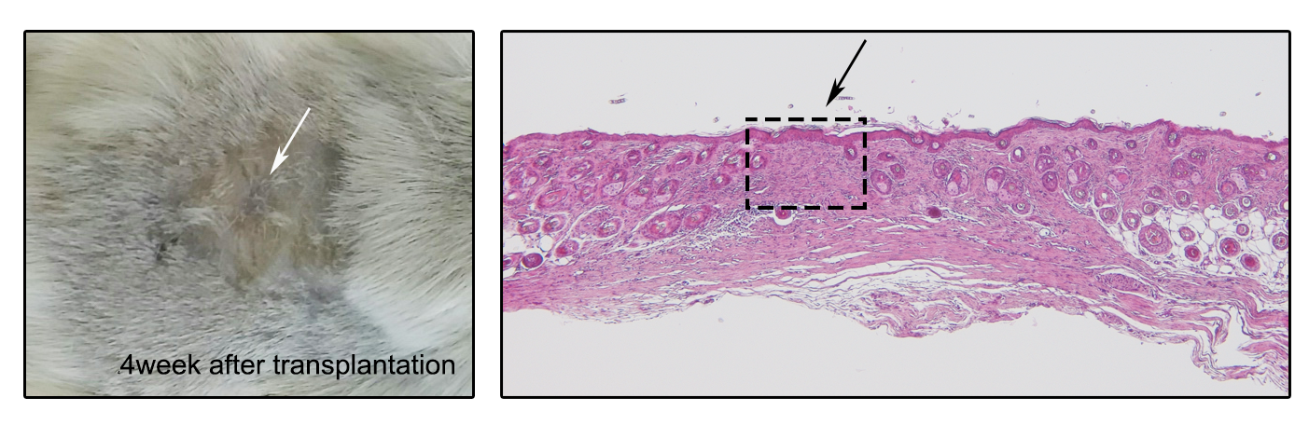
Figure 1. Histological analysis after 4 week of transplantation
3. The result section does not show the efficiency of iPSC differentiation into fibroblasts and keratinocytes using the provided protocol. The description of Figure 3 is confusing (see below for details). In addition, the quality of epidermis formation in grafts/organoids cannot be assessed due to low magnification of images and poor staining quality. If better quality staining and images are not provided, I will not be convinced that the protocol results in the formation of a normal epidermis.
Answer) Thank you for your kindly comment. We performed the additional staining and changed the resolution of figures.
4. There are many protocols that have been published on the differentiation of iPSCs into keratinocytes and fibroblasts with the subsequent generation of 3D skin equivalents. These protocols have not been cited or discussed although the procedures described in this manuscript are in many ways similar to those previous reports. For example, the following publications may need to be cited: 1. Itoh et al, PLOS One, 2013; Generation of 3D skin equivalents fully reconstituted from human induced pluripotent stem cells (iPSCs); 2. Itoh at al, PNAS 2011; Generation of keratinocytes-induced pluripotent stem cells. Instead, the authors are trying to make an emphasis on the benefits of CBMC-iPSCs, which are probably not applicable for allogeneic skin transplantation (see Concern #1).
Answer) Thank you for your generous comments. We cited this report and edited the discussion section based on your comments.
5. Another major point is that the protocol lacks details and therefore will be hard to reproduce. Below, I indicated some major deficiencies of the protocol.
Thank you for your kindly comments, we revised the manuscript base on your comments.
1.1. Medium preparation:
line 77: How long the medium can be stored at +4C?
Answer) We used all medium within 3 month.
lines 76-95: Not all reagents and supplies are listed in the tables of materials: NAA, L-asc acid, Insulin, Adenine, L-glut, Transferrin, CaCl2 as well as surgery supplies. What is the size of an insert that is recommended for cell numbers described in the protocol?
Answer) We edited the tables of materials. We reordered the table of materials in alphabetical order according to the name of material/equipment and added all reagent and supplies. We used 6well size of transwell for formation of 3D skin organoid. The insert size of 6well-transwell is 24 mm of diameter and 4.67 cm² of growth area. This size is appropriated unit to cover the mice skin defects.

1.2 Coating of culture dishes:
The section is not clear since the number of TC plates, size of the plates and volumes of coating reagents per surface area are not indicated. lines 101-103: Matrigel comes at different concentrations depending on the lot. Therefore, the dilution factor is not clear. lines 102: Do you use F12 or DMEM/F12 for matrigel dilution?
It is also not clear whether coatings are allowed to dry or not and how critical is that if the coating dries out.
Answer) We added the catalog number of dish to table of material and reagent. We used the 100 mm dish for differentiation. And the volume of coated solution for 100 mm is 5 mL. We diluted the matrigel to the DMEM/F12 medium and aspirate the coating material before use. Stock concentration of matrigel is 5 μg/mL and final concentration of matrigel is 600 ng/mL.
1.3 EB generation:
line 115: Low O2 or regular incubator for iPSC maintenance? What TC dish size to use for the maintenance of iPSCs to ensure sufficient numbers of starting cells for the protocol? What is the confluency of iPSCs?
Answer) We used the 100 mm dish for maintenance of iPSC. We maintained the cells at 80% confluent at 10% CO₂ before differentiation. We obtained more than 1 x 10⁷ cells that detached in 100 mm dish. It is sufficient numbers of starting to EB formation.
line 117: "Add 1 ml of EDTA" into what well/tc plate size? One well of a 6 well plate? After 2 min of incubation, do you aspirate EDTA followed by adding complete E8 medium? Provide details. "3 ml of medium to harvest cells" from what size of a dish/well? Do you apply strainer to remove iPSCs clumps before centrifugation?
Answer) We used the 100 mm dish for maintenance of iPSC. We added 1 mL of EDTA to 100 mm dish and detached cell were harvested using the 3 mL of Essential 8 medium. By treating EDTA, iPSC colonies were dissociated. So, we didn’t use the strainer for remove iPSCs clumps.
line 124: No description of how to generate hanging drops. Details have to be provided, such as what pipette to use, how to apply the drops, whether to apply PBS on the bottom of the dish with drops, how to invert the lid, etc. If the Aggrewell Kit is used, and not just medium, then it needs to be indicated.
Answer) We used the multi-channel pipette to generate hanging drops at the lid of 100 mm dish then turn over the dish. We used just aggrewell medium, didn’t use the aggrewell plate.
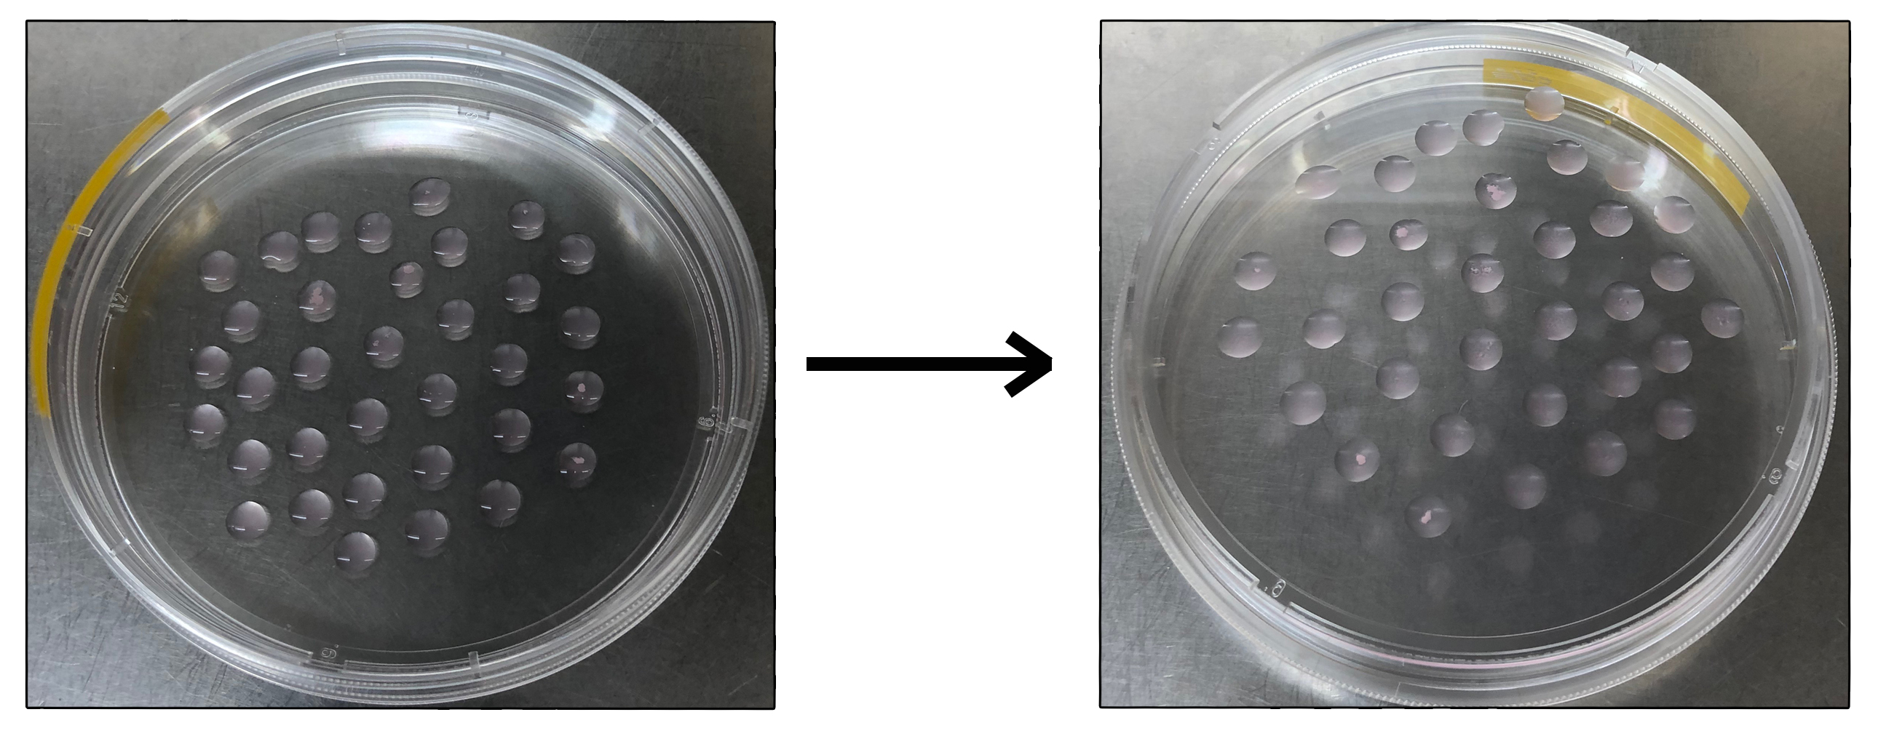
Figure 2. Hanging drop method
line 126: How to harvest EBs? What medium to use and what pipette? How many total EBs are needed to obtain sufficient numbers of iPSC-fibroblasts and keratinocytes for a single organoid? No details are provided.
Answer) We harvested the EBs using pipette with Essential 8 medium or PBS and washed out the lid of plate. We formed the 100 EBs from 1 x 10⁶ cells (1 x 10⁴ cells / 1 EB) for keratinocyte and fibroblast differentiation.

1.4 Fibroblast differentiation:
line 128: The schematic in Fig 2A does not show the EB formation stage.
Answer) We edited the figure 2A and added EB formation stage at the schematic.
line 129: How many EBs do you need to plate to obtain how many fibroblasts?
Answer) We formed the 100 EBs from 1 x 10⁶ cells (1 x 10⁴ cells / 1 EB) and transferred about 100 EBs to the 100 mm dish for keratinocyte and fibroblast differentiation.
line 133: What is the size of a dish to use for plating in 6 ml? How many EBs per surface area to plate?
Answer) We transferred the 100 EBs to 100 mm dish for keratinocyte and fibroblast differentiation.
line 134: Do EBs attach by the next day? To change or not to change medium during these 3 days? Do you keep cell cultures with ROCK inhibitor for the duration of 3 days?
Answer) We changed the medium every other day. We only added the ROCK inhibitor at EB attachment stage. We added this information to the protocol section.
line 135: More details are required:
- do you change medium after 3 days of incubation before adding cytokines? how to prepare FDM1+BMP4? Do you keep ROCK in the medium?
Answer) For 3 days after attachment EBs, we didn’t add any cytokines. We changed the FDM1 every other day. After 3 days, 0.5 nM BMP4 was added at the FDM1 medium. ROCK inhibitor is need at the stage of attachment in the differentiation process. So, we only added the ROCK inhibitor at EB attachment stage.
lines 137-139: No details are provided:
- It is absolutely unclear what you mean by "transfer attached EBs to.."? Do you detach them first? How? What is the detaching agent, temperature, time?
Answer) We detached the attached EBs using EDTA at 37 ℃ with 5% CO₂ for 2 min and transferred to the new dish. We described more detail at 1.5.6-1.5.8 of the manuscript.
- How many iPSC-derived fibroblasts per surface area do you get in each step between D 14 and 28. Show efficiency. How frequently do you change media?
Answer) We obtained about 1 x 10⁷ cells per each 100 mm dish. We subcultured the 2 x 10⁶ cells to new dish. We changed the medium every other day.
- Do you passage cells after day 28? If so, how? How long can you keep the cells in culture to be used for 3D skin formation?
Answer) iPSC-derived fibroblasts was proliferate like primary fibroblast and was passage up to 10 passages. We used iPSC-derived fibroblast of 2-5 passage for 3D skin formation.
- Show the changes of iPSCs morphology during differentiation into fibroblasts and indicate the efficiency of differentiation.
Answer) During differentiation, iPSCs were changed the morphology into fibroblast (Figure 3). In previous study, we performed flow cytometric analysis in CBMC iPSC-derived fibroblast of hematopoietic markers and fibroblast surface markers for characterization of iPSC-derived fibroblasts ¹. Figure showed that hematopoietic markers of CD34 and CD45 were downregualted in iPSC, also fibroblast markers of CD73 and CD105 were downregualted in iPSC. After differentiation, expression of CD34 and CD45 was also still downregualted in iPSC-F. However, expression of CD73 and CD105 was increased in iPSC-F and it was similar to primary fibroblasts (Figure 4). Flow cytometry assay confirmed that iPSCs were differentiated to fibroblasts and efficiency of differentiation.
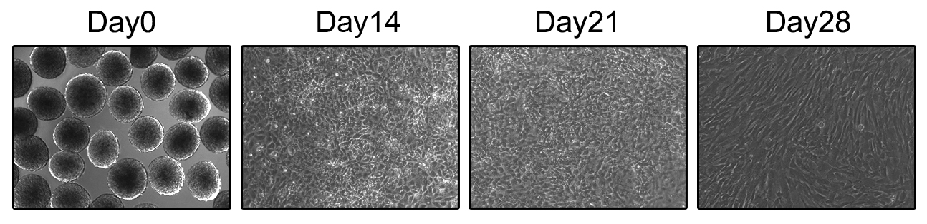
Figure 3. Fibroblast morphology during differentiation
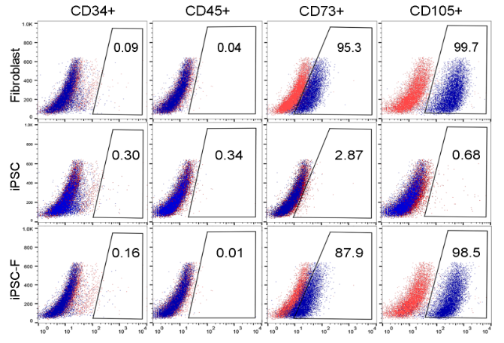
Figure 4. Flow cytometric analysis of iPSC-derived fibroblast.
- How many plates do you need in order to get a sufficient number of fibroblasts for one skin graft/organoid?
Answer) For one skin graft, we need just one 3D skin organoid. And for one 3D skin organoid, we need 2 x 10⁵ fibroblasts and 1 x 10⁶ keratinocytes. 3D skin organoid was formed using 6 well transwell plate.
- What is the best day after D28 to harvest iPSC-Fibroblasts for 3D? How exactly to harvest iPSC-Fibroblasts for 3D?
Answer) iPSC-derived fibroblast might be used like primary fibroblast. We used iPSC-derived fibroblast of 2-5 passage for 3D skin formation. We used to EDTA for detachment for harvest iPSC-fibroblasts. We added 1 mL of EDTA and incubated at 37 ℃ with 5 % CO2 for 2 min. And we harvested the detached cells and counted the cells for formation of 3D skin organoid.

1.5 Keratinocyte differentiation:
line 141: Your schematic in Fig. 1A does not match the protocol. The schematic shows Aggrewell medium + BMP4 for the EB formation stage. Your protocol does not say to use BMP4 during EB formation stage with Aggrewell medium.
Answer) We treated the BMP4 with Essential 8 medium after EB formation. We edited the Figure 1A and protocol.
line 142: How many EBs do you need to plate to get how many keratinocytes?
Answer) We formed the 100 EBs from 1 x 10⁶ cells (1 x 10⁴ cells / 1 EB) and transferred about 100 EBs to the 100 mm dish for keratinocyte differentiation. After differentiation, we obtained about 1-2 x 10⁷ iPSC-derived keratinocytes.
line 145: What size of dishes to use. How long to culture EBs in KDM1+ROCK inhibitor before D0?
Answer) For differentiation, we used 100 mm dish and only added the ROCK inhibitor at EB attachment stage.
line 147: How to change medium during 8 days?
Answer) We changed all medium every other day during 8 days.
line 149: How to change medium between D9 and 13 and after D13?
Answer) We changed all medium every other day between day 9 and day 13 and after day 13.
line 151: More details are needed:
- What does 30+ in the schematic mean (Fig. 1A)?
Answer) iPSC-derived keratinocytes can be used like primary keratinocyte cell lines. iPSC-derived keratinocytes was proliferate like primary keratinocytes and was passage at type IV collagen coated dish. iPSC-K was survived over 30 days.
- What is the longest period of time you keep dishes with iPSC-Keratinocytes after D13 in KDM3 with 10ng/ml BMP4 and 20 ng/ml EGF? Do you passage iPSC-Keratinocytes during this time?
Answer) We passaged the iPSC-derived keratinocytes at day 21 at type IV collagen coated dish with KDM3 medium.
- When is the best day to harvest cells for 3D?
Answer) We used to 2-4 passage of iPSC-Fibroblast and day 21 of iPSC-Keratinocytes.
- How to harvest iPSC-Keratinocytes for 3D organoids? The authors mentioned in line 165 that it has to be EDTA, but didn't describe the procedure.
Answer) We used the EDTA to harvest iPSC-keratinocyte for 3D organoid. We revised the manuscript more detail of 2.1.6.
- Do you somehow purify iPSC-derived keratinocytes at Day 30+? What is the efficiency of differentiation? The efficiency is usually not 100% (under 50% in most cases) unless you do a specific enrichment, which I do not see in the protocol. If the provided protocol gives an ultra-high efficiency of differentiation, the results have to be demonstrated.
Answer) In previous study, we performed flow cytometric analysis in CBMC iPSC-derived keratinocytes of keratinocyte markers for characterization of keratinocytes. When compared to primary keratinocytes and iPSC-derived keratinocytes, 97.1% of cells in primary cell line were expressed the keratin 14 and 85.4% of cells were expressed in iPSC-derived keratinocytes (Figure 5). Flow cytometry assay confirmed that iPSCs were differentiated to keratinocytes.
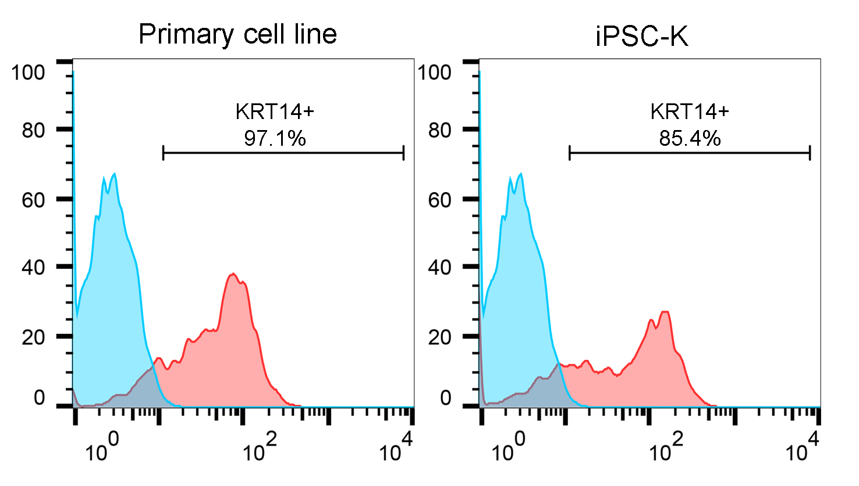
Figure 5.Flow cytometric analysis of primary keratinocytes and iPSC-derived keratinocytes.
- How many plates do you need in order to get a sufficient number of keratinocytes for one skin graft/organoid?
Answer) For one skin graft/organoid, we need 1 x 10⁶ keratinocytes. After differentiation at one 100 mm dish, we obtained about 1-2 x 10⁷ iPSC-derived keratinocytes.
- Show how the phenotype of iPSCs changes during differentiation into keratinocytes.
Answer) During differentiation, iPSCs were changed the morphology into keratinocyte (Figure 6).
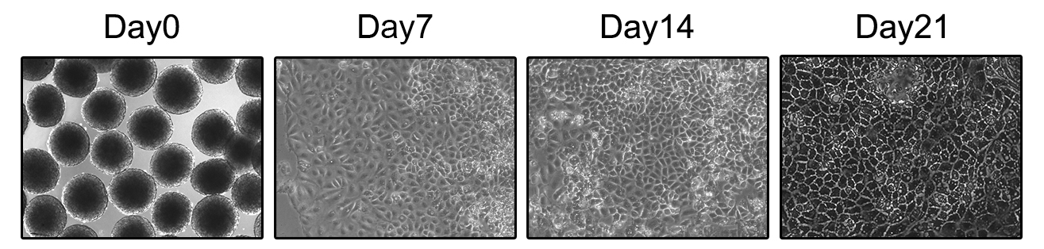
Figure 6. Morphology of iPSC-derived keratinocytes

2.1 3D skin organoid:
line 156: What is the final concentration of collagen I (mg/ml, stiffness)? Describe briefly how to mix collagen with neutralization solution and other components (medium, serum and other if applicable). What is neutralizing solution? Is it provided as a kit with Collagen I or does it need to be prepared in the lab? If latter, describe preparation and storage conditions.
Answer) Final concentration of type I collagen is 3 mg/mL. We followed the manufacturer’s recommendations for neutralizing. Add the tube following volume of 10X PBS (Final volume/10 = Volume of 10X PBS). Calculate the volume of type I collagen to be used (Final volume x Final collagen concentration /Stock collagen concentration = Volume of collagen to be added). Add to the 10X PBS the following volume of 1N NaOH (Volume of collagen to be added x 0.023 mL = Volume of 1N NaOH). Add to the 10X PBS with 1N NaOH the following volume of dH2O (Final volume-Volume of collagen- Volume of 10X PBS- Volume of 1N NaOH = Volume of dH2O to be add). Mix the contents of tube and hold in ice until ready to use. We revised more detail of the 2.1.1.
line 160: Indicate the size of the insert and plates to accommodate the described cell numbers.
Answer) We used the 6 well size of transwell plate for generation of 3D skin organoids. And the size of insert is 24 mm of diameter and 4.67 cm² of growth area.
line 164: What is the sign of "completion" of gelation? How to decide which day (5,6 or 7) is the best to continue the formation of 3D skins. Show a representative image in the result section.
Answer) The iPSC-derived fibroblast and collagen mixture is contract at the first. The meaning of completion is to keep it until it does not contract.
line 173: What is cornification medium? Is it EP3? Not clear.
Answer) Epithelial medium 3 is induced cornification and that means cornification medium. We revised the protocol.
line 175: How frequently to change medium during these 14 days?
Answer) We maintained the 3D skin organoid for up to 14 days and changed the medium every other day.
2.2 Skin graft:
The procedure will not be reproducible the way it is described here:
- What type of anesthesia to use?
Answer) We used the inhalation anesthesia for skin graft surgery using Surge-vet anesthesia machine.
- Any mouse preparatory steps?
Answer) We used the NOD/SCID mice (male, 6 weeks old, Jackson Laboratories).
- Is the protocol approved by IACUC?
Answer) We added ethics statement to the protocol of 2.2 skin graft. All procedures involving animals were performed in accordance with the Laboratory Animals Welfare Act, the Guide for the Care and Use of Laboratory Animals, and the Guidelines and Policies for Rodent Experimentation provided by the Institutional Animal Care and Use Committee of the School of Medicine of The Catholic University of Korea. The study protocol was approved by the Institutional Review Board of The Catholic University of Korea (CUMC-2018-0191-01). IACUC and Department of Laboratory Animal (DOLA) in Catholic University of Korea, Songeui Campus accredited the Korea Excellence Animal laboratory Facility from Korea Food and Drug Administration in 2017 and acquired AAALAC International full accreditation in 2018.
- What surgical instruments and bandages to use?
Answer) We added information of the surgical instruments and bandages. We used iris standard curved scissor with forceps and BAND-AID FLEXIBLE FABRIC Band.
- How to collect the 3D skin organoid from the insert? Do you use any enzymatic treatment?
Answer) 3D skin organoid can be easily harvested by using the transwell plate. By cutting the edge (Figure 7, White dotted line) of insert makes it easy to get the 3D skin organoid. After cutting, we used this 3D skin organoid for skin graft and histological analysis.
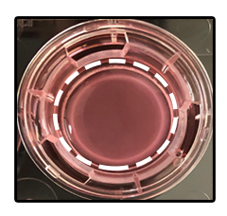
Figure 7. Morphology of 3D skin organoid
- How to suture the organoid to prevent its rupture. Provide a link to other protocol papers if available or give detailed description of the surgery.
Answer) We used tie-over dressing method for skin graft. This original technique was first described in 1929 by Blair and Brown and has been commonly used for skin graft ^{7,8}. This method prevented the graft from moving, favored a good adhesion to the wound and thus accelerated tissue healing.
Results
line 191: The pictures quality is low. Increase resolution.
Answer) We changed all resolution of images.
line 200: Medium change conditions are not described in the protocol (see comments above) and only mentioned in the result section. Modify the protocol section to include appropriate media changes steps.
Answer) We edited the protocol about medium change condition.
line 211: What exactly is a Transwell plate? Is it an insert for the organoid formation? Not clear.
Answer) We used the 6 well size of transwell plate (CORNING) for generation of 3D skin organoids (Figure 8). Transwell plate is used for permeable support systems that closely mimic the in vivo environments. 24 mm Transwell insert being placed into a 6 well microplate. After formation of 3D skin, take out the insert and use it for graft or histological analysis.
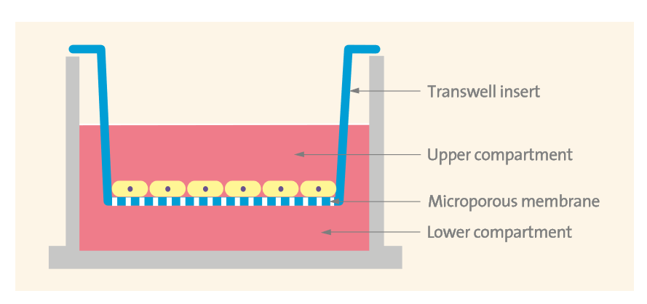
Figure 8. Schematic diagram of transwell plate provided by the manufacturer.
lines 217-218: The statement is not clear and very confusing:
- Are you talking about thickness of epidermis, dermis or both?
Answer) Thickness was measured from bottom of dermis to epidermis of the skin by image J program (Figure 9, Black arrow).
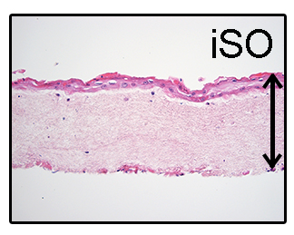
Figure 9. Histological analysis of 3D skin organoid
- Increase by how much? (~ mm)?
Answer) 3D skin organoid grows up to 300 μm for 14 days.
- What exactly are you comparing to? Fig. 3C to what? What is a human skin organoid? How is it different from a 3D skin organoid? What do you mean by saying that "a 3D skin organoid is similar to a human skin organoid in Fig 3C"?
Answer) In previous our study, we compared to primary cell line-derived 3D skin and CBMC iPSC-derived 3D skin . CBMC iPSC-derived 3D skin organoid was similar to primary cell line-derived 3D skin organoid (Figure 10).
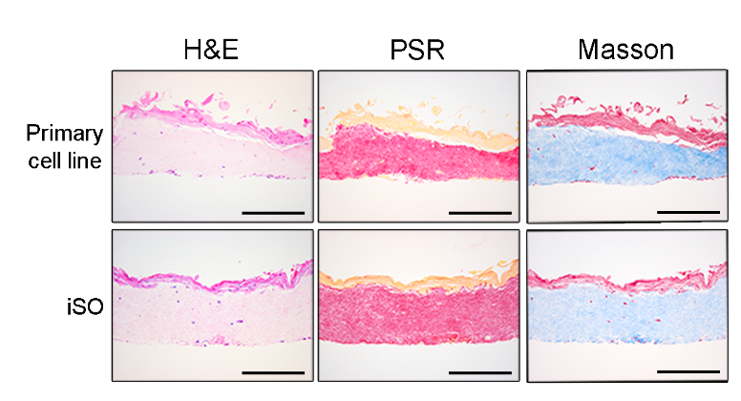
Figure 10. Histological analysis of primary cell line and iPSCderived 3D skin organoid.
- When do you measure thickness (before iPSC-Keratinocytes are added, during stratification or at the end, after 14 days of airlifting)?
Answer) 3D skin was harvested after 10-14 days that iPSC-keratinocytes were seeded. After harvest the 3D skin, we stained the skin and measured the thickness using image J program.
Figure 3:
- K14 staining looks too superficial. Increase magnification of the images, so that multiple epidermal layers are visualized with the appropriate staining pattern. Otherwise, I'm not convinced that the protocol results in the formation of a normal epidermis.
Answer) We performed the additional staining and changed the resolution of figure. After transplantation, the skin organoids were efficiently grafted and healed the mice skin adequately. Loricrin is a main component of the stratum corneum that found in terminally differentiated and keratinized epithelial cells. Keratin 14 was expressed in the basal layer of stratifying squamous and non-sequamous epithelia. Epidermal differentiation marker of loricrin was expressed in transplated skin and basal layer marker of KRT14 was expressed in transplanted skin. Expression of KRT14 and loricrin confirmed that the skin organoid was fully mature, and differentiation was demonstrated by immunohistochemical staining.
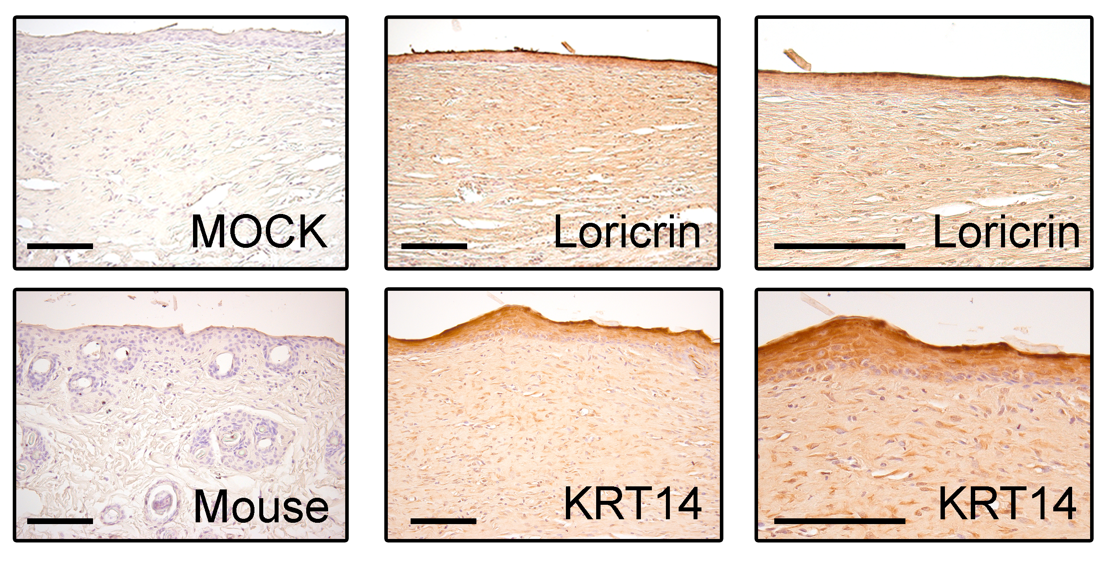
Figure 11. Immunocytochemical analysis of Loricrin and KRT14.
Minor Concerns:
1. I am not sure why the authors made such a big emphasis on CBMC-iPSC when it is very likely, that the provided protocol will also work for iPSC generated from other cell types. If not, the authors need to indicate this and explain the difference in the performance of different iPSCs.
Answer) Thank you for your comments. In previous study, we observed the differentiation potential among human induced pluripotent stem cells from diverse origin primary cells ². No significant morphological difference was shown from diverse origin primary cells. However, CBMC-iPSCs differentiated with fair quality. Furthermore, CBMC-iPSCs have several advantages of cell banking systems, stored HLA-typing information and homozygous HLA type. Generation of cell lines from homozygous HLA-typed iPSCs obtained from CBMC-iPSC banks is a novel and efficient strategy for cell-based therapy. The generation of personalized human iPSCs has opened up new possibilities for personalized regenerative medicine. Patient-derived personalized iPSCs can overcome the limitations of primary cell sources and the problem of immune rejection. However, the production of such cells is time-consuming, expensive, laborious, and therefore not economically viable. HLA-homozygous iPSCs have been suggested as an alternative to solve this problem. Such cells are thought to be economically valuable because a small number of these cell lines can be applied to a large number of patients. HLA-homozygous CBMC-iPSCs might be used to very various patients. CBMC-iPSCs have been differentiated into cardiomyocytes, hepatocytes, and chondrocytes ^{3,4}. However, the differentiation of CBMC-iPSCs into skin cells has not been reported to our knowledge. So, we used HLA homozygous CBMC-iPSC to differentiation of keratinocytes and fibroblasts.
2. Change the order of figures in the result section showing fibroblast differentiation protocol (Figure 2) first as Figure 1 to be consistent with the logistics of sub-protocols in the text.
Answer) Thank you for your kindly comment. We reflected your comments and edited the order of protocol.
3. Refer to schematics presented in Fig. 1A and Fig. 2A in the appropriate section of the protocol and not just in the result section.
Answer) Thank you for your comment. We reflected your comments and edited the order of protocol.
4. Figure 3:
- Mark dermis and epidermis in Fig. 3D. It seems like your H&E stains dark a part of the dermis, which is confusing.
- Given how thin your epidermis is, it may be useful to show a staining for an additional marker of epidermal differentiation, like K10, and a marker of a basement membrane, like collagen and/or laminin.
- Why is the mouse skin section looks rectangular in Fig. 3B if the 3D skin organoid has a round- shape from the insert. Is any cutting involved? Describe the procedure in details ( see major concerns above).
- If you show loricrin and K14 staining on separate sections, ensure that sections are consecutive.
5. In 2.2.3 (line 181), it may be useful to give a brief description of how to collect a graft for analysis and how to fix it or provide an appropriate citation.
4-5 Answer) Thank you for your sharp comments. After transplantation, the skin organoids were efficiently grafted and healed the mice skin adequately. Loricrin is a main component of the stratum corneum that found in terminally differentiated and keratinized epithelial cells. Keratin 14 was expressed in the basal layer of stratifying squamous and non-sequamous epithelia. Epidermal differentiation marker of loricrin was expressed in transplanted skin and basal layer marker of KRT14 was expressed in transplanted skin. Expression of KRT14 and loricrin confirmed that the skin organoid was fully mature, and differentiation was demonstrated by immunohistochemical staining. The staining protocol was verified in previous studies.

Response to Comments from Reviewer 3
Reviewer #3
Manuscript Summary: This manuscript describes methods for making epidermal keratinocytes and fibroblasts from human induced pluripotent stem cells.
Concerns:
Although novelty is not a criteria for publication, it does appear that this work is a collection of methods previously established in other labs. In addition there are several points that need to be clarified:
1.It's unclear what benefit deriving iPSC from cord blood has.
Answer) Thank you for your sharp comment. In previous study, we observed the differentiation potential among human induced pluripotent stem cells from diverse origin primary cells ². No significant morphological difference was shown from diverse origin primary cells. However, CBMC-iPSCs differentiated with fair quality. Furthermore, CBMC-iPSCs have several advantages of cell banking systems, stored HLA-typing information and homozygous HLA type. Generation of cell lines from homozygous HLA-typed iPSCs obtained from CBMC-iPSC banks is a novel and efficient strategy for cell-based therapy. The generation of personalized human iPSCs has opened up new possibilities for personalized regenerative medicine. Patient-derived personalized iPSCs can overcome the limitations of primary cell sources and the problem of immune rejection. However, the production of such cells is time-consuming, expensive, laborious, and therefore not economically viable. HLA-homozygous iPSCs have been suggested as an alternative to solve this problem. Such cells are thought to be economically valuable because a small number of these cell lines can be applied to a large number of patients. HLA-homozygous CBMC-iPSCs might be used to very various patients. CBMC-iPSCs have been differentiated into cardiomyocytes, hepatocytes, and chondrocytes ^{3,4}. However, the differentiation of CBMC-iPSCs into skin cells has not been reported to our knowledge. So, we used HLA homozygous CBMC-iPSC to differentiation of keratinocytes and fibroblasts.
2. It's unclear why EBs are used rather than an entirely monolayer culture.
Answer) Thank you for your comment. EB-derived differentiation method is better than monolayer culture about differentiation efficient.
3. Terminology issue: This does not appear to be an "organoid" system. The transwell culture has been discribe in the literature for many years as an organotypic culture or a 3D skin equivalent culture. Organoid is typically used to refer to floating cell aggregates that form a cyst-like shape. Please changes the terminology.
Answer) Thank you for your kindly comment. Define an organoid as containing several cell types that develop from stem cell or organ progenitors ⁹. Organoid is a 3D multicellular in vitro tissue construct that mimics its corresponding in vivo organ, such that it can be used to study aspects of that organ in the culture dish. We generated the 3D skin using iPSC-derived keratinocytes and fibroblasts and that skin mimics its corresponding in vivo skin. For this reason, we used the terminology of 3D skin organoid.
4. 1.3.7. EB formation; using aggrewell medium to hang the cells on the plate lid (hanging drop method) doesn't make sense - probably it had to be cultured in aggrewell medium on aggrewells, and hang each EB on the lid in a matrix?
Answer) Thank you for your comment. We used just aggrewell medium, didn’t use the aggrewell plate. We used the multi-channel pipette to generate hanging drops at the lid of 100 mm dish then turn over the dish. We revised the protocol.
Figure 1. Hanging drop method
5. 2.2.2. Skin graft - how were the skin layers taken out from the transwell insert? Can the layers pop out? Can the skin layer be sutured without any scaffold (e.g. integra/silicon)?
Answer) Thank you for your kindly comment. 3D skin organoid can be easily harvested by using the transwell plate. By cutting the edge (Figure 2, White dotted line) of insert makes it easy to get the 3D skin organoid. After cutting, we used this 3D skin organoid for skin graft and histological analysis. In generally, most of skin transplantation experiment was done using single cells of fibroblast and keratinocyte by silicon bubble chamber. This system is easy to transplant but it can be needed more time for transplantation efficiency. 3D skin organoid isn’t needed much time for transplantation efficiency. Also, 3D skin organoid is more similar to human skin compared to single cell system. In 3D skin model of iPSC-derived differentiation cell, we didn’t used plastic or silicon chamber. Using our protocol, it was efficient to confirm the healing ability of the 3D skin structure, however, the natural healing ability of mice skin was very fast and it was difficult to block the healing process of mice, which can be thought as a shortcoming of our study. When we transplanted iPSC-derived skin organoid (iSO) for 4 weeks, mice skin covered many parts of human iSO. It was difficult to observe the effect of the transplantation because the mice skin covered the human skin even after 4 weeks of transplantation (Figure 3, black arrows and dotted lines in following figure). So, we changed the transplantation protocol for skin graft. But skin graft model should be available to long term transplantation. This point is a part that must be improved in our experiments. Therefore, an optimized protocol to generate an iSO that is more similar to real human skin might be helpful. In addition, the iSO must be observed for a longer duration to further analyze its fate. We reflected of your kindly comments and revised the discussion section.
Figure 2. Morphology of 3D skin organoid
Figure 3. Histological analysis after 4 week of transplantation
6. Figure 1D and 2D needs comparison images of primary keratinocytes (1D) and primary fibroblasts (2D) as they mention about them in the text several times
Answer) In previous study, we compared iPSC-derived keratinocytes and fibroblast with primary keratinocytes and fibroblasts. To generate iPSC-Fs, cell outgrowth from EBs was induced and then fibroblasts were differentiated. A scheme of the fibroblast differentiation protocol is shown in Figure 4a. EBs were transferred to Matrigel-coated dishes and then differentiated cells were passaged onto non-coated and type I collagen-coated dishes. CBMC iPSC-Fs had a similar morphology as 3T3 cells, an established fibroblast cell line, on day 30 (Fig. 4b). Gene expression of the pluripotency marker OCT4 was lower in iPSC-Fs than in iPSCs. CBMC iPSC-Fs expressed various markers of fibroblasts, including CD44, COL1A1, COL1A2, COL3A1, and vimentin (Fig. 4c). Fibronectin and vimentin are well-known markers used to characterize fibroblasts. Immunocytochemistry confirmed that expression of these proteins was increased in iPSC-Fs (Fig. 4d). Flowcytometric analysis showed that hematopoietic markers of CD34 and CD45 were less expressed in iPSC, also fibroblast markers of CD73 and CD105 were less expressed in iPSC. After differentiation, expression of CD34 and CD45 was also still less expressed in iPSC-F. However, expression of CD73 and CD105 was increased in iPSC-F and similar to primary fibroblast. These results confirmed that iPSCs were differentiated to fibroblast.
We also differentiated CBMC-derived iPSCs into keratinocytes, another representative skin cell type. Keratinocyte differentiation was performed via induction and maturation of keratinocytes. A scheme of the keratinocyte differentiation protocol is shown in Figure 5a. CBMC-derived iPSCs were treated with 1 μg/ml RA, 25 ng/ml BMP4, and 20 ng/ml EGF to generate keratinocytes. We generated EBs using the hanging drop method to ensure uniform and well-controlled differentiation. EBs were transferred to type IV collagen-coated dishes. iPSC-Ks expanded from EBs had a primary keratinocyte-like cobblestone morphology when cultured on type IV collagen-coated dishes (Fig. 5b). Expression of the pluripotency marker OCT4 and the neuroectoderm markers PAX6 and SOX1 was decreased in iPSC-Ks (Fig. 5c, d). These results indicate that iPSC-Ks lacked characteristics of iPSCs and did not differentiate along the neuroectoderm lineage. Gene expression of the keratinocyte markers Np63, KRT5, and KRT14 was increased in iPSC-Ks at day 21 (Fig. 5e). These results demonstrated that iPSC-Ks were similar to primary keratinocytes in terms of their gene expression and morphology.
Figure 4. Differentiation of CBMC iPSC-derived fibroblasts
Figure 5. Differentiation of CBMC iPSC-derived keratinocytes

7. All the expression level graphs would ideally contain positive controls? The current results are unconvincing. A better approach would be to quantify the percentage of cells expressing keratinocyte or fibroblast markers.
Answer) In previous study, we performed flow cytometric analysis in CBMC iPSC-derived fibroblast of hematopoietic markers and fibroblast surface markers for characterization of iPSC-derived fibroblasts. Figure 6 showed that hematopoietic markers of CD34 and CD45 were downregualted in iPSC, also fibroblast markers of CD73 and CD105 were downregualted in iPSC. After differentiation, expression of CD34 and CD45 was also still downregualted in iPSC-F. However, expression of CD73 and CD105 was increased in iPSC-F and it was similar to primary fibroblasts. Flow cytometry assay confirmed that iPSCs were differentiated to fibroblasts. Also, we performed flow cytometric analysis in CBMC iPSC-derived keratinocytes of keratinocyte markers for characterization of keratinocytes (Figure 7). When compared to primary keratinocytes and iPSC-derived keratinocytes, 97.1% of cells in primary cell line were expressed the keratin 14 and 85.4% of cells were expressed in iPSC-derived keratinocytes. Flow cytometry assay confirmed that iPSCs were differentiated to keratinocytes.
Figure 6. Flow cytometric analysis of iPSC-derived fibroblast.
Figure 7. Flow cytometric analysis of iPSC-derived keratinocytes.

8. What is Figure 3C and D staining? H&E?; didn't mention.
Answer) Figure 3C and D is H&E staining. We edited the protocol and result section. The staining protocol was verified in previous studies.
9. Figure 3C needs comparison images with human skin layers - the IHC is not convincing that 1. the region we are looking at is a real graft area (needs human specific marker proving the grafted area), and 2. both Loricrin and KRT14 staining are not convincing; they all look as if the antibodies were absorbed on the cornified layer or an outermost edge (even H&E?! staining is darker in that layer in Figure 3C and D) - needs to show all the skin layer markers starting from the basal to the cornified layer.
Answer) In previous our study, we compared to primary cell line-derived 3D skin and CBMC iPSC-derived 3D skin. CBMC iPSC-derived 3D skin organoid was similar to primary cell line-derived 3D skin organoid (Figure 8). We performed the additional staining and changed the resolution of figure. After transplantation, the skin organoids were efficiently grafted and healed the mice skin adequately. Loricrin is a main component of the stratum corneum that found in terminally differentiated and keratinized epithelial cells. Keratin 14 was expressed in the basal layer of stratifying squamous and non-sequamous epithelia. Epidermal differentiation marker of loricrin was expressed in transplanted skin and basal layer marker of KRT14 was expressed in transplanted skin (Figure 9). Expression of KRT14 and loricrin confirmed that the skin organoid was fully mature, and differentiation was demonstrated by immunohistochemical staining.

Figure 8. Histological analysis of primary cell line and iPSCderived 3D skin organoid.
Figure 9. Immunocytochemical analysis of Loricrin and KRT14.
References
1 Kim, Y. et al. Establishment of a complex skin structure via layered co-culture of keratinocytes and fibroblasts derived from induced pluripotent stem cells. Stem Cell Res Ther. 9 (1), 217, (2018).
2 Rim, Y. A. et al. Different Chondrogenic Potential among Human Induced Pluripotent Stem Cells from Diverse Origin Primary Cells. Stem Cells Int. 2018 9432616, (2018).
3 Pham, T. L., Nguyen, T. T., Van Bui, A., Nguyen, M. T. & Van Pham, P. Fetal heart extract facilitates the differentiation of human umbilical cord blood-derived mesenchymal stem cells into heart muscle precursor cells. Cytotechnology. 68 (4), 645-658, (2016).
4 Stecklum, M. et al. Cell differentiation mediated by co-culture of human umbilical cord blood stem cells with murine hepatic cells. In Vitro Cell Dev Biol Anim. 51 (2), 183-191, (2015).
5 Wang, C. K., Nelson, C. F., Brinkman, A. M., Miller, A. C. & Hoeffler, W. K. Spontaneous cell sorting of fibroblasts and keratinocytes creates an organotypic human skin equivalent. J Invest Dermatol. 114 (4), 674-680, (2000).
6 Yang, R. et al. Generation of folliculogenic human epithelial stem cells from induced pluripotent stem cells. Nat Commun. 5 3071, (2014).
7 Joyce, C. W., Joyce, K. M., Kennedy, A. M. & Kelly, J. L. The Running Barbed Tie-over Dressing. Plast Reconstr Surg Glob Open. 2 (4), e137, (2014).
8 Bern, R. et al. Original and modified technique of tie-over dressing: Method and application in burn patients. Burns. 44 (5), 1357-1360, (2018).
9 Lancaster, M. A. & Knoblich, J. A. Organogenesis in a dish: modeling development and disease using organoid technologies. Science. 345 (6194), 1247125, (2014).

