

October 24, 2018

To the JoVE editorial team:

I am pleased to submit an original methods article entitled “Validating tail vein injections in rat with near infrared labelled agents; a new best practice” for consideration for publication in JoVE Medicine. We previously demonstrated theranostic utility of a nanoemulsion in a rat model of chronic constriction injury – one that is packaged with drug and near infrared dye (Janjic, Jelena M. et al. Journal of Neuroimmunology, 2018). Whole body imaging in a fluorescence scanner reveals neuroinflammation. This manuscript builds on our prior study to demonstrate a method of validating the quality of agent administration by the tail vein. A procedure that can be difficult to perform and may be critical to experimental outcome. Partial or incomplete injection into the vein may go un-noticed, leaving much of the biological agent sequestered in the tail.

In this manuscript, we show that by imaging the tail of rodents before and after agent administration, and quantifying resulting fluorescence, a determination of injection success can be made.

We believe that this manuscript is appropriate for publication by JoVE because it addresses quality control for a method of agent administration that is notoriously difficult to validate.

This manuscript has not been published and is not under consideration for publication elsewhere. We have no conflicts of interest to disclose.

Thank you for your consideration!

Sincerely,

Sincerely,
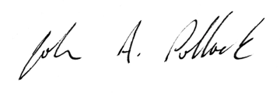
John A. Pollock, Ph.D.
Professor of Biological Sciences
Co-Director of the Chronic Pain Research cOnsortium

412-855-4043
pollock@duq.edu
http://www.duq.edu/academics/faculty/john-a-pollock

