Nandita Singh, Ph.D.
Senior Science Editor
Journal of Visualized Experiments
Email: nandita.singh@jove.com

15 January 2019

Dear Dr. Singh,

Please find enclosed our revised manuscript entitled, “Growth and Characterization of Irradiated Organoids from Mammary Glands.” We would like to thank the editorial staff and the reviewers for their supportive statements of the article. We appreciate the feedback and have addressed each comment in the attachment. We have also updated our manuscript to reflect the editorial comments.

Thank you for considering our revised manuscript for publication. Please contact us if you have any questions.

Sincerely,
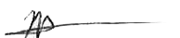
Marjan Rafat, Ph.D.
Assistant Professor of Chemical and Biomolecular Engineering
Assistant Professor of Biomedical Engineering (Secondary)
Assistant Professor of Radiation Oncology (Secondary)
Faculty Member, Breast Cancer Research Program, Vanderbilt Ingram Cancer Center
Vanderbilt University

Ms. No. JoVE59293R2
Title: Growth and Characterization of Irradiated Organoids from Mammary Glands

We thank the editor and reviewers for their careful feedback, which has helped us to strengthen our manuscript significantly. We believe that we have addressed their comments and criticisms thoroughly. Below, we respond to the specific issues raised by the reviewers and discuss how we have revised the paper to address these points.

Response to the Editor’s Comments

Editor Comments | Response
1. In a tube, petridish, please specify. (step 1.6) | We appreciate the request for clarification and have updated the protocol to read: “Transfer to the collagenase solution in a 50 mL centrifuge tube.”
2. Aspirate from the tube? (step 1.11) | We thank you for the comment and have updated the text with the following clarification: “Aspirate the aqueous layer from the tube with original pellet.”
3. Question about counting organoids in step 2.2 | We appreciate the question and have clarified the procedure as follows: “Transfer 50 µL to a 30 mm Petri dish, and view under a phase contrast microscope at 20x. Count the number of organoids with a tally counter.”
4. Question about calculating the organoid density in step 2.3 | We appreciate the request for mathematical clarification and have included an equation for calculating density.  $$\frac{\# organoids in 50μL}{50μL}=\frac{\# organoids in tube}{volume of tube} \left[=\right]\frac{organoids}{μL}$$
5. Please include how to visually identify the fibroblast? | We appreciate the request for clarification. We have updated the second paragraph of representative results to read: “Interestingly, the morphology of these fibroblasts is strikingly similar to pre-adipocytes, as both cell types exhibit spindly, elongated shapes (Figure 2E, F)¹⁶.” ¹⁶Gregoire, F.M., et al, Physiological Reviews, 1998.
6. How do you look for stromal growth? | We appreciate the question. Stromal cells are easily identifiable under phase contrast microscopy. They will usually be in or near the same plane of view as epithelial cells/organoids and appear within a few days of plating. They grow out from the organoid quickly. We have updated the protocol representative results to read: “Fibroblasts were identified under phase contrast microscopy in or near the same plane of focus as organoids, and they quickly grew out from plated organoids within a few days.”
7. Request for citation in 5th paragraph of representative results | We appreciate the comment, and have inserted the following references: LaBarge et al, JoVE, 2013; Campbell et al, Integrative Biology, 2014;Chanson et al, PNAS, 2011.
8. Please refer to the figure panels wherever applicable in the protocol section to bring out clarity. | We appreciate the request for clarification and have inserted references to figure one into the protocol section.  1.2. Resect abdominal and inguinal mammary glands from mice using pre-sterilized scissors and forceps. Remove lymph nodes before resection. Rinse in sterile 1x phosphate buffered saline (PBS) (Figure 1A).  1.4. Irradiate samples at 20 Gy using a cesium source (Figure 1B).  1.5. 45 min after irradiating, place mammary glands in a 35 mm sterile cell plate and mince with scalpels (Figure 1C, D). Mince approximately 40 strokes until the tissue relaxes and pieces are obtained that are no larger than approximately 1 mm² in area.  1.7. Place in water bath at 37 °C, vortexing every 10 min for 30-60 min. Digestion is complete when the collagenase solution is cloudy (Figure 1E, F).  1.8. Spin down at 450 x g for 10 min at room temperature. Three layers will be observed. The supernatant is composed of fat, the middle layer is an aqueous solution, and the bottom is a pellet. The pellet will appear red as it is a mixture of epithelial cells, individual stromal cells, and red blood cells (Figure 1G).  1.18. Repeat steps 1.16-1.17 three more times to purify organoids via centrifugal differentiation. The pellet should now be an off-white color consisting of only epithelial organoids (Figure 1H).
9. What does the yellow arrow show here, please describe? | We appreciate the request for clarification. The yellow lightning bolt is a pictorial representation of ionizing radiation, and we have added a descriptor below the arrow (20 Gy) in the figure to clarify its presence.
10. E and G are 15 mL tube while G and H are 1.5 ml Tube. Please clarify this. Also in the figure caption put the panel number A… and then describe what is being shown. It gets confusing from D onwards | We appreciate the comment. E and F are in 50 mL tubes while G and H are in 15mL tubes. We have updated the caption to read as follows: “Figure 1. Method Workflow. A. Mammary glands were resected from mice. The abdominal and inguinal mammary glands were used. B. Mammary glands were irradiated in 50 mL centrifuge tubes containing DMEM/F12 media. C. Mammary glands were transferred to sterile six-well plates and cut with surgical scalpels until minced (D). E. Mammary glands were transferred into 50 mL centrifuge tubes containing 5 mL sterile DMEM/F12 media per gland and digested in a collagenase VIII solution (F). G. After being transferred to a 15 mL tube, centrifugal differentiation was utilized to remove stromal cells, single cells, and red blood cells, observed in a red pellet (white arrow-head) until only white epithelial organoids were obtained (H). (I). 50 organoids were plated in 200 µL of media in 96-well low adhesion plates and imaged using phase contrast microscopy Scale bar represents 50 µm.”
11. Please describe what does scale bar represent in each panel. | We appreciate the request for clarification and have added “Scale bars for A-G represent 100 µm” in the caption for Figure 2.
12. In D the cells are not clear. | We appreciate the comment and have replaced the image with one that is more clear in Figure 2D.  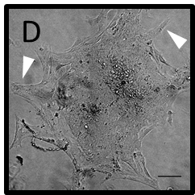
13. In the figure please replace hrs to h. Please remember to leave a single space between number and units. | We thank the editor for the comment and have updated the units as requested.
14. Is this also shown on irradiated organoid? | We appreciate the question. All images shown are irradiated organoids. We have updated the figure caption title to reflect this: “Figure 4. Epithelial Marker Expression on Irradiated Organoids.”
15. Presently the discussion essentially describes the result. Please move the result details to the representative result section.  As we are a methods journal, please revise the Discussion to explicitly cover the following in detail in 3-6 paragraphs with citations:  a) Critical steps within the protocol  b) Any modifications and troubleshooting of the technique  c) Any limitations of the technique  d) The significance with respect to existing methods  e) Any future applications of the technique | We appreciate the editor’s comment. We have moved these discussion points to the representative results sections and have addressed the desired points in the discussion section.

Response to Reviewer #1

Reviewer 1 Comments | Response
1. The explanation and justification of the radiation treatment and dosing needs more detail. Why are glands treated in a 50mL conical tube as opposed to irradiating the mouse before resection? Why irradiate resected glands as opposed to organoids? Is 20 Gy the appropriate dose in all cases, how was that dose determined? | We thank the reviewer for bringing up this point of clarification. In vivo irradiation is an experiment that we will indeed be performing in the future; however, whole glands were instead treated ex vivo to isolate the damage of ionizing radiation on the tissue itself. Additional studies will explore the effect of in vivo irradiation as that would allow for a wound healing response and infiltration of multiple cell types. 20 Gy was chosen to mirror previous in vivo models of tumor cell recruitment (Rafat et al., Cancer Research 2018). Typically, patients receive ionizing radiation of 60 Gy in fractionated doses of 2 Gy. However, intraoperative and post-operative radiotherapy is also given to human patients at doses consistent with 20 Gy. In addition, previous pre-clinical studies have used a single dose of 20 Gy due to aggressive metastasis of the 4T1 mouse mammary carcinoma model, which makes fractionated dosing infeasible.  To this end, we have updated paragraph one of the discussion section to read: “An irradiation dose of 20 Gy was applied to mirror previous in vivo models of tumor cell recruitment⁵. Irradiation of mammary glands ex vivo prior to organoid formation allowed for isolation of radiation damage effects without a corresponding infiltration of immune cells.” ⁵Rafat, M. et al. Cancer Research, 2018.
2. When co-culturing macrophages with organoids, are there considerations that need to be taken for the long-term culture of immune cells e.g. treatment with cytokines, effects of serum starvation by switching to organoid media? Will the reproducibility of this protocol be affected by choice of cytokines, source of macrophages (e.g. bone marrow derived vs. cell line), and organoid culture system? If so, the authors should acknowledge deviations could yield very different conclusions about tumor-immune interactions. | We thank the reviewer for this comment. We began our experiments by using non-polarized RAW 264.7 macrophages to determine whether macrophage migration was influenced by the cytokine secretion of the organoids. Future studies will evaluate the effect of both macrophage polarization and serum starvation. We will evaluate the growth effects of culturing organoids in complete media once they have formed. We have also conducted initial macrophage polarization experiments using RAW 264.7 macrophages. We have found macrophages polarized to an M1 phenotype (in DMEM media with 10% FBS, and cytokines LPS and IFN-gamma) retain their polarization when transferred to cytokine-free media and are currently conducting similar experiments with M2 macrophages. We will look more thoroughly at the effects of serum free organoid media on polarization status before doing further co-culture experiments with M1 or M2 macrophages. Following experiments with the RAW 264.7 cell line, we will use primary bone marrow derived macrophages in our studies.  We have updated the final paragraph of the discussion section to read: “Additional analyses will evaluate the consequence of serum starvation and the growth effects of culturing organoids in complete media, as these variables may have significant effects on organoid-immune cell interactions.”
3. Additionally the protocol to "monitor macrophage infiltration over time" is unclear. How are infiltration and kinetics measured? At 100,000 macrophages/mL, identifying specific interactions between macrophages and organoid cells or migration appears difficult. The authors report that macrophages colocalized with organoids within 14 hours - however, the images included in Fig. 5 show a very high local density of macrophages, so it is unclear if they are actively infiltrating/colocalizing with the organoids or just randomly associating due to high density. If this is included in the protocol, additional detail for robust and reproducible measurements of the described phenotype (i.e. infiltration) should be included. | We appreciate the reviewer’s concern. We monitored macrophage behavior by using live cell imaging where we quantified the kinetics of macrophage association with organoids over time through fluorescence intensity measurements. This procedure is now clarified, and the results are reported in in a new Figure 6. We conducted co-culture experiments at the previously reported concentration of 100,000 macs/mL and also at 50,000 and 10,000 macs/mL. Co-localization continues to be observed even at the lowest concentrations, and quantification of fluorescence signal over 24 hours indicates that macrophage migration is enhanced toward irradiated organoids. Macrophages also completely co-localized with both control and irradiated organoids or parts of dissociated organoid tissue by 48 hours. We also obtained Z-stack images to confirm macrophage infiltration into organoids (shown below).  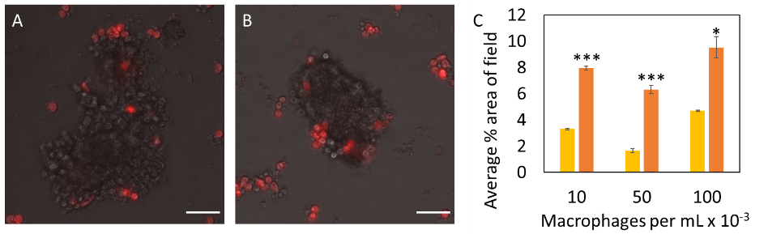  Figure 6. Evaluating cell-cell interactions through macrophage-organoid co-culture. Macrophages (red) infiltrated control (A) and irradiated (B) organoids. Scale bars represent 50 μm. Average percent area of macrophages in the image field (C) was reported at 24 hours of co-culture for control (yellow) and irradiated (orange) organoids (n=3 glands for each sample). Macrophages were seeded at concentrations of 10,000 cells/mL, 50,000 cells/mL, and 100,000 cells/mL, and their infiltration was captured every 30 minutes via live cell fluorescence imaging. All co-culture experiments commenced 7 days after initial organoid seeding. Statistical significance was determined using a two-tailed, unpaired t-test, *p<0.05, ***p<0.0001.  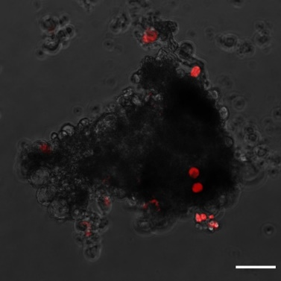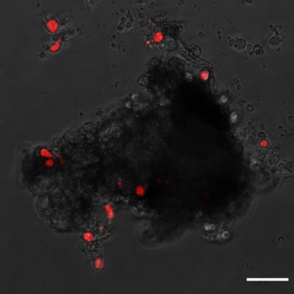  Z-stack slices of irradiated organoid after 48 hours of co-culture. A step size of 1.56 μm was used. Scale bars are 50 μm.
4. The authors should acknowledge previous papers that describe co-culture of mammary organoids and immune cells (e.g. DeNardo et al. Cancer Cell 2009). | We thank the reviewer for this comment and have updated the manuscript to include additional relevant studies where organoids and immune cells were co-cultured. We have updated the final paragraph of the introduction to read as follows:  “Earlier models co-culturing mammary organoids and immune cells have shed light on mechanisms of metastasis and dissemination. DeNardo et al. found that CD4+ T cell regulation of tumor associated macrophages enhanced a metastatic phenotype of mammary adenocarcinomas¹⁴. Co-culture models have also been used to elucidate mechanisms of biological development. Plaks et al. clarified the role of CD4+ T cells as down-regulators of mammary organogenesis¹⁵.” ¹⁴DeNardo, D.G. et al. Cancer Cell, 2009. ¹⁵Plaks, V. et al. Developmental Cell, 2015.
5. For growth measurements of organoids (as in 3D), were area measurements taken from time lapse images or start and endpoint images? If the latter, how confident are the authors that the organoids did not clump together in the non-adherent Sphera plates between time points? | We appreciate the question. Images were taken every 24 hours, and the area was measured from these images. At each time point, a 5x overview of the wells growing the organoids was taken. While clumping did occur occasionally, the vast majority of the time organoids did not clump together. This can be seen from representative data attached, where organoids per well were counted over time in irradiated and control wells. Any decrease in organoid count over time is attributed to aspiration when changing media while any increase is attributed to dissociation.  We have added a sentence in the fourth paragraph of the discussion to read: “Occasional clumping of low adhesion organoids was observed, and organoids could be cultured up to two weeks before dissociating.”
6. N (# mice or glands) should be reported for each experiment, unless representative data are used. If the experiment or image is representative, that should be noted in the legend. For experiments where p-values can be calculated, they should be reported. Without statistical support, unqualified statements such as "irradiated organoids grew more slowly than non-irradiated controls" regarding Fig. 3D should be avoided. If p>0.05, the authors should report these as trends, but not draw direct conclusions. | We thank the reviewer for this comment. We have updated the paper to address sample size and statistical significance. This includes updates to the following figure captions:  Figure 2H: “Different collagenase types (I (CI) and VIII (CVIII)) and cell processing methods (filtration and centrifugal differentiation (Cent Diff)) were tested, and organoid yield per mammary gland was quantified (n = 2 glands for CI, Filter; 2 glands for CVIII, Filter; 4 glands for CI, Cent Diff, and 12 glands for CVIII, Cent Diff). Statistical significance was determined using a two-tailed, unpaired t-test, ***p<0.0001. Error bars represent standard error.”  Figure 3H: “Area measurements were obtained in different growth conditions: organoids immediately seeded after digestion and sorting (Irradiated (●), Control (▪)),and organoids seeded in basement membrane (Irradiated (○), Control (□)) (n = 3 glands each). Area calculations were made using ImageJ software. Error bars represent standard error. Scale bars represent 50 µm.”  Figure 5G: “Phalloidin fluorescence data from low adhesion plate images were quantified in ImageJ (n = 3 glands).”  Figure 6C: “Average percent area of macrophages in the image field (C) was reported at 24 hours of co-culture for control and irradiated organoids (n=3 glands for each sample)."
7. In Fig 3A-C the white arrows are not described in the figure legend - it appears that they are meant to mark "ducts" and "lobes". Without further characterization it is not appropriate to use these specific terms. | We appreciate this comment. We have updated our language to describe what we observed as potential ducts and lobes that cannot be confirmed without further characterization. We have included the following clarification in the representative results section: “White arrowheads indicate constructs morphologically similar to ducts and lobes^{23,24} (Figure 3C), which are critical for the production and transport of milk in the mammary gland²⁵. However, further characterization is required to confirm this observation.” The Figure 3 caption has been updated to read: “White arrowheads indicate structures that have similar morphology to ducts and lobes.” ²³Zhang, L. et al. Cellular Signaling, 2016. ²⁴Sokol, E.S. et al, Breast Cancer Research, 2016. ²⁵Richert, M.M. et al. Journal of Mammary Gland Biology and Neoplasia. 2000.

Response to Reviewer #2

Reviewer 2 Comments | Response
1. Figure1 please provide the overall yield of viable organoids from irradiated fatpad compared to non irradiated fatpads to provide an estimate to the viewers to develop any quantitative assays. | We appreciate the reviewer’s comment. We did not observe significant differences in yield of viable organoids comparing irradiated to non-irradiated. On average, we obtain 1170 +/- 157 organoids per mammary gland for unirradiated organoids, and 1006 +/- 364 organoids per mammary gland for irradiated organoids. We have updated the third paragraph of the results section to read: “No significant differences in yield between irradiated and control organoids were observed.”
2. It is not clear fig 2G was from 3D or 2D plastic grown cells. | We appreciate the reviewer’s comment. We have updated the protocol with the following revisions: In the Figure 2 caption: “Cells in Figures E-F were seeded on tissue culture treated plastic.”  We have also updated the 2nd paragraph of the results section to: “Seeding cells directly onto tissue culture treated 10 cm cell plates yielded an overgrowth of fibroblast cells.”
3. Presence of fibroblast is a common factor in organoid preparation especially when they are grown in 2D plastic. | We thank the reviewer for their comment and agree. However, we are interested in evaluating purely epithelial organoids.
4. Mammary organoids undergo branching morphogenesis upon plating on 3d matrix. It is not clear whether irradiated organoids also underwent morphogenesis.  More representative images of good quality will guide the viewers on the efficiency of the protocol. | We thank the reviewer for this comment. While it is true that organoids undergo branching morphogenesis upon plating in Matrigel, this requires the addition of growth factors in the media, typically FGF2 (Nguyen-Ngoc et al., Tissue Morphogenesis: Methods and Protocols, 2015). We have included additional panels (Figure 3 A-G) to better guide the reader on the efficiency of this protocol.  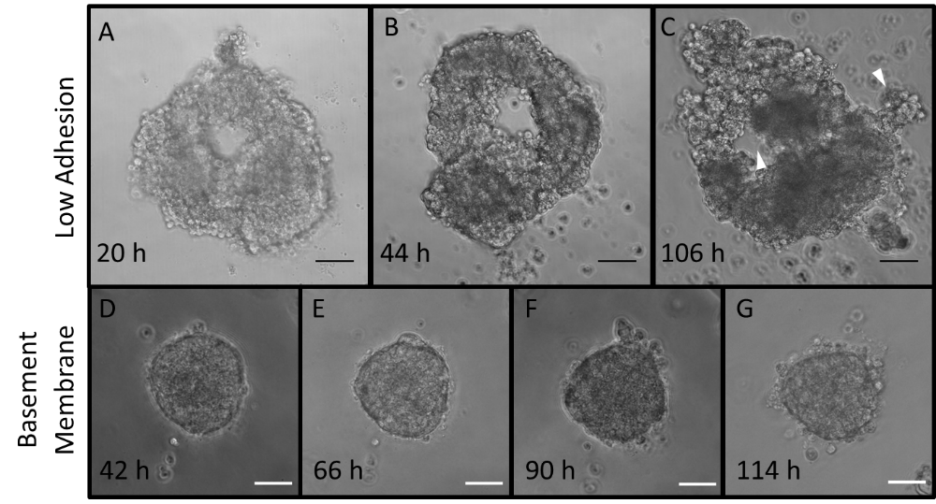  Figure 3. Representative Organoid Growth. Phase contrast images of irradiated organoid growth in low adhesion plates obtained 20 (A), 44 (B), and 106 (C) hours after seeding. White arrowheads indicate structures that have similar morphology to ducts and lobes. Phase contrast images of irradiated organoid growth in basement membrane obtained 42 (D), 66 (E), 60 (F), and 114 (G) hours after seeding. Scale bars represent 50 μm.
5. The centrifugation speed should be provided in g (rcf) | We appreciate the reviewer’s comment. We have updated the protocol, converting all “rpm” values to “x g.”
6. Page 2 line 112, presence of red pellet indicates RBC contamination. Pure epithelial cells should be a light brown pellet. | We thank the reviewer for this comment. We have now included additional details about our procedure to indicate where RBCs have been removed following centrifugation. We have updated the manuscript to read: “The pellet will appear red as it is a mixture of epithelial cells, individual stromal cells, and red blood cells (Figure 1G)” in step 1.8 following centrifugation, and “The pellet should now be an off-white color consisting of only epithelial organoids (Figure 1H)” in step 1.18 following centrifugal differentiation.

Response to Reviewer #3

Reviewer 3 Comments | Response
1. The introduction should describe further how the presented protocol is different from the well established organoid development protocols. In other words, why would these protocols not work for growing organoids from irradiated tissue? | We appreciate the reviewer’s comment. This protocol expands upon existing protocols. We show that irradiated organoids can be grown and characterized in a variety of ways. While other protocols may be used for growing organoids from irradiated tissue, we have focused here on describing a working protocol to characterize irradiated organoids as well as how immune cells interact with these organoids. To our knowledge, no other group has developed irradiated organoids to establish how normal tissue damage can alter immune cell behavior as we have done.  We have updated the introduction to include the following: “Previously established protocols may be used to evaluate irradiated organoids. Earlier models co-culturing mammary organoids and immune cells have shed light on mechanisms of metastasis and dissemination. DeNardo et al. found that CD4+ T cell regulation of tumor associated macrophages enhanced a metastatic phenotype of mammary adenocarcinomas¹⁴. Co-culture models have also been used to elucidate mechanisms of biological development. Plaks et al. clarified the role of CD4+ T cells as down-regulators of mammary organogenesis¹⁵. However, our group is the first to establish a procedure of visualizing how normal tissue irradiation influences immune cell behavior.” ¹⁴DeNardo, D.G. et al. Cancer Cell, 2009. ¹⁵Plaks, V. et al. Developmental Cell, 2015.
2. Does the pipet tips used in steps 1.20, 2.1 and so on, need to be of a particular size to make sure the organoid sizes are maintained? Some of the established organoid protocols use different pipet tip sizes to break apart organoids during passaging, so it seems like the size should be carefully chosen. | We appreciate the reviewer’s comment. For measurements and translating of organoids in media of volume 1 mL or smaller, we consistently used pipette tips with a minimal diameter of 457 μm. This is 5-10 times the diameter of the organoids that are seeded. In step 1.20 and 2.1, serological pipettes are used that have tip diameters excess of 1500 μm. In the future, we will explore how pipette tip size can be used to control organoid size.  Here, we have clarified the pipette tip sizes used in our protocol to form organoids and specified that the centrifugation step was used to differentiate organoids by size after step 2.2: “Note: We have consistently used pipette tips with a minimal diameter of 457 μm, which is 5-10 times the diameter of the organoids that are seeded. For transferring volumes of 2 mL or larger (e.g. steps 1.16 and 2.1), we used serological pipettes with tip diameters excess of 1500 μm.”
3. I am confused about the definition of the organoids in this manuscript. In most protocols, after dissociation of cells from excised tissue and seeding them, usually it takes a while for the cells to grow into organoids. However, step 2.2 directly to refers to counting organoids. What qualifies as a organoid? Please clarify. | We thank the reader for this observation. The term “organoid” has a wide variety of definitions in the literature. We define an epithelial organoid as a 3D construct of isolated mammary epithelium larger than 50 μm, which is supported by other studies (Shamir and Ewald, Nature Reviews Molecular Cell Biology, 2014; Simian et al., Development, 2001; Shamir et al., The Journal of Cell Biology, 2014; Ewald et al., Developmental Cell, 2008; Nguyen-Ngoc et al., Proceedings of the National Academy of Sciences, 2012).  We have updated the manuscript with this clarification, stating in the third paragraph of the introduction: “A mammary organoid is a multicellular, three dimensional construct of isolated mammary epithelium that is larger than 50 μm^{6–10}.” ⁶Shamir, E.R. and Ewald, A.J. Nature Reviews Molecular Cell Biology, 2014. ⁷Simian, M. et al. Development (Cambridge, England), 2001. ⁸Shamir, E.R. et al. Journal of Cell Biology, 2014. ⁹Ewald, A.J. et al. Developmental Cell, 2008. ¹⁰Nguyen-Ngoc, K.-V. et al. Proceedings of the National Academy of Sciences, 2012.
4. Does this protocol yield organoids of homogeneous sizes? How is this ensured? | We thank the reviewer for this request for further detail. After 20 hr of plating, the surface area of organoids exhibit the following area range (μm²)  We ensure that the organoids have similar size between experiments by using the same amount of collagenase solution per trial (10 mL for each mouse, or 5 mL per gland) and by sorting with centrifugal differentiation.
  Irradiated (±Std. dev.) | Control (±Std. dev.)
  32776 ± 15990 | 44403 ± 24320
5. How long can the organoids grow in cultures? Can these be passaged to maintain growth? | We thank the reviewer for these questions. The longest that the organoids can be grown is two weeks, after which they begin to dissociate. Passaging is not required, as the organoids do not grow to confluency on the microplates. We have frozen them in 90% FBS and 10% DMSO and found that they grow well after thawing.  We have updated the protocol to include directions for freezing and thawing in steps 2.3.2-2.3.3: “Note: To freeze organoids, transfer desired volume to a separate centrifuge tube. Spin down at 450 x g for 5 minutes. Aspirate media, then add the same volume of 90% FBS/10% DMSO. Resuspend the organoids, then aliquot into cryotubes. Transfer to -80˚C, then to liquid nitrogen within one week. To thaw, warm in a 37˚C water bath for one minute. Centrifuge at 450 x g for five minutes, then aspirate freezing media. Rinse with sterile DPBS, then centrifuge again. Aspirate DPBS, and add organoid media.” We have also made a note in the fourth paragraph of the discussion that “organoids can be cultured up to two weeks before dissociating.”
6. Figure 2 caption, page 5, line 222, the manuscript does not talk about the 'filtration' mentioned here. How does the technique sort organoids? Please include filtration protocol in the main manuscript. Also describe what is expected to be present in the 'filtrate' and 'retentate' mentioned in line 223. | We thank the reviewer for bringing up this point for clarification. The technique sorts organoids from individual cells via differences in size. We have updated the protocol to read as follows after step 1.18: “Note: organoids can also be filtered using sterile mesh 40μm filters. After step 1.16, pipette media containing organoids through a filter into a centrifuge tube, and then rinse with 5 to 10 mL of DMEM/F12 media. Flip the filter over a new 50 mL centrifuge tube. Pass 10 mL of DMEM/F12 media through, going the opposite way to rinse off any retentate. The retentate should consist of organoids, and the filtrate should contain mainly stromal cells, which can be discarded or kept if desired.”
7. Line 224, why does trypsinizing allow selective removal of fibroblast? Is there a reason for not including this step in the main protocol? | We thank the reviewer for this remark. We used a partial trypsinization method to remove fibroblasts as described by LaBarge et al, Journal of Visualized Experiments, 2013. In this protocol, the authors grow organoids on tissue culture treated plastic, and they claim to use differential trypsinization to “promote rapid detachment of fibroblasts from the surface plastic.” We did not include this step in the main protocol as we do not culture organoids on tissue culture treated plastic, and we did not observe fibroblast growth on the low adhesion plates.
8. Describe the ' cell processing methods' referred here. Define 'Cent. Diff.' in figure 2H. | We appreciate the reviewer’s comment and have updated the caption for Figure 2 to read the following: “(H) Different collagenase types (I (CI) and VIII (CVIII)) and cell processing methods (filtration and centrifugal differentiation (Cent Diff)) were tested, and organoid yield per MFP was quantified (n = 2 glands for CI Filter; 2 glands for CVIII, Filter; 4 glands for C1, Cent Diff, and 12 glands for CVIII, Cent Diff).”
9. Figure 3 C and Fig 5, what does the white arrowheads indicate? | We thank the reviewer for the requesting clarification. We have updated the Figure 3 caption to read: “White arrowheads indicate structures that have similar morphology to ducts and lobes.”  A new figure has been added, moving the macrophage results from Figure 5 to Figure 6. We have removed the arrows and instead indicated that the macrophages are red in color.
10. Page 6, line 286, could the authors indicate ' ducts and lobes' formed in the organoid images shown in Fig 3 referred to in the discussion. | We appreciate the comment and have updated the manuscript to include the following clarifications. The Figure 3 caption now reads: “White arrowheads indicate structures that have similar morphology to ducts and lobes.” The 4th paragraph of the results section now reads: “White arrowheads indicate constructs morphologically similar to ducts and lobes^{23, 24}(Figure 3C), which are critical for the production and transport of milk in the mammary gland²⁵.” ²³Zhang, L. et al. Cellular Signaling, 2016. ²⁴Sokol, E.S. et al, Breast Cancer Research, 2016. ²⁵Richert, M.M. et al. Journal of Mammary Gland Biology and Neoplasia. 2000.
11. Page 1, line 60, citation is required | We thank the reviewer for the comment and have updated the protocol with a citation. That sentence now reads: “Previous work has shown that radiation of normal tissue increases recruitment of various cell types⁵.” ⁵Rafat, M. et al. Cancer Research, 2018.
12. Page 4, line 184-185, define PBST | We thank the reviewer for the comment and have defined PBST as “0.1% PBS/Polyethylene glycol sorbitan monolaurate”
13. Page 5, line 243, rephrase 'less intensify' | We appreciate the reviewer’s comment and have rephrased it to read “with lower intensity.”

