Dear Dr. Phillip Steindel:

Thank you for sending the Editorial and Reviewer comments on our manuscript JoVE59284. Please find our revised manuscript as well as a letter providing detailed responses to each comment enclosed with this submission. We have supplied the manuscript file as a Microsoft Word docx file with track changes turned on, as requested. Further, we have highlighted 2.75 pages of the protocol to indicate the portion that we propose be filmed, also as requested. If you or the Reviewers would like a non-marked-up version, please let me know, as I will be happy to supply one.

We are also supplying a zip file that includes the software, scripts, and input files used in this protocol. These files can additionally be found on the Getman Group github page at https://github.com/getman-research-group/JoVE_article.

Thank you again for handling our manuscript.

Sincerely,
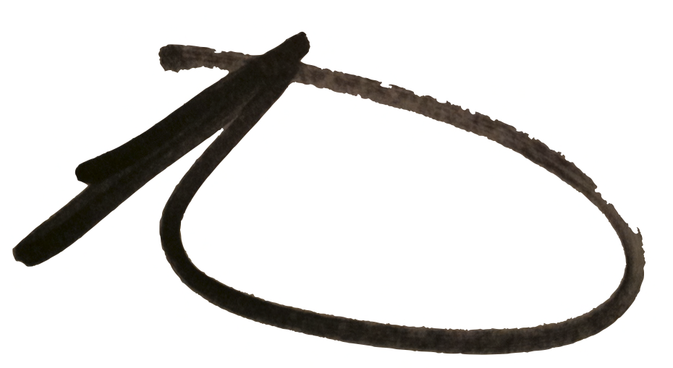
Rachel Getman

