Prof. Dr. Julia-Stefanie Frick
Institute of Medical Microbiology and Hygiene
University of Tübingen
72076 Tübingen
Germany
Telephone: 0049-7071-29 82352
Fax: 0049-7071-29 5440
E-mail: julia-stefanie.frick@med.uni-tuebingen.de

November, 28th 2018
Dear Sir or Madam,

we are pleased to resubmit the revised version of the manuscript “Galleria mellonella oral administration model to study commensal-induced innate immune responses” by Anna Lange, Andrea Schäfer and Julia-Stefanie Frick to be considered for publication in “Journal of Visualized Experiments” in the section “Immunology & Infection”.
We thank the editor and reviewers for their constructive suggestions, which we have all incorporated into our manuscript.
We have the impression that our manuscript has significantly improved, thanks to the work and suggestions of the reviewers and hope that our work is now suitable for publication in “Journal of Visualized Experiments”.

Yours sincerely,
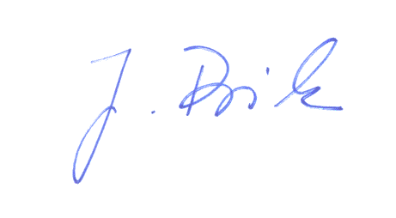
Julia-Stefanie Frick

