Dear Dr. Cao:

We have completed the revision of our manuscript (JoVE submission JoVE59254) which, following the recommendation of the 2nd reviewer, is not titled Imaging of Extracellular Vesicles by Atomic Force Microscopy. The permissions to re-print certain figures or their modifications have been obtained and submitted with the revision.

The detailed description of changes and the response to the comments follow. We thank you and the reviewers for the constrictive comments that helped improve the manuscript.

Sincerely,

MS and VSC

Response to editorial comments

1. Please take this opportunity to thoroughly proofread the manuscript to ensure that there are no spelling or grammar issues.

- We have thoroughly rewritten the manuscript for clarity and completeness. We did our best to proofread it carefully, and to catch spelling errors and grammar issues.
2. Please revise lines 268-270, 272-274, 278-281, 287-297, 341-346 to avoid previously published text.

- Done.
3. Please obtain explicit copyright permission to reuse any figures from a previous publication. Explicit permission can be expressed in the form of a letter from the editor or a link to the editorial policy that allows re-prints. Please upload this information as a .doc or .docx file to your Editorial Manager account. The Figure must be cited appropriately in the Figure Legend, i.e. “This figure has been modified from [citation].”

- Done.
4. Please remove the embedded figure(s) and Table of Materials from the manuscript. All figures/tables should be uploaded separately to your Editorial Manager account. Each figure must be accompanied by a title and a description after the Representative Results of the manuscript text.

- Done.
5. Figure 1: Please include a space before and after the “±” symbol.

- Done.
6. Figure 3: Please use the uppercase letters A, B, C and D for panel labels.

- Done.
7. Keywords: Please provide at least 6 keywords or phrases.

- Done.
8. JoVE cannot publish manuscripts containing commercial language. This includes trademark symbols (™), registered symbols (®), and company names before an instrument or reagent. Please remove all commercial language from your manuscript and use generic terms instead. All commercial products should be sufficiently referenced in the Table of Materials and Reagents. You may use the generic term followed by “(see table of materials)” to draw the readers’ attention to specific commercial names. Examples of commercial sounding language in your manuscript are: ExoQuick TC, SBI, Ted Pella Inc., Sigma-Aldrich, Veeco Multimode Nanoscope V, Bruker, etc.

- Done.
9. Please adjust the numbering of the Protocol to follow the JoVE Instructions for Authors. For example, 1 should be followed by 1.1 and then 1.1.1 and 1.1.2 if necessary.

- Done.
10. Please revise the protocol text to avoid the use of any personal pronouns (e.g., "we", "you", "our" etc.).

- Done.
11. Please revise the protocol to contain only action items that direct the reader to do something (e.g., “Do this,” “Ensure that,” etc.). The actions should be described in the imperative tense in complete sentences wherever possible. Avoid usage of phrases such as “could be,” “should be,” and “would be” throughout the Protocol. Any text that cannot be written in the imperative tense may be added as a “Note.” Please include all safety procedures and use of hoods, etc. However, notes should be used sparingly and actions should be described in the imperative tense wherever possible. Please move the discussion about the protocol to the Discussion.

- Done.
12. Lines 94-109, 214-220: The Protocol should contain only action items that direct the reader to do something. Please either write the text in the imperative tense as if telling someone how to do the technique (e.g., “Do this,” “Ensure that,” etc.), or move them into the Introduction/Discussion section.

- Done.
13. Please simplify the Protocol so that individual steps contain only 2-3 actions per step and a maximum of 4 sentences per step. Use sub-steps as necessary. Please move the discussion about the protocol to the Discussion.

- Done.
14. 4.2.2: Please provide the composition of precipitation solution. If it is purchased, please cite the Table of Materials.

- Cited in the ToM. An alternative protocol that does not use proprietary commercial product is now cited.
15. 4.2.4: What volume of PBS is used to re-suspend the pellet?

- Answered. See step 1.14.
16. Line 215: Please verify whether the reference numbers are correct.

- We removed these referenced from the Protocol section. They now appear in Representative Results.
17. Lines 222-252: Software must have a GUI (graphical user interface) and software steps must be more explicitly explained ('click', 'select', etc.). Please add more specific details (e.g. button clicks for software actions, numerical values for settings, etc.) to your protocol steps.

- We added multiple GUI screen captures illustrating all the essential steps in data analysis.
18. Table of Materials: Please sort the items in alphabetical order according to the Name of Material/Equipment.

- Done.

Response to reviewers' comments
Reviewer #1:
Manuscript Summary:
The protocol reported by Skliar and Chernishev is dealing with the characterisation of Extracellular Vesicles by means of Atomic Force Microscopy. The paper is definitely targeting a challenging issue in the exciting field of Extracellular Vesicles characterisation. The protocol is sound and the reference to previous protocols on AFM on EVs is correctly addressed.
I've only few concerns: the authors claim that without modification of Mica surface with NiCl2 they cannot observe vesicles on the surface while measuring in air, while in several reports the unmodified mica has been used for imaging in air (es. Sharma et al ACS Nano 2010, Radeghieri et al, Biophys Biochem Res. Comms 2017, Woo et al. J Circulation Res 2016).

- We added an extensive discussion of the advantages and disadvantages of these two approaches to imaging EVs in the air. Please see Importance of Surface Immobilization in the Discussion section. We added all the references you suggested. We clarified that images A, C, and D in Figure 10 (Figure 2a, c, and d in the original manuscript) were obtained with the same sample. We also made it clear that panels A and D were acquired after the same incubation time but with and without surface modification (D and A, respectively), which illustrates that, without imparting positive surface charge, the immobilization of EVs is not effective.

Moreover looking at the image in Figure 1a we can see in the top part some bright spots that in principle could be ascribed to the sparse presence of vesicles.

- We cleaned the surface with DI water which was then removed from the surface by aspiration. However, not all liquid could be pipetted out. Those vesicles that are visible, most likely, are the result of incomplete aspiration of DI water that resuspended vesicles not fixed to the surface and then deposed them on the substrate during the evaporation. The number of vesicles is very small in absolute terms and relative to the results when mica surface was modified. Although not included in the paper a similar result was obtained when working with negatively charged liposomes. A significantly higher number of liposomes remained on modified mica after washing.
Then even though the paper is not related to novelty it is puzzling me that they are using as Figure 2 the exact figure reported in the supporting information of their paper (Skliar et al Biochem Biophys Res. Comms 501 (2018) 1055) without a proper referencing.

- Additional citations added. The expanded Discussion now clarifies the importance of many factors (charge screening, the impact of vesicle mobility on immobilization, desiccation artifacts, to mention a few) on the AFM characterization, which should be instructive to most readers.

Reviewer #2:
Manuscript Summary:
AFM is undoubtedly a powerful characterization tool for EVs. Overall, the manuscript is timely and well described.
Major Concerns:
**Abstract: "The fixation and imaging protocols described by us are simple, repeatable, and produce data for a large number of vesicles. The versatility of the AFM data provides rich information about biophysical properties for a large number of exosomes, including the size distribution and the morphology of vesicles".
Rigor and reproducibility of EV analysis is a prime concern in the biomedical field in general. The authors present no data to suggest the repeatability of the results.

- We responded to your comment by completely re-writing the paper. In the revision, we emphasize that the reproducibility of AFM imaging results primarily depends on the reproducibility of EV fixation on the substrate. We summarize this point in the abstract by stating " The representative results demonstrate that the fixation of EVs on the modified mica surface is predictable, customizable, and allows the user to obtain sizing results for a large number of vesicles." The variability in biological samples and EV isolation protocols are important issues beyond the scope of the paper, as we now clearly annunciate.

- The immobilization of the EVs on the surface is the primary source of variability in AFM data since all downstream steps (scanning and data analysis) are easily controlled by the selection of instrumentation, probes, scanning parameters, and the data analysis sequence and algorithms. The revised manuscript substantially expands the discussion of factors that influence the immobilization of EVs including the charge screening, the influence of the liquid medium, EV transport from the liquid to the substrate, and the evaporation of the sample. We added new subsections in the Discussion where we analyze potential variability in the immobilization results caused by drying artifacts (and included a new Figure 13 as the illustration), the difference in EVs' hydrodynamic mobility, and surface deformation of the vesicles produced by electrostatic attraction to the substrate and non-uniform capillary forces during desiccation (Figure 14).

- The explicitly identified causes of potential variations and the suggestions on how to reduce or account for their influence are the most important changes in the revised manuscript. These changes are meant to help the users to obtain reproducible AFM characterization results for any given sample and provide the guidance in understanding the likely sources when variations do occur.

- We now point in the Representative Results that the same MCF-7 sample was reanalyzed three times, from sample preparation to imaging. Each repeat produced statistically similar results to those shown in Figure 12.

Also, can they clarify approximate numbers of EVs amenable to AFM imaging. Both EM and AFM are typically used as qualitative methods to probe EV structures, so this would be helpful for the readers to know.

- In the Discussion section, we now explicitly state that " The number of vesicles amenable to AFM imaging scales with the imaged surface area and the surface concentration of the vesicles immobilized on the substrate." We now include an expanded discussion of factors controlling the density of the immobilized EVs on the modified mica's surface. A dedicated subsection on Control of Surface Density of Immobilized EVs is now included in the Discussion. We now explicitly state that "A high density of immobilized vesicles... increases the number of vesicles analyzed during the scanning and the statistical power of conclusions arrived by the analysis of the AFM data," caution the user that "an excessively dense surface concentration, as in the case shown in Fig. 10C where particles tightly cover the entire surface with no intervening areas of the substrate, complicates the image analysis and the interpretation of results and may lead to scanning artifacts caused by the interaction between closely spaced particles." We explicitly describe the reason why it is not desirable to have concertation of EVs as dense as in Figure 10C; from the Representative Results section: "A number of algorithms rely on having sufficient unoccupied substrate between the grains to perform image correction and data analysis. For example, the leveling and shifting the substrate to the zero plane, the line correction, and the estimation of the grains' volume need the intervening flat surface to perform accurate calculations." We provide the suggested liquid concentration of EVs and sample incubation times to obtain adequate surface concentration of immobilized EVs. We also discuss factors that allow the user to customize the surface concentration of the immobilized EVs on the modified mica substrate to meet the goals of a study.
**Use a double-sided tape to attach a mica disk (10 mm diameter, Ted Pella Inc., Redding, CA) to the AFM/STM metal specimen stage.
Double sided tape will drift and create issues when imaging, particularly so for fluid imaging?
- We had no adverse issues with using a particular laboratory-grade double-sided tape (listed in Table of Materials). It held well with no drift in the results. The tape was placed on the sample holder, and mica (not yet cut) was firmly pushed down to get good bonding. The sessile drop of PBS on mica's surface was small enough and never touched the tape.

- Nevertheless, to address your concern and to caution a user, we now state in the Protocol: " Use strong double-sided tape, epoxy, or an alternative adhesive to firmly attach a mica disk to the AFM/STM magnetic stainless steel specimen disk."
**Mica is a layered silicate mineral with general formula K(Al2)Si3Al)O10(OH)2 that naturally has a negatively charged surface and a "near perfectly flat surface" ideal for imaging nanoparticles by the AFM.
Can the authors provide quantitative assessment of the flat surface, eg. surface roughness, and why it matters for imaging EVs.

- The following Figure 1 shows the roughness of our sample was comparable with the previously published results (Figure 2 taken from DOI: 10.1021/am100697z). In Representative Results, we added the following quantification of flatness of the modified surface: " The roughness of cation-derivatized surface was below 0.3 nm, which is consistent with the previous report¹³." However, because mica is such a common and widely used substrate in AFM imaging of biological samples, we did not add further details in the paper but will do so if advised.

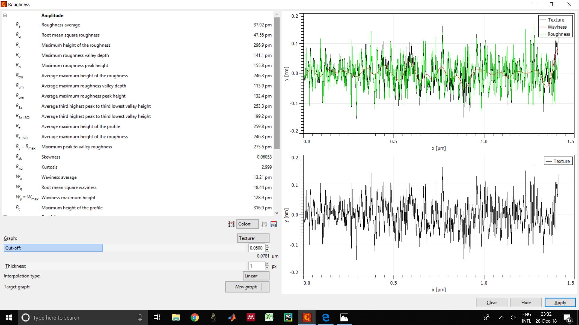

Figure 1: Surface roughness of the modified mica used in our study.

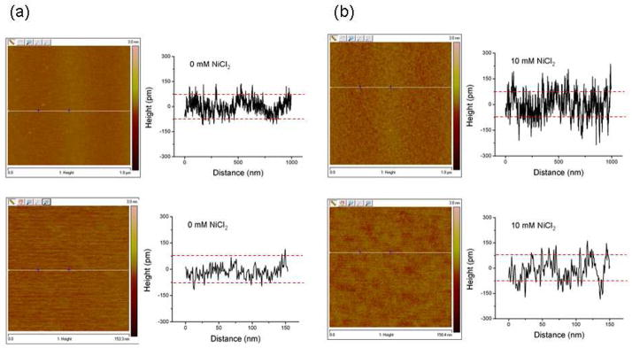

Figure 2: Surface roughness reported in DOI: 10.1021/am100697z

**2.Cleave mica disc by using a sharp razor or utility knife. An initial cut on the side of the mica disc will cause a thin layer of the material to easily detach. Remove the cleaved layer. The remaining thin layer must still be firmly attached to the AFM/STM metal specimen disc.
Peeling with double-sided tape should suffice?

- We added this option to the Protocol.
** for AFM imaging, the scan rate and approximate time it takes to acquire a 5X5 micron image of certain resolution must be included.

- We include the following Note in the Protocol which will allow users to estimate the time it would take to image the selected surface area (# of lines/rate). We also give suggestions on the selection of default values.

Note: The scan time will increase will the imaged area (5×5 µm being a common choice), the number of lines selected to form the image (512 lines are often acquired), and the scan rate defined as the number of lines scanned per second. The scan rate is often set to ~1 Hz. Fast scan rates may impact the image quality. Therefore, the speed of rastering should judicially balance the tradeoff between the acquisition time and the image quality.

** 24 hours of EV incubation the surface seems longer than most protocols?

- Figure 10C, obtained after 24 h incubation, shows a surface that is covered with an excessively large number of exosomes. So, this was an example of what not to do.

- More generally, we do think that longer incubations are important to avoid the fixation bias. This issue is addressed in new subsection in the Discussion titled Immobilized Vesicles May Represent a Liquid Sample with a Bias, which states: "For the case when the rate of immobilization is limited by diffusion, vesicles with smaller hydrodynamic sizes, determined by the combination of the vesicle size and the thickness of the coronal layer surrounding it (Figure 1), are more likely to enter the attraction layer because of their higher mobility. Consequently, after the initial depletion period, the hydrodynamically small EVs will be overrepresented on the substrate compared to their contribution to the EV population in the liquid sample. Note that a smaller hydrodynamic size does not automatically point at EVs with smaller vesicle sizes because of the heterogeneity in the thickness of the coronal layer³. The biased representation is avoided with long incubations that deplete the entire population of EVs in the liquid by its immobilization on the substrate."
** Can authors suggest a dilution expt to optimize the time and concentration for EV imaging, for greater efficiency of imaging.

- We added a subsection in the Discussion on Control of Surface Density of Immobilized EVs. We also added the recommendation to use the NTA to confirm that the desired liquid concentration of EVs was attained after the dilution.
**Fig 2. It would be helpful to show baseline zero height for all panels for easy comparison. Is Fg 2B a height or amplitude image? Fig 2(C) The AFM scan of the surface after an excessively long 24-hours exposure to an exosome sample shows a surface concentration of immobilized vesicles that is too high for an accurate analysis. The features are all aligned ~45degree angle in 2(C). Is that draft or directional effect of washing the surface?
- We clarified in the text of the manuscript that all images in Figure 10 (old Figure 2) are height images. We agree that there is a drift in the old Fig. 2C. We have replaced the old image with a scan of the same sample without a drift. The height images now show Z=0 as a baseline.

**Fig 3D. Can the authors include a phase image of the same particle for comparison, to show the complementarity of height and phase images of EVs?

- Done. See updated Figure 11.
The authors should also discuss the limitations of AFM imaging and comparisons to EM. For instance, time, surface scanning features, loss of particles that fail to adhere to the surface.
- We now discuss in more details the issues related to surface deformation of EVs due to electrostatic immobilization -- an issue not present in cryo-TEM results. We also added a discussion of desiccation artifacts (illustrated in new Figures 13 and 14) that do not affect cryo-TEM (they can affect SEM results, though!) or when hydrated samples are imaged by AFM. We now include the direct comparison of the exosome sizing results based on cryo-TEM images and AFM data (Figure 12C) to show their consistency. The discussion related to the potential difference between the population of immobilized EVs and EVs in the solution was also included during the revision.
**A useful resource on AFM and EM imaging of vesicles from researchers in the imaging and characterization of EVs, is covered in the MOOC "Basics of Extracellular vesicles" and should be available as a reference to interested readers.

- The field of Extracellular Vesicles has become so active that it is difficult to recommend a single review of the subject to a beginner. Fortunately, our audience are EV researchers interested in the adoption of AFM in their projects, which is why we avoided citing review papers, textbooks, and course material.
Minor Concerns:
**Given the scope of the characterization of EVs discussed in the current manuscript, it would be rather appropriate to use change the title to Imaging of EVs by AFM.

- Thank you for an excellent suggestion which has now been adopted.
**Typos and grammar
After the incubation, remove 80-90% of sample from the surface by aspiration. If the imaging of the hydrated exosomes is desired, was rinse the surface 4 times with 1x PBS, making sure that the sample remains hydrated throughout the process.
- This part of the protocol was rewritten.
Reviewer #3:
Comments:
Line 150: Double sided tape is inherently a bad idea for any AFM samples - often times the tape thermally expands/contracts leading to drift that can be devastating for experiments characterizing exosomes on the scale of tens of nanometers. Epoxy or some other adhesive is much better.

- We added a comment to the protocol that notes the need to thermally equilibrate the specimen after the incubation and before scanning. We also added the suggested alternatives to a double-sided tape when attaching mica disk to the AFM/STM magnetic specimen disk.
Line 155: Why wouldn't you use tape to cleave the mica? Much simpler and less room for error.

- We added this option to the Protocol.
Line 162: you should specify blot the mica puck with some lint-free wipes (kimtech is actually awful in my experience, I would suggest a knit cloth like alpha wipes, or anything suitable for a class 100 clean room - even this can be risky for introducing particulates to your substrate).

- We added the need to use lint-free blotting paper when blotting NiCl2 from mica's surface. We added options for lint-free wipes and lint-free blotting paper to Table of Materials.
Line 164: please clarify/rewrite "Place the AFM specimen stage with the surface-modified mica in a petri dish". Are we putting the Mica puck into a petri dish, and then putting that into the AFM stage? If so, later is step 3 you say incubate at 4C, which almost no AFMs have the capability to control their temperature that low.

- It should have said "specimen disk." Corrected. We now refer to it as "magnetic specimen disk" to clarify the mechanism of its attachment to the AFM stage.
Line 176: I assume the 1X PBS is with Mg & Ca ions?

- We use PBS (listed in ToM) manufactured without Calcium and Magnesium.
Line 187: Even fresh DDW on freshly cleaved mica can leave reside/particulates when air drying in lieu of quicker nitrogen drying - why do you suggest this?

- We do use and recommend drying in a stream of dry nitrogen. The protocol is now corrected.
Line 301: please list the detailed results of the AFM size vs cryo-TEM size analysis including mean, standard deviation, and number of exosomes measured for each data set in a table.

- We added the comparison of AFM and cryo-TEM sizing results as Figure 12C. Additional details are given in the cited reference (DOI: 10.1016/j.bbrc.2018.05.107) and its Supplemental Information.
Figure 2:
* Please clarify - is this done in air (i.e. DI wash then dry) or liquid? It seems like there may be some exosomes on the very top - please confirm that this control was done in the exact same manner as the NaCl2 runs (i.e. same density of exosomes incubated with the same conditions/time/rinse steps).

- All scans shown in Figure 10 (old Figure 2) were performed in the air, as we now clarify in the manuscript. The same sample was used in scans A, C, and D.

- As mentioned in our response to the 1st reviewer, we cleaned the surface with DI water which was then removed from the surface by aspiration. However, not all water could be pipetted out after washing. Those visible vesicles are, most likely, the result of incomplete aspiration of DI water that resuspended vesicles not fixed to the surface and then deposited them on the substrate during the evaporated.
* 2A seems to be very rough compared to 2B, given that the Z scales of the two are nearly an order of magnitude different. Is it due to contaminants/precipitates left over from the exosome incubation (see comment below about SBI products), or other debris?

- The difference in roughness is too small to be seen by eye in the images. But, since you asked, (A) is, indeed, rougher than (B) (400-700 pm roughness vs. ~350 pm for mica modified with NiCl2). The likely cause is a more complex composition of a bio-sample, which contain proteins, peptides, and amino acids found in growth medium (positively charged residues would be attracted to the negatively charged surface of mica). Some PEG (the active ingredient in ExoQuick, as far as I can tell) may contribute to an increased roughness, but likely less than proteins because of smaller MW.
* Please make the z-scales in each 2A, 2C, and 2D the same range for a better comparison of the three cases (I think the lower scale on 2B makes sense given how smooth the surface is).

- The z-scale was changed.
In general:
While I understand you may not have the capability at your facilities/lab, PeakForce Tapping AFM by Bruker is truly the best suited AFM modality for delicate samples in fluid. This could easily be addressed in the discussion section.

- Thank you. Noted.
ExoQuick TC by SBI is known to contain polymeric precipitates from their proprietary process/product, which is rather frustrating. How does this method give confidence in the measured topography is due to solely that of exosomes vs. polymeric precipitates? It seems as if they could be present in Figures 2 & 3. This should also be addressed in the discussion section.

- The discussion of the EV isolation is the topic beyond the scope of this paper. This hotly debated subject has plenty of opinionated opponents and proponents of every EV enrichment option (usually with solid justifications!). A small increase in surface roughness in the scan shown in Figure 10A (old 2A), incubated with the biological sample containing leftover PEG, proteins and other molecular mêlée from the growth medium, points to a minimal contribution of precipitants to the AFM results even when a desiccated sample is imaged.

