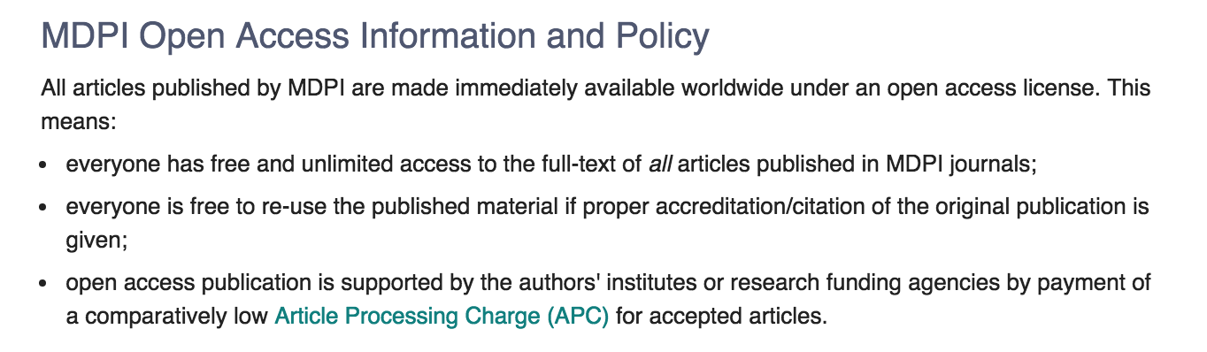
More detailed information can be found at:

https://www.mdpi.com/about/openaccess

