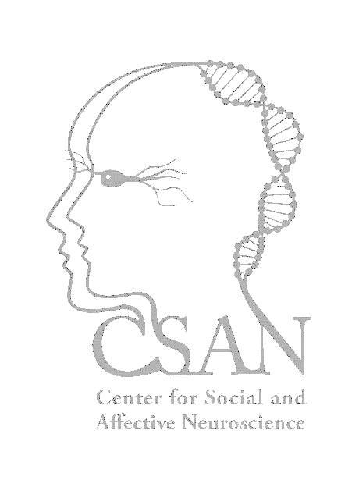
Dr. Leah M. Mayo
Center for Social and Affective Neuroscience
Linköping University
SE-58431 Linköping, Sweden

Dr. Aaron Berard
Editor
Journal of Visualized Experiments

November 28, 2018

Dr. Berard,

We are pleased to submit the revised version of our manuscript, “Using facial electromyography to assess facial muscle reactions to experienced and observed touch in humans” for publication in the Journal of Visualized Experiments.

We are grateful to the editor and reviewers for their thorough and constructive feedback. As requested, we have made extensive changes to the manuscript, including a more directed protocol, a more detailed results section, and a more thorough discussion. We have also included additional figures and a table including details of our tasks. Most importantly, we have included enough information to ensure that others can replicate our experimental setup in their own endeavors to explore affective touch using facial electromyography.

We hope that the editor and reviewers find our revisions to be satisfactory on all accounts, and will be happy to provide further clarifications if needed.

Sincerely,

Leah M. Mayo
(on behalf of all authors)

