DEPARTMENT OF THE ARMY
UNITED STATES MILITARY ACADEMY
WEST POINT, NY 10996

December 2, 2018

Dear Sir/Ma’am,

We have addressed the editorial and reviewer comments below for our manuscript entitled “Synthesis Method for Cellulose Nanofiber Biotemplated Palladium Composite Aerogels” by Fred J. Burpo, Jesse L. Palmer, Alexander N. Mitropoulos, Enoch A. Nagelli, Lauren A. Morris, Madeline Y. Ryu, and J. Kenneth Wickiser. Our responses to the comments are indicated in red font below.


We appreciate the consideration of our work and the opportunity to address the concerns identified during the review, as well as your patience as members of our research team dealt with medical and other issues. Please let us know if there is anything else needed.

Respectfully,

F. John Burpo, Sc.D.
Colonel, U.S. Army
Professor and Head, Department of
Chemistry & Life Science

Editorial comments:

Changes to be made by the author(s) regarding the manuscript:

1. Please take this opportunity to thoroughly proofread the manuscript to ensure that there are no spelling or grammar issues.

Completed.

2. Please obtain explicit copyright permission to reuse any figures from a previous publication. Explicit permission can be expressed in the form of a letter from the editor or a link to the editorial policy that allows re-prints. Please upload this information as a .doc or .docx file to your Editorial Manager account. The Figure must be cited appropriately in the Figure Legend, i.e. “This figure has been modified from [citation].”

Figures were used from Reference XX in the journal Molecules which is an open access journal allowing authors permission for reuse. The journal re-use permissions are copied here from the weblink https://www.mdpi.com/about/openaccess :

“All articles published by MDPI are made immediately available worldwide under an open access license. This means: everyone has free and unlimited access to the full-text of all articles published in MDPI journals; everyone is free to re-use the published material if proper accreditation/citation of the original publication is given.”

This information is uploaded as a “Copyright Permission.docx” file to the Editorial Manager Account.

3. Please expand the Short Abstract to briefly describe the applications of this protocol.

The short abstract was expanded and now reads:

“A synthesis method for cellulose nanofiber biotemplated palladium composite aerogels is presented. The resulting composite aerogel materials offer potential for catalysis, sensing, and hydrogen gas storage applications.”

4. In the protocol, please describe how the products are characterized with different analytical techniques such as SEM, XRD, TGA, and BET analysis and electrochemical characterization because such data are presented in the Representative Results.

An additional step, Step 4, was added to the protocol and reads as:

4. Composite aerogel material characterization.

4.1. Scanning electron microscopy (SEM). Cut the CNF-palladium aerogel with a razor blade to obtain a thin film approximately 1 – 2 mm thick. Affix the thin film sample with carbon tape on a SEM sample stub. Initially use an accelerating voltage of 15 kV and beam current of 2.7 – 5.4 pA to perform imaging.

4.2. X-ray diffractometry (XRD). Place the CNF-palladium aerogel in a sample holder and align the top of the aerogel with the top of holder. Alternatively, place a thin film sample section, as in Step 4.1, on a glass slide. Perform XRD scans for diffraction angles 2Θ from 5 ° to 90 ° at 45 kV and 40 mA with Cu K_{α} radiation (1.54060 Å), a 2 θ step size of 0.0130 °, and 20 s per step.

4.3. Thermal gravimetric analysis (TGA). Place the aerogel sample in the instrument crucible. Perform analysis by flowing nitrogen gas at 60 mL/min and heating at 10 °/min from ambient temperature to 700 °C.

4.4. Nitrogen gas adsorption-desorption. Degas samples for 24 h at room temperature. Use nitrogen at -196 °C as the test gas with equilibration times for adsorption and desorption of 60 s and 120 s, respectively.

Note: Elevated degas temperatures are not recommended to avoid decomposition of the cellulose nanofibers.

4.5. Electrochemical characterization.

4.5.1. Immerse aerogel samples in 0.5 M H₂SO₄ electrolyte for 24 h.

4.5.2. Use a 3-electrode cell with an Ag/AgCl (3 M NaCl) reference electrode, a 0.5 mm diameter Pt wire auxiliary/counter electrode, and a lacquer coated 0.5 mm diameter platinum working electrode. Place the lacquer coated wire with a 1 mm exposed tip in contact with the top surface of the aerogel at the bottom of the electrochemical vial.¹²

4.5.3. Perform electrochemical impedance spectroscopy (EIS) from 1 MHz to 1 mHz with a 10 mV sine wave.

4.5.4. Perform cyclic voltammetry (CV) using a voltage range of −0.2 to 1.2 V (vs. Ag/AgCl) with scan rates of 10, 25, 50, 75, and 100 mV/s.

5. Table of Equipment and Materials: Please sort the items in alphabetical order according to the Name of Material/ Equipment.

The Table of Equipment and Materials was updated, re-sorted, and is now alphabetically listed.

Reviewers' comments:

Reviewer #1:

Manuscript Summary:
Self-supporting CNF-palladium aerogels were prepared and characterized.

FTIR should be done to prove the crosslinking.

FTIR spectroscopy was performed on 3% (w/w) carboxymethyl cellulose (CNF) solutions and compared to CNF hydrogels after crosslinking with 1-ethyl-3-(3-dimethylaminopropyl) carbodiimide hydrochloride (EDC) in the presence of ethylenediamine. Both CNF solutions and crosslinked CNF hydrogels were equilibrated in deionized water prior to FTIR analysis. The FTIR spectra are shown in the figure below and was added as Figure 3 in the manuscript with the subsequent figures renumbered. The Protocol section was updated to include FTIR characterization. The text that follows was added to the Protocol and Representative Results, with references added as indicated:

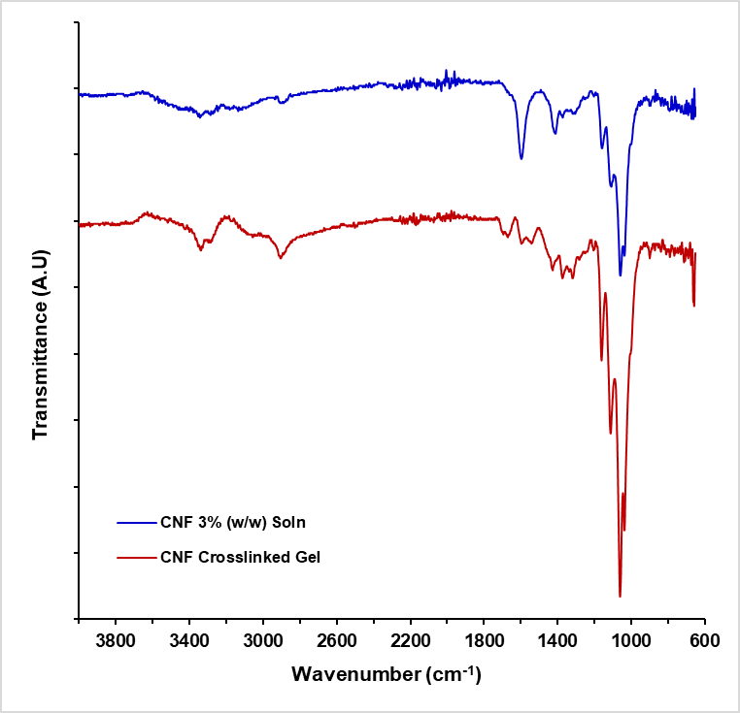

Figure 3. FTIR spectra for 3 % (w/w) carboxymethyl cellulose nanofiber (CNF) solution in deionized water and CNF hydrogels crosslinked with 1-ethyl-3-(3-dimethylaminopropyl) carbodiimide hydrochloride (EDC) in the presence of ethylenediamine and subsequently equilibrated in deionized water.

Protocol

1.6. Fourier Transform Infrared (FTIR) spectroscopy. Place approximately 0.5 mL of 3 % (w/w) CNF solution in deionized water on the sample stage and scan percent transmittance from 650 – 4000 cm⁻¹. Use the same scan conditions and repeat for a CNF crosslinked hydrogel from Step 1.5.

Representative Results:

“To confirm crosslinking, Figure 2 shows FTIR spectra for 3% (w/w) carboxymethyl cellulose (CNF) solutions compared to CNF hydrogels after crosslinking with using 1-ethyl-3-(3-dimethylaminopropyl) carbodiimide hydrochloride (EDC) in the presence of ethylenediamine. Both CNF and crosslinked CNF hydrogels were equilibrated in deionized water prior to FTIR analysis. The 3% (w/w) CNF solution presents a broad peak between approximately 3200 to 3600 cm⁻¹ and is attributed to O-H stretching ²⁸. The prominent peak at 1595 cm⁻¹ is likely attributed to the vibration of the -COO⁻Na⁺ groups on the carboxymethyl cellulose nanofibers ²⁹. After crosslinking the carboxymethyl cellulose nanofibers with 1-ethyl-3-(3-dimethylaminopropyl) carbodiimide hydrochloride (EDC) in the presence of ethylenediamine, three bonding possibilities result. The first is an effective crosslink between two CNF’s with ethylenediamine forming two amide bonds with carboxylates on the CNF’s. The second is ethylenediamine forming a single amide bond with a CNF carboxylate with a primary amine at the other end of the diamine molecule. The third possibility is EDC forming an unstable o-acylisourea intermediate that hydrolyzes to reform the initial carboxyl group ³⁰.

After crosslinking, the broad O-H absorption band between 3200 to 3600 cm⁻¹ decreases, with the emergence of prominent peaks at 3284 and 3335 cm⁻¹, attributed to primary amines and amide bonds resulting from both amides of crosslinked CNFs, and single amide bonds between CNFs and ethylenediamine resulting in a primary amine at the terminal end of the ethylenediamine molecule ^{28,31}. The peak at 2903 cm⁻¹ associated with C-H stretching becomes more prominent after crosslinking and is attributed to the increased presence of -NH₃⁺ from the terminal primary amines. The decrease in the carbonyl stretch at a wavenumber of 1595 cm⁻¹ is attributed to the decreased number of -COO⁻Na⁺ groups due to crosslinking with ethylenediamine. The formation of amide bonds due to crosslinking is seen in the amide peaks at 1693 and 1668 cm⁻¹, as well as at 1540 cm⁻¹, and a small peak at 1236 cm⁻¹ ^{28,29,31}. ”

References:

28. Coates, J. in A Practical Approach. In Encyclopedia of Analytical Chemistry doi:10.1002/9780470027318.a5606 (ed R. A. Meyers and M. L. McKelv) (2006).
29. Wang, S. et al. Cellulose nanofiber-assisted dispersion of cellulose nanocrystals@polyaniline in water and its conductive films. RSC Advances. 6 (12), 10168-10174, (2016).
30. Grabarek, Z. & Gergely, J. Zero-length crosslinking procedure with the use of active esters. Analytical Biochemistry. 185 (1), 131-135, (1990).
31. Shabanpour, B., Kazemi, M., Ojagh, S. M. & Pourashouri, P. Bacterial cellulose nanofibers as reinforce in edible fish myofibrillar protein nanocomposite films. International Journal of Biological Macromolecules. 117 742-751, (2018).

One possible application like catalytic experiments can also be done.

The CNF-Pd aerogels were tested using cyclic voltammetry for ethanol oxidation in a 1 M KOH and 1 M ethanol solution with the resulting CV curve shown in the figure below where current is normalized to the palladium mass of the CNF-Pd composite aerogel. The scan rate was 50 mV/s and the second cycle is shown. The forward and reverse current peaks occur at -0.18 V and -0.29 V (vs Ag/AgCl), respectively, with a forward to reverse current ratio of 3.4. While the current peaks voltages are similar to previous reports of palladium aerogels (Fu, et al. ACS Appl. Mater. Interfaces 2015, 7, 13842−13848; Douk, et al. Electrochim Acta 275 (2018) 182e191), the peak magnitudes are approximately an order of magnitude lower on a per mass basis. This suggests that despite achieving metal composition as high as 75 % in the CNF-palladium aerogel composites, the electrical conductivity is not sufficient for complete current distribution throughout the aerogel. As a continuation of composite materials development, our group has been pursuing means of pyrolyzing the CNF framework of the aerogels to increase conductivity, as well as integrating carbon nanotubes within the CNF hydrogel templates.

The authors fully agree that a catalytic application would be a worthwhile addition to the manuscript; however, given that the composite material does not currently achieve similar catalytic current densities for ethanol oxidation as pure palladium aerogels on a per mass basis, we recommend that the manuscript remain focused on the synthesis method, retaining the cyclic voltammetry results in H₂SO₄ in Figure 8 (previously Figure 7) to demonstrate the metallization of the aerogel composite.

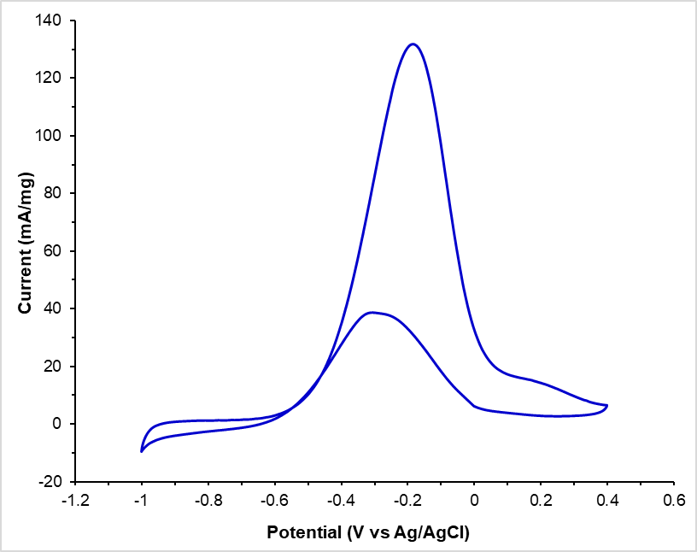
Figure. Cyclic voltammetry of CNF-palladium composite in 1 M KOH and 1 M ethanol at a 50 mV/s scan rate. Current (mA/mg) is normalized to the mass of palladium in the aerogel composite.

Reviewer #2:

Manuscript Summary:
The manuscript is well-written and interesting to a broad audience. It deserves publication in JOVE after the following comments are addressed.

Major Concerns:
- Authors must provide more detailed information about the aqueous dispersion of carboxymethyl cellulose nanofibers (fiber morphology, charge density, solution pH...). Also, how is the sonication temperature controlled (was the sonication conducted in an ice bath)?

Carboxymethyl cellulose nanofibers with Na⁺ counterions were purchased from the University of Maine Process Development Center. The freeze dried TEMPO oxidized nanofibers have a nominal length of approximately 300 nm with a width of 10-15 nm confirmed with atomic force microscopy. The concentration of -COO⁻Na⁺ is 1.2 mmol/g of dry powder and the pH of the indicated 3% (w/w) solution was approximately 5. To provide this additional information and context for the CNF solutions, the following text was added to the first paragraph of the Discussion section:

“The TEMPO-oxidized cellulose nanofibrils used in this study had a nominal -COO⁻Na⁺ density of 1.2 mmol/g with approximate length and width of the cellulose nanofibers of 300 and 10 nm, respectively, and the 3 % (w/w) solutions had a pH of 5. Likely due to the short fiber length, crosslinking at concentrations 3 % (w/w) and less did not result in stable hydrogels. Centrifuging the 3 % (w/w) solutions to compact the fibers to an approximate concentration of 3.8 % (w/w) resulting in well crosslinked hydrogels that were stable during the electrochemical reduction of palladium step.”

Sonication was performed in a temperature controlled ultrasonic cleaner purchased from MTI (product number EQ-VGT-1860QTD). The materials list was updated with this information.

- Degassing conditions for the nitrogen sorption analysis are missing.

The samples were vacuum degassed for 24 h at room temperature prior to measurement. The following Step and Note was added in conjunction with the addition of the Step 4 material characterization steps:

4.4. Nitrogen gas adsorption-desorption. Degas samples for 24 h at room temperature. Use nitrogen at -196 °C as the test gas with equilibration times for adsorption and desorption of 60 s and 120 s, respectively.

Note: Elevated degas temperatures are not recommended to avoid decomposition of the cellulose nanofibers.

- Heating rate for the thermogravimetric analysis is missing.

The heating rate for the presented thermogravimetric analysis is 10 °/min. This heating rate is now specified in Step 4 and reads as,

“4.3. Thermal gravimetric analysis (TGA). Place the aerogel sample in the instrument crucible. Perform analysis by flowing nitrogen gas at 60 mL/min and heating at 10 °/min from ambient temperature to 700 °C.”

Minor Concerns:
- Please ensure a consistent space between numerical values and units (e.g. line 114).

The value and unit spacing was corrected on Line 114 and spacing was verified throughout the document.

- In the introduction, please note that TEMPO oxidized cellulose nanofibers were recently used as both templating and reducing agent to prepare Pd@cellulose aerogels (Gu et al. Applied Catalysis B 2018. 237, 482-490).

The introduction has been modified to address the multiple uses of TEMPO-oxidized cellulose nanofibers and added the indicated reference added to References. The second paragraph of the introduction now includes,

“Further, TEMPO-oxidized cellulose nanofibers have been used both as a biotemplate and reducing agent in the preparation of palladium decorated CNF aerogels.²⁷”

- Authors should discussed the possibility of Pd leaching.

The authors acknowledge the reviewers concern and agree that palladium leaching is a significant concern for practical catalytic applications and extended material use. The Discussion section was expanded to include,

“Another potential issue with extended use of the CNF-palladium aerogel composite for catalytic applications is palladium leaching with detachment of palladium nanoparticles from the CNF template.”

Reviewer #3:

Manuscript Summary:
This manuscript provides a method for the synthesis of chemically crosslinked cellulose nanofiber hydrogels that are then metallized by reduction of palladium salts within the hydrogel. The composite material then undergoes supercritical drying to yield palladium aerogels. The diffusion times recommended for infiltration of all reagents in this process has been optimized to ensure uniformity throughout the material. Further, the authors show tunable metal content of the composite corresponding to the starting concentration of the metal salts. Overall, the authors show multiple advantages of this method including the resulting robust structural integrity and shape control of the aerogels.

Major Concerns:
None

Minor Concerns:
- What is meant by the term "electrically addressable," mentioned both in the abstract and introduction?

The phrase “electrically addressable” was intended to connote “conductivity.” To avoid confusion this phrase was deleted from the Abstract and last paragraph in the Introduction.

- Can the authors comment in the introduction about the interaction between palladium and the cellulose nanofibers during the reduction process? Additionally, is there any insight into how this process yields robust aerogels, ie is this attributed to the chemical crosslinking or to the strength of cellulose nanofibers?

The mechanical robustness of the CNF hydrogels and resulting composite aerogels is attributed to the chemical/covalent crosslinking mediated by EDC. Physically entangled CNF hydrogels concentrated using the same method as detailed in Step 1.3, but not covalently cross-linked, do not remain fully intact during and after the chemical reduction step with sodium borohydride. To reflect these observations, the Discussion section was modified to now include,

“CNF hydrogels not covalently crosslinked with EDC did not remain fully intact during the electrochemical reduction step.”

- In the Hydrogel Preparation procedure, it may be helpful to comment on the expected observations during the step of concentrating the 3 % cellulose solution. Is there a noticeable change in viscosity by centrifugation? Is there a clear interface between clarified water and concentrated cellulose or a density gradient? Is the final concentration calculated based on the remaining volume after decanting the supernatant?

Centrifugation results in a concentrated layer of cellulose nanofibers at the bottom of the microfuge tube that is translucent white in color and distinct from the supernatant above with a clearly observable interface. The approximately 3.8 % (w/w) concentration of the concentrated solution was calculated based on the volume of supernatant removed. The resulting concentrated CNF solution is noticeably more viscous than the 3 % (w/w) CNF solution.

Based on the discussion above,the Note after Step 1.3. was modified to read,

“Note: After centrifuging, the cellulose nanofiber solutions present a distinct interface between the concentrated CNF’s and the clear supernatant. Based on removal of the excess water, the final CNF concentration will be approximately 3.8 %.”

- In the Palladium Reduction procedure, is it expected that observable diffusion of palladium particles will occur during the rinsing step, or is the majority of the palladium solution cellulose bound?

No diffusion of palladium particles were observed to diffuse away from the CNF hydrogels during the reduction step and no palladium particles were observed at the bottom of the reaction tubes after reduction was complete. The following line was added to the first paragraph of the Discussion,

“Further, no palladium nanoparticles were observed to diffuse away from the CNF-palladium aerogel composites during the reduction step suggesting that all of the reduced palladium is bound within the resulting aerogels.”

- Overall, the procedure would benefit from providing recommended ratios between reagents in addition to the specific volumes used. For example, the ratio of cellulose, palladium salt solution, and sodium borohydride volumes appears to be 0.25X, 1X, and 10X. Are these same ratios scalable if the reader wishes to work with different sample sizes?

The author team agrees that generalizing the solution concentrations to ratios would be helpful for scaling up the material synthesis. Given the dependence on chemical species diffusion, and the practical limitations on aerogel monolith size, we recommend maintaining the specific volumes indicated in the manuscript protocol. Our group is currently exploring methods to extend this synthesis approach to larger scaled materials to overcome the long diffusion times required.

- While the analytical methods are not part of the procedure described here, it would be helpful for the authors to comment on the purpose of each technique for evaluating the aerogel properties, especially to educate readers who have less expertise in this field.

To add to the descriptions in the Representative Results sections, Step 4 was added to include details on the material characterization. The new Step 4 now reads,

“4. Composite aerogel material characterization.

4.1. Scanning electron microscopy (SEM). Cut the CNF-palladium aerogel with a razor blade to obtain a thin film approximately 1 – 2 mm thick. Affix the thin film sample with carbon tape on a SEM sample stub. Initially use an accelerating voltage of 15 kV and beam current of 2.7 – 5.4 pA to perform imaging.

4.2. X-ray diffractometry (XRD). Place the CNF-palladium aerogel in a sample holder and align the top of the aerogel with the top of holder. Alternatively, place a thin film sample section, as in Step 4.1, on a glass slide. Perform XRD scans for diffraction angles 2Θ from 5 ° to 90 ° at 45 kV and 40 mA with Cu K_{α} radiation (1.54060 Å), a 2 Θ step size of 0.0130 °, and 20 s per step.

4.3. Thermal gravimetric analysis (TGA). Place the aerogel sample in the instrument crucible. Perform analysis by flowing nitrogen gas at 60 mL/min and heating at 10 °/min from ambient temperature to 700 °C.

4.4. Nitrogen gas adsorption-desorption. Degas samples for 24 h at room temperature. Use nitrogen at -196 °C as the test gas with equilibration times for adsorption and desorption of 60 s and 120 s, respectively.

Note: Elevated degas temperatures are not recommended to avoid decomposition of the cellulose nanofibers.

4.5. Electrochemical characterization.

4.5.1. Immerse aerogel samples in 0.5 M H₂SO₄ electrolyte for 24 h.

4.5.2. Use a 3-electrode cell set-up with an Ag/AgCl (3 M saturated) reference electrode, a 0.5 mm diameter Pt wire auxiliary/counter electrode, and the lacquer coated working electrode. Place the lacquer coated wire in contact with the top surface of the aerogel at the bottom of the electrochemical vial.¹²

4.5.3. Perform electrochemical impedance spectroscopy (EIS) from 1 MHz to 1 mHz with a 10 mV sine wave.

4.5.4. Perform cyclic voltammetry (CV) using a voltage range of −0.2 to 1.2 V (vs. Ag/AgCl) with scan rates of 10, 25, 50, 75, and 100 mV/s.”

