 | MAX-PLANCK-INSTITUTE  of Experimental Medicine |  | 
−Electron Microscopy Core Unit−  Department of Neurogenetics  Hermann-Rein-Str. 3  D -37075 Göttingen  Germany |  | Wiebke Möbius, PhD  Phone.: +49 (551) 3899 786  e-mail: moebius@em.mpg.de

Vineeta Bajaj, PhD
JoVE, Editorial Office
1 Alewife Center
Suite 200
Cambridge, MA 02140

Göttingen, November 12, 2018

Resubmission 59156_R1 "Biological sample preparation by high-pressure freezing, microwave-assisted contrast enhancement and minimal resin embedding for volume imaging"

Dear Dr. Bajaj,

In the attached rebuttal document we carefully addressed the editorial comments. We have rewritten the summary and the discussion, added references and changed the text. We hope that the manuscript meets now all the requirements for publication on JoVE.

Thank you for handling our manuscript and I am looking forward to your response.

Sincerely,
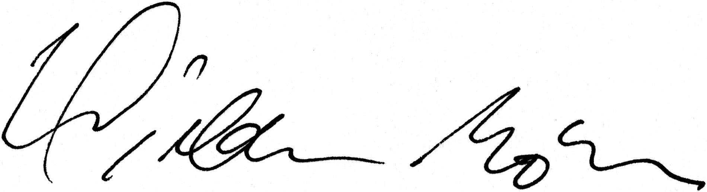

(Dr. Wiebke Möbius)

Editorial comments:
1. The editor has formatted the manuscript to match the journal's style. Please retain the same.
2. Please address all the specific comments marked in the manuscript.

Our answers:
We kept the style and addressed all the comments.

3. For the protocol section, please use imperative tense as if you are directing someone how to do your experiment with all specific details.

Our answer: we applied this rule

4. Please make the protocol crisp but only having one action step per sentence. There can be 2-3 action steps in one step. Please only provide hard experimental steps, knob turns, graphical user interface in the protocol section.
5. Please do not have paragraphs but make substeps instead.

Our answer: We separated protocol steps for more clarity and included substeps.

6. Once formatted please ensure that the protocol is no more than 10 pages and the highlighted portion is no more than 2.75 pages including heading and spacings.

We reduced the highlighted portion to 2.75 pages.

7. Please ensure that there is a result for every section of the protocol.

Our answer: for every protocol section there is a visible result.

8. Please proofread the manuscript carefully before submitting.

Our answer: We did our best.

9. Please obtain explicit copyright permission to reuse any figures from a previous publication. Explicit permission can be expressed in the form of a letter from the editor or a link to the editorial policy that allows re-prints. Please upload this information as a .doc or .docx file to your Editorial Manager account. The Figure must be cited appropriately in the Figure Legend, i.e. “This figure has been modified from [citation].”

Our answer: We did not reuse any figures from published work.

