Major Concerns:
My main concern is that the authors just concentrated on male rats. The authors should have attempted to optimize the same protocol with female rats. A submissive female rat should be used as the test animal and its inhibitory control should be tested towards a male rat.

Reply: The estrous cycle of female rats can affect their sexual motivation to male rats, and then affect their behaviors in this conflict task. Probably for the similar reason, most of behavioral studies use male rats as subjects. Therefore, in order to introduce an alternative behavioral model for most scientists, we firstly used male rats as subjects for testing inhibitory control under this conflict task. Attempting to examine female rats’ inhibitory control with this task will be very interesting and also lack of study so far.

Moreover, since the authors claim that this protocol can be used to test reward-seeking inhibitory control following stress the authors should provide data that supports this notion. The data that they present do not show a significant differences between stress vs control group and the number is to small to support a bi-modal distribution.

Reply: Thanks for pointing out the shortage of the animal number. There is no significant difference in approaching behaviors between the stress and control groups, probably mainly because the acute stress did not affect or even decreased animals’ approaching behaviors, but increased approaching behaviors only in a small subpopulation (Figure 4b). Actually this bi-modally distributed individual difference was sort of result beyond our expectations, otherwise we would have recruited more animals when performing this experiment. However, what makes us be confident with this result is that we also found an exactly similar bi-modal distribution after exposure to the same stress procedure in another cohort of male rats pretreated with morphine. (Please see the supplementary figure adjusted from Bai et al., 2017). Hence we hoped to share this result with more scientists.
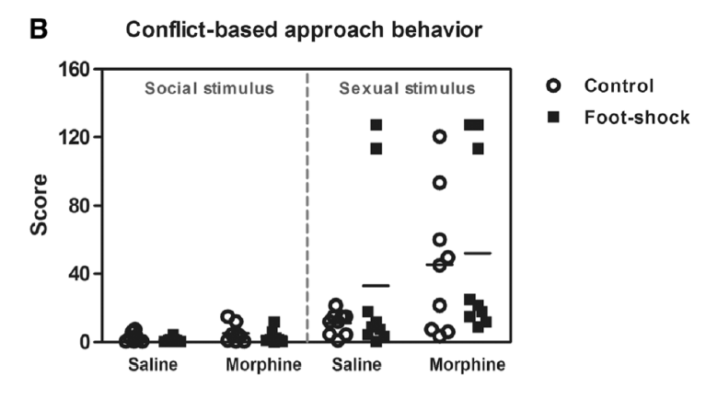
Minor Concerns:
It's not clear to me what the authors mean by inhibitory control. That lies between impulsivity and decision-making. Do the authors believe that this test investigates both aspects or yield towards one f them? Please clarify

Reply: Inhibitory control is the main component of executive function, and it refers to an adaptive ability to suppress inappropriate behavior or unrelated information interference (Miyake et al., 2000).

In the conflict task in this paper, male rats need to make decisions on approaching sexual rewards (estrus female rats) or avoiding aversive stimuli (pins), in another word, inhibiting their appetitive behaviors due to the presence of pins. Hence, the ability of inhibitory control plays a role in this behavioral process and influence the behavioral output.

Impulsivity is a trait of an individual, and also can be a kind of state (e.g., abused drugs can increase impulsivity). Hence, inhibitory control also is involved in impulsivity. The individuals with impairment of inhibitory control usually behave impulsively and/or compulsively.

Under this conflict task (or, this simple decision making task), the individuals displaying maladaptive appetitive behaviors may have high impulsivity/compulsivity.

The authors present their data as "Score". What the score is? Timme spent in sec for the rats to surpass the pins? Please clarify

Reply: The score was used to evaluate to what extent the rats were willing to climb or jump over the obstacle in spite of the aversiveness of the pins. The amount of difficulty the male subject conquered every time to approach the stimulus cage was graded and summed up to the total score for each subject.

Reference.
Bai, Y., Belin, D., Zheng, X., Liu, Z., Zhang, Y. Acute stress worsens the deficits in appetitive behaviors for social and sexual stimuli displayed by rats after long-term withdrawal from morphine. Psychopharmacology, 234:1693–1702(2017).
Miyake, A., Friedman, N. P., Emerson, M. J., Witzki, A. H., Howerter, A., & Wager, T. D. The unity and diversity of executive functions and their contributions to complex "frontal lobe" tasks: A latent variable analysis. Cognitive Psychology, 41, 49–100. (2000).

