Major Concerns:
1. How did the authors design the grading for the amount of difficulty the subject conquered per approach shown in Fig.5? What is the scientific evidence under this evaluation?

Reply: The conflict task introduced in this article is a new behavioral paradigm which was designed based on both the understanding of inhibitory control/compulsivity and our own experiences.

It has been well known that abused drugs can impair the ability of inhibitory control which is critically involved in compulsive drug-seeking behaviors and relapse (1,2). Some previous studies usually evaluate animals’ operant responses that lead to drug reward as well as a probability of negative outcome (e.g., foot shock or quinolinic acid), and in that situation, the conflict is introduced in nature. The negative outcome-resistant responding, i.e., perseverative responding, is defined as compulsive drug seeking and taking behavior (3,4,5,6). Therefore, we established the present conflict task in which animals also face the risk of negative consequences (being pricked), aiming to reveal the impairment of the ability of inhibitory control in opiate-treated animals.

In this conflict task, we graded the difficulty of the obstacle according to the height of the barrier as well as the dangerous level of the pins. The validity of this conflict task is evidenced by our findings that morphine-treated animals always displayed more perseverative appetitive behaviors than saline-treated animals. In addition, we found the inter-individual difference in the perseverative appetitive behaviors within the morphine-treated group, well resonating with the findings that there also exist individual differences in compulsive drug-seeking behaviors induced by abused drugs/substances (3,6). We also found that inactivation of the anterior cingulate cortex (which is involved in conflict and inhibitory control) increased perseverative appetitive behaviors in saline-treated animals (unpublished data in our lab), further verifying that this task is suitable for investigating the ability of inhibitory control under various conditions..
2. The authors mentioned that this conflict task is much simpler and easier to perform, since it only consists of single reward and single risk at line 414-415. I agree that this task is very simple. However, this task contains two risks, not single risk: the pins and the height of board. Only the height of board works as difficulty/cost for reward-seeking behavior. What do the authors think of this point?

Reply: As a matter of fact, this task was developed from another task that we had designed to investigate the effort-based reward-seeking behaviors. In that task, a barrier was placed between male subject and sexual stimulus, and repeatedly heightened over trials (Fig B). In our opinion, the effort-based task is not related to risk since animals only need to pay labor but never face any negative consequences. Hence, the effort-based task is suited for evaluating the motivation of animals, like the progressive ratio procedure of operant reinforcement. In the conflict task, the pins imply the risk that animals have to face and suffer to approach the rewarding stimulus. Hence, we tend to regard the combination of pins and board as a risk or cost.
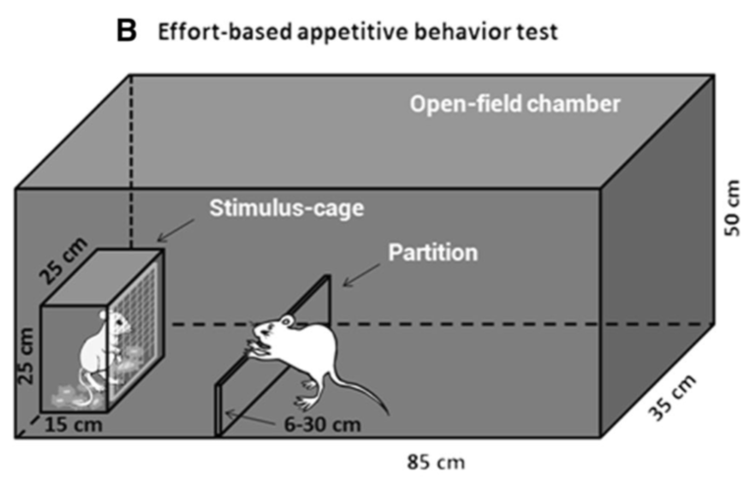

3. To investigate the influence of stressful events on the ability of inhibitory control in animals, the authors performed acute stress experiment of foot-shock. The authors analyzed the chronic effects of binge-like morphine treatment. Thus, chronic stressful events other than acute stressful events would be more intriguing.

Reply: Thank you for this suggestion. Investigating the influence of chronic stress on inhibitory control under this conflict task will be interesting, for example, the influence of chronic stressful events occurring at puberty on the development of inhibitory control in adulthood.

Minor Concerns:
On several lines in the protocol part, highlights with yellow color are observed. What do these highlights mean?

Reply: The highlights are required by JoVE for showing the video scripts.

Reference.
1. Belin, D., Belin-Rauscent, A., Murray, J. E., & Everitt, B. J. Addiction: failure of control over maladaptive incentive habits. Curr Opin Neurobiol. 23(4), 564-572. (2013).
2. Everitt, B. J. Neural and psychological mechanisms underlying compulsive drug seeking habits and drug memories--indications for novel treatments of addiction. Eur J Neurosci. 40(1), 2163-2182. (2014).
3. Giuliano, C., Y. Pena-Oliver, et al. "Evidence for a Long-Lasting Compulsive Alcohol Seeking Phenotype in Rats." Neuropsychopharmacology. (2017).
4. Pelloux, Y., B. J. Everitt, et al. "Compulsive drug seeking by rats under punishment: effects of drug taking history." Psychopharmacology 194(1): 127-137. (2007).
5. Vanderschuren, L. and B. J. Everitt. "Drug seeking becomes compulsive after prolonged cocaine self-administration." Science 305(5686): 1017-1019. (2004).
6. Deroche-Gamonet, V., D. Belin, and P.V. Piazza. Science. 305(5686): p. 1014-1017. (2004).

