Hereby we submit the revision for the manuscript “Full-field strain measurements for microstructurally small fatigue crack propagation using digital image correlation method”. We thank the reviewers for the instructive comments of the manuscript.

Response to Editorial and production comments
Following suggestions:
1. Please take this opportunity to thoroughly proofread the manuscript to ensure that there are no spelling or grammar issues.
The manuscript was proofreaded and corrected.
2. Please revise lines 134-136, 164-167, 196-199 to avoid previously published text.
The lines was revised and corrected as shown in lines 280-283, 299-301, 250-253.
3. Please avoid abbreviations in the title.
The abbreviation in the title of the manuscript was removed.
4. Please provide an email address for each author.
Email address was provided for each author.
5. Please spell out each abbreviation the first time it is used.
Each abbreviation were spelled out the first time it is used.
6. Please use SI abbreviations for all units: L, mL, µL, h, min, s, etc.
SI abbreviations were used for all units.
7. Please include a space between all numerical values and their corresponding units: 15 mL, 37 °C, 60 s; etc.
Space between all numerical values and their corresponding units was included.
8. JoVE cannot publish manuscripts containing commercial language. This includes trademark symbols (™), registered symbols (®), and company names before an instrument or reagent. Please remove all commercial language from your manuscript and use generic terms instead. All commercial products should be sufficiently referenced in the Table of Materials and Reagents. You may use the generic term followed by “(see table of materials)” to draw the readers’ attention to specific commercial names. Examples of commercial sounding language in your manuscript are: Outokumpu Stainless Oyj, LaVision, MatLab, etc.
The commercial language was removed from the manuscript and replaced using generic terms followed by reference “(see table of materials)”.
9. Please adjust the numbering of the Protocol to follow the JoVE Instructions for Authors. For example, 1 should be followed by 1.1 and then 1.1.1 and 1.1.2 if necessary. Please refrain from using bullets, dashes, or indentations.
The numbering of the Protocol was adjusted.
10. Please revise the protocol text to avoid the use of any personal pronouns (e.g., "we", "you", "our" etc.).
The protocol text was revised and all personal pronouns was removed.
11. Please revise the protocol to contain only action items that direct the reader to do something (e.g., “Do this,” “Ensure that,” etc.). The actions should be described in the imperative tense in complete sentences wherever possible. Avoid usage of phrases such as “could be,” “should be,” and “would be” throughout the Protocol. Any text that cannot be written in the imperative tense may be added as a “Note.” Please include all safety procedures and use of hoods, etc. However, notes should be used sparingly and actions should be described in the imperative tense wherever possible. Please move the discussion about the protocol to the Discussion.
The Protocol was revised. The Protocol steps were rewritten in imperative mode. Safety procedures were added with appropriate references.
12. The Protocol should be made up almost entirely of discrete steps without large paragraphs of text between sections. Please simplify the Protocol so that individual steps contain only 2-3 actions per step and a maximum of 4 sentences per step. Use sub-steps as necessary. Please move the discussion about the protocol to the Discussion.
The Protocol steps were simplified reducing the number of sentences per individual step and using sub-steps. The discussion about protocol was moved to the Discussion.
13. Please add more details to your protocol steps. There should be enough detail in each step to supplement the actions seen in the video so that viewers can easily replicate the protocol. Please ensure you answer the “how” question, i.e., how is the step performed? Alternatively, add references to published material specifying how to perform the protocol action. See examples below.
More details were added to the protocol steps. References [19], [20], [23], [24] were added to specify the actions of the Protocol steps.
14. Line 140: Please describe how to use Vickers microindentations.
The procedure of microindentation and use of the Vickers marks was described in more details as shown in lines 155-163, 229-231.
15. Line 143: Please describe how to perform electron backscatter diffraction (EBSD) analysis.
The procedure of EBSD analysis was described in lines 164-173.
16. Line 144: Please describe how this is done.
The procedure was specified in lines 224-226.
17. Line 153: Please specify the purity of ethanol.
Purity of ethanol was specified in table of materials.
18. Line 154: Please describe how.
The procedure was specified in lines 179-180.
19. Line 171: Please describe how to run the fatigue test.
The procedure was specified in lines 193-197.
20. Figure 1: Please indicate the unit for the numbers shown in the figure.
The unit was specified in the figure name. Please see the line 248-249.
21. Figure 2 and Figure 4: Please use the micro symbol µ instead of u.
Figures 2 and 4 were corrected.
22. Discussion: As we are a methods journal, please also discuss critical steps within the protocol, any modifications and troubleshooting of the technique, and any limitations of the technique.
The critical steps were discussed in lines 268-271, 286-288, 292-294.
23. For in-text references, the corresponding reference numbers should appear as superscripts after the appropriate statement(s) in the text (before punctuation but after closed parenthesis). The references should be numbered in order of appearance.
The references were updated and placed after appropriate statements.
24. Please ensure that the references appear as the following: [Lastname, F.I., LastName, F.I., LastName, F.I. Article Title. Source. Volume (Issue), FirstPage – LastPage (YEAR).] For more than 6 authors, list only the first author then et al. See the example below:
Bedford, C.D., Harris, R.N., Howd, R.A., Goff, D.A., Koolpe, G.A. Quaternary salts of 2-[(hydroxyimino)methyl]imidazole. Journal of Medicinal Chemistry. 32 (2), 493-503 (1998).
The style of references was updated according the comment.
25. References: Please do not abbreviate journal titles.
The journal title abbreviations were removed.
26. Table of Equipment and Materials: Please sort the items in alphabetical order according to the Name of Material/ Equipment.
The items of table of materials were sorted in alphabetical order.
Changes to be made by the Author(s) regarding the video:
1. 01:21, 01:44, 03:46, 04:18, 05:07, 05:23, etc.: Please use the micro symbol µ instead of u.
The micro symbol u was replaced by µ in video.
2. 04:44: Different from the video, the written protocol does not have step 6. Please include it in the manuscript.
The Step 6 was included in Protocol in lines 212-233.
3. The video must have chapter title cards to show the video is changing from one section to the other.
Chapter title cards were added in the video.
4. Branding concerns
• 0:01 - The university logo should be removed from the opening title card. It can remain at the end of the video.
The university logo was removed from the opening title card.
• Please remove all commercial language references from the video and use generic terms instead. All commercial products should be sufficiently referenced in the Table of Materials and Reagents. Examples of commercial sounding language are: Outokumpu Stainless Oyj, LaVision, MatLab, etc
Commercial language was removed from the video.
5. Text/formatting issues
• 5:23 - A chapter title card that reads "Representative Results" should be added here. This will be necessary for the chaptering feature on our website.
The title card “Representative results” was added to the video.
6. Please upload a revised high-resolution video here: https://www.dropbox.com/request/BwkGIFoIbsq1n8HFrAtN
The updated high resolution video was uploaded using the link.
Response to Reviewer #1 comments
Major Concerns:
Page 1, lines 32-34: « At the same time, the intensity of the shear strain localization seems to be dependent on the grain orientation » This information appears only in the abstract and is not discussed in the paper nor in the video. Could the authors discuss this aspect in the paper as they present results about grain orientation (cf Fig. 2)
Target of the present work is to describe the method used to study the mechanism of small fatigue crack propagation described in details in Reference [18] of the manuscript. In order to avoid misunderstanding we changed the emphasis by modification of Abstract.
Page 4:
Lines 151-152: How is the silicone stamp fabricated? Do the authors compare several pattern before choosing this one? Please provide more information as I doubt that the stamp is so easy to obtain and as it seems to me that the pattern with such a spatial resolution is the most important part of the proposed methodology.
The silicone stamp used in the present work is the result of the ongoing research in our university. All information related to pattern quality and stamp fabrication process can be found in Reference [22] and [23] of the manuscript. The manuscript was updated with respect to the pattern properties (lines 184-186, 289-292) and additional Reference [23] included.
Page 5:
Lines 174-176: Please provide more details about DIC with LaVision with at least the spatial resolution of DIC and the images that were used for correlation, i.e. the reference and deformed images that allow to measure a cumulative strain. How is the crack growth rate computed: crack tip identification from the raw image or from DIC? In the video it is said that LaVision is used? Is there a fitting of the crack length as a function of the number of cycles? The CGR is not presented into details in the paper but it is shown in the video so it would be useful to detail how it is obtained.
The information about spatial resolution of DIC and images as well as the correlation method was described in lines 200-204, 289-296, 299-301. The CGR can be calculated automatically or manually using LaVision software. We use the raw images directly from the camera to calculate the CGR. Since the quality of the raw images is not always good enough to perform the automatic CGR analysis the best and most accurate solution is to make it manually. The procedure is described in lines 213-219.
Page 6: The discussion emphasizes the observation of strain localization zones ahead of the crack tip and suggests there is a link between these zones and "anomalous growth of the small fatigue cracks". On has to look at the video to discover how this link works. It would be nice to have some explanation in the paper. Besides the authors do not explain where these high shear strain localization stem from. Do the authors observe a link between the highly strained area and the grain orientation as indicated lines 33-34?
The present paper is targeted to reveal the experimental approach that allows to study the small fatigue crack growth behavior. The detailed analysis of the relationship between the observed shear strain localization zones, crack growth rate and microstructure was performed and published previously (see Reference [18] of the manuscript). Step of the results analysis was added in Protocol (lines 212-233)
Video:
3min39: Maps of Schmid factor and grain orientation are shown although they are not used after.
In the video, we try to reveal the steps that need to be performed for further cumulative analysis of the results described in reference [18]. Objective of the manuscript is now presented more clearly in Abstract and Introduction of the manuscript (lines 25-35, 92-102).
5min51: The relationship between crack growth rate and strain localization is discussed but not the link between the grain boundaries and grain orientation and strain localization. It would be nice to discuss a little bit more the relationship between short fatigue crack growth and the microstructure that is presented sooner in the video.
Discussion about the relationship between SFC growth and the microstructure is closely related to the studied material. Since we discuss the method, the detailed analysis of the results performed for one particular material is not the objective of this paper. However, the detailed analysis of the link between CGR, strain localization, grain boundaries and grain orientations of the 18%Cr ferritic stainless steel is available in reference [18] and discussed in lines 212-233 of the manuscript.
Minor Concerns:
Page 2, line 52: « such a complicate processes » → such a complicated process
The mistake was corrected. Please see line 51.
Page 3:
Line 126: the sentence has no verb: « 2 Optical monitoring of the initial crack formation after 10 000 cycles. »
The sentence was corrected. Please see line 139.
Line 128: « 3 Repeat the fatigue loading cycle if an initial crack was not produced. ». Please rephrase the sentence as to have subject - verb - complement and be consistent with the previous items.
The sentence was rewritten. Please see line 146.
Page 4, Line 169: Why were the images acquired at a 210MPa stress level which is neither the minimum nor maximum stress of the fatigue cycle? Please justify.
The image acquisition was performed at an average stress of about 210 MPa in order to stabilize plastic deformation. This avoids fatigue crack closure and extensive creep accompanied with min and max of loading force, respectively. Please see lines 302-305.
Page 5:
Line 195: I guess the dimensions in Fig. 1 are in mm. Please indicate it.
The dimensions were indicated. Please see lines 248-249.
Line 202-203: The range of the strain map is not visible. Please use a larger font size.
The font size of the strain map was increased.
Response to Reviewer #2 comments
Manuscript Summary:
The small fatigue crack growth of bcc Fe-Cr ferritic stainless steel has been studied using digital image correlation. The paper is not the first on small fatigue crack growth assessment and is just presenting shortly a standard DIC test. There is almost no scientific analysis of the obtained results. This work can be only classified as a letter with limited novel scientific outcome. The authors are expected to improve the discussion of the results and don't postpone this to their future articles. I'm sorry but I cannot accept this article in its current form. It requires major revision before second submission.
Experimental investigation of the small fatigue crack growth behavior is a complicated task due to the limitations of the experimental techniques. The DIC measurement performed at high magnification using scanning electron microscopy evidences strain localization in vicinity of the crack, however, the ex-situ measurement approach blurs out the details of the deformation field accompanying the short crack propagation (see Ref. [14] of the manuscript). The novelty of the approach consists of in-situ full field strain measurement that allows to reveal the trahsitional details of the strain field evolution during SFC propagation. The proposed approach is novel also due to the unique patterning technique with spatial resolution at least one order of magnitude below the characteristic length scale of the microstructure. Since the JoVE is the journal of methods, in our manuscript we focused on detailed explanation of the experimental procedure of the small fatigue crack growth study over hundreds of thousands of load cycles using DIC, crack growth analysis and microstructure analysis. The scientific analysis of the results obtained using this methodology is already published in ref. [18] of the manuscript. The manuscript was considerably rewritten to emphasize better the main objective of the study.
Major Concerns:
- The authors have mentioned in the text "The most promising tool for analysis of cyclic material deformation behavior at micro-scale is the digital image correlation (DIC) technique.". how do you prove this claim? Did you compare different methods to come to this conclusion? Or it's you imagination? Please provide citation for this statement.
In order to avoid unclear sentence, the text was rewritten in lines 65-68.
- provide the country and city for "Outokumpu Stainless Oyj".
Outokumpu Stainless Oyj is located in Tornio, Finland. The information about location is added in table of materials.
- how did the authors choose the displacement range for pre-cracking the test specimens? Did you use any standard? Please add more details.
The displacement range was chosen experimentally so the σ min and σ max are in range of about -50 MPa and 300 MPa, respectively. The maximum tensile stress should not be over the yield point of the material to avoid extensive plastic deformation. Manuscript was rewritten in lines 134-147, 271-277.
- how the initial pre-crack of 1um was detected? Did you use a potential drop? Or only DIC. Please add a picture of pre-cracked specimen with 1um pre-crack.
Definitely, the crack with only 1 µm length is difficult to observe. We specified the range from 1 µm to 20 µm to show the pre-crack length we typically accept for our tests. The crack with length of about 1 µm is usually difficult to distinguish using optical microscopy, so the pre-cracking test was repeated to get the pre-crack visible. The manuscript text was rewritten in lines 144-145 to exclude the misunderstanding. The typical pre-crack with length of about 20 µm is shown in Fig. 1.
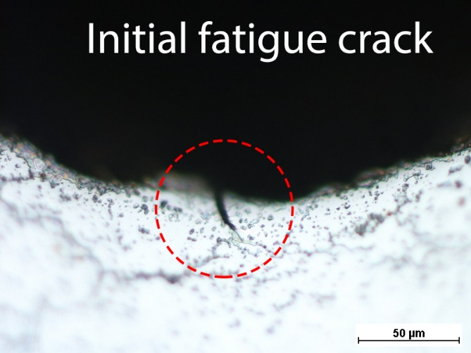 | 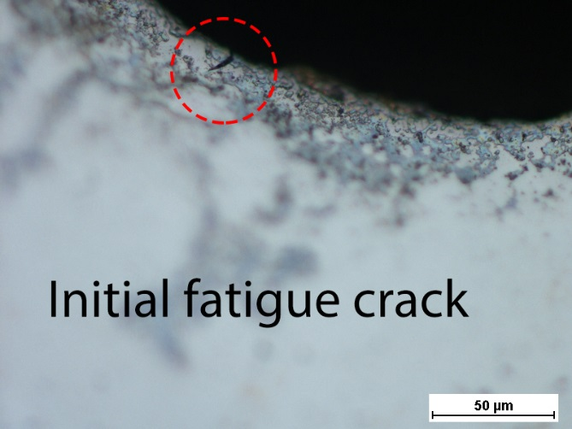
Figure 1. Optical micrograph of the initial fatigue crack produced by pre-cracking procedure.
Minor Concerns:
- Fig. 4 is not well-described, please add some sound scientific description of the observed pattern.
The silicone stamp used in the present work is the result of the ongoing research in our university. All information related to pattern quality and stamp fabrication process can be found in Ref. [22] and [23] of the manuscript (lines 184-188).

Thank you for the substantial comments.

On behalf of authors
Sincerely Yours,
Evgenii Malitckii

