November 12th, 2018
Drs. Alisha DSouza and Aaron Berard
Journal of Visualized Experiments
1 Alewife Center
Suite 200
Cambridge, MA 02140

Dear Drs. DSouza and Berard:
Please find a revised manuscript titled “Behavioral approaches to studying innate stress in zebrafish” by Chin et al., which we are resubmitting for your consideration to the Journal of Visualized Experiments.

The protocol provides steps for measuring innate stress in adult zebrafish using a widely used experimental approach, the novel tank test. The previous submission of this manuscript was reviewed by five reviewers, most of which were favorable. We have now addressed all concerns raised by reviewer’s and the editorial staff of JoVE. Along with the revised manuscript, we are including a detailed response to each reviewer and editorial staff’s concerns. We hope this addressed all of the points raised previously.

We look forward to hearing from you. If you have any questions, please feel free to contact me.

Sincerely,
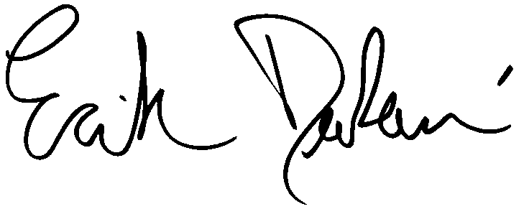
Erik Duboue, Ph.D.
Florida Atlantic University
5353 Parkside Drive
RE Building MC19, Room 205
Jupiter, FL 33458
eduboue@fau.edu
(561) 799-8054

