Editorial comments:
1. 3.1.1: Is only one primer used here?
Response: We have added the reverse primer sequence.
2. 6: This seems to be one of the principal sections of the protocol (e.g., it’s in the summary), but you only have highlighted discontinuous steps and there seems to be some detail lacking; e.g., how exactly do you program the software to take shots? Would it be possible for you to add more detail/highlight more for filming here?
Response: Thanks for the comments! We revised the summary to emphasize both the FRET assay and the stopped-flow technique. We intended to put more emphasis on the FRET assay because this is indeed the novel part of our work. We have now included two references (Biro et al., JoVE, 2010; Patel et al., JoVE, 2014) to help explain the operation of a stopped-flow system and the data analyses. We have also added as many details as we can in Step 6 and 7. Our major consideration is that the protocol of operating a stopped-flow machine highly depends on the brand and model of the equipment, and we are trying to focus on the common steps of our experiment that do not vary from system to system.
The steps we highlighted will form a continuous protocol. Steps we skipped are basically repeating the highlighted ones using different sample solutions, and they would look identical in a film. We now added Step 7 for filming, and although these steps will look the same as Step 6, they aim to measure a different parameter.
Here is a screenshot of the software used to take shots (eg, 6.3.4). We plan to show this in the film.
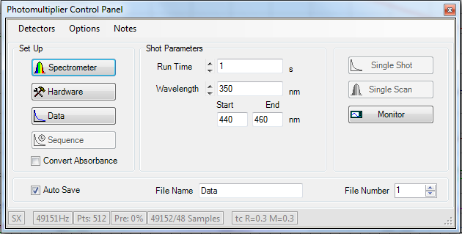
3. 7.2: Where does the Skp1•Skp2 come from? Please add a reference here regarding its production.
Response: We have added the reference.
4. Figure 4: Are exponential fits used here as well?
Response: In Fig 4A-4C, we did not do any fitting (these are to show what raw data one can get and what results are acceptable for analyses). In Fig 4D, we did a linear regression, and the figure legend said “Linear slope gives k_{on} of 1.8 x 10⁷ M⁻¹ s⁻¹”. Steps for data analysis are described in 6.3.8 and 6.4. We have also revised the “REPRESENTATIVE RESULTS” to explain how to treat the data.
5. Please remove ‘Figure 1’/’Figure 2’/etc. from the Figures themselves.
Response: OK.

