Prof Xiaoyan Cao
Review Associate
Journal of Visualized Experiments
USA

2nd November 2018

Dear Prof Cao,

We have provided our responses to the editorial comments below as well as in the manuscript as Tracked Changes.

Editorial comments:
- As we can only film 2.75 pages of the protocol, please review and shorten the highlighted portion to 2.75 pages. Note that the highlighted content should be continuous and contain essential steps of the protocol for the video, i.e., the steps that should be visualized to tell the most cohesive story of the Protocol. Please note that the editor has made some minor changes (e.g., combining some shorter steps) to condense the highlighted content.

Thank-you for your help with this. We have made some additional modifications to the highlighted sections of the protocol so that it is approximately 2.75 pages in length.

- Please address specific comments marked in the attached manuscript.

We have addressed the specific comments marked in the revised manuscript.

Thank-you for considering our revised manuscript for publication in JoVE.

Yours sincerely,

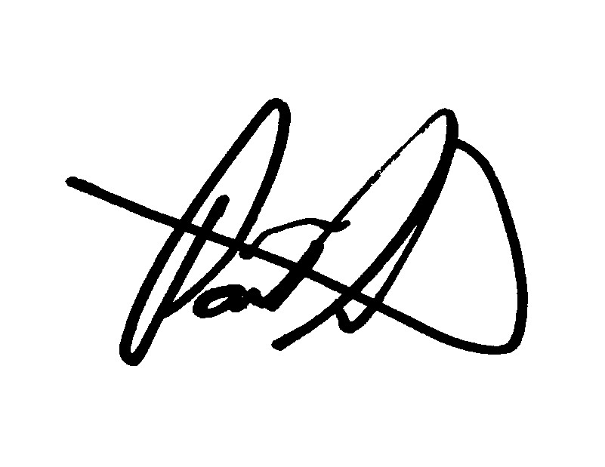

A/Prof Paul Licciardi
Murdoch Children’s Research Institute
Melbourne, Australia

