

8/30/18

Dear Ms. Troyer,

Thank you indeed for the invitation to publish our methods in JoVE. We are flattered by your invitation and agree that JoVE is the perfect forum through which to share our unique methods with others in the scientific community. In this manuscript we describe our method for subcellular fractionation of eukaryotic cells. Our procedure is distinct from subcellular fractionation methods based on detergent solubilization and high speed centrifugation (the two main methods currently employed for subcellular fractionation). Detergent- and high speed centrifugation-based methods have several drawbacks including the inability for detergent-based fractionation to distinguish between cellular organelles and plasma membrane and the prohibitive costs of high speed centrifuges. Our procedure does not include these drawbacks as it is based on digitonin extraction of the cytoplasm followed by differential centrifugation in a standard, refrigerated, benchtop centrifuge. Therefore, we believe this procedure will be useful to investigators who wish to perform an efficient yet cost-effective subcellular fractionation.

Due to the potentially wide-reaching implications of this procedure for others in the scientific community, we believe that JoVE is an ideal journal for its publication. Thank you again for the invitation to publish as well as your time and consideration.

Sincerely,
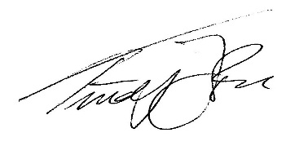

Timothy J. LaRocca, PhD
Assistant Professor of Microbiology
Department of Basic and Clinical Sciences
Albany College of Pharmacy and Health Sciences
106 New Scotland Avenue
Albany, NY 12208

