Response to reviewers’ comments for JoVE manuscript 59015:

We wish to thank the reviewers for their detailed comments, which we have used to improve the manuscript. We have carefully considered each comment and provide our point-by-point responses below indicated in red. We have added 2 figures to the manuscript. Figure 1 shows the correlation between Staphylococcus aureus optical density and concentration, and Figure 2 provides examples of ROIs drawn for image analysis.

Editorial Comments:
• Please take this opportunity to thoroughly proofread the manuscript to ensure that there are no spelling or grammatical errors.
Addressed
• Protocol Detail: Please note that your protocol will be used to generate the script for the video, and must contain everything that you would like shown in the video. Please add more specific details (e.g. button clicks for software actions, numerical values for settings, etc) to your protocol steps. There should be enough detail in each step to supplement the actions seen in the video so that viewers can easily replicate the protocol.
Addressed
1) 1.3: 10-16 weeks?
Addressed
2) 2.3: Which antibiotic at what concentration?
Addressed (10 µg/ml chloramphenicol)
3) 2.4: What is the shaker speed?
Addressed (.134xG or 200RPM)
4) 2.7: Do you have a reference for the relation between OD and CFU?
Yes, this is added to new figure 1.
5) 2.8: Dilute in TSB? How are the CFUs counted? Under a microscope? Mention magnification if so.
Addressed (colonies counted by gross examination)
6) 3.2: What is the oxygen flow rate?
Addressed (2-3 Liters per minute)
7) 3.3: Do you mean “depilatory” instead of dilapidation? Please revise this step for grammar.
Addressed
8) 3.4: % povidone-iodine?
Addressed (10%)
9) 4.2: how do you relate the photon counts to bacterial concentration? Was this calibrated?
These instructions were removed from the manuscript. Bacteria concentration is determined through other methods (OD600 and serial dilutions and plating, which are described in the manuscript), and this process is used by us as a sanity check to verify bioluminescent signal, and isn’t required in the manuscript.
10) 4.4: Mention needle gauge, inoculant max volume, needle angle and depth to ensure that a bubble is formed.
Addressed
11) 4.5: Are there are any post-procedure steps? Please add a step to mention that the animal is monitored until recovery from anesthesia.
Addressed
12) 5.1: Mention oxygen flow rate.
Addressed
13) 5.2: Are there are any post-procedure steps? Please add a step to mention that the animal is monitored until recovery from anesthesia.
Addressed
• Commercial Language: JoVE is unable to publish manuscripts containing commercial sounding language, including trademark or registered trademark symbols (TM/R) and the mention of company brand names before an instrument or reagent. Examples of commercial sounding language in your manuscript are IVIS Spectrum, Becton Dickinson Biosciences, Nanodrop (Thermo Fisher Scientific), buprenex, Perkin Elmer, Living Image 4.3.1 (Caliper Life Science),
1) Please use MS Word’s find function (Ctrl+F), to locate and replace all commercial sounding language in your manuscript with generic names that are not company-specific. All commercial products should be sufficiently referenced in the table of materials/reagents. You may use the generic term followed by “(see table of materials)” to draw the readers’ attention to specific commercial names.
Mention of commercial sounding language was removed from the manuscript.
• Table of Materials: Please revise the table of the essential supplies, reagents, and equipment. The table should include the name, company, and catalog number of all relevant materials/software in separate columns in an xls/xlsx file. Please include items such as bioluminescent S. aureus strain, imaging instrument, animal strain, software etc.
Table of materials was updated.
• If your figures and tables are original and not published previously or you have already obtained figure permissions, please ignore this comment. If you are re-using figures from a previous publication, you must obtain explicit permission to re-use the figure from the previous publisher (this can be in the form of a letter from an editor or a link to the editorial policies that allows you to re-publish the figure). Please upload the text of the re-print permission (may be copied and pasted from an email/website) as a Word document to the Editorial Manager site in the "Supplemental files (as requested by JoVE)" section. Please also cite the figure appropriately in the figure legend, i.e. "This figure has been modified from [citation]."
This manuscript is composed entirely of original data.

Comments from Peer-Reviewers:
Reviewer #1:
Manuscript Summary:
This manuscript describes the development of a bioluminescent model to track neutrophils migration to a wound infected with staphylococcus aureus.
Major Concerns:
Can the authors better explain the results in Figure 2A and B? There does not seem to be much difference in neutrophils flow between uninfected and infected MyD88-/- mice in panel A. What are the repercussion of these data on the described model?
There is a significant difference in trafficking to the wound between the two strains on days 1, 2, & 3 (see below). We point to this defect in neutrophil recruitment as a reason for the increased susceptibility of MyD88^{-/-} mice to succumb to S. aureus infection.
Minor Concerns:
1) Some sentences are broken and will need editing (see end of first paragraph in Introduction)
Addressed
2) section 1.3 "ages 10-16": weeks?
Addressed
3) 4.1 and 4.2: more details should be given about the protocol for bioluminescence. Also would be helpful to quote some ROI values for different bacterial concentrations. as examples
These instructions were removed from the manuscript. Bacteria concentration is determined through other methods (OD600 and serial dilutions and plating, which are described in the manuscript), and measuring the in vivo bioluminescence imaging (BLI) signals provides a real time estimate of the bacterial abundance and spatial density.
4) I think the discussion of the critical steps and pitfalls provided in the Discussion section should be extended, and some of this information should also be included in the Methods.
Content was added to the discussion. Specifically, the pitfalls of using the ALC2906 SH1000 strain were added.
Reviewer #2:
Manuscript Summary:
This is a nice method paper on the use of bioluminescent S. aureus and LysM-EGFP mice to track bacteria and neutrophils during subcutaneous infection. Adequate details are provided to allow the reader to use the method to study host immune responses to staph in vivo.
Minor concerns:
1) Page 3 line 143 - Did the authors use antibiotic selection to maintain optimal bioluminescence after thawing from -80? If not, how quickly is plasmid lost in vitro?
In these studies, thawed bacteria were streaked onto blood agar without antibiotics. Bioluminescence imaging has confirmed that >90% of the colonies produce bioluminescent signals. Since 3-4 colonies are chosen for overnight culture in antibiotics, at least one bioluminescent positive colony is nearly guaranteed to be expanded in overnight culture.
A previous publication from our laboratory (Bernthal et al, PLoS ONE (2010)) using the same strain of SH1000 grown in broth without selection, showed that 97% of SH1000 colonies produced bioluminescent signals on day 3. This frequency dropped to 53% on day 5, and 21% on day 10. Thus, at later time points during the infectious course, the in vivo BLI signals will likely begin to slightly (<1 log difference) underestimate the actual in vivo bacterial burden. This information has been added to the manuscript.
2) Page 4 line 207 - Please define ROI
Region of interest, now written out and abbreviation defined.
3) Page 5 line 255 - How stable is LysM expression level? Does it change with inflammation and recruitment to tissues? This is important because neutrophil number is standardized based on imaging of neutrophils harvested from blood or bone marrow of naïve mice?
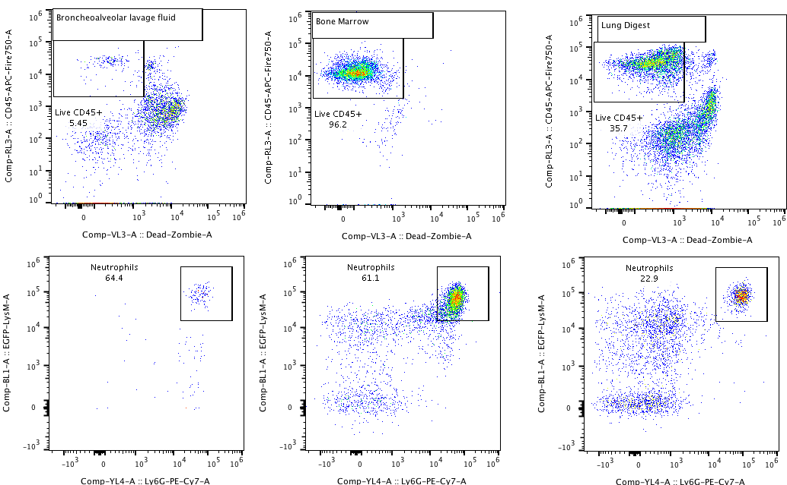
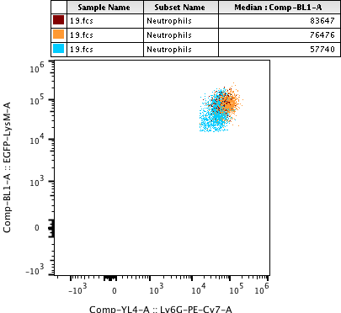
Expression of LysM-EGFP increases in the cytosol of neutrophils as they as mature in the bone marrow, and thus is expressed at slightly higher levels in distal tissues where mature cells traffic. In the plots below, the expression of LysM-EGFP is compared between neutrophils in the bone marrow, neutrophils migrating through the lung parenchyma, and neutrophils that trafficked to the alveolar space. Bone Marrow neutrophils expressed 25% less EGFP than lung neutrophils and 30% less EGFP than BALf neutrophils. When correlating EGFP to neutrophil number, bone marrow neutrophils are used because of the higher quantity that can be isolated. This information has been added the to the manuscript. Because of this difference in EGFP expression between bone marrow and blood neutrophils, it is possible that the number of neutrophils in the wound is overestimated by up to 20%.
4) Page 9 line 397- How rapidly are plasmids lost in vivo and what is a reasonable max length for an experiment given the plasmid is not stably maintained?
This is an important point and additional commentary has been added to the discussion.
Reviewer #3:

Manuscript Summary:
They present standardized approach to monitor bacterial infection of the skin and its progression in a specialized immunocompromised animal model that has GFP neutrophils. This would allow the investigators to correlate PMN with bacteria burden.
Major Concerns:
1) Some explanation of potential crosstalk between the light produced by the bacteria and any impact on GFP signal. Since bioluminescence is generally emitting around 560 nm it is unlikely to be excited by the GFP but since both are colocalized it should be at least addressed. How does this impact cell numbers or is it controlled for. I am worried that the light being produced by the bioluminescence microbes is also able to exciting GFP and thus cause overlap.
The potential crosstalk between in vivo BLI and FLI emission signals in this model is worthy of discussion but is negligible. If we perform experiments without light excitation and only collect in vivo FLI EGFP signals using the 520/20 filter, we do not observe any appreciable signals from infected mice, demonstrating that collected signals are from in vivo FLI EGFP signals and not from overlap of in vivo BLI signals of the bacteria (data not shown). This is primarily due to the signal collection time, which is only 1 second for in vivo FLI and 1 minute for in vivo BLI, and a specific excitation wavelength filter of 465/30 nm and emission filter of 520/20 nm. These settings allow for optimal detection of in vivo FLI EGFP signals without contribution from in vivo BLI signals. This is best demonstrated when comparing the order of magnitude of the y-axis between Figure 3D and Figure 4A. The signals from the in vivo BLI is about 100-fold less than the in vivo FLI of EGFP signals, indicating that the in vivo BLI signals are negligible and contribute to less than 1% of the signals observed from in vivo FLI.
This is an important point and additional commentary has been added to the discussion.
2) Step one on the mouse housing states that your have to derive LysM-eGFP mice and then cross with MyD88-/- from Jax. Seems that for this to be broadly used that the resulting strain should be deposited at Jax or another resource to have more investigators use their model in this protocol.
Upon publication of this manuscript, we will offer to donate this strain to The Jackson Laboratory. In addition, we have made our LysM-eGFP strain available to all investigators who request them and would be willing to provide the LysM-EGFPxMyD88^{-/-} strain as well.
Line 202 - Is it accurate that bacteria concentration is determined prior to injection. It maybe interesting to stress as typically we estimate inoculum by absorbance measures and confirm by overnight incubation of serial dilutions. Here serial dilutions are not being done either.
We use the same technique. Absorbance is used to estimate bacteria concentration. After bacteria is washed and resuspended in PBS, we incubate serial dilutions to confirm concentrations. We updated sections 2.5 and 2.8 to include this information in the manuscript.
Line 129-131 - may need actual protocol number of animal protocols approved depending on the journal requirements.
We do not believe this is required by JoVE, but will be added per request by the editor.
Minor Concerns:
Line 53 - "knocked in" should be replaced, as it is more slang than clear "inserted in" instead.
“knocked in” replaced with “inserted in”
Line 72. There is punctuation missing
punctuation added
Line 87, NET abbreviation is not needed as it is only used once
“NET” removed
Line 182 - may need to add some text on how fully anesthetized is determined since this is a methods paper.
Additional information added in section 3.2
Line 187 - "by be inflammatory" maybe should be "may cause inflammation".
This section was rewritten and should be clearer.
Line 204 - should read more correctly "… image the total bioluminescence signal from the plate for 1 minute." Removed from the submission
Line 207 - pretty sure it is more accurately the LivingImage software not the Spectrum Software.
Use of commercial language is not permitted by JoVE, so this was removed from the submission, but is accurately described in the list of materials.
Line 247 - probably should be PerkinElmer now a days.
Use of commercial language is not permitted by JoVE, so this was removed from the submission, but is accurately described in the list of materials.
Line 366 - not sure what is meant by "dark wild type mice"
The word dark is removed for clarity
Line 403 - needs a comma between citations
Comma added
Reviewer #4:
Manuscript Summary:
Anderson et al convincingly presents a robust method to simultaneously monitor the kinetics of a bacterial infection and the immune response in a longitudinal fashion. They convincingly present the method that includes a breeding strategy to create a knockout reporter strain (LysM-EGFPxMyD88-/-) followed by a wound infection using a bioluminescent bacteria strain they generate (ALC2906 SH1000-Lux). This method presented, albeit not novel, is an important example for the scientific community to replicate in other studies to simultaneously monitoring wound injury with bioluminescent and fluorescent reporters.
Major Concerns:
1. It is not clear why the authors chose to use such a wide range of subjects in Figure 1 (N=3-16).
Longitudinal animal weights were only recorded for a subset of animals (n=3). The other graphs all correspond to 7-16 mice per group. I added this information into the figure legend.
2. The image resolution in both figures 1e and 2c are unacceptable for an imaging paper.
This is the best image resolution possible from the IVIS device and have been widely published by us and others (Cho et al. 2010 & Kim et al. 2011) These images can be removed from the figure set if desired by the editor.
3. Is the measurement of Flux (P/s) a max, median or mean? More in-depth description of the analysis techniques is needed in this manuscript. A potential addition to increase the utility of this manuscript would include a figure to outline how the ROI was drawn and the data interpreted. This is essential since it is well known that optical imaging analysis is highly variable.
The measurement is a mean flux of photon detection. This was added to section 6.2. Figure 2 was added to show methods used to draw ROIs.
4. BLi and FLi is not quantitative, it is semi-quantitative at best. I would recommend that use of the word quantitatively (line 118) be modified accordingly.
Addressed by removal
5. More thorough description of the bacterial strain used.
More detail is provided in section 2.1 regarding the bacteria strain.
Minor Concerns:
None

References

Bernthal, N. M., Stavrakis, A. I., Billi, F., Cho, J. S., Kremen, T. J., Simon, S. I., et al. (2010). A mouse model of post-arthroplasty Staphylococcus aureus joint infection to evaluate in vivo the efficacy of antimicrobial implant coatings. PLoS ONE, 5(9), e12580. http://doi.org/10.1371/journal.pone.0012580

Cho, J. S., Pietras, E. M., Garcia, N. C., Ramos, R. I., Farzam, D. M., Monroe, H. R., et al. (2010). IL-17 is essential for host defense against cutaneous Staphylococcus aureus infection in mice. The Journal of Clinical Investigation, 120(5), 1762–1773. http://doi.org/10.1172/JCI40891

Kim, M. H., Granick, J. L., Kwok, C., Walker, N. J., Borjesson, D. L., Curry, F. R. E., et al. (2011). Neutrophil survival and c-kit+-progenitor proliferation in Staphylococcus aureus-infected skin wounds promote resolution. Blood, 117(12), 3343–3352. http://doi.org/10.1182/blood-2010-07-296970

