October 3rd 2018

Dear Editor,

Please find attached in the submission materials our revised manuscript entitled “Applications of spatio-temporal mapping and particle analysis techniques to quantify intracellular Ca²⁺ signaling in situ” by Bernard T. Drumm, Grant W. Hennig, Salah A. Baker and Kenton M. Sanders for consideration for publication in JoVE. Our manuscript describes detailed protocols used in our laboratory to quantify Ca²⁺ imaging recordings acquired from in situ intact tissue preparations.

As outlined in our original submission, the protocols described in our paper facilitate a more complete analysis and quantification of Ca²⁺ signals recorded from cells in situ using a combination of spatiotemporal map (STM)-based analysis and particle-based analysis. For illustration, the protocols will examine Ca²⁺ signalling in a specialized population of cells in the small intestine, interstitial cells of Cajal (ICC). These protocols can also be applied to other cell types within other preparations and thus should provide a valuable tool for other researchers that wish to more completely describe Ca²⁺ dynamics in their experiments.

We would like to thank the reviewing editor and referees for the careful consideration and examination of our work. After the decision letter received on 09/21/2018 we have completed the revisions requested by the reviewing editor and all 4 reviewers. Our revised manuscript and figures are attached and our point-by-point responses to the editorial and reviewers comments (shown in blue in the document) are also attached.

Thank you for the consideration of our revised manuscript.

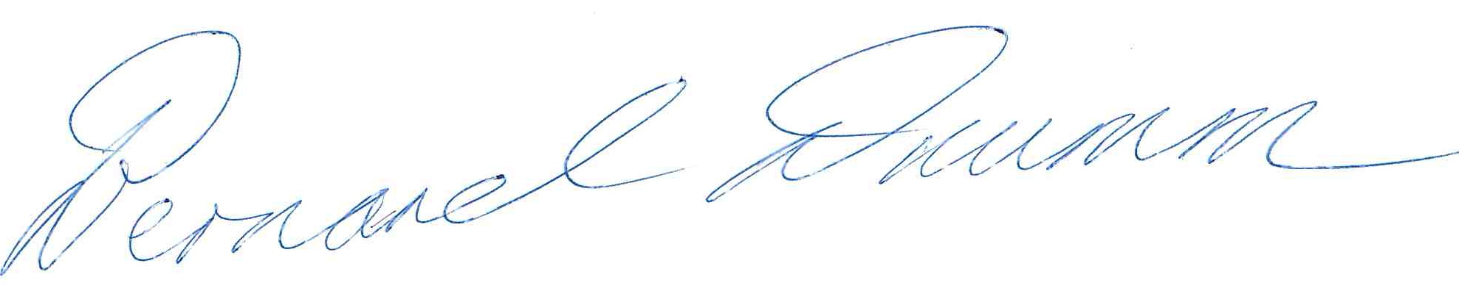
Bernard T Drumm, PhD

