To:
Vineeta Bajaj, Ph.D.
Review Editor JoVE

Leuven, September, 2018

Dear Doctor Bajaj,

Ref: Manuscript JoVE58960

On behalf of all the authors, I would like to thank you for handling out the manuscript ‘Production of adeno-associated virus-based vectors for transgene expression in the central nervous system of adult mice after systemic delivery’ that we submitted.

We have read the points that were raised by both reviewers and the editorial committee and found their critiques to be both considered and fair. Therefore, we have applied several changes in the manuscript and indicated these changes in a point-by-point response letter for the benefit of the reviewers.

We hope the manuscript is now suitable for publication in JoVE and remain available to address any additional concerns.

Sincerely,

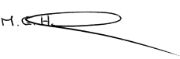

Matthew G. Holt
Corresponding author
VIB-KU Leuven Center for Brain & Disease research.

The editorial comments have been addressed by the authors as follows:

-Please take this opportunity to thoroughly proofread the manuscript to ensure that there are no spelling or grammar issues.
All the authors have thoroughly proofread the manuscript to correct spelling and grammar issues.

-As the authors already paid for Open Access, please print and sign the attached Author License Agreement (ALA) with the Open Access checkbox checked.
The Author License Agreement (ALA) with the Open Access Checkbox checked has been uploaded.

-Please revise lines 426-428, 665-667 to avoid previously published text.
Lines 426-428, 665-667 have been modified to avoid previously published text.
In the revised manuscript the lines originally indicated as 426-428 are now lines 326-328.
Lines originally indicated as 665-667 are now lines 485-487.

-Please define all abbreviations before use.
All abbreviations have been defined prior to their use in the manuscript.

-JoVE cannot publish manuscripts containing commercial language.
All commercial language and company names have been removed from the manuscript.

-Please revise the protocol text to avoid the use of any personal pronouns.
The protocol text has been revised to avoid the use of personal pronouns.

-Please revise the protocol to contain only action items that direct the reader to do something (e.g., “Do this,” “Ensure that,” etc.).
In the manuscript are now included only actions to direct the reader. Actions are now described in imperative tense.

-Lines 188-227, 558-566, etc.: The Protocol should be made up almost entirely of discrete steps without large paragraphs of text between sections. Please move the introduction/discussion about the protocol to the Introduction/Discussion. Please move the solutions, materials and equipment information to the Materials Table.
The protocol has been revised in order to contain exclusively discrete steps. Introduction/Discussion paragraphs, as well as solutions, materials and equipment information have been moved according to the reviewer suggestion. Therefore, new paragraphs have been added to introduction and discussion and have been highlighted.

-Please revise the Protocol steps (1.1, 1.9, etc.) so that individual steps contain only 2-3 actions per step and a maximum of 4 sentences per step. Use sub-steps as necessary.
The protocol has been revised to describe only discrete steps in a maximum of 4 sentences per step. Sub-steps have been included when necessary.
-Lines 319-320, 523-524, 607-608: Please remove the embedded tables from the manuscript. Please upload tables individually to your Editorial Manager account as an .xls or .xlsx file and reference them in the protocol.
Embedded tables have been removed from the manuscript and individually uploaded in an .xls or .xlsx format. Tables have been properly referenced in the protocol.

-In the JoVE Protocol format, “Notes” (Tip in this manuscript) should be concise and used sparingly. They should only be used to provide extraneous details, optional steps, or recommendations that are not critical to a step. Any text that provides details about how to perform a particular step should either be included in the step itself or added as a sub-step.
The number of notes in the manuscript has been reduced. They have been only used when necessary to provide extraneous details, optional steps and recommendations that are not critical to the development of the methodology.

-Please consider moving some of the notes about the protocol to the discussion section. For example, include details in lines 321-329 in a numbered step.
The protocol section has been modified accordingly to the editorial recommendations.
New discrete steps have been added to the protocol starting from step 2.9.1.

-Please reference different panels of Figure 1 in the protocol where these steps are described.
The protocol has been modified in compliance with the editorial advices.

-Line 508: Table 3 does not exist. Please revise.
The manuscript has been revised to correct the issue.

-Table 1: Please use small x for dilution.
The manuscript has been revised accordingly.

-Please remove the title of tables from the uploaded table files. The information provided in the Figure and Table Legends after the Representative Results is sufficient.
The title of tables has been removed from the uploaded table files.

-Please obtain explicit copyright permission to reuse any figures from a previous publication. Explicit permission can be expressed in the form of a letter from the editor or a link to the editorial policy that allows re-prints. Please upload this information as a .doc or .docx file to your Editorial Manager account. The Figure must be cited appropriately in the Figure Legend, i.e. “This figure has been modified from [citation].”
We confirm that Dr. Melvin Y. Rincon retains copyright on the figures 4A, 4B included in the manuscript “Production of adeno-associated virus-based vectors for transgene expression in the central nervous system of adult mice after systemic delivery”. The figures were previously published in “Widespread transduction of astrocytes and neurons in the mouse central nervous system after systemic delivery of a self-complementary AAV-PHP.B vector. Gene Therapy 25(2):83-92, 2018 Apr”. The copyright policies of Springer Nature allow Dr. Melvin Y. Rincon to reuse the figures, provided proper referencing of the original work.

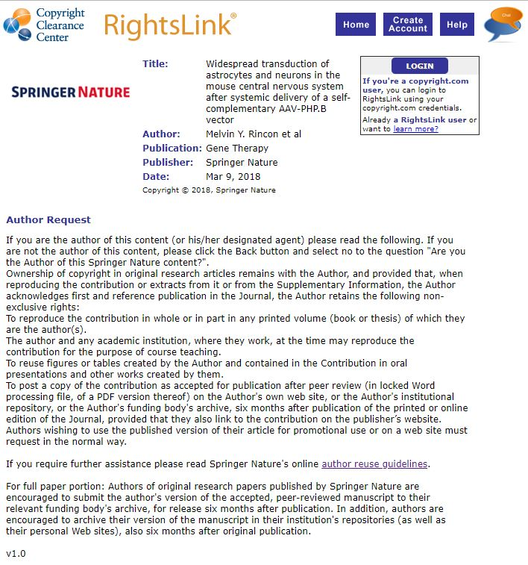

-Please provide the composition of the lysis buffer.
As with other solutions, materials and equipment, information on the composition of the lysis buffer are included in Table 1 (AAV purification and desalting).

-After you have made all the recommended changes to your protocol (listed above), please highlight 2.75 pages or less of the Protocol (including headings and spacing) that identifies the essential steps of the protocol for the video, i.e., the steps that should be visualized to tell the most cohesive story of the Protocol.
As requested, we highlighted 2,75 pages of text. However, we believe that the desalting and concentration of the vector (step 3) would be of great interest to the reader. Therefore, we would be grateful if it could be added to the video. Moreover, showing how the filters are loaded would be a great visual help to the reader.
Meanwhile, we ensured that the editorial comments “Please highlight complete sentences (not parts of sentences). Please ensure that the highlighted part of the step includes at least one action that is written in imperative tense” and “Please include all relevant details that are required to perform the step in the highlighting” have also been properly addressed.

Reviewer #1 comments have been addressed by the authors as follows:

Manuscript Summary:
The Manuscript "Production of adeno-associated virus-based vectors for transgene expression in the central nervous system of adult mice after systemic delivery" describes the production and purification of AAV vectors for in vivo use. The manuscript is well written and contains well-defined instructions for the production of AAV vectors. Overall, this protocol should prove very helpful for laboratories who would like to produce AAVs. However, prior to publishing a few minor points should be addressed.

We are thankful to the reviewer for the positive feedback.

Major Concerns:
no major concerns. The introduction needs some re-modelling tough.
The introduction has been remodeled to assume a clearer methodical cut. Moreover, an introduction to the methods employed in the protocol has been provided.

Minor Concerns:
- The abstract states that PHP.B did not have toxic side effects, however, recent reports by Wilson and group reported safety concerns in non-human primates. Although it is unclear whether the safety concerns were due to the vector or impurities thereof, this issue needs to be acknowledged and thus, maybe this sentence should be removed from the abstract and other parts of the text unless this paper is cited and properly discussed that we currently don't know the origin of the problem.
We thank you for pointing out this problem and we acknowledge the fact that this has been reported. Therefore, following reviewer advice the sentence has been removed.

- Accuracy of qPCRs for titration (as mentioned in the abstract). Although qPCRs can be very accurate, the authors should discuss that there remains an error range that experimenters should keep in mind (this could be part of the discussion)
We are grateful for your feedback. In the discussion, we added a section addressing the issue.

- Introduction: the introduction reads very much like an introduction from a review paper for AAVs rather than an introduction into a methods paper. Thus, the introduction should be altered to include more details (at least a paragraph or more) about how AAV vectors are currently produced, what different methods of transfection, harvesting and purification are used and advantages and disadvantages and major difficulties in AAV production (yields, purity and such) - some other parts of the introduction could be shortened
We revised the introduction and removed the unnecessary information. To comment on the alternative methods, the discussion was expanded. In particular, we added new information concerning the chosen methods of transfection and purification and other options currently available.

- The statement AAVs provoke little to no immune response is misleading. We recommend to use little or milder immune responses compared to other viral vectors.
Thank you for raising the point. We are in agreement with your recommendation and the sentence has been altered accordingly.

- Line 124 and following: If praising PHP.B for crossing of the blood brain barrier, AAV9 should at least be mentioned here...it should not sound like PHP.B is the only vector that crosses the blood brain barrier
Thank you for bringing this point to our attention. We have modified the section by mentioning AAV9 as another serotype which is able to cross the BBB, as recommended.

- Line 128/129: The sentence "In an AAV vector, ..." is confusing at the position where it was entered - it could also be deleted, or alternatively, should be moved to a different position
The introduction has been altered according to your recommendation and the section you indicated has now been removed.

- Line 147: needs to be remembered could be replaced by "should be kept in mind"
Thank you for your feedback. The paragraph has been remodeled.

- Discussion could go in more detail for factors that influence yield of production
Taking into consideration your comment, we have added a paragraph in the discussion section that handles about determining factor that could influence the final yield of the production.

- Line 198: it would be good to mention here the size of the 18 culture dishes here
Information on the size of the 18 culture dishes has been added to the manuscript in line 174.

- Line 224: for someone who never made AAVs, it might be unclear what E4, E2A and VA RNA is for...maybe one could add another sentence explaining this.
Thank you for bringing this point to our attention. Hoping to clarify the concept for the readers, a description of the role of E4, E2A and VA RNA has been added in line 152.

- The step from 1.2 to 1.3 is a bit confusing - from a mix for 18 plates to suddenly having 3 tubes...maybe one could add in brackets something like: 1 tube per 6 plates...
The modification you suggested has been inserted in the manuscript (step 1.5)

- 1.8: maybe it should be specified that the media is not changed
The modification you suggested has been inserted in the manuscript (step 1.10)

- 4.1.1 : the plasmid needs to be linearized is not correct, this sentence should be changed to "in this method, we use linearized plasmid as a standard and therefore, the plasmid needs to be cut..."
Thank you for your feedback. We inserted the recommended modification in line 305.

- 4.1.2: a sentence could be added that the efficiency of the digest should be verified on a gel...also, can the plasmid stock be prepared and then stored and re-used, or is it prepared fresh every time?
The modifications you suggested have been implemented in the step 4.1.3.

- For the qPCR, a tip could also be that if you want to compare two different preparations, you should try and use the same primers (ergo primers in the promoter) as different primers can have different amplification efficiencies.
Thank you for your comment. Hoping to add relevant information for the readers, we have introduced changes in the manuscript (lines 621-634).

- Representative Results: the first paragraph is a bit misleading - it is currently unclear how much better PHP.B is compared to AAV specifically in different mouse strains. It should at least be mentioned that the mouse strain could have an impact on the transduction efficiency with different AAVs...
Thank you for raising this point to our attention. The Representative Results section has been modified to include your suggestions.

- Line 677: the sentences should say "vector administration was PERFORMED via tail vain
Thank you for bringing the issue to our attention (line 504).

Figure and tables:
- Figure 1: we need a closer zoom in for e) and an arrow as to where the band is that needs to be pulled - this will help people to follow the protocol if they know how it looks after the spin
We have added a zoomed-in picture of the fraction that needs to be collected.

Discussion:
- The paragraph 758 - 763 could be in the introduction for example.
Many thanks for your feedback. Hoping to improve the clarity of the manuscript, the introduction and discussion paragraph have been reshaped.

- Discussion about passage number of 293 cells: where were those purchased and what was the passage when they were acquired? or does it only matter how long they were in culture?
Thank you for your comment. Information about the purchasing of HEK293T cells have been provided in the material table.

- Csf delivery should be mentioned as an alternative
Following your suggestions, the discussion has been modified by mentioning CSF as an alternative route of administration.

Reviewer #2 comments have been addressed by the authors as follows:

Manuscript Summary:
The manuscript entitled „Production of adeno-associated virus-based vectors for transgene expression in the central nervous system of adult mice after systemic delivery" by Shelly Fripont et al. Provides a full protocol of production and purification of two AAV serotypes including titration and quality/purity controls, leading all the way to systemic delivery (i.v. injection) of the viral vectors and detection of transgene expression in the CNS.
Although the technologies used are not completely novel, the manuscript displays a very informative and complete walkthrough for the whole procedure.
The steps in the protocol are well described and the list of materials would allow the reader to easily reproduce the AAV-production and utilization.
We are thankful to the reviewer for the positive feedback.

Major Concerns:
None

Minor Concerns:
I only have minor remarks on the manuscript and would suggest discussing a few additional aspects that are not directly related to the AAVs and transgene constructs provided here:

- It would be great to include perspectives for additional AAV serotypes in the discussion to give the reader some hints (where possible) if their AAV-serotype of choice may be suitable at least for production and purification as described here. E.g. AAV2/5 may be tricky on iodixanol gradients.
Thank you for bringing this point to our attention. The discussion has been modified to insert your suggestion (lines 614-620)

- Also for qPCR approaches for tittering it may be useful to include some additional promotor elements, or alternative sequence areas, that would enable titration of viruses with alternative constitutive (e.g. CAG, CMV, TK) or tissue specific propters (in CNS e.g. hSYN, CamKII etc.).
We are grateful for your suggestion. Hoping to provide useful information to the readers, we have added a tip in the discussion section (625-634).

- Also, there are some spelling mistakes in various positions, which easily can be addressed prior to publication
We thank you for pointing this out. The checked manuscript has been proof-read to address these mistakes.

