
Department of Neurology,
New York University Langone Health
222 E 41st St, 14th Floor, 14-025G
New York, NY 10017, USA
Office: (929) 455-5116

Editorial Board
Journal of Visualized Experiments

September 25, 2018

Dear Editors,

With this letter we are resubmitting our invited manuscript, entitled “Bilateral assessment of the corticospinal pathways of the ankle muscles using navigated transcranial magnetic stimulation” for review (NOTE: we have slightly revised the title). We appreciate the thoughtful comments of the editor and reviewers; the changes we have made in response to their comments have strengthened the paper.
As before, I will serve as the corresponding author for this manuscript.

If you have questions or need any further information, please contact me.

Sincerely,
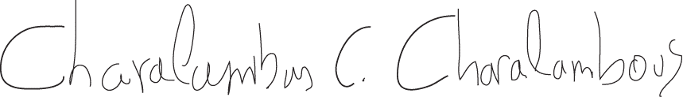

Charalambos C. Charalambous, PhD
Postdoctoral Researcher
Email: charalambos.charalambous@nyulangone.org

