November 1, 2018

Phillip Steindel, Ph.D.
Review Editor
JoVE
One Alewife Center, Suite 200
Cambridge, MA 02140
Tel: 617-674-1888
Email: Phillip Steindel at em@editorialmanager.com

RE: JoVE manuscript revision JoVE58937R3

Dear Dr. Steindel:

We thank you for the 3 editorial comments for our manuscript, entitled “The Clinical Application of Tumor Treating Fields Therapy in Glioblastoma” and accommodated all of them. A clean copy of the revised manuscript and one with the track changes are enclosed. All authors have agreed submission of this manuscript.

We hope that our revised manuscript is satisfactory. We look forward to hearing from you.

Sincerely yours,

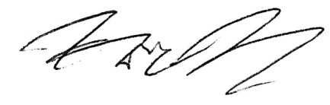

Eric T Wong, MD
Associate Professor of Neurology
Harvard Medical School

Director, Brain Tumor Center & Neuro-Oncology Unit
Beth Israel Deaconess Medical Center

Director, Neuro-Oncology Fellowship Program
Beth Israel Deaconess Medical Center

Member, Neuro-Oncology Protocol Committee
Dana Farber/Harvard Cancer Center

