Badalona, October 22nd 2018

Dear Dr. Bajaj,

Please, find enclosed the revised version of our manuscript entitled “Simultaneous Electrical and Mechanical Stimulation to Enhance Cells Cardiomyogenic Potential” by Llucià-Valldeperas et al.

We deeply appreciate the second review of our manuscript submitted to Journal of Visualized Experiments. Based on editor’s comments, we have revised the manuscript as described in the enclosed point-by-point response. We have also prepared a second version of Figure 2 to clarify some steps of the Protocol section. We could include this new Figure upon Editor’s decision.

We hope that the revised version of our manuscript meets with your approval and is suitable for publication. We wish to thank the editor for the comments to improve our paper. I look forward to hearing form you.

Sincerely,


Dr. Aida Llucià-Valldeperas, PhD.
ICREC Research Program, Health Science Research Institute Germans Trias i Pujol.
Amsterdam UMC, Pulmonology and Physiology, Amsterdam Cardiovascular Sciences.
E-mail: llucia.valldeperas@gmail.com, a.lluciavalldeperas@vumc.nl.

Editorial comments:
1. The manuscript is poorly written, please use a professional copyediting service or proofread it very well to bring out the clarity and removal of redundancy throughout.
The comment is well received and the manuscript was sent to a professional copyediting service.

2. The editor has formatted the manuscript to match the journal's style. Please retain the same.

3. Please address all the specific comments marked in the manuscript.
All comments were addressed. However, we want to explain some of the changes to the following comments for their relevance:

Comment 1:
The stimulation could be simultaneous or not, so we slightly modified the title according to the comment but maintaining the word “Simultaneous” as it is important for the stimulation regime.

Comment 10:
Figure 1 citation has been added on line 212.

Comment 20:
The PDMS construct characteristics were described in the Introduction section and it has been shown in Figure 1A,B.

Comment 28:
The cell pool has been described before and also shown in Figure 1A,B.

Comment 49:
The paraffin film is added above the cell pool to minimize the evaporation during incubations. Additionally, the culture plate is always placed throughout culture and immunostainings.

Comment 54:
Transcriptional data is shown in Figure 3, as well as protein data (immunostaining). In that publication we did not perform westernblot analyses after electromechanical stimulation, so we cannot include this data. However, the technique allows us to collect protein samples for western blot.

4. For the introduction section, Please revise to include all of the following:
a) A clear statement of the overall goal of this method
b) The rationale behind the development and/or use of this technique
c) The advantages over alternative techniques with applicable references to previous studies
d) A description of the context of the technique in the wider body of literature
e) Information to help readers to determine whether the method is appropriate for their application
All this information has been addressed in the Introduction.

5. For the protocol section, Please ensure that all text in the protocol section is written in the imperative tense as if telling someone how to do the technique (e.g., “Do this,” “Ensure that,” etc.).
The whole protocol has been revised to ensure the imperative tense was used.

6. Please ensure you answer the “how” question, i.e., how is the step performed? Please provide all button clicks, graphical user interface, the knob turns etc. wherever needed.
Clarification and more details were added to some steps.
Regarding section 3.8 a new Figure 2 has been prepared with a detail of the mechanical stimulation user interface:
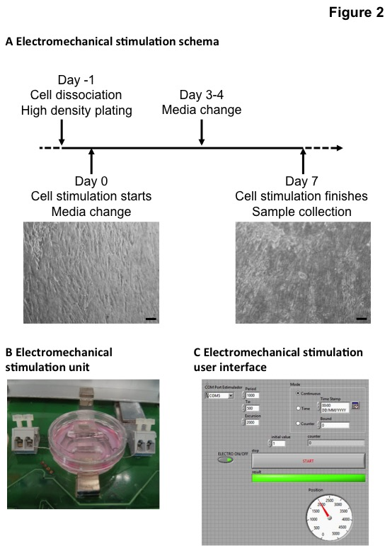
If the Editor prefers the revised version of Figure 2, it could be incorporated instead of the original Figure 2. Both Figures will be uploaded.

7. The Protocol should be made up almost entirely of discrete steps without large paragraphs of text between sections.
The protocol was rewritten into discrete steps.

8. Once formatted please ensure that the protocol is no more than 10 pages long and the highlighted section is no more than 2.75 pages including headings and spacings.
The new revised protocol fits in the page limits.

8. Results: Please ensure that you have representative results for all the sections described in the protocol.
Representative results for immunostainings and PCR data are shown. However, we do not show western blot results after electromechanical stimulation of cardiac ATDPCs, as we did not perform it. The westernblot analyses section was added because the technique is allowed by the protocol. However, if results are needed we can omit this section.

9. Please reword lines 102-105, 148-151 as it matches with the previously published protocols.
We appreciate the comment and they were rewritten in the revised version of the manuscript.

